Yuvraj Singh
Phagwara, Punjab, India
+91-9056706317 ✉ mainyuvraj05@gmail.com
LinkedIn: https://www.linkedin.com/in/yuvrajsingh GitHub: https://github.com/alley0405

Objective
To secure a challenging role as a Software Engineer in a reputed organization where I can utilize my skills in full-stack development, data analysis, and AI-based applications, contribute to impactful projects, and continuously grow as a professional while helping the organization achieve its goals.

Education
Lovely Professional University Punjab, India
Bachelor of Technology – Computer Science and Engineering 2027
CGPA: 6.10
Relevant Coursework:
Data Structures and Algorithms, Artificial Intelligence, Database Management System
Swami Sant Dass Public School Phagwara, Punjab
Intermediate (Class XII) 2022
Percentage: 74%
Swami Sant Dass Public School Phagwara, Punjab
Matriculation (Class X) 2020
Percentage: 85%

Technical Skills
Programming: C++, Java, Python, JavaScript
Frameworks:: React, Django, NumPy, Pandas, Scikit-Learn
Core Concepts:: Data Structures, Algorithms, Object-Oriented Programming, REST APIs Tools: Git, GitHub, MySQL, Power BI, Excel

Projects
Project Title: Side Hustle Planner Jan 2026
Description: An AI-powered web application that generates personalized side hustle ideas based on user skills and interests with an interactive chatbot-style interface.
Technologies Used: Next.js, React, JavaScript, Local Storage, HTML, CSS.

Impact/Achievements: Implemented dark/light mode, dynamic content rendering, and state management to improve user engagement and ensure persistent data across sessions.
Github Link: GitHub Repository

Project Title: Bike Sales Analysis Dashboard Nov 2025
Description: A data analytics project that analyzes bike sales data to identify trends, customer behavior, and regional sales performance using interactive dashboards.
Technologies Used: Power BI, Power Query, DAX, Excel.
Achievements: Built interactive dashboards with KPIs, slicers, and filters to provide actionable insights and support data-driven business decision making.
Github Link: GitHub Repository

Project Title: SkillBridge – Side Hustle Platform Feb 2026
Description: A full-stack platform that connects users with side hustle opportunities based on their skills, providing a modern and interactive user experience.
Technologies Used: React, Vite, Django, SQLite, Axios, Framer Motion.
Impact/Achievements: Developed a modular Django backend with REST APIs and integrated it with a responsive React frontend for seamless client-server communication.
Github Link: GitHub Repository

Training

Mastering Data Structures and Algorithms Using C++ July 2025
Completed intensive training in data structures and algorithms, solving 100+ coding problems and implementing core structures like trees, graphs, heaps, and hash tables.

Certifications
- Computational Theory: Language Principle & Finite Automata Theory Aug 2025
- ChatGPT-4 Prompt Engineering: Generative AI & LLM Aug 2025
- Java Programming May 2025
- Cloud Computing (NPTEL) Apr 2025
- C++, DSA, ML, Python

AI Recommendations for Improvement
Recommendation 1: Strengthen DSA & Add Competitive Programming Proof
Recommendation 2: Add a Backend/API-Focused or ML Project with Real Depth Recommendation 3: Pursue a High-Signal Certification

Self-Assigned Tasks (Till 10th week of this semester)
Task 1: Currently practicing Data Structures and Algorithms on LeetCode to strengthen problemsolving skills and prepare for technical interviews.
Task 2: Developed a full-stack application with a RESTful Django backend, integrated with a React frontend, and deployed on Render for live accessibility.
Task 3: Oracle Data Platform 2025 Foundations Associate — Oracle University

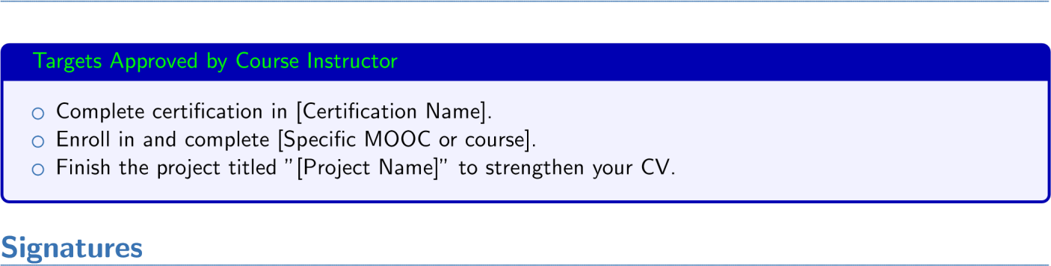
Targets Allocated (Till 10th week of this semester)

Student’s Full Name Instructor’s Full Name

