Instructions

In this experiment, we want to study how people make decisions.
Overview: The task is a two-stage decision task, in which you need to make two sequential choices (by pressing ‘‘LEFT’’ or ‘‘RIGHT’’ button) to obtain a monetary outcome (coin) at the end stage. The two choices will be followed by a coin delivery. You will get to keep the money you “earned” at the end of the experiment.
Task: Your job is to collect as many coins as possible. The higher the total amount, the greater is the probability that you will win money when you finish the experiment. During the first two stages, you can choose to press the left or right button according to the given state. Each state is represented by a different fractal image. The first state (image) is always the same.
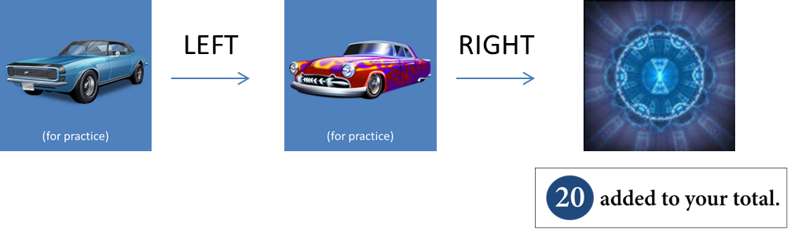
<Two sequential choice task – one trial>
States and choices: Your choice in the first state determines which state will be your second state. Your choice in the second state determines a monetary outcome (coin). In the first state, you should make a choice that gives you a better chance of meeting a second state which has a higher chance of a good outcome; in the second state, you should make a choice that gives you a better chance of a good outcome. Making no choice in 4sec will have a computer make a random choice to proceed and that trial will be marked as a penalizing trial.

<Example of 5 states in which you need to make a choice. Fractal pictures will be shown in main sessions>
Coins you should collect: There are 4 kinds of coins: for example, red coins that make you earn 40 points, blue for 20 points, yellow for 10 points, darkgray for 0 points.

<An example of coin colors. In the experiment, color might be different with these colors>
Boxes for your coin collection: You will be given a collecting box, whose color may change over trials. The red, blue, and yellow boxes are very specific; you get the amount on the coin only if you find a coin whose color is the same color as your collecting box. For example, finding a red coin when your box is blue won’t make you win 40; you will get NOTHING. But the white box is flexible; it accepts *any* coin color,
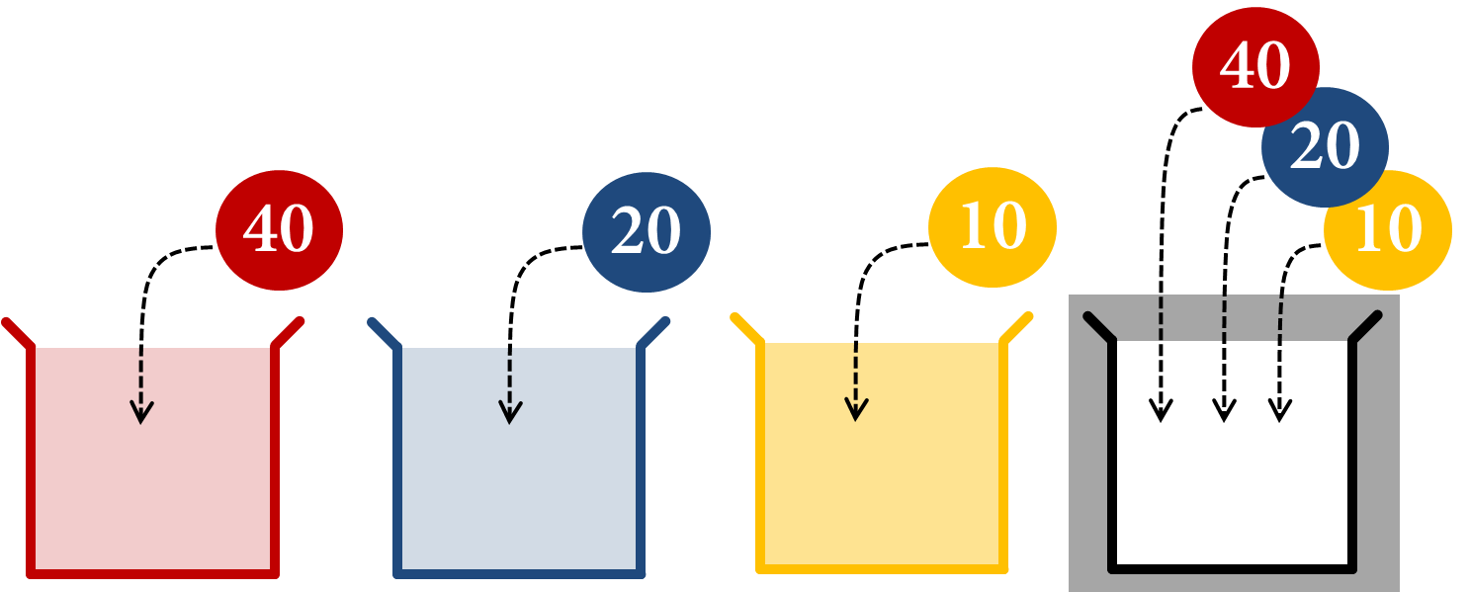
<Collecting boxes in different colors and the coins they will accept>
A few examples:
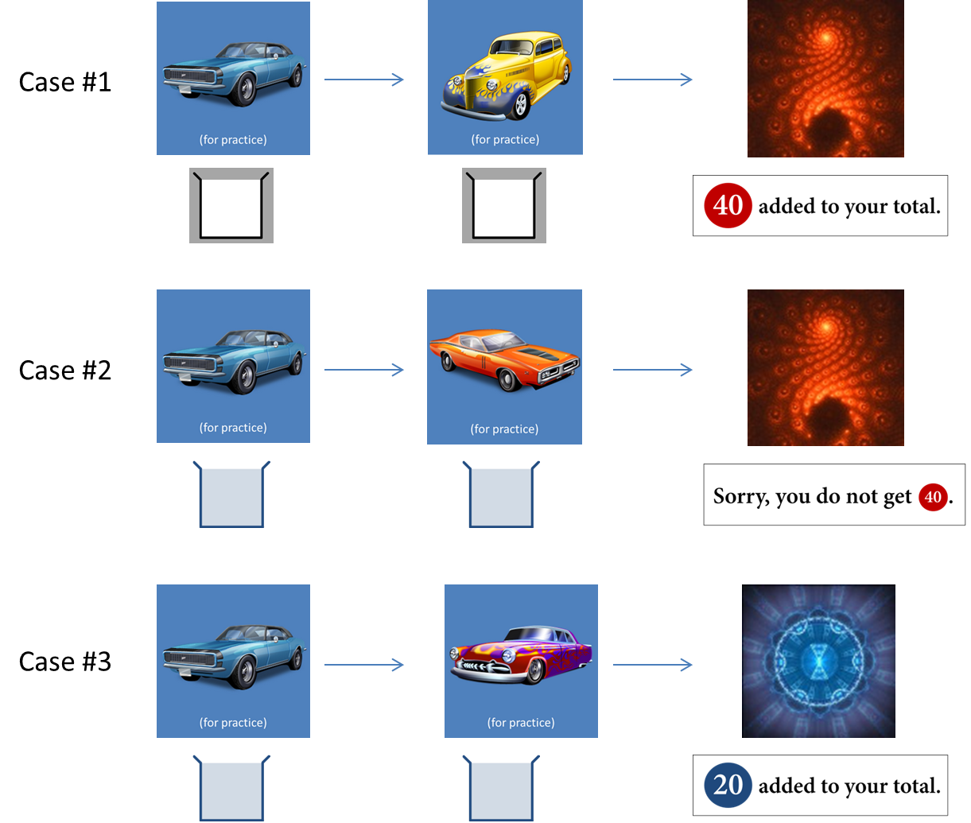
<Case study: (case #1) you can collect any color coins when your box is green-striped. (case #2) you can’t put the red coin in your blue box. (case #3) you can put the blue coin in your blue box.>
Experiment: The experiment consists of six sessions - one practice session + five main scanning sessions.
In the practice session, the green-striped box will be given during the first 80 trials. Then the color of the box will change over the remaining 20 trials. The practice session won’t count, but be advised that the more you learn in the practice session, the higher chance of winning you have in the main session. You will need to roughly learn (1) better choices for each state and (2) an association between states and color of coins. Try to explore states as much as possible.
In the main sessions, the box of the color may or may not change. In order to collect as many coins as possible, you will need to use the information you have acquired in the practice session.
Rewards: Your initial endowment is $30. At the end of the experiment, we will randomly select one trial from all main sessions and pay you the amount that you have earned. One point corresponds to $1. For example, if the trial#37, in which you collected 40 points, is selected, then you would receive extra $40, whereas if the trial#42, in which you collected 10, is selected, then you would receive extra $10. Therefore in order to win as much money as possible you should do your best in every trial.
Good luck!

