**Angular - Task3**

**app.component.html**

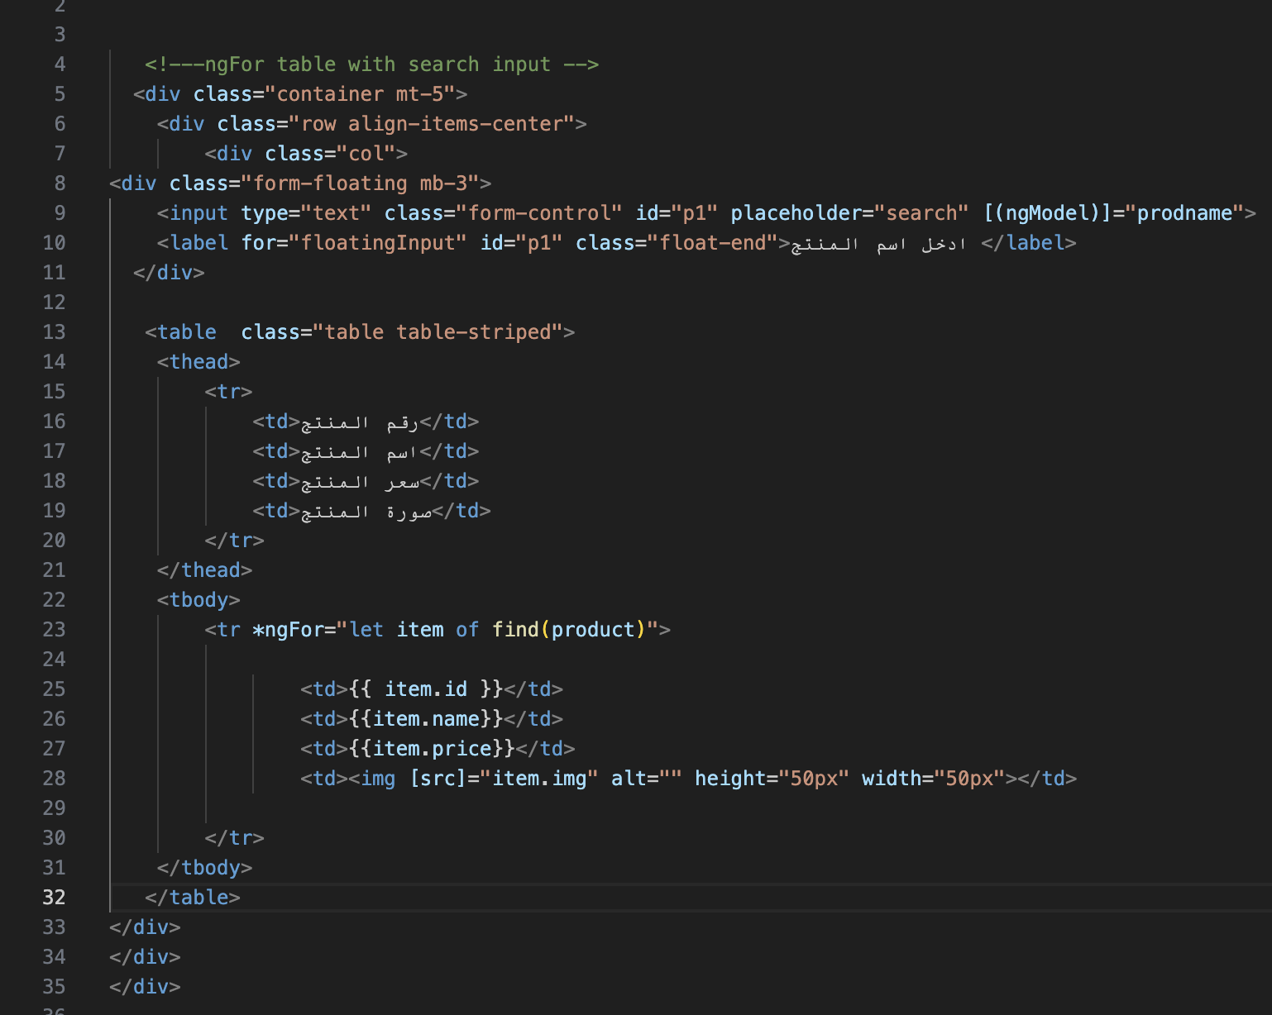

**app.component.ts**

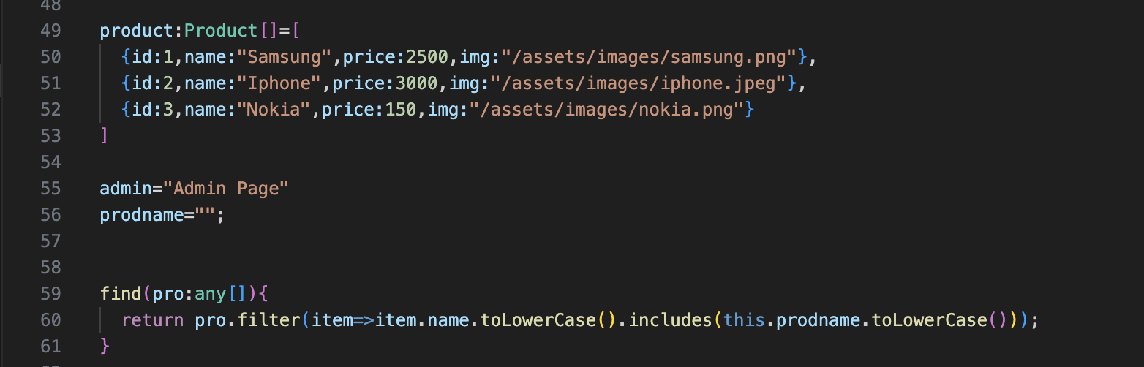

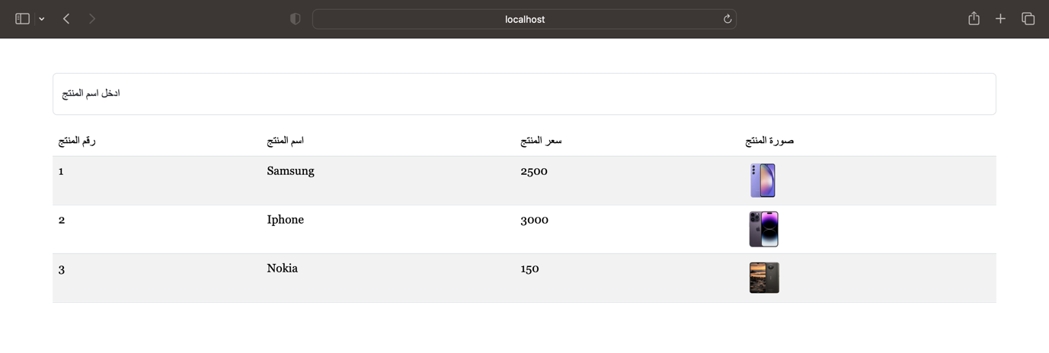**Output on http://localhost:4200**