**Software Testing assignment 4**

1 2 and 3)

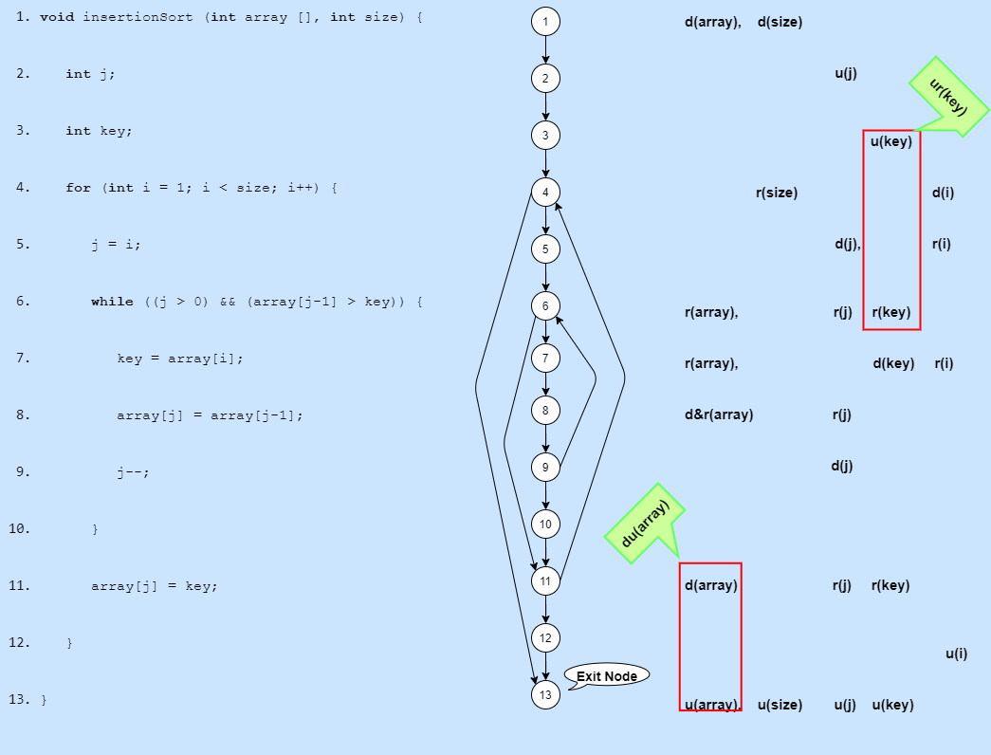

**Note**: there should be an Starting note at note 1.

There could be a problem with the ur(key) anomaly because you are reading a value that is undefined, there is not a problem with du(array) since the u(array) is after the function has finished, unless you plan to use the array outside of the insertion sort function, then there could be a problem.

4)

v(G) := e - n + p

e = 16

n = 13

p = 2

**v(G) = 16-13+2 = 5**

5)

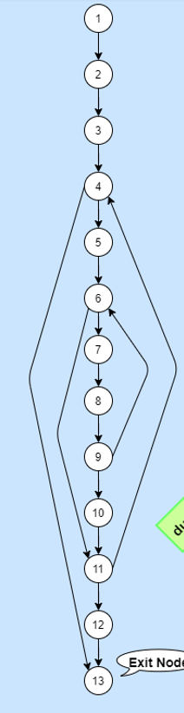Let’s look at each path:  
path 1 = {1,2,3,4,5,6,7,8,9,10,11,12,13}  
path 2 = {1,2,3,4,13}  
path 3 = {1,2,3,4,5,6,11…*}  
path 4 = {1,2,3,4,5,6,7,8,9,6…*}  
path 5 = {1,2,3,4,5,6,7,8,9,10,11,4…*}

Just like in McCabe Cyclomatic above, there are 5 linerally independent paths.

6)

1. 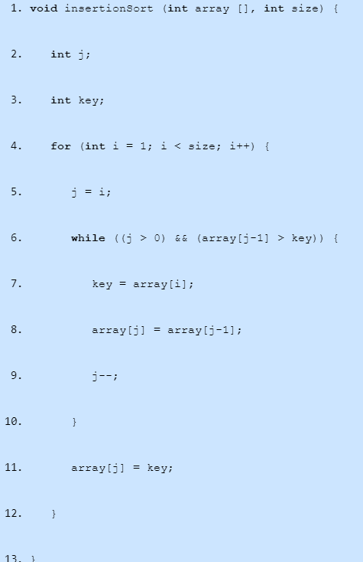nesting = 0
2. nesting = 1
3. nesting = 1
4. nesting = 1
5. nesting = 2
6. nesting = 2
7. **nesting = 3**
8. **nesting = 3**
9. **nesting = 3**
10. nesting = 2
11. nesting = 2
12. nesting = 1
13. nesting = 0

Maximum level og nesting = **3**