Modelling Human Activity States using Hidden Markov Models
Alliane UMUTONIWASE · Formative 2 · 30th October 2026
GitHub repository: https://github.com/allia-wase/Hidden_markov-models

1. Background and motivation
The use case is an activity monitor for an older person living alone, using a phone to communicate with. The family member could be notified when the pattern is broken, so he or she could know that the phone is not being used normally. Without any cameras or dedicated wearable, if the phone can tell whether, his/her family member is walking, standing, being unusually active or has left the phone lying still for hours, they could be notified when it is not being used normally. It's not the phone that is measuring activity, it's noisy accelerometer and gyroscope signals. This is well suited to a Hidden Markov Model, which treats the activity as a hidden state, and allows for the incorporation of two aspects: what the activity "appears" to be in the features measured from the sensors, and how activities tend to evolve over time, or be followed by other activities. I took my own data for 4 activities (standing, walking, jumping and still), and created the HMM from scratch using numpy, and tested it on data it had not been trained on.

2. Data collection and pre-processing
I took 61 labelled training clips, and 3 continuous test sessions, on an iPhone 14 at native frame rate of 100Hz using Sensor Logger.

Item | Detail
Device and app | iPhone 14, Sensor Logger 1.68 (iOS)
Sensors | Accelerometer + Gravity (added together into total acceleration, m/s²), Gyroscope (rad/s)
Sampling rate | 99.8 Hz measured from the timestamps (nominal 100 Hz), timestamp jitter under 1%
Phone position | Held flat, screen up, at waist level for standing, walking and jumping; flat on a table, screen up, for still
Training data | 61 clips of 5 to 10 s: standing 15 clips (103.7 s), walking 16 (118.9 s), jumping 15 (98.1 s), still 15 (99.5 s)
Test data | 3 continuous sessions of 44 to 46 s, each containing all four activities in a different order

Video evidence
Activity | Video (face and full body, phone in hand)
Standing | https://drive.google.com/file/d/1Hc-7JuFMNjDIyc8vTTDgJF645VrOVo9M/view?usp=drive_link
Walking | https://drive.google.com/file/d/1VTWMarIPIKNewofSt5uE4qYsZ0iSnmiz/view?usp=drive_link
Jumping | https://drive.google.com/file/d/1depReIVwLN4IAf_veE4kjWD8ZHYJcCQl/view?usp=drive_link
Still | https://drive.google.com/file/d/1E6PHQBcCtrlErBuN93QFxcTyeGweL2In/view?usp=drive_link

Cleaning

Each export is transformed with the help of a small script (prepare_data.py) into an export with a column for a time stamp. On iOS, Sensor Logger removes the gravity from the accelerometer and stores the gravity in a separate file, the script combines them back together again, gravity indicates the tilts of the phone. All clips were length and timestamp checked. Three clips fell outside the 5 to 10 s range (2.7 s, 4.6 s and 11.9 s), so I left them out. I also remounted the still clips, seeing that the phone was not laying flat, but rather upright. The maximum gap in the file is 0.1 s.
The sampling rate should be harmonized with the other factors.
The first step in each recording is to interpolate it to an evenly-spaced grid at its native sampling rate, after which it is low-pass filtered (4th-order zero-phase Butterworth, 20 Hz) to avoid aliasing and resampled to 50 Hz. I cut the 0.5 s at both ends of every clip to remove the tap on the screen. I selected 50 Hz because human emotions are low-frequency and almost all energy of human motion is below 20 Hz, walking rhythm is 1 to 3 Hz, and standard dataset like UCI-HAR use the same frequency rate.

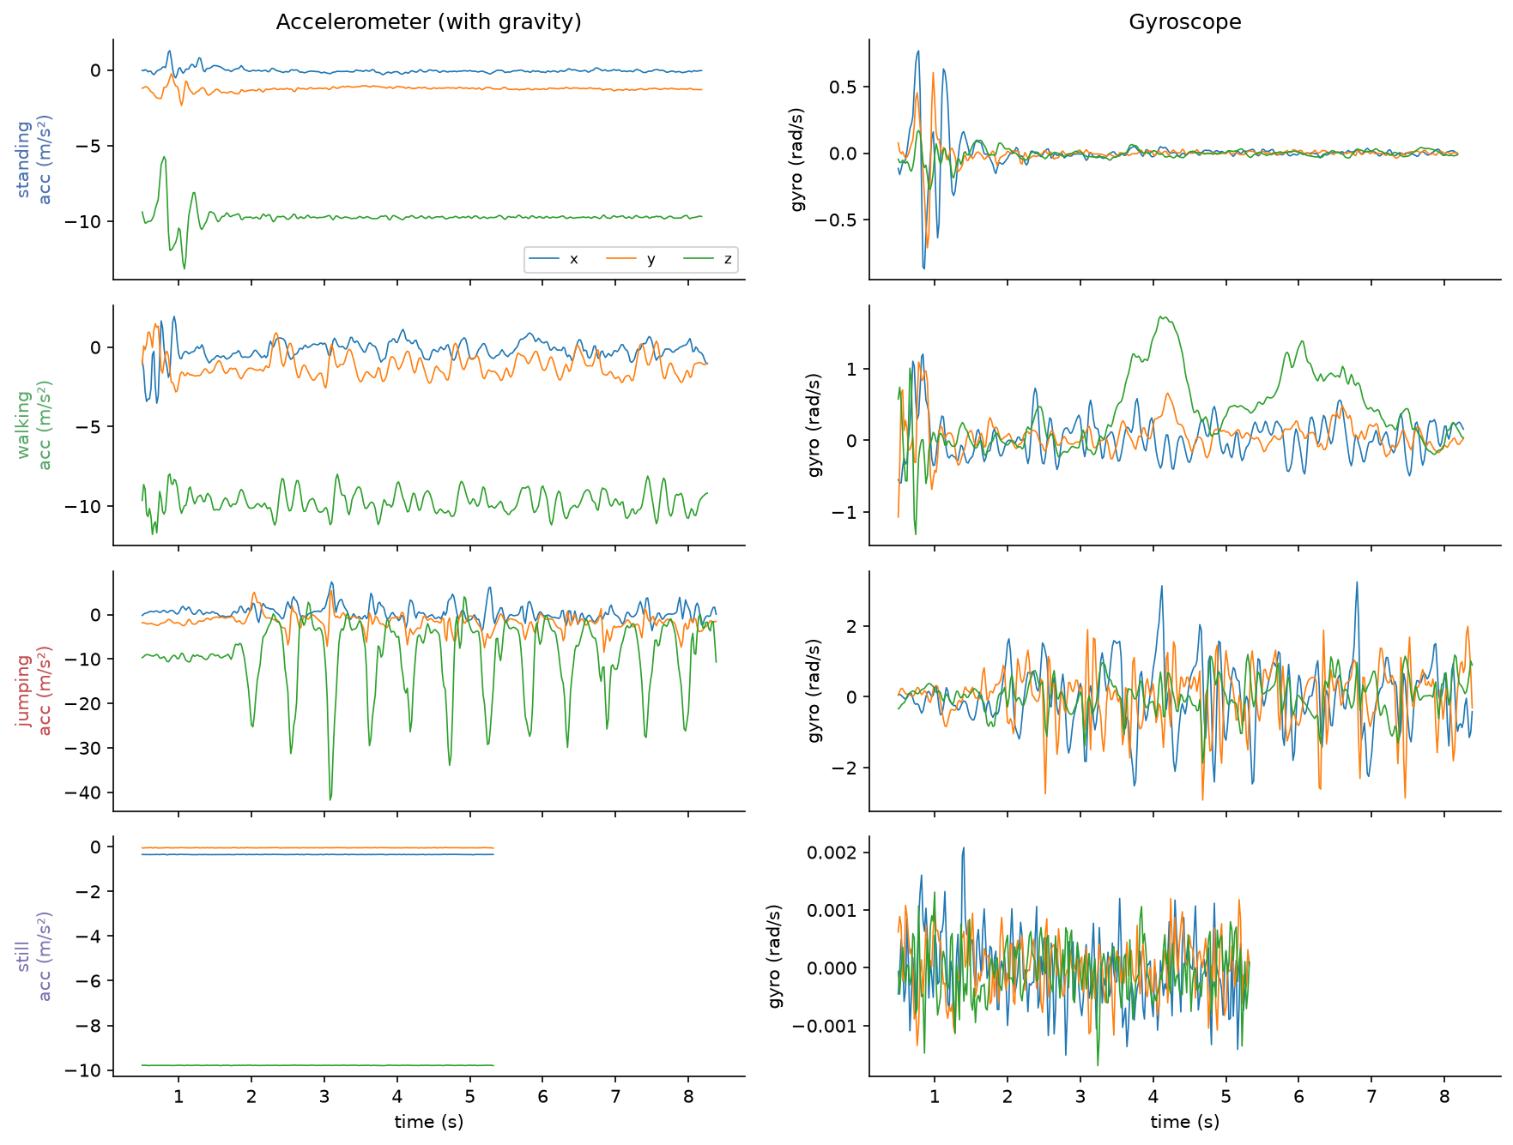

Figure 1. A sampling of a training clip was taken once for each activity: accelerometer with gravity (left), gyroscope (right). The jump landings come in around −40 m/s2 on z; the still clip is flat (except for sensor noise around 0.001 rad/s).

Windowing

Signals are processed in 2 s windows (100 samples at 50 Hz) and each window has been processed with the next window every 1 s, a 50% overlap. Two seconds contains at least three steps or jumps at 1.5 to 2.5 Hz, and 100 samples provides an FFT frequency spacing of 50 / 100 = 0.5 Hz, so suitable for separating a 1.5 Hz rhythm from a 2.5 Hz rhythm. If the window were longer, there wouldn't be as many windows per clip – a 7 s clip only provides around 5. This resulted in 267 training windows and 129 test windows.

Features and normalization
Each window is now a 12-time domain and 4 frequency domain feature vector, or 16 dimensional feature vector.
Feature | Domain | Why it helps
Mean of x, y, z acceleration | Time | Direction of gravity, so how the phone is tilted. Jumping tilts it slightly more than the other activities.
Std, range and SMA of acceleration magnitude (log) | Time | How much I am moving. Standing has the small shake of my hand, about 15 times the noise of a phone on a table, and this is what separates standing from still.
Mean and std of gyroscope magnitude (log) | Time | Rotation. Walking swings the phone with my hips; a phone on a table does not rotate at all.
Correlation between axes (xy, xz, yz) | Time | Jumping moves mostly along one axis, while walking mixes vertical and forward motion.
Dominant frequency of acceleration | FFT | Step or jump rate. Noise-only activities have no clear peak.
Power at the dominant frequency (log) | FFT | How strong that rhythm is.
Share of energy in 0.5 to 5 Hz | FFT | Human movement puts its energy in this band; sensor noise spreads it out.
Spectral entropy | FFT | Low for rhythmic movement, high for flat noise such as the still state.
Dominant frequency of rotation | FFT | The hip rotation rhythm while walking.

The intensity is several orders of magnitude (0.01 m/s² for still and > 10 m/s² for jumping), so I take the log of them. Then I z score using only the mean and SD of the training windows and not the test windows. Hz, m/s² and unit less ratios are on one scale and the shared variance floor of the Gaussian emissions requires them. It also is able to handle outliers more effectively than the min-max scaling approach, where one "hard" jump landing would establish the max and cause everything else to be scaled down. These statistics are based only on the training data, which means that the test set will not be seen while doing these statistics.

3. HMM setup and implementation
The model is a four state HMM with diagonal Gaussian emissions, implemented from scratch in numpy. Trained using two stages: counting from labels and Baum-Welch.

Component | Definition
Hidden states Z | standing, walking, jumping, still
Observations X | One z-scored 16-dimensional feature vector per 2 s window
Transitions A | A_ij = P(activity j at t+1 given activity i at t), one step = 1 s
Emissions B | A Gaussian per state with diagonal covariance and a variance floor of 0.01
Initial probabilities π | P(the first window's activity)

I used the diagonal covariance as each activity only has about 60-80 training windows. A 16×16 covariance requires 136 values per state, while a diagonal 16 covariance requires 16 values per state. With the almost flat gyroscope readings of the still state, the variance floor prevents it from getting too close to zero.

Viterbi is used for decoding. It gives you the most probable sequence of activities, one label per window and also calculates sensitivity, specificity and accuracy based on those labels. Since Viterbi is based on the transition matrix, an atypical window in the middle of a long activity will correct and will not reverse the label. The "forward" algorithm returns the probability of a recording, and the "forward-backward" algorithm returns the state posterior probabilities that Baum-Welch requires.

The model learns nothing from each of the training clips individually since each one only has one activity. I therefore sorted the clips, according to the recording date and time, and merged clips that were recorded in less than 5 minutes into one sequence. This provided 3 sequences of training with 144, 36 and 87 windows. Using only the labels, I tried to estimate π, A, the means and the variances; and added one to each value so that no transition has exactly probability zero. Baum-Welch was then used to tune all the parameters, while stopping the algorithm after observing a mean log-likelihood per window greater than ε = 10⁻⁴. It converged after 4 iterations, going from −2.076 to −1.683. All calculations are performed in log space with log-sum-exp, corresponding to the multiplication of hundreds of small probabilities, which would otherwise round to zero.

4. Results and interpretation
The model correctly labels 92.6% of windows in three unseen test sessions, whereas it was able to do so with 98.5% accuracy on the training data.

The test data is obtained from three new continuous recordings which are performed after the training clips of a separate test session on the same evening. The activities are the same as those used for the training clips (walking, jumping, standing, still; standing, walking, jumping, still; walking, jumping, standing, still; and still, walking, standing, jumping), but each test recording is repeated in 10 s with a stopwatch, in different order each time. The few seconds I used the term when I was moving from one activity to another, like putting the phone down on the table was a transition. Viterbi decodes them as part of the sequence, but the 8 transition windows are left out of the scores, which leaves 121 scored windows.

State (Activity) | Number of Samples | Sensitivity | Specificity | Overall Accuracy
Standing | 29 | 0.759 | 1.000 | 0.926
Walking | 33 | 0.970 | 0.909 | 0.926
Jumping | 30 | 1.000 | 0.989 | 0.926
Still | 29 | 0.966 | 1.000 | 0.926

Table 1. Performance on the three unseen test sessions. Samples are 2 s windows.
The model is generalized well. The test sessions range between 92.1% and 93.0% accuracy, with a gap of around 6% to the training accuracy. Each error occurs at an "activity change point", at which a 2 s interval incorporates the end of one activity and the start of the next, making the switch that is actually decoded, one second earlier or later. Within an activity the decoded label never changes. The most frequent is standing, identified as walking (7 windows) always at the beginning or the end of a standing segment, when I was just settling or right before I had to move.
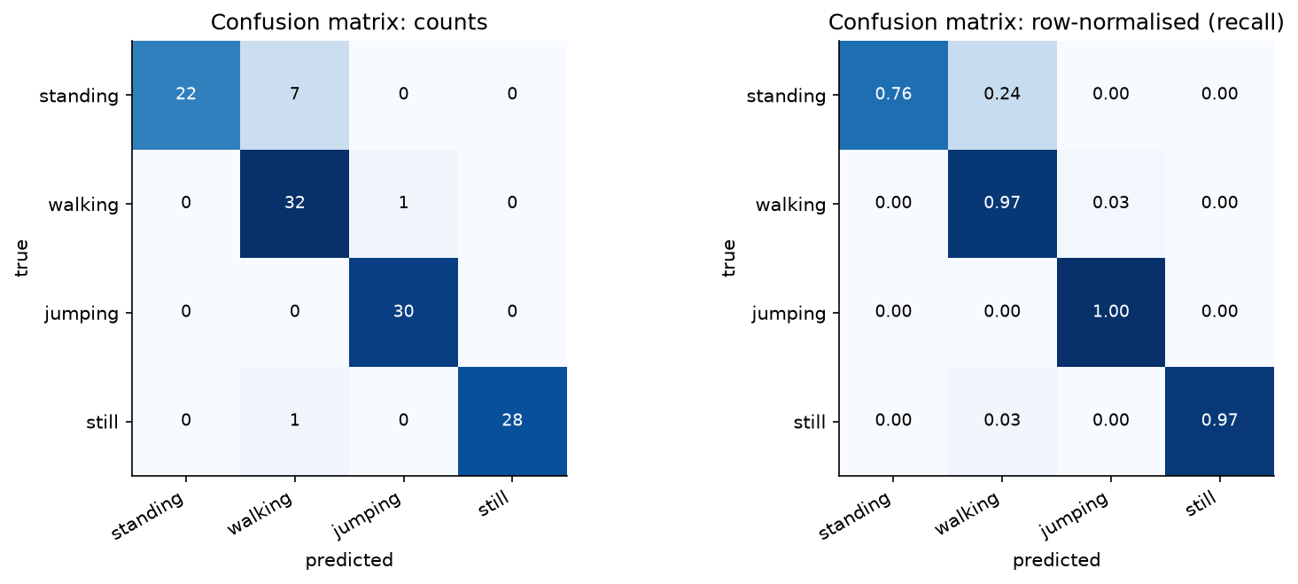
Figure 2. Confusion matrix on the 121 scored test windows, as counts (left) and row-normalized (right).
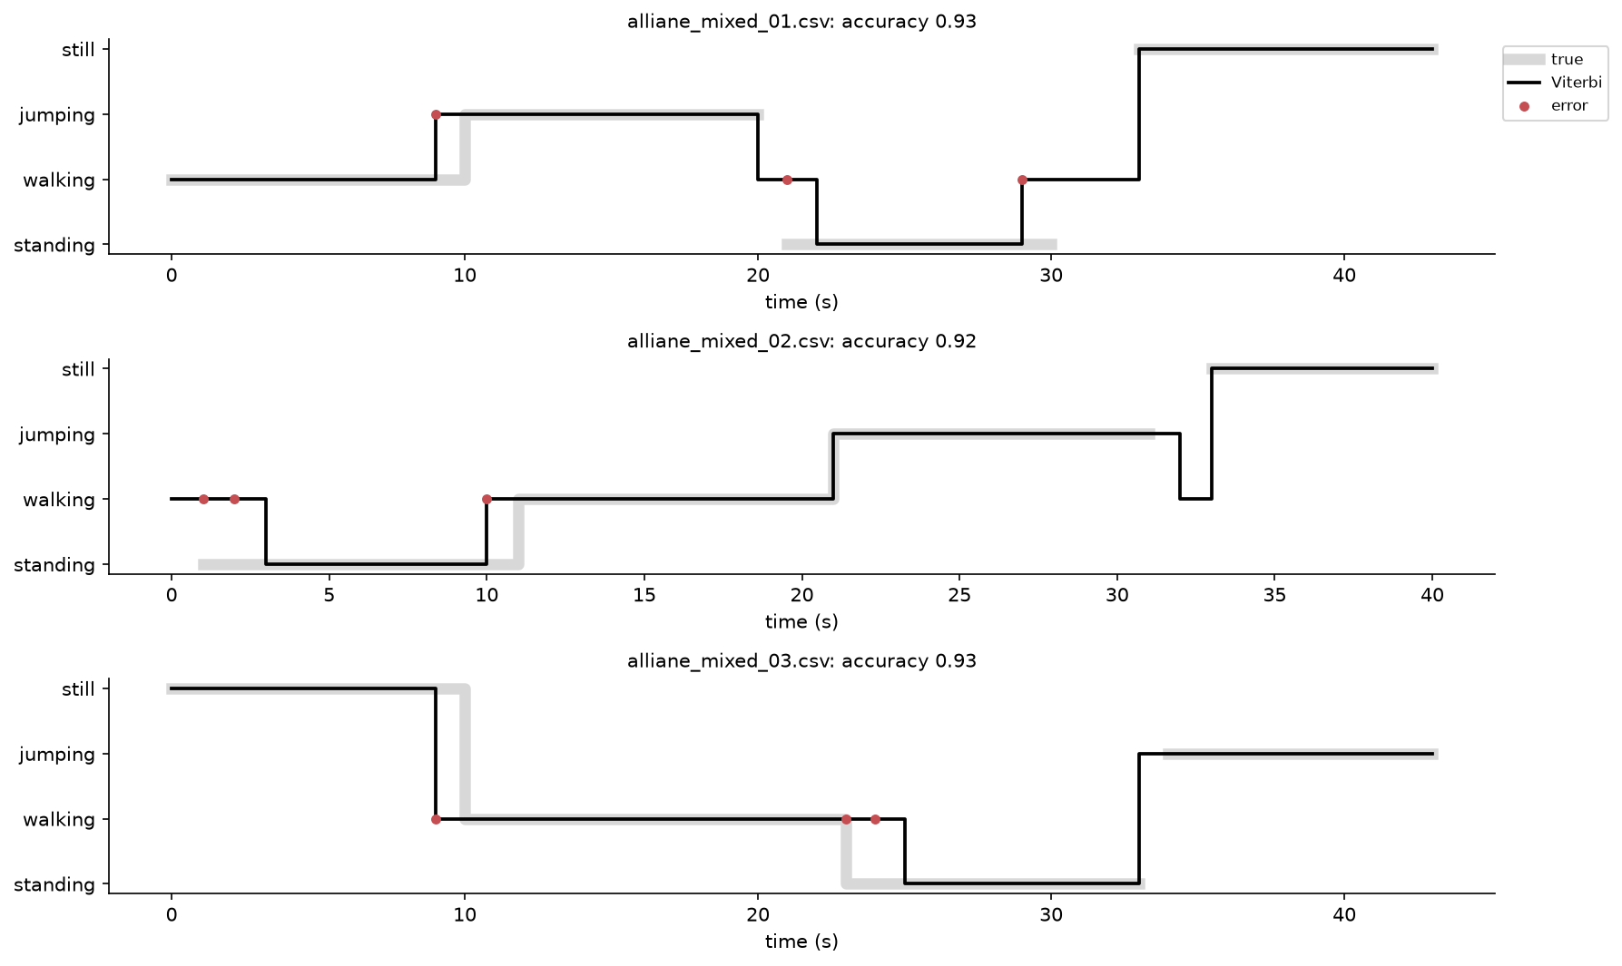
Figure 3. True activity (grey) and Viterbi decoding (black) for each test session; red dots mark wrong windows, all at activity changes. Gaps in the grey line are transition windows.
The self-transition probabilities after training range from 0.91 to 0.95, and thus each of these activities is to be expected to last 11-21 s before switching. Baum-Welch made a better fit to the training set, but did not increase accuracy. The counting-only model achieved a score of 94.2% on the test set, the Baum-Welch model 92.6% and the version without transitions (emission only) also 92.6%. It is unlikely that a better fit will result in a better label; after all, Baum-Welch is designed to maximize the probability of the data, not the number of correctly labeled windows. In this case, it's two windows.
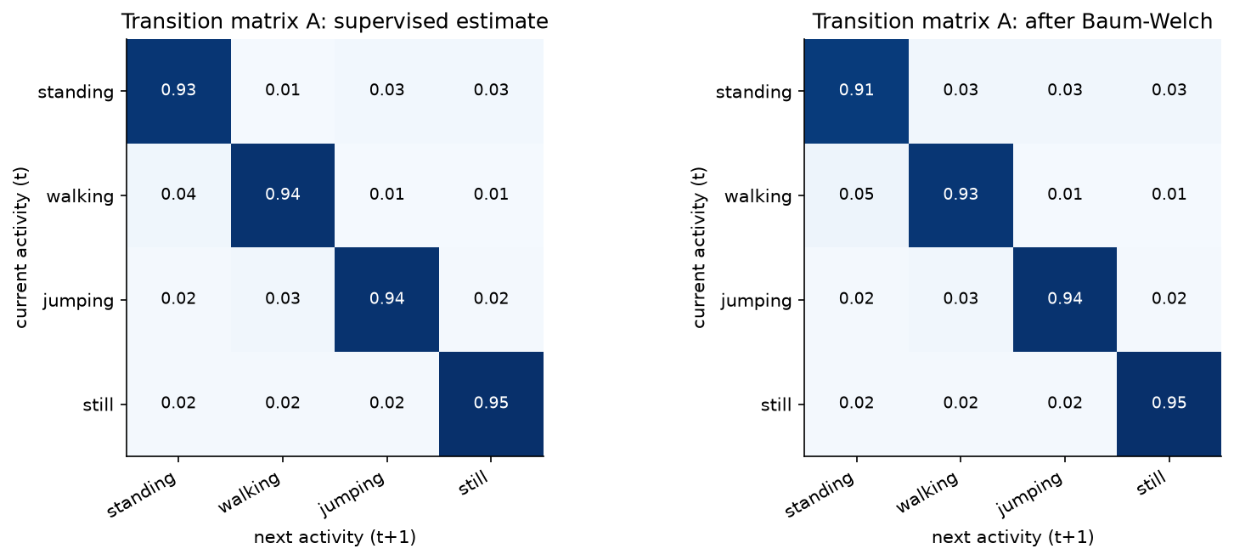
Figure 4. Transition matrix A estimated by counting (left) and after Baum-Welch (right).
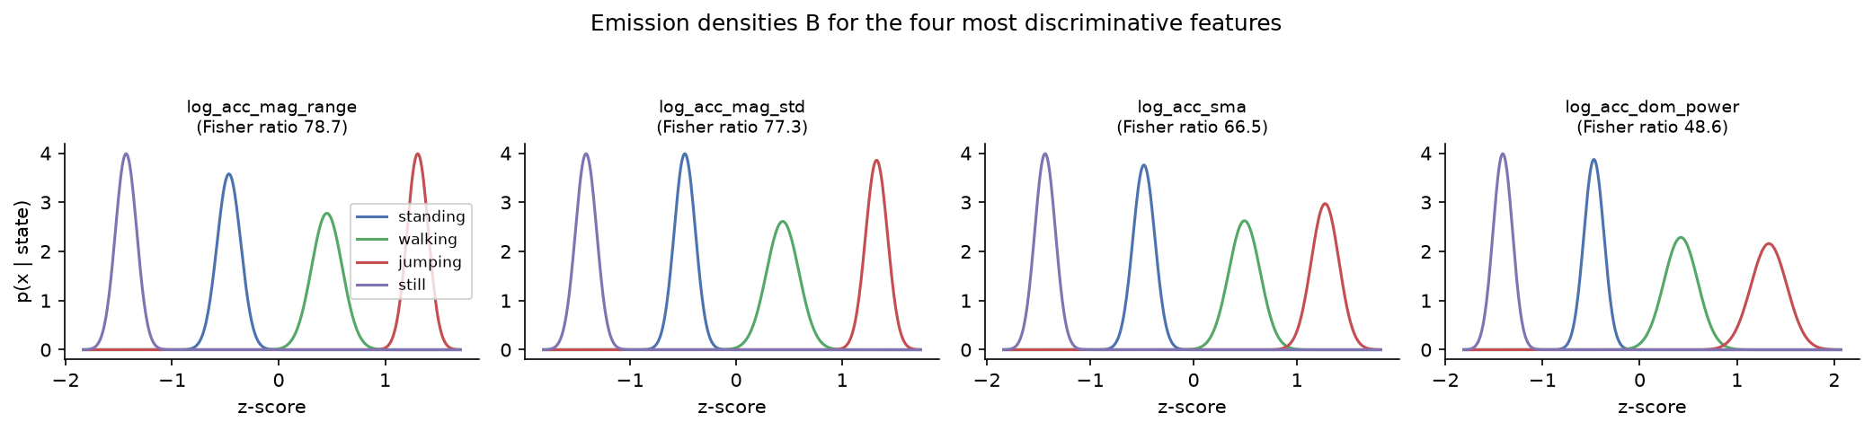
Figure 5. Emission densities of the four features that separate the states best. The four activities sit in the same order on every intensity feature: still, standing, walking, jumping.

5. Discussion and conclusion

Easiest and hardest activities

Jumping was the most easily performed (sensitivity 1.00). Its acceleration spikes are approximately ten times greater than walking, making no other state come close. It was also easy with Still (0.97), as there is very little rotation and just sensor noise from a phone on a table. Standing was the most difficult (0.76). I kept the phone flat (like it is on the table) for standing so a tilt won't separate the two phones, only the little shake of my hand will. I would like to explain that at the boundaries of a standing segment there is a growth of shakiness, and that the model refers to these areas as walking.

Transition probabilities

The large values along the diagonal (0.91 to 0.95) are consistent with human behavior: when people do an activity they tend to do it for a while before stopping. The values not on the diagonal are less reliable. Their sources are based primarily on the order in which the clips were recorded, such as when someone jumps from a still to jump, there is no real evidence for the model. Longer natural behavior would provide transitions that would reflect daily life.

Sensor noise and sampling rate
The iPhone was sampling at 99.8 Hz with a jitter of less than 1%, so the resampling at 50 Hz was not significant and did not gain anything. The 20 Hz filter does not obscure the jump landings which are more extreme in the data. The two quiet activities had the most significant effect on noise, as this activity's signal lies near the noise floor. That helped in taking the log of the intensity features as it spread out the very small number of values that separate standing from still.

Improvements

More continuous recordings with natural transitions would be beneficial for both training the transition matrix and for testing. A finer hop or shorter windows would yield smaller errors on the activity boundaries of one second. Other phone positions (pocket, bag) and other people would provide information on whether the model is applicable to other people's hands or not, and with more data full-covariance or Gaussian-mixture emissions would become feasible. A jump confirmation could also be accomplished by the use of a barometer.

Conclusion
On the test set of four activities from four unseen continuous recordings, a from-scratch Gaussian HMM with 16 time and frequency features achieved an accuracy of 92.6% of the changes of activity. In the monitoring use case, the model is able to correctly distinguish between activity and inactivity, and the timing of the switches between the two are within about a second. It has a significant constraint – it has been trained and tested on one person, one phone, one handhold.

