1. <https://github.com/>

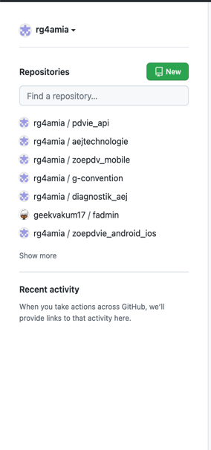

1. Mot de Passe : 1234567890

PDVIE_POCKET : Sagesse@123

1. Page parametre :

<https://github.com/settings/profile>

1. SideBar : SSH and GPG keys

<https://github.com/settings/keys>

git add .

git commit -m "first commit"