|  |  |
| --- | --- |
| **Sew Fantastic** | Abstract  Where the old becomes new, trash becomes treasure, and purpose is restored.  Allie Davis |
|  |  |

Contents

**KEY:** 2

SITE SPECIFICATION: 2

Rationale/Focus: 2

Measurement of Success: 3

MAIN ELEMENTS OUTLINE: 3

TARGET AUDIENCE ANALYSIS: 3

HEIRARCHY CHART STORYBOARD: 5

VISUAL DIAGRAMS: 6

Sketches: 6

Wireframes: 9

SITE STANDARDS: 13

Templates: 13

Font Specifications: 13

Graphics Specifications: 16

Naming Conventions: 16

Industry Standard: 16

Development Standard: 16

Test Plan: 16

Maintenance Plan: 18

External CSS: 19

# **KEY:**

**Site Map:** SF_sitemap.html

**External CSS:** shell.css, blog_page.css, diy_idea.css, large_image.css, links_page.css

**Float Property:** Every html page has an example of float property in Shell.css. There are other examples of the float property in: Index.html, SF_sales.html, SF_contact_page.html, SF_diy.html, SF_idea.html and their corresponding stylesheets.

**Form:** SF_contact.html, SF_sales_cart.html

**Table:** Index.html, SF_sales_cart.html, SF_diy.html, SF_ideas.html

**Ordered List:** SF_diy_tutorial.html, SF_ideas_how.html

**Unordered List:** every page has an unordered list for navigation. Additional unordered lists are located on pages: SF_diy_tools.html, SF_diy_tips.html,

**Description List**: SF_sitemap.html, SF_ideas_how_links.html

**3 External Links**: SF_ideas_how_links.html

**Link to Email Address:** SF_contact.html, SF_sales.html

**ID Attribute:** Every HTML page has a #container ID element

|  |  |
| --- | --- |
| **ID Attributes:** | **Found on these pages:** |
| #about #classes #main | Index.html |
| #products #ads #blog | SF_diy.html, SF_diy_tutorial.html, SF_diy_tutorial2.html, SF_diy_tutorial3.html, SF_diy_tools.html, SF_diy_tips.html, SF_diy_tools_material.html, SF_ideas.html, SF_ideas_what.html, SF_ideas_why.html, SF_ideas_how.html |
| #wrapper #feedback #sign #contact | SF_contact_page.html |
| #large | SF_sales_accessories.html, SF_sales_apron.html,  SF_sales_bags.html, SF_sales_clothes.html, SF_sales_pillows.html, SF_sales_tail.html |
| #links | SF_ideas_how_links.html, SF_sitemap.html |
| #left #middle #right | SF_sales.html |
| #review #cart | SF_sales_cart.html |

**Graphics:** Every HTML page has a header graphic. Other graphics are located on the following pages: index.html, SF_diy.html, SF_diy_tutorial.html, SF_diy_tutorial2.html, SF_diy_tutorial3.html, SF_diy_tools.html, SF_ideas.html, SF_ideas_what.html, SF_ideas_why.html, SF_ideas_how.html, SF_sales.html, SF_sales_accessories.html, SF_sales_apron.html, SF_sales_bags.html, SF_sales_clothes.html, SF_sales_pillows.html, SF_sales_tail.html, SF_sales_cart.html

# **SITE SPECIFICATION:**

## **Rationale/Focus:**

Sew Fantastic is a website intending to create a recognizable “brand”. It entices new users by detailing the Author’s experiences with repurposing. Sharing new, creative, and frugal ways for the average person to take outdated, unused, or “garbage” items and transform them into something new and useful. The goal in doing this is to establish credibility and create brand recognition in a large network. With brand recognition the demand and price for items such as finished products, and templates will increase. Through customer comments, and general word of mouth, traffic will increase to the site. With enlarged circulation there will be more interest from outside companies to advertise to these specific customers.

## **Measurement of Success:**

Sew Fantastic will measure success in both increased sales as well as increased visits. Visible increases in sales can be seen as a percentage in comparison to sales before the website. Initial success here would be a 10% increase in sales. As for site traffic there are two measures that would be used to verify success. One would be Google analytics to measure actual traffic and client penetration into the site. The other would be social media reach and comments. A measure of success in this area would be a 50% increase in not only visits but also followers in sites such as Facebook, Instagram, and Pintrest. This can easily be monitored in these specific social media sites.

# MAIN ELEMENTS OUTLINE:

**Sales-** The sales section includes several categories of items that are for sale. In these categories there will be a few specific items for sale along with an option to “customize” or “special order” items. There will also be a transaction area that will contain a “shopping cart” that lists items and prices the customer has selected as well as additional information for tax and shipping charges.

**Idea Creation-** The idea creation section will include accounts that detail the processes used by the author to generate new products, as well as the reasons to undertake them in first place. There will also be a portion dedicated to salvaging projects that have gone awry.

**DIY-**The DIY section details how a reader can create their own versions of specific products in a step-by-step manner. It also gives information on how to select tools and materials not only so they are cost-effective but also for ease of use. There will also be information on how to substitute for what they already have or for what they can easily acquire. A list of training options in the form of sewing classes at a local provider will be also be available for the beginners as well as links to additional resources or “idea generators”.

**Contact**- The contact section has a log in area, a comment and feedback section, and also a list of contact information.

# TARGET AUDIENCE ANALYSIS:

* Audience definition: Users are utilizing my site to gain knowledge and hone skill, as well as to purchase products. They will gain new techniques and ideas on how to create and repurpose items for personal gain. They will also be exposed to advertising related to improving their skills. They will be enticed to view the site with tutorials and blogs regarding specific concepts. They will continue to come back to see what new ideas and products have been added. Most typical users will have newer devices such as laptops, smart phones, and tablets. Although additionally some visitors will have older devices due to budget, or location they primarily use their device (ie. Work). The internet speeds will vary as well. The majority will have quicker speeds, however there will also be a smaller demographic with slower speeds due to budget or location.
* Anticipated age of user: 25-55.
* Target gender: Primarily women/moms, and maybe on a smaller scale single dads.
* All education levels will be involved with a focus towards those with some post-secondary education.
* Reading and vocabulary level will be college level for credibility. However, included will be plenty of descriptions and definitions for those who are not to that level, or are simply beginners.
* Technical ability will be mostly basic/beginner level. This is to target the older user demographic. Skills necessary to navigate the website would be very simple such as use of forms, email, and basic online shopping. They would have to be able navigate the site using links.
* All operating systems will be accommodated, again to assist with the older user demographic as well as the more frugal user whose technology may be financially limited.
* All browsers will also be experienced to allow for greater usability and a larger audience.
* All connection speeds will be considered when using images and links.
* The resolutions used will be 640x480, 1280x720, 1920x1080. These resolutions will specifically be verified to give maximum user experience regardless of the viewing device’s capabilities.
* People will visit this site primarily to get information and ideas. The goal is to attract attention and develop a following that are interested in the topics presented to grow a customer base. With a larger viewing audience, the brand recognition increases as well as overall sales and the price for advertising on the site.

# HEIRARCHY CHART STORYBOARD:

# VISUAL DIAGRAMS:

## Sketches:

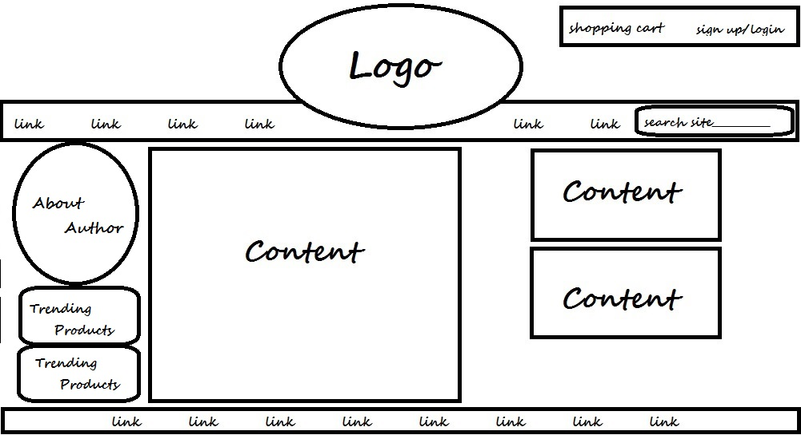

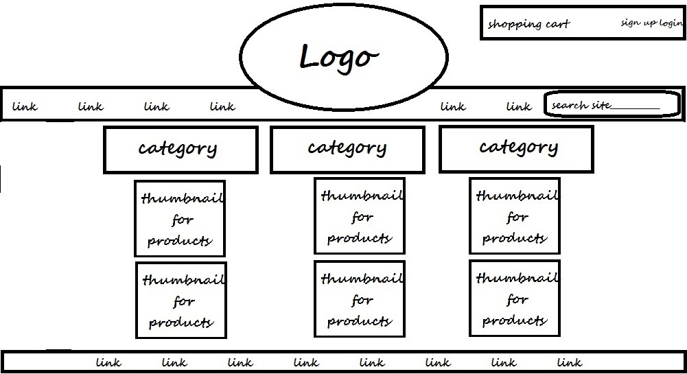

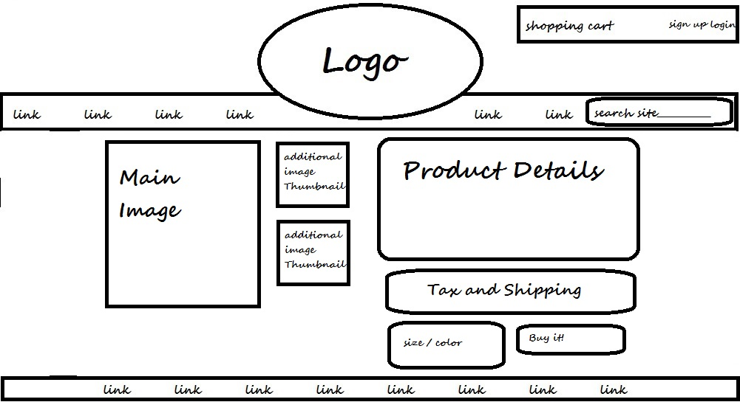

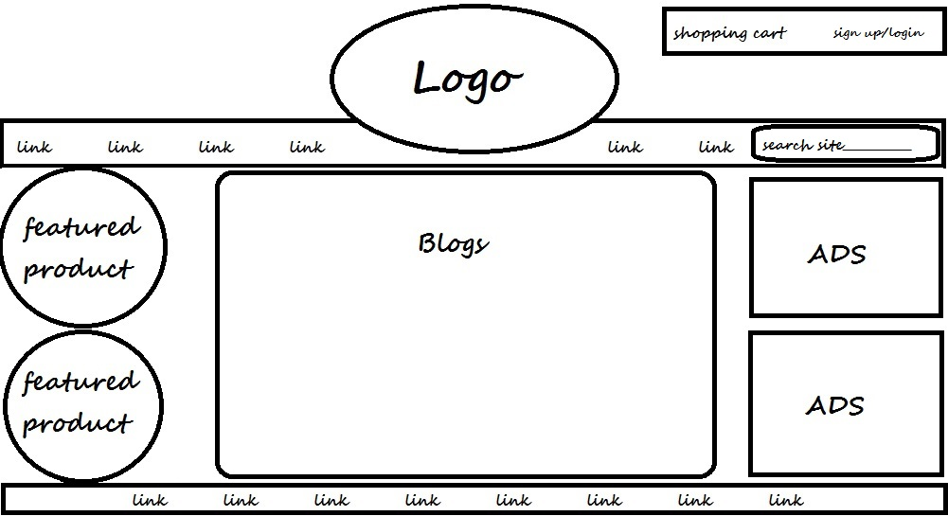



## Wireframes:

**Index**

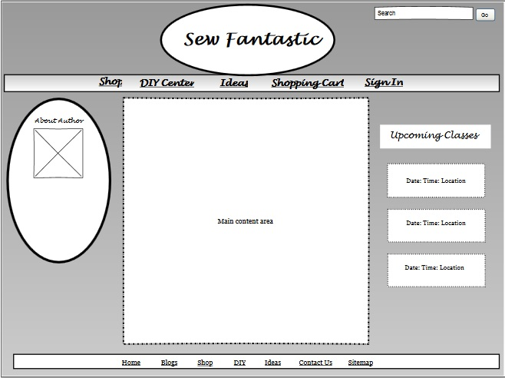

**DIY_ideas**

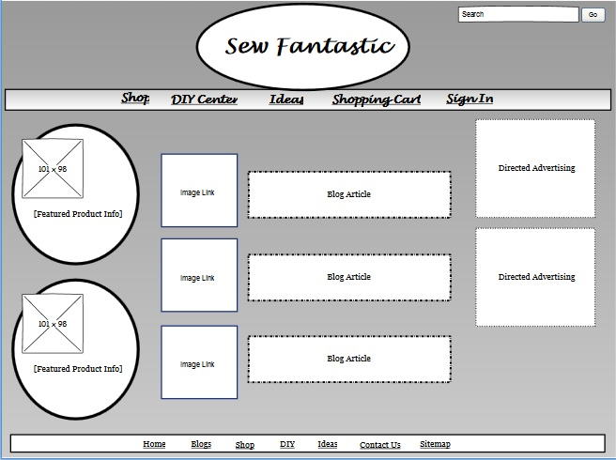

**Blog_page**

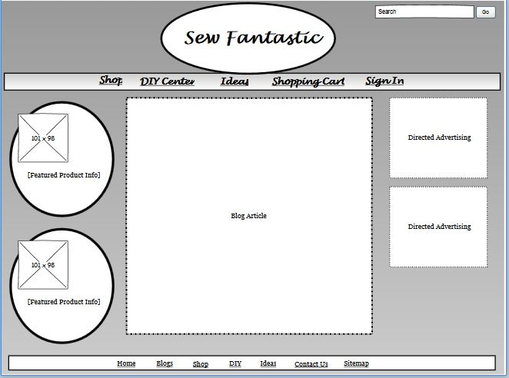

**Contact_page**

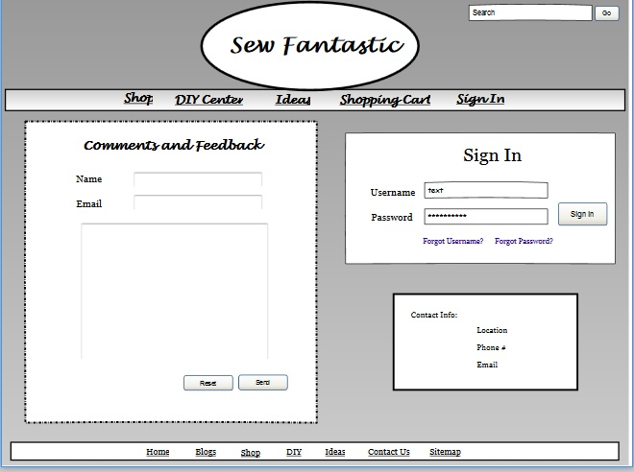

**Links_page**

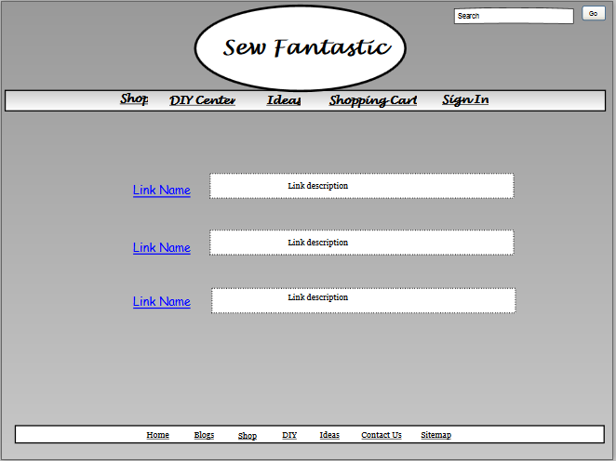

**Product_detail**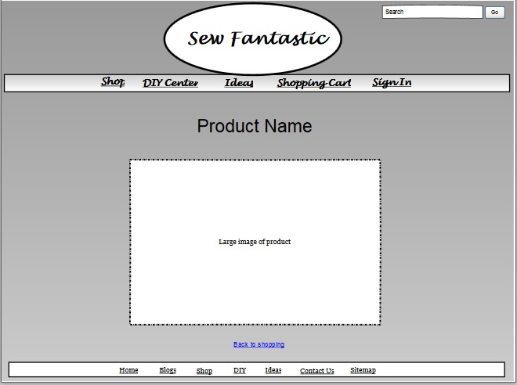

**Sales_cart**

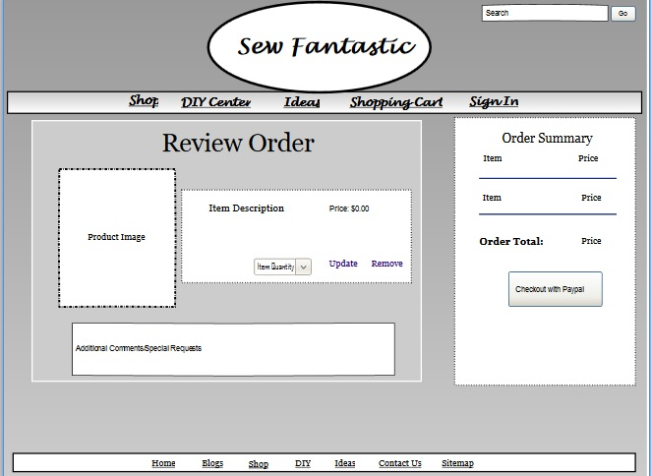

**Sales_page**

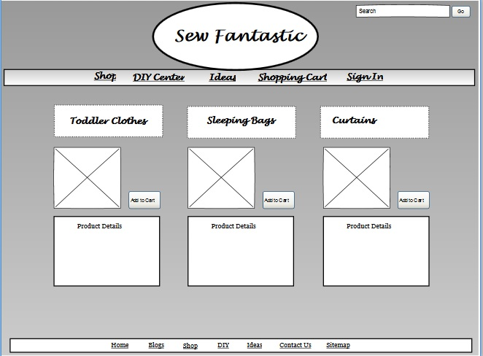

# SITE STANDARDS:

## Templates:

Templates for all components are located in the “HTML and CSS Templates” folder

|  |  |  |  |
| --- | --- | --- | --- |
| **Template Name:** | **Locations Used:** | **Page Name(s):** | **CSS applied to page:** |
| index_template.html | Used for the Index (home) page; First level | Index.html | Embedded/ import shell.css |
| blog_page_template.html | Used for all blog pages in the DIY center, and  Idea creation;  Third and Fourth Levels | SF_diy_tutorial.html, SF_diy_tutorial2.html, SF_diy_tutorial3.html, SF_diy_tools.html, SF_diy_tips.html,  SF_ideas_what.html,  SF_ideas_why.html,  SF_ideas_how.html | External-  blog_page.css |
| contact_template.html | Contact/sign in page; Second Level | SF_contact_page.html | Embedded/ import shell.css |
| diy_idea_template.html | DIY center and Idea creation intro pages; Second Level | SF_diy.html, SF_ideas.html | External- diy_ideas.css |
| links_page_template.html | External links page in the idea creation, and sitemap; Second and Fourth level | SF_ideas_how_links.html, SF_sitemap.html | External- links_page.css |
| sales_cart_template.html | Shopping cart; First Level | SF_sales_cart.html | Embedded/ import shell.css |
| sales_template.html | List of all products sales page; Second Level | SF_sales.html | Embedded/ import shell.css |
| sales_product_template.html | Large image pages of each sales item; Third level | SF_sales_accessories.html, SF_sales_apron.html,  SF_sales_bags.html,  SF_sales_clothes.html,  SF_sales_pillows.html,  SF_sales_tail.html | External- large_image.css |
|  |  |  |  |

## Font Specifications:

* **Font Family:** 
  + headings- cursive, Lucinda Handwriting, Comic Sans, Florence
  + paragraph- serif, Georgia, Palatino Linotype, Times New Roman
  + list items- serif, Georgia, Palatino Linotype, Times New Roman & cursive, Lucinda Handwriting, Comic Sans, Florence
* **Size:**
  + Headings- h1: 5em, h2: 3em, h3: 2em, h4: 1.5, h5: 1em, h6: 0.5em
  + Paragraph- 1em-2em
  + Tables- 1em, 1.2em
* **Colors:**
  + Background- tan linen image
  + Foreground- snow, firebrick, saddlebrown
  + Accent colors- goldenrod, saddle brown,
  + Font- black, white, snow, saddle brown, goldenrod
* **Class Names and Rules:**
  + .link-
    - background-color: #FFFAFA; /*snow*/
    - text-decoration: none;
    - border: 3px inset #8B4513; /* saddlebrown */
    - color: #DAA520; /*goldenrod*/
    - font-weight: bold;
    - text-shadow: 1px 1px black;
    - margin: 50% auto;
    - padding: 2% 1%;
    - clear: left;
    - float: right;
  + .center
    - text-align: center;
  + .border {
    - border-top: inset 4px #DAA520; /*goldenrod*/
    - border-left: inset 4px #DAA520; /*goldenrod*/
    - background-color: #f7f4d5; /*snow*/
    - padding: 3% 5%;
    - font-size: 1.2em;
    - color: black;
    - text-align: left;
  + header input.text
    - border-radius: 7px;
    - border: solid 2px #CD853F; /*peru*/
    - color: #8B4513; /* saddlebrown */
  + header input.button {
    - background-image: url(images/fabric_background.jpg);
    - border: outset 2px #DAA520; /*goldenrod*/
    - border-radius: 5px;
    - font-weight: bold;
    - text-shadow: 1px 1px black;
    - color: #DAA520; /*goldenrod*/
  + #feedback input.text {
    - padding: 1% 0 1% 5%;
    - margin: 2% 0 2% 35%;* (universal selector)
  + #sign input.text {
    - padding: 1% 0 1% 3%;
    - margin: 2% 0 2% 40%;
  + #review input.button {
    - background-color: #8B4513; /* saddlebrown */
    - border: outset 4px #B8860B; /*dark golden rod*/
    - border-radius: 5px;
    - font-weight: bold;
    - text-shadow: 2px 2px black;
    - color: #EEE8AA; /* palegoldenrod */
    - font-size: 1em;
    - padding: 0.5% 1%;
    - margin: 2%;
    - float: right;
    - display: inline;
    - box-shadow: 2px 2px black;
  + #cart input.button {
    - font-family: "Lucida Handwriting", "comic sans", Florence, cursive;
    - background-color: #8B4513; /* saddlebrown */
    - border: outset 4px #B8860B; /*dark golden rod*/
    - border-radius: 5px;
    - font-weight: bold;
    - text-shadow: 2px 2px black;
    - color: #EEE8AA; /* palegoldenrod */
    - font-size: 1em;
    - padding: 0.5em;
    - margin: 4% 10% 10% auto;
    - float: right;
    - display: inline;
    - box-shadow: 2px 2px black;
  + #wrapper input.button {
    - background-image: url(images/fabric_background.jpg);
    - border: outset 4px #DAA520; /*goldenrod*/
    - border-radius: 5px;
    - font-weight: bold;
    - text-shadow: 1px 1px black;
    - color: #DAA520; /*goldenrod*/
    - font-size: 1em;
    - padding: 0.5em;
    - margin: 1em 2em 2em 0;
    - float: right;
    - display: inline;
    - box-shadow: 2px 2px black;
  + #wrapper input.text {
    - border-radius: 7px;
    - border: solid 2px #CD853F; /*peru*/
    - color: #8B4513; /* saddlebrown */
    - font-size: 0.75em;
    - display: block;
    - font-family: "Lucida Handwriting", "comic sans", Florence, cursive;
    - clear: right;nav a –
* Pseudo class (navigation)
  + nav a:hover-
    - color: #DAA520; /*goldenrod*/
    - text-decoration: none;
  + footer a:hover-
    - color: #FFFAFA; /*snow*/
    - text-decoration: none;
    - text-shadow: 2px 2px 1px #50301a; /* deep tangelo */
* Pseudo Class (content)
  + #blog a:hover {
    - color: #DAA520; /*goldenrod*/
    - text-shadow: 1px 1px 1px black;
    - text-decoration: underline;
  + #large a:hover{
    - color: #8B4513; /* saddlebrown */
    - text-shadow: 3px 3px #FFFAFA; /*snow*/
  + #links a:hover {
    - color: #FFFAFA; /*snow*/
    - text-shadow: 1px 1px 2px black;
  + #sign a:hover {
    - color: #DAA520; /*goldenrod*/
    - text-decoration: none;
  + #contact a:hover {
    - color: #DAA520; /*goldenrod*/
    - text-decoration: underline;

## Graphics Specifications:

* All graphics must be submitted to webmaster for approval prior to introduction to the site.
* Graphics must be sized according to their function.
  + Blog images go into the main blog container
    - must be 500px wide or smaller and must be positioned in the center of the blog container.
  + Sales photos will go on SF_sales.html
    - must have a width of 200px and a length of 200px. Images may be cropped to accommodate sizes and full sized images may be included on a larger image page if they become distorted.
  + Featured products will go into the #products container
    - must be 200px wide exactly.
  + Large product images will be in the #large section on all product detail pages.
    - Must have a width of 800px and can be any length. Image will be centered on the page.
  + Images in all other areas must be submitted to the webmaster and their desired purpose explained. Sizes will be evaluated by the webmaster for new image locations.
* Legalities: only graphics that are created or from free sites are allowed on this site.
* Download: time requirements- all pages must load in 5 seconds at 12mbps.

## Naming Conventions:

### Industry Standard:

This site will adhere to the Mac naming convention prior to Lion. This standard allows up to 31 characters, and only the underscore as a special character.

### Development Standard:

The development standard for this site will be the bread crumb standard. Files will be named in a progressive manner based on their location in the hierarchy. For example, the links for the files **SF_diy_tools_material.html**, and **SF_diy_tools.html** are all ultimately inside of **SF_diy.html**. Each successive file contains the referring files identifier as well as an additional identifying name that is specific to the page content. This is done to maintain consistency and promotes usability of the website. Another example of this are the file names: **Index.html**, **SF_sales.html, SF_sales_apron.html, SF_sales_bags.html, SF_sales_clothes.html, and SF_sales_tail.html.**

## Test Plan:

* Browsers: Chrome version 52, Firefox 48, Internet Explorer version 11, and Safari 5.1.
  + I also plan to use older versions of these same browsers in my final tests.
* Connections speeds of 8mbps to 18mbps will be used throughout the testing process.
  + Speeds will vary depending on peak or non-peak time of use. Viewing of website composition and testing will be done during both peak and non-peak hours.
* The resolution used to view the site will be 1366 x768 at every instance of testing
  + Resolutions of 1920x1080, and 1280x800 will also be used upon completion of the site.
* The site will be experienced in Windows 7 as well as in Windows 10.
* Pages will be validated upon their individual completion to avoid potential carry-over errors.

## Maintenance Plan:

|  |  |  |  |  |  |
| --- | --- | --- | --- | --- | --- |
| **Tasks Performed:**  **AS NEEDED** | **Editor Approval**  **Needed?** | **Tasks Performed:**  **MONTHLY** | **Editor Approval Needed?** | **Tasks Performed:**  **QUARTERLY** | **Editor Approval Needed?** |
| Update product images | Yes-verify changes via email | Review spelling, grammar, punctuation | No | Review content pertinence | Yes- verify at monthly meeting |
| Update product details | Yes-verify changes via email | Review and update page content | Yes- verify at monthly meeting | Review and update technical content | No |
| Add additional products | Yes-verify changes via email | Identify broken or misconfigured links | No | Revalidate all pages | No |
| Update contact information changes | No | Update broken or misconfigured links | Yes- verify at monthly meeting | Revise any errors found in Validator | No |
| Update shipping cost information | No | Verify correct information in forms | No | Edit outdated or inaccurate content | Yes- verify at monthly meeting |
| Add new templates and tutorials | Yes-verify changes via email | Update incorrect form information | Yes- verify at monthly meeting | Collect website data and statistics | No |
| Add new features or special elements | Yes-verify changes via email | Verify form’s overall functionality | No | Verify overall site function and usability | No |
|  |  | Verify appropriate graphic and image usage | No | Update coding to comply with newer standards | No |
|  |  | Update inaccurate graphics or images | Yes- verify at monthly meeting |  |  |
|  |  | Deployment of new and updated code | No |  |  |
|  |  | Detect defects, bug fixes, and enhancements | No |  |  |

## External CSS:

**Shell.css-**

* {

margin: 0;

padding: 0;

}

/* section ids */

#container {

width: 90%;

margin: 0 auto;

}

/* independant */

.center {

text-align: center;

}

/* header */

header {

width: 100%;

margin: 0;

text-align: center;

}

header input {

margin: 0;

padding: 3px 10px 3px 4px;

position: absolute;

top: 3%;

right: 3em;

font-family: "Lucida Handwriting", "comic sans", Florence, cursive;

float: right;

display: inline;

box-shadow: 2px 2px 5px black;

}

header input.text {

border: solid 2px #CD853F; /*peru*/

border-radius: 7px;

color: #8B4513; /* saddlebrown */

}

header input.button {

background-image: url(images/fabric_background.jpg);

border: outset 2px #DAA520; /*goldenrod*/

border-radius: 5px;

color: #d9ac8d; /* nan */

font-weight: bold;

text-shadow: 1px 1px black;

}

/* navigation */

nav {

width: 100%;

height: 40%;

margin: 0;

padding: 0.5%;

clear: both;

text-align: center;

border-bottom: double 10px #8B4513; /* saddlebrown */

}

nav ul li{

margin: 0 1% 2% 1%;

padding: 0.25% 1% 0.25% 0.5%;

background-color: #FFFAFA; /*snow*/

font: bold 1.5em "Lucida Handwriting", "comic sans", Florence, cursive;

line-height: 1.5em;

text-shadow: 1px 1px black;

border: outset 2px #DAA520; /*goldenrod*/

display: inline;

list-style-type: none;

}

/* links */

nav a {

color: #8B4513; /* saddlebrown */

display: inline;

text-decoration: none;

}

nav a:hover {

color: #e1b74c; /* light goldenrod*/

text-decoration: underline;

}

/* body */

body {

background-image: url(images/SF_background.jpg);

}

/* footer */

footer {

width: 100%;

height: 25%;

margin-top: 1em;

clear: both;

background-color: #EEE8AA; /* burleywood */

opacity: 0.8;

text-align: center;

font-weight: bold;

border-top-left-radius: 50px;

border-top-right-radius: 50px;

border: double 5px #8B4513; /* saddlebrown */

}

footer ul li {

margin-right: 1em;

margin-left: 1em;

padding-top: 5%;

list-style-type: none;

display: inline;

font: 1.5em Georgia, "Times New Roman", "Palatino Linotype", serif;

line-height:1.5;

}

footer a {

color: #8B4513; /* saddlebrown */

text-shadow: 1px 1px 1px black;

}

footer a:hover {

color: #e1b74c; /* light goldenrod*/

text-decoration: none;

text-shadow: 2px 2px 1px #50301a; /* deep tangelo */

}

**blog_page.css-**

@import url(shell.css);

/* headings */

h2 {

margin: 2% auto;

color: #FFFAFA; /*snow*/

font: 3em "Lucida Handwriting", "comic sans", Florence, cursive;

text-align: center;

text-shadow: 3px 3px black;

}

h4 {

font: bold 1.5em "Lucida Handwriting", "comic sans", Florence, cursive;

}

/* products*/

#products {

width: 17%;

margin: 5% auto;

padding: 0.5%;

background: url(images/SF_about.jpg) no-repeat;

opacity: 0.9;

float: left;

text-align: center;

box-shadow: 10px 10px 5px #8B4513; /* saddlebrown */

border-top-right-radius: 35px;

border-bottom-right-radius: 35px;

border-bottom-left-radius: 35px;

}

#products h4 {

padding-top: 2em;

padding-right: 1em;

color: #EEE8AA; /* burleywood */

font: 2em "Lucida Handwriting", "comic sans", Florence, cursive;

text-align: right;

text-shadow: 2px 2px black;

line-height: 1.5em;

}

#products p {

padding: 1em;

clear: both;

color: #FFFAFA; /*snow*/

font: 1.2em Georgia, "Times New Roman", "Palatino Linotype", serif;

text-align: center;

line-height: 0.8em;

}

#products em {

line-height: 1.2em;

}

/* blog */

#blog {

margin: 2% 22% 3% 22%;

padding: 0.5%;

text-align: center;

}

#blog img{

margin: 2%;

padding: 0.75em;

border: dashed 2px #8B4513; /* saddlebrown */

}

#blog p {

padding: 3%;

background-color: #EEE8AA; /* burleywood */

opacity: 0.8;

color: black;

font: bold 1em Georgia, "Times New Roman", "Palatino Linotype", serif;

text-align: center;

line-height: 1.5em;

border-radius: 10px;

}

#blog ul li{

margin: 4% 5%;

padding: 2%;

background-color: #EEE8AA; /* burleywood */

opacity: 0.8;

color: black;

font: 1.2em Georgia, "Times New Roman", "Palatino Linotype", serif;

text-align: left;

line-height: 1.5em;

border: dashed 1px #EEE8AA; /* burleywood */

border-top-right-radius: 15px;

border-bottom-left-radius: 15px;

list-style-type: none;

}

#blog ol li{

margin: 2% 5%;

padding: 1% 2%;

background-image: url(images/fabric_background.jpg);

color: #FFFAFA; /*snow*/

font: 1.2em Georgia, "Times New Roman", "Palatino Linotype", serif;

text-align: left;

text-shadow: 2px 2px black;

line-height: 1.5em;

border: dashed 1px #EEE8AA; /* burleywood */

border-top-right-radius: 20px;

border-bottom-left-radius: 20px;

}

#blog a {

margin-left: 65%;

color: #50301a; /* deep tangelo */

font: italic bold 1em "Lucida Handwriting", "comic sans", Florence, cursive;

text-decoration: none;

text-shadow: 2px 2px 2px #EEE8AA; /* burleywood */

}

#blog p a {

font-size: 1em;

margin: 1%;

}

#blog em a{

margin: 3%;

font-size: 1.5em;

}

#blog strong a{

margin: 3%;

font-size: 2em;

}

#blog a:hover {

color: #DAA520; /*goldenrod*/

text-shadow: 1px 1px 1px black;

text-decoration: underline;

}

/* ads */

#ads {

width: 15%;

margin: 25em auto;

float: right;

}

#ads p{

position: fixed;

bottom: 5%;

}

**diy_idea.css-**

@import url(shell.css);

/* headings */

h2 {

margin: 1%;

padding-bottom: 3%;

color: #FFFAFA; /*snow*/

font: 3em "Lucida Handwriting", "comic sans", cursive;

text-align: center;

text-shadow: 3px 3px black;

}

/* products */

#products {

width: 17%;

margin: 5% auto;

padding: 0.5%;

background: url(images/SF_about.jpg) no-repeat;

opacity: 0.9;

float: left;

text-align: center;

border-top-right-radius: 35px;

border-bottom-right-radius: 35px;

border-bottom-left-radius: 35px;

box-shadow: 10px 10px 5px #8B4513; /* saddlebrown */

}

#products h4 {

padding-top: 2em;

padding-right: 1em;

color: #EEE8AA; /* burleywood */

font: 2em "Lucida Handwriting", "comic sans", cursive;

text-align: right;

text-shadow: 2px 2px black;

line-height: 1.5em;

}

#products p {

padding: 1em;

clear: both;

color: #FFFAFA; /*snow*/

font: 1.2em Georgia, "Times New Roman", "Palatino Linotype", serif;

text-align: center;

line-height: .8em;

}

#products em {

line-height: 1.2em;

}

/* blog */

#blog {

margin: 2% 22%;

padding: 0.5%;

text-align: center;

}

#blog a img{

padding: 0.5em;

background-color: #EEE8AA; /* burleywood */

border: solid 2px #8B4513; /* saddlebrown */

box-shadow: 7px 7px 3px #8B4513; /* saddlebrown */

}

#blog p {

margin: 3% 0 3% 5%;

padding: 3% 1% 3% 5%;

background-color: #EEE8AA; /* burleywood */

color: black;

font: 1em Georgia, "Times New Roman", "Palatino Linotype", serif;

text-align: left;

line-height: 1.5em;

border-top-right-radius: 50px;

border-bottom-right-radius: 50px;

box-shadow: 7px 7px 3px #8B4513; /* saddlebrown */

}

#blog a {

color: black;

font-size: 1.5em;

font-weight: bold;

text-align: center;

text-decoration: none;

text-shadow: 1px 1px #EEE8AA; /* burleywood */

}

#blog a:hover{

color: #8B4513; /* saddlebrown */

text-shadow: 2px 1px black;

}

/* ads */

#ads {

width: 15%;

margin: 25em auto;

float: right;

}

#ads p{

position: fixed;

bottom: 0;

}

/* table */

td {

margin: 3% 1%;

padding: 3% 1%;

text-align: center;

}

**large_image.css-**

@import url(shell.css);

/*headings*/

h3 {

font-size: 2em;

padding-bottom: 2%;

text-shadow: 3px 3px #FFFAFA; /*snow*/

color: #50301a; /* deep tangelo */

}

/* large */

#large {

margin: 1% 0 5% 0;

padding-bottom: 1%;

font: bold 2em "Lucida Handwriting", "comic sans", Florence, cursive;

text-align: center;

line-height: 2em;

}

#large img {

padding: 2%;

border: dashed 3px #FFFAFA; /*snow*/

}

#large a {

color: #FFFAFA; /*snow*/

text-decoration: none;

text-shadow: 2px 2px #50301a; /* deep tangelo */

}

#large a:hover{

color: #8B4513; /* saddlebrown */

text-shadow: 3px 3px #FFFAFA; /*snow*/

}

**links_page.css-**

@import url(shell.css);

/*section ids */

#links a:hover {

color: #FFFAFA; /*snow*/

text-shadow: 1px 1px 2px black;

}

/* lists */

dl {

width: 80%;

margin: 3% 10%;

padding: 2%;

font-weight: bold;

text-align: left;

border: dashed 2px #FFFAFA; /*snow*/

list-style-type: none;

}

dt a {

padding: 1%;

color: #50301a; /* saddlebrown */

font: 1.5em "Lucida Handwriting", "comic sans", Florence, cursive;

text-decoration: none;

text-shadow: 2px 2px 2px #EEE8AA; /* burleywood */

}

dd {

margin-left: 21%;

padding: 2px 0 2px 10px;

background-color: #EEE8AA; /* burleywood */

color: #8B4513; /* saddlebrown */

font-size: 1.2em;

border-bottom: solid 1px #8B4513; /* saddlebrown */

border-right: solid 1px #8B4513; /* saddlebrown */

box-shadow: 2px 2px 2px #50301a;/* deep tangelo */

}