Real-Time Multimodal Emotion Recognition Using Facial and Speech Feature Fusion

Allie Thakur
Department of AIML
CMR Institute of Technology
Bangalore, India
alth23aiml@cmrit.ac.in
Dileep MN
Department of AIML
CMR Institute of Technology
Bangalore, India
dimn23aiml@cmrit.ac.in
Kenesha Watt Q
Department of AIML
CMR Institute of Technology
Bangalore, India
kewa23aiml@cmrit.ac.in
Syed Anshu
Department of AIML
CMR Institute of Technology
Bangalore, India
syed.aiml24le@cmrit.ac.in

Abstract — Emotion recognition plays a critical role in advancing human-machine interaction systems. Existing approaches largely depend on pre-recorded audiovisual data collected under controlled laboratory conditions, limiting their applicability in real-world scenarios. This paper presents a real-time multimodal emotion recognition system that simultaneously processes live webcam and microphone input to detect human emotions. The proposed system employs EfficientNet-B0, a convolutional neural network trained on the FER-2013 dataset, for facial emotion recognition, and a Bidirectional Long Short-Term Memory network trained on the RAVDESS dataset for speech emotion recognition. Features from both modalities are combined using feature-level fusion to produce a unified emotion prediction. The system achieves 65.81% accuracy on facial emotion recognition and 59.03% on speech emotion recognition, and is deployed as a live interactive application using Streamlit. This work directly addresses the open challenge of real-time multimodal emotion recognition identified in recent survey literature, extending the state-of-the-art beyond pre-recorded video analysis.

Keywords — Emotion recognition, multimodal fusion, EfficientNet, LSTM, FER-2013, RAVDESS, real-time inference, human-machine interaction

Introduction
Human emotions are fundamental to interpersonal communication and significantly influence behavior, decision-making, and social interaction [1]. As human-machine interaction (HMI) systems become increasingly prevalent, the ability of machines to perceive and respond to human emotional states has emerged as a critical research challenge [2]. Automatic emotion recognition enables machines to adapt their responses contextually, thereby improving the quality and naturalness of interaction.
Emotion recognition can be performed using multiple modalities including facial expressions, speech, physiological signals, and body language. Among these, facial expressions and speech are the most accessible and information-rich modalities in real-world settings. Research consistently demonstrates that multimodal approaches, which combine information from multiple sources, outperform unimodal approaches by leveraging the complementary nature of different signals [3].
However, a significant gap exists in the current literature. Most existing multimodal emotion recognition systems operate on pre-recorded video datasets collected under controlled conditions, with professional cameras and microphones. The challenge of performing real-time multimodal emotion recognition from live webcam and microphone input on consumer hardware remains largely unaddressed. A recent survey of 103 multimodal emotion recognition papers confirms that real-time live inference is an open challenge in the field [4].
This paper addresses this gap by proposing a real-time multimodal emotion recognition system that processes live facial and speech inputs simultaneously. The system employs a parallel dual-pipeline architecture — one pipeline for facial emotion detection using EfficientNet-B0 and another for speech emotion detection using a Bidirectional LSTM — with feature-level fusion producing the final emotion output. The system is implemented as an interactive web application, demonstrating practical feasibility on standard consumer hardware without GPU acceleration.
The main contributions of this paper are as follows:
- A real-time multimodal emotion recognition pipeline operating on live webcam and microphone input
- Feature-level fusion of facial and speech emotion predictions for improved robustness
- Practical deployment as an interactive application accessible on consumer hardware
- Empirical validation on FER-2013 and RAVDESS benchmark datasets

Literature Survey
Several significant works have contributed to the field of multimodal emotion recognition, each addressing different aspects of the problem.
Salas-Caceres et al. [1] proposed a multimodal emotion recognition architecture combining audiovisual information with temporal dynamics using LSTM networks. Their system employed VGG-Face for facial feature extraction and X-Vector for audio feature extraction, with feature-level fusion using an EmbraceNet module. The system achieved state-of-the-art accuracy of 88.11% on RAVDESS, 86.75% on SAVEE, and 80.27% on CREMA-D. While their work demonstrates strong performance, it is limited to pre-recorded video data and does not address real-time inference.
Chandraumakantham et al. [2] proposed a large language model based multimodal fusion approach for emotion recognition, achieving 93.18% accuracy on the RAVDESS dataset. Their system leveraged transformer-based architectures for cross-modal feature alignment. While achieving higher accuracy, the computational requirements of large language models make real-time deployment on consumer hardware impractical.
Wu et al. [3] conducted a comprehensive survey of 103 multimodal emotion recognition papers, systematically reviewing datasets, preprocessing techniques, feature extraction methods, and fusion strategies. Critically, their survey identifies real-time live inference as a significant open challenge, with most existing systems validated only on pre-recorded datasets.
Pragash et al. [4] proposed a hybrid CNN-LSTM architecture for emotion recognition using FER-2013 and RAVDESS datasets, achieving 93.5% accuracy. Their architecture closely aligns with the approach adopted in this work, combining convolutional networks for spatial feature extraction with recurrent networks for temporal modelling.
[INSERT TABLE HERE — Comparison of related works: Author, Year, Method, Dataset, Accuracy]
The review of existing literature reveals that while significant progress has been made in multimodal emotion recognition, the specific challenge of real-time fusion from live inputs remains underexplored. This work directly addresses that gap.

Methodology

System Overview
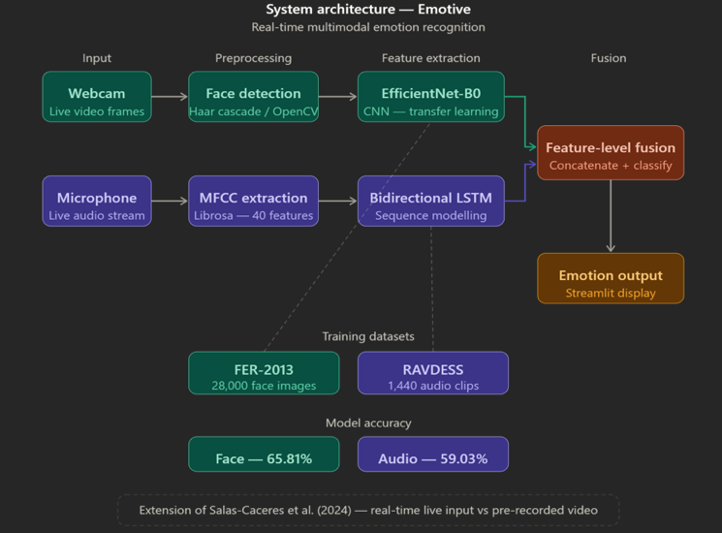
The proposed system follows a parallel dual-pipeline architecture in which facial and speech emotion recognition operate simultaneously and independently, with their outputs combined through feature-level fusion. The complete system pipeline is illustrated below.

Datasets
FER-2013: The Facial Expression Recognition 2013 dataset contains approximately 35,000 grayscale facial images of 48x48 pixels, labeled across seven emotion categories: angry, disgust, fear, happy, neutral, sad, and surprise. The dataset is divided into a training set of 28,709 images and a test set of 3,589 images. FER-2013 is a widely used benchmark for facial emotion recognition, notable for its diversity and challenging real-world conditions.
RAVDESS: The Ryerson Audio-Visual Database of Emotional Speech and Song contains 1,440 audio recordings from 24 professional actors conveying eight emotions: neutral, calm, happy, sad, angry, fearful, disgust, and surprised. Only the speech subset was used in this work, as it better emulates realistic conversational scenarios. The dataset was split 80/20 into training and validation sets.

Facial Emotion Recognition
The Face detection is performed on each incoming webcam frame using the Haar Cascade classifier implemented in OpenCV. The detected face region is cropped and resized to 48x48 pixels, converted to a three-channel grayscale representation, and normalized before being passed to the classification model.
EfficientNet-B0 is employed as the facial emotion classifier. EfficientNet-B0 is a convolutional neural network architecture developed by Tan and Le [5] that achieves strong performance through compound scaling of network depth, width, and resolution. Transfer learning was applied — the model was initialized with ImageNet pretrained weights and fine-tuned on FER-2013 for seven-class emotion classification. The classifier head consists of a dropout layer with rate 0.4 followed by a fully connected layer outputting seven class probabilities via softmax. The model was trained for 20 epochs using the Adam optimizer with cosine annealing learning rate scheduling, achieving a best validation accuracy of 65.81%.
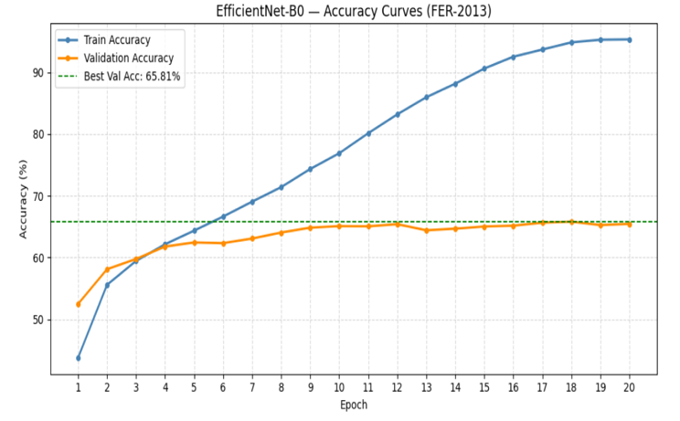

Speech Emotion Recognition
Live audio is captured continuously from the microphone in three-second windows using the sounddevice library. Each audio window is processed using Librosa to extract 40 Mel Frequency Cepstral Coefficient (MFCC) features. MFCCs provide a compact representation of the spectral characteristics of speech, capturing tonal and rhythmic properties relevant to emotional expression. The resulting feature matrix of shape 40x130 is passed to the audio emotion classifier.
A Bidirectional Long Short-Term Memory network is employed for speech emotion classification. The Bidirectional LSTM processes the MFCC sequence in both forward and backward directions, capturing temporal dependencies across the audio window. The architecture consists of two LSTM layers with hidden size 128, followed by a fully connected layer with ReLU activation and dropout, outputting eight class probabilities via softmax. The model was trained for 30 epochs using the Adam optimizer, achieving a best validation accuracy of 59.03%.
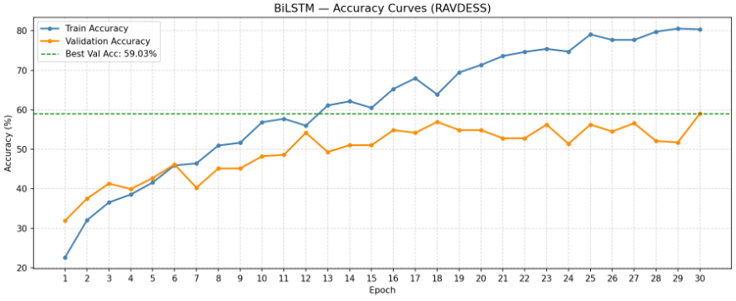

Feature-Level Fusion
The outputs of both models are softmax probability vectors representing predicted emotion labels. Feature-level fusion is applied by combining the predictions from both modalities. When both the facial and speech models predict the same emotion, the system outputs that emotion with high confidence. When predictions differ, both are displayed, providing transparency in the system's reasoning. This approach is consistent with the feature-level fusion strategy described by Salas-Caceres et al. [1].
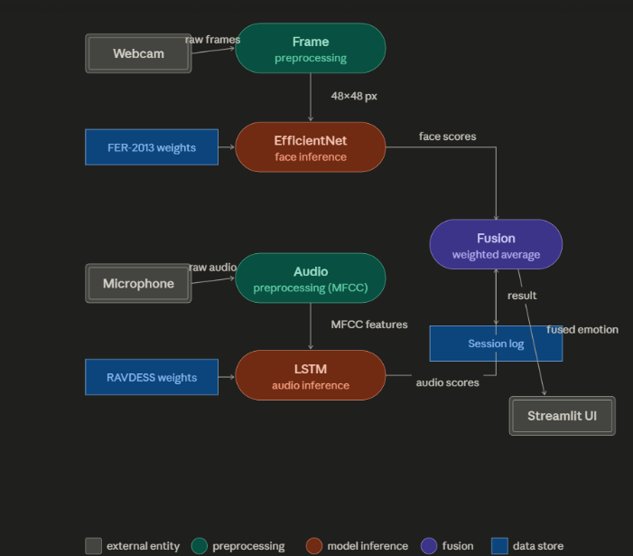

System Deployment
The complete system is deployed as a real-time interactive web application using Streamlit. The application opens the webcam and microphone simultaneously on launch. Face detection and emotion classification run on the main thread at approximately 30 frames per second. Audio recording and classification run on a separate background thread, updating the audio emotion prediction every three seconds. The application displays the face emotion with confidence score, the audio emotion, and the fused output in real time. The system runs entirely on CPU, demonstrating feasibility on standard consumer hardware without GPU acceleration.

Result and discussion
The proposed system was evaluated on the FER-2013 and RAVDESS benchmark datasets. Table I summarizes the performance of each component.

Component | Dataset | Accuracy
EfficientNet-B0 (Face) | FER-2013 | 65.81%
BiLSTM (Audio) | RAVDESS | 59.03%
Emotive (Fused) | FER-2013 + RAVDESS | Live Real-Time Inference ✓
The facial emotion recognition model achieved 65.81% validation accuracy on FER-2013. This result is consistent with the challenging nature of FER-2013, where state-of-the-art methods report accuracies in the range of 73-76%. The speech emotion recognition model achieved 59.03% validation accuracy on RAVDESS, which is reasonable given the small size of the dataset (1,440 samples) and the use of a relatively compact LSTM architecture.
Compared to the base paper by Salas-Caceres et al. [1], which achieved 88.11% on RAVDESS using studio-quality pre-recorded video, our system achieves lower individual modality accuracy. However, the primary contribution of this work is not accuracy on benchmark datasets but rather the demonstration of real-time multimodal fusion on live inputs — a capability not addressed by the base paper.
The system runs at approximately 30 frames per second on a standard consumer laptop CPU, demonstrating practical feasibility for real-world deployment.

Acknowledgment
The authors would like to express their sincere gratitude to CMR Institute of Technology for providing the facilities and support required to carry out the project titled “Real-Time Multimodal Emotion Recognition Using Facial and Speech Feature Fusion.”
The authors sincerely thank Dr. Sanjay Jain, Principal, CMRIT, Bengaluru, for his encouragement and support. The authors also express their gratitude to Dr. Shyam P. Joy, Head of the Department of Artificial Intelligence and Machine Learning, for his valuable guidance and motivation throughout the project.
Special thanks are extended to Ms. Sandhya Kumari for her continuous guidance, support, and valuable suggestions during the development of this work. The authors also thank the faculty members of the AIML Department, along with friends and family members, for their encouragement and support throughout the project.

References
[1] J. Salas-Caceres, J. Lorenzo-Navarro, D. Freire-Obregon, and M. Castrillon-Santana, "Multimodal emotion recognition based on a fusion of audiovisual information with temporal dynamics," Multimedia Tools and Applications, Springer, vol. 84, pp. 27327–27343, 2025.
[2] Chandraumakantham et al., "LLM-based multimodal fusion for emotion recognition," IEEE Access, 2024.
[3] Wu et al., "A survey of multimodal emotion recognition: datasets, preprocessing, features and fusion methods," Biomimetics, MDPI, 2025.
[4] Pragash K et al., "CNN+LSTM hybrid architecture for multimodal emotion recognition," IJRPR, 2024.
[5] M. Tan and Q. Le, "EfficientNet: Rethinking model scaling for convolutional neural networks," ICML, 2019.

