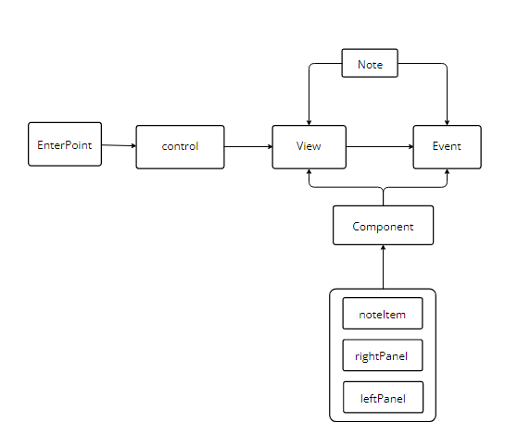Program structure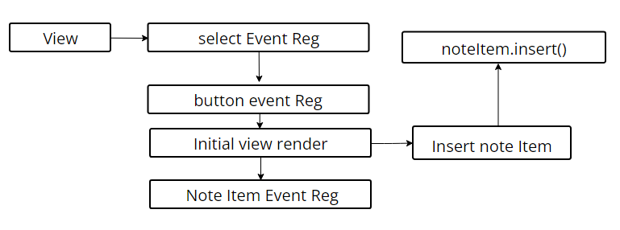

View structure

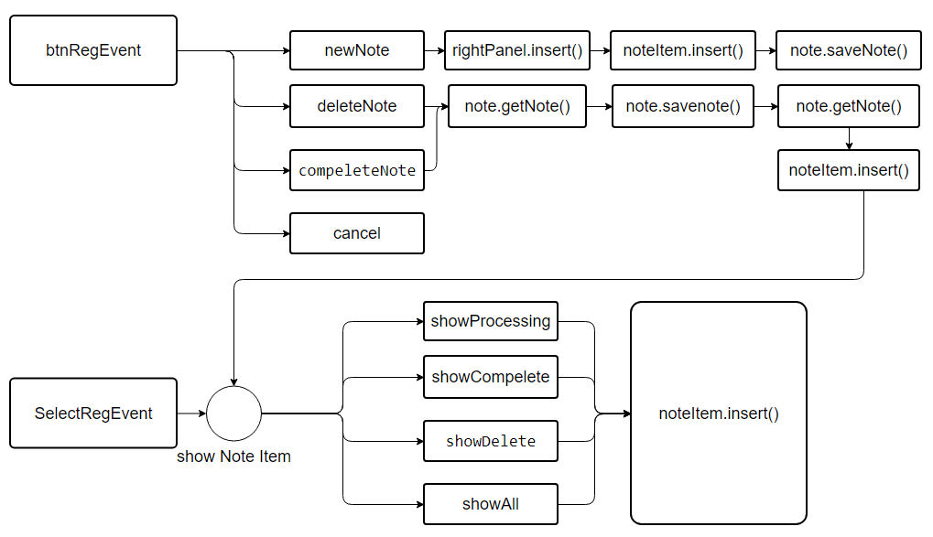

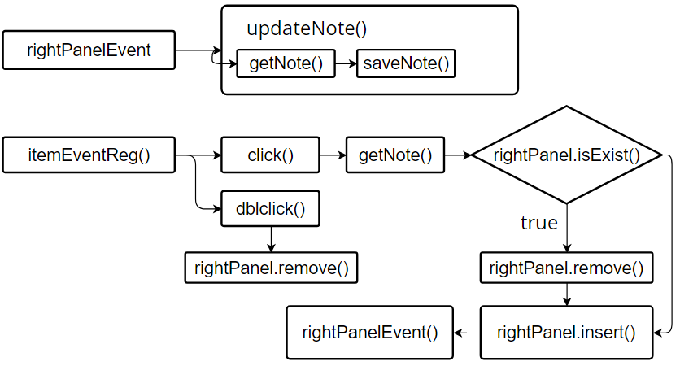

Enevt structure

In my project I achieves add/delete/complete note and the note will save automatically .

If you want to mark notes delete or complete you can double click note-item in the panel left and you will enter the select mode to select what you want to delete or complete .

If u want to cancel the delete and complete status you can double click the note-item and select the note you want to cancel delete or complete status and click delete or complete button. And it will back to previous status

If your note have deleted or completed you can’t edit it because a note u delete or complete can be edit it is so odd ,I decide disable edit function on delete and complete status

If want flowchart svg can see this

<https://github.com/allin-all-money/allin-all-money.github.io/tree/main/hw/mt1/flowchart>

Github :

<https://allin-all-money.github.io/>

<https://karta2341940.github.io/>