Description
Hierarchical Clustering of
Motion Planning Preferences
Master’s Project
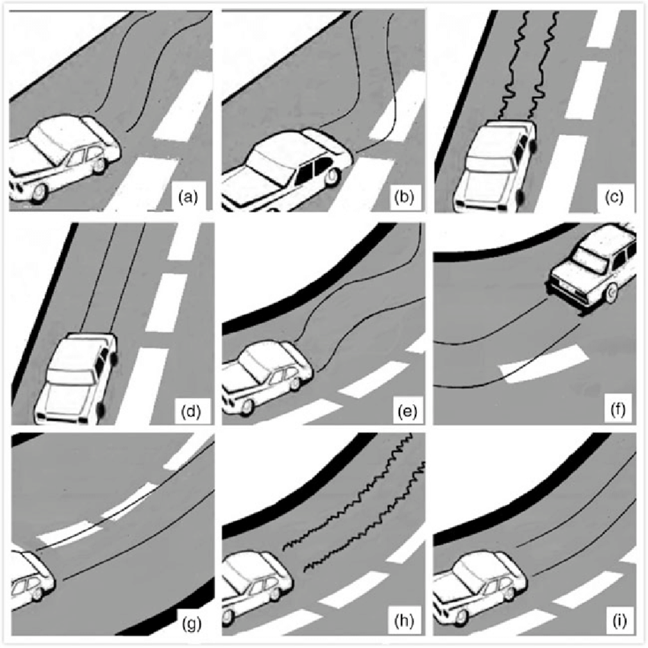
One of the goal of robotics is to make sure that robots can move according to a motion plan. The motion plan can also include spatial/temporal preferences e.g. where the robot should go and how fast it should complete its task. To that end, Signal Temporal Logic (STL) [1] can be used to shape the robot’s trajectories. It is a formalism to specify complex tasks and to characterize (desired) behaviours of systems in a machine-interpretable way.
This project will focus on learning a specification from data. There exist recent data-based approaches [2-4] which include observed trajectories of the robot. To obtain accurate and tight results, this process usually requires that the trajectories only belong to a single target specification. Nevertheless, in reality, trajectories are recorded from multiple specifications during the operation of a system. For instance, an autonomous vehicle performs different manoeuvres during its operation, depending on the current traffic situation. Another example spans different driving styles one can encounter while driving: from careful driving styles to more aggressives.
Goals
Your task will be to develop a hierarchical clustering approach to separate the trajectories into distinct subsets. Each of these subsets should belong to a different target specification. Therefore, you need to determine suitable metrics [5] and identify clustering approaches to separate the trajectories, e.g., using their frequency spectrum.
Requirements
The project is suitable for students interested in the fields of robotics, formal methods and machine learning. An excellent command of Python is required.
Contacts
Alexis Linard (linard@kth.se), Christian Pek (pek2@kth.se)

References
[1] O. Maler and D. Nickovic, “Monitoring temporal properties of continuous signals,” in Formal Techniques, Modelling and Analysis of Timed and Fault-Tolerant Systems. Springer, 2004, p. 152–166.
[2] E. Asarin, A. Donze, O. Maler, and D. Nickovic, “Parametric identification of temporal properties,” in Proc. of the Int. Conf. on Runtime Verification. Springer, 2011, pp. 147–160.
[3] G. Bombara, C.-I. Vasile, F. Penedo, H. Yasuoka, and C. Belta, “A decision tree approach to data classification using signal temporal logic,” in Proceedings of the 19th International Conference on Hybrid Systems: Computation and Control. ACM, 2016, pp. 1–10.
[4] A. Jones, Z. Kong, and C. Belta, “Anomaly detection in cyber-physical systems: A formal methods approach,” in Proc. of the IEEE Int. Conf. on Decision and Control (CDC). 2014, pp. 848–853.
[5] C. Madsen, P. Vaidyanathan, S. Sadraddini, C.-I. Vasile, N. A. De-Lateur, R. Weiss, D. Densmore, and C. Belta, “Metrics for signal temporal logic formulae,” in Proc. of the IEEE Int. Conf. on Decision and Control (CDC). 2018, pp. 1542–1547.

