Description
Visualization of Motion Planning Preferences
Master’s Project
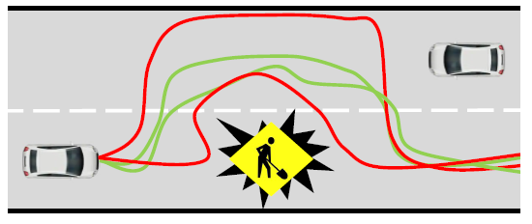
One of the goal of robotics is to make sure that robots can move according to a motion plan. The motion plan can also include spatial preferences, such as safety specifications (the robot should not enter a given zone) and mission goals (zones the robot should visit). To that end, Signal Temporal Logic (STL) [1] can be used to shape the robot’s trajectories. It is a formalism to specify complex tasks and to characterize (desired) behaviours of systems in a machine-interpretable way. However, designing a temporal logic formula is usually a tedious task, often requiring manual tuning.
This project will focus on implementing the visualization of specifications of robot trajectories. In previous work [2], we developed a learning-based approach that infers a specification of a given system by interacting with this system. To improve the inference approach, we envision incorporating guidance from a human expert. Therefore, the human expert needs to visualize example trajectories so that the human expert can judge their membership. Moreover, the human expert may also draw trajectories which can be used by the learning algorithm to improve the inferred specification further.
Goals
In this project, you will develop:
- a signal generation approach that is capable of generating a variety of example signals (positive as well as negative) from a given specification.
- a visualization of the satisfaction area of the specification so that the human expert can evaluate the whole specification learnt so far by the algorithm [3-4].

Requirements
The project is suitable for students interested in the fields of robotics, formal methods and machine learning. An excellent command of Python is required.
Contacts
Christian Pek (pek2@kth.se), Alexis Linard (linard@kth.se)

References
[1] O. Maler and D. Nickovic, “Monitoring temporal properties of continuous signals,” In Formal Techniques, Modelling and Analysis of Timed and Fault-Tolerant Systems. Springer, 2004, pp. 152–166.
[2] A. Linard and J. Tumova, “Active Learning of Signal Temporal Logic Specifications,” To appear in Proc. of the IEEE 15th Int. Conf. on Automation Science and Engineering (CASE). 2020.
[3] C. Madsen, P. Vaidyanathan, S. Sadraddini, C.-I. Vasile, N. A. De-Lateur, R. Weiss, D. Densmore, and C. Belta, “Metrics for signal temporal logic formulae,” in Proc. of the IEEE Int. Conf. on Decision and Control (CDC). 2018, pp. 1542–1547.
[4] B. Hohxha, N. Mavridis, G. Fainekos: VISPEC: A graphical tool for elicitation of MTL requirements. In Proc. of the IEEE/RSJ International Conference on Intelligent Robots and Systems (IROS). 2015.

