Description

**Constrained Reinforcement Learning for Formation Control**

**Master’s Project**

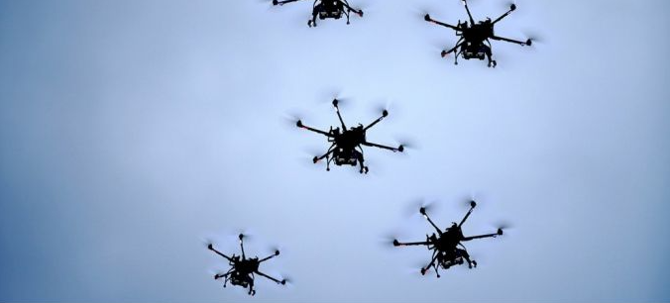The project aims at exploring multi-agent control for mobile and aerial robots (e.g., UAVs). In the class of multi-agent systems, formation control is defined as the problem of controlling the position and orientation multiple robots in a group, while following the group trajectory as a whole and maintaining a desired spatial pattern [1]. Although there are several advantages of the coordinated formation control for real-life applications, several theoretical challenges such as partial and relative information between agents, as well as practical constraints such as collision avoidance, arise and make the problem of coordinated formation control more interesting and challenging.

This project will focus on implementing a constrained reinforcement learning algorithm for the formation control problem [2], and evaluation in simulations and/or with the use of small UAVs (Crazyflies). Constrained reinforcement learning enriches reinforcement learning framework with constrained exploration, preventing the robots from reaching unsafe states, such as collisions or zero battery life.

Goals

Your task will be to design, implement, and evaluate a constrained reinforcement learning algorithm for UAV formation control. The exploration phase will include provable satisfaction of constraints, such as safety rules, written for instance in linear temporal logic or signal temporal logic.

Requirements

The project is suitable for students interested in the fields of robotics, and reinforcement learning. Interest in formal verification, motion planning, control, and/or multi-agent coordination are a merit.

You have to:

* Have taken DD2410 Introduction to Robotics and preferably also EL2805 Reinforcement Learning
* Have solid programming skills in Python and preferably also ROS.

Contacts

Alexis Linard ([linard@kth.se](mailto:linard@kth.se)), Christian Pek ([pek2@kth.se](mailto:pek2@kth.se)), Jana Tumova ([tumova@kth.se](mailto:tumova@kth.se))

References

[1] Yang Quan Chen and Zhongmin Wang. Formation control: a review and a new consideration. In2005 IEEE/RSJ International Conference on Intelligent Robots and Systems (IROS), pages 3181–3186.IEEE, 2005.

[2] Wanbing Zhao, Hao Liu, and Frank L Lewis. Robust formation control for cooperative underactuatedquadrotors via reinforcement learning.IEEE Transactions on Neural Networks and Learning Systems,2020.