Images:





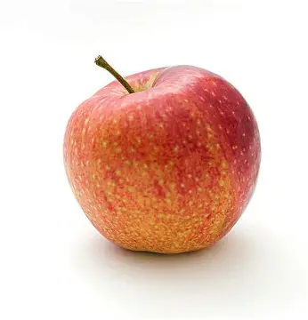





Links:
WCAG 2 Overview | Web Accessibility Initiative (WAI) | W3C
WCAG 2 Overview | Web Accessibility Initiative (WAI) | W3C
WCAG 2 Overview | Web Accessibility Initiative (WAI) | W3C
WCAG 2 Overview | Web Accessibility Initiative (WAI) | W3C
WCAG 2 Overview | Web Accessibility Initiative (WAI) | W3C

