Introduction

This is a test to see how Ally checks accessibility.

Images

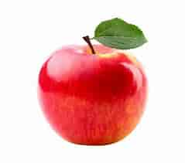


List

- Favorite color: blue
- Time is 4:02PM
- 3 classes today

Links

WCAG Guidelines
Food network recipes

Color Contrast

This is a color contrast test

