Introduction

This is a test to see how Ally checks accessibility.

Images

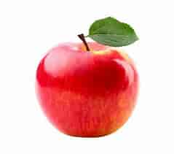


Table

Number | Color
5 | blue
7 | orange

List

1) Favorite color: blue
2) Time is 4:02PM
3) 3 classes today

Links

WCAG Guidelines
Food network recipes

Color Contrast

This is a color contrast test

