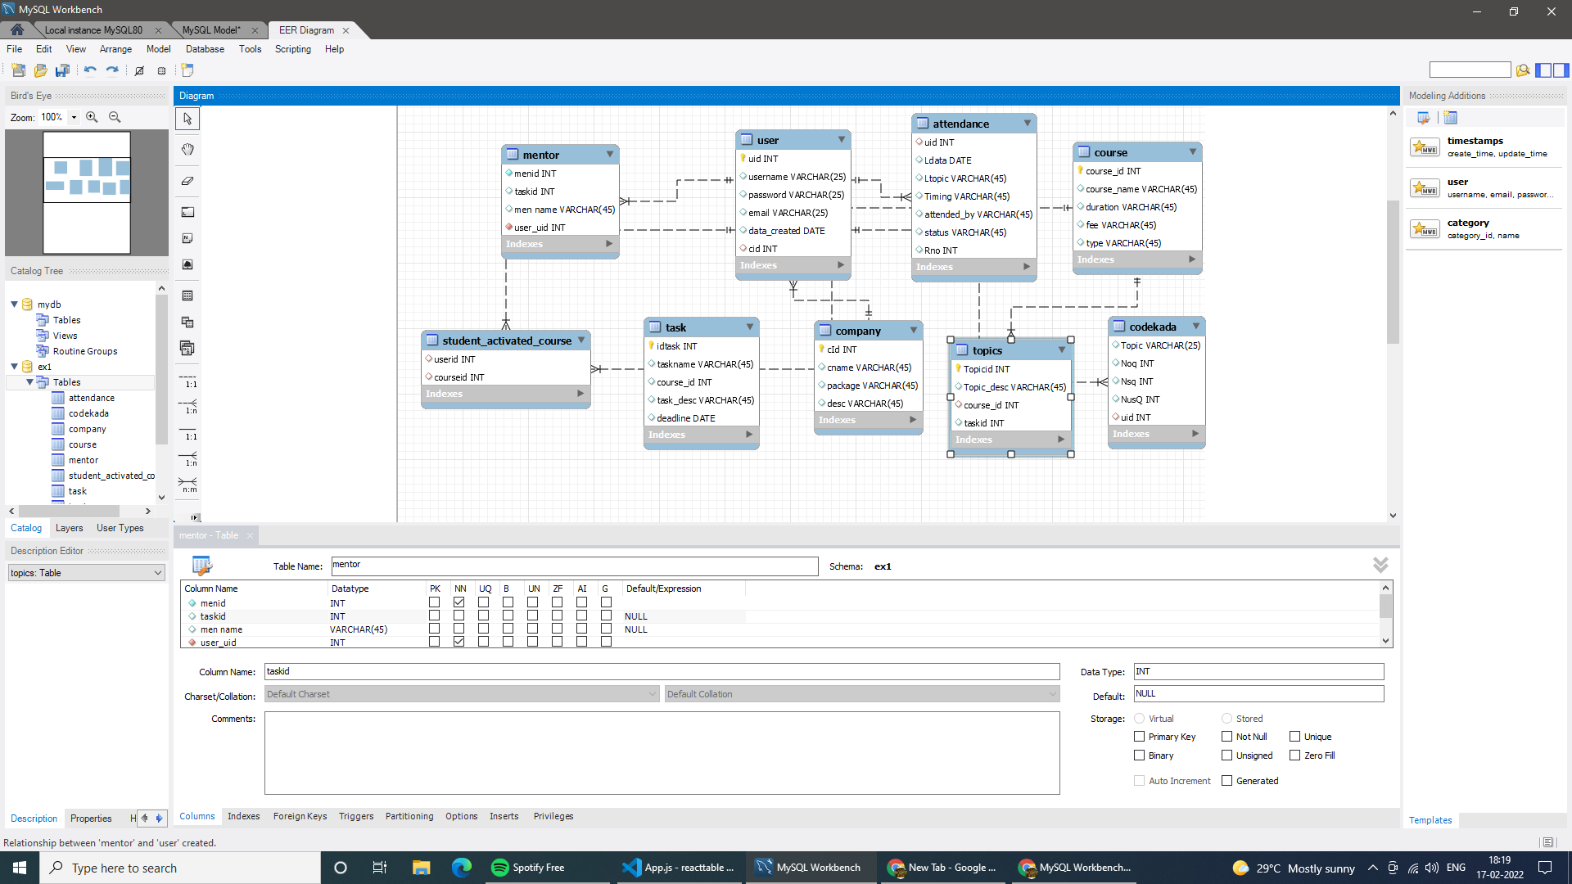







**Sql**

**Get number problems solved in codekata by combining the users.**

**Ans: select a.uid,b.username,a.Nsq from codekada a ,user b where a.uid=b.uid;**



Display the no of company drives attended by a user.

Ans: select count(cid),uid from user group by uid;



combine and display students_activated_courses and courses for a specific user groping them based on the course

mysql> select c.userid,a.username,c.courseid,b.course_name from user a,course b, student_activated_course c where a.uid=c.userid and c.courseid=b.course_id;

+--------+----------+----------+-------------+

| userid | username | courseid | course_name |

+--------+----------+----------+-------------+

| 100 | amutha | 1 | MERN |

| 101 | hema | 1 | MERN |

| 102 | guna | 2 | Node Js |

| 103 | james | 2 | Node Js |

| 104 | vimala | 3 | React Js |

+--------+----------+----------+-------------+

5 rows in set (0.00 sec)

mysql> select c.userid,a.username,c.courseid,b.course_name from user a,course b, student_activated_course c where a.uid=c.userid and c.courseid=b.course_id group by c.courseid;

+--------+----------+----------+-------------+

| userid | username | courseid | course_name |

+--------+----------+----------+-------------+

| 100 | amutha | 1 | MERN |

| 102 | guna | 2 | Node Js |

| 104 | vimala | 3 | React Js |

+--------+----------+----------+-------------+

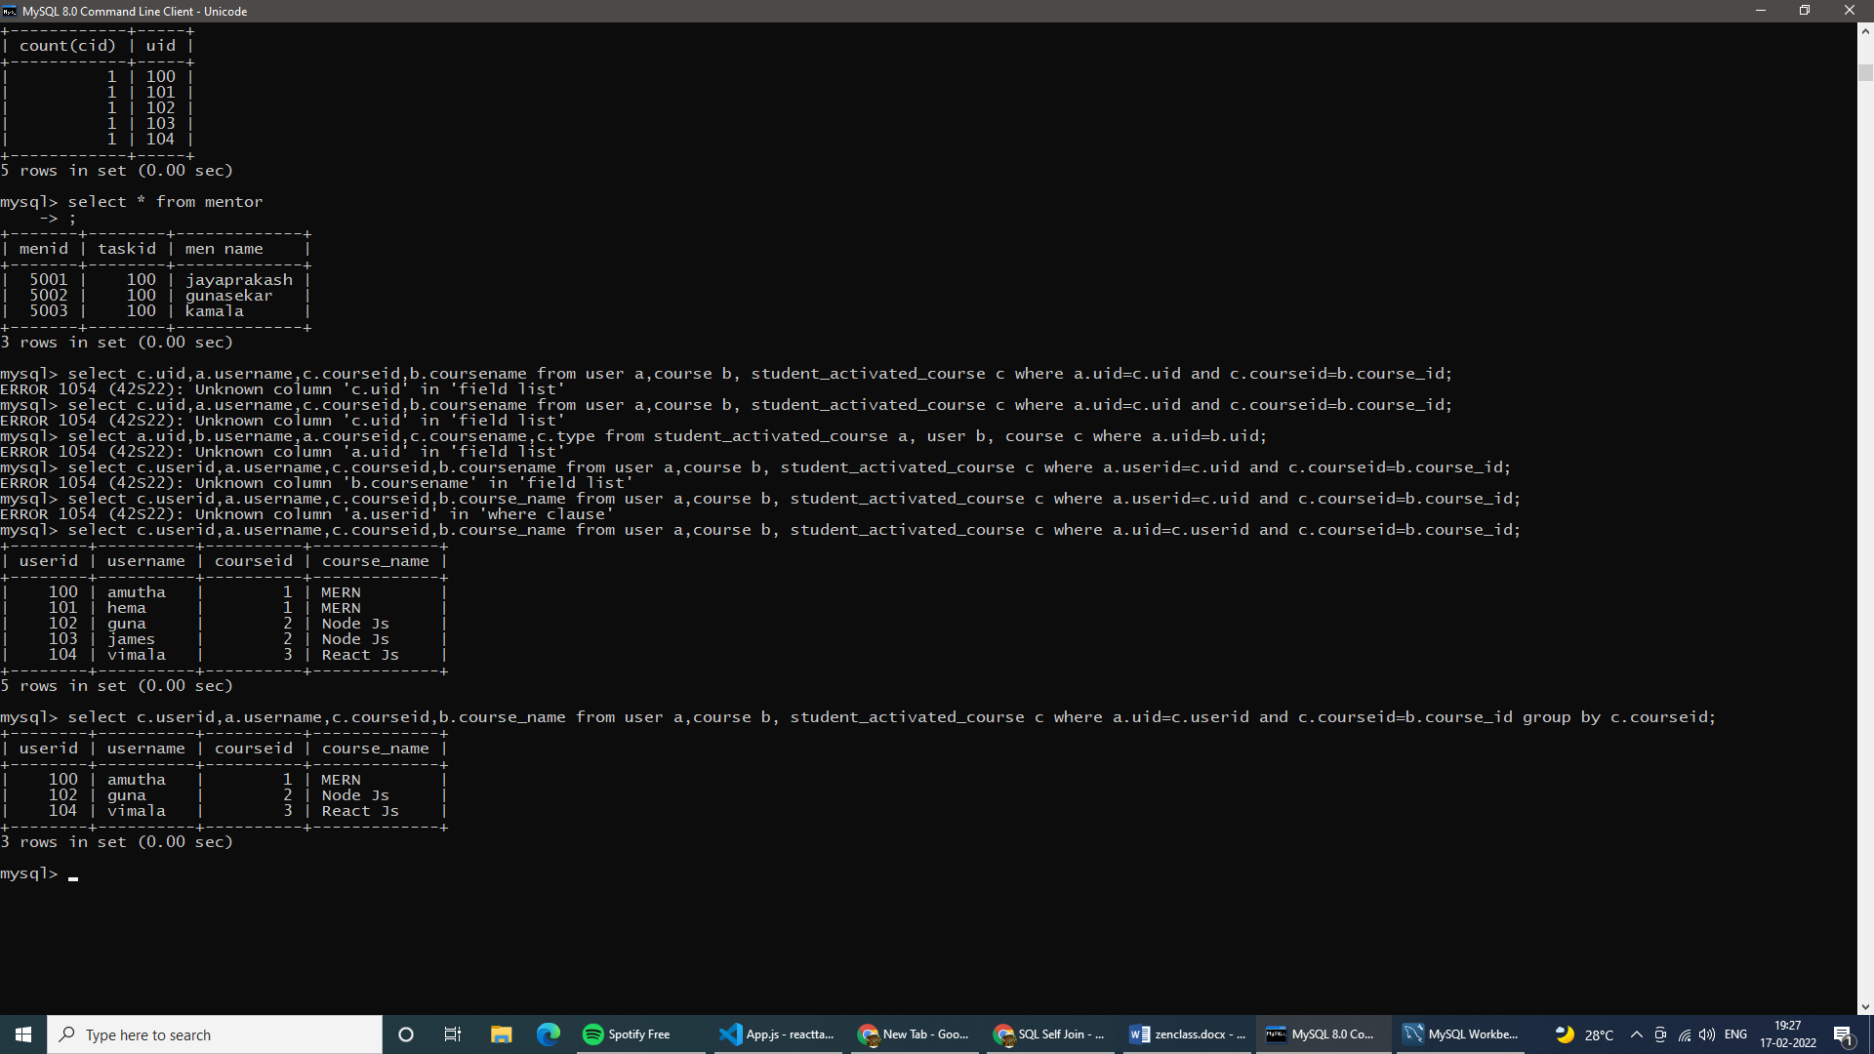

list all the mentors

Ans: Select * from Mentors;



list the number of students that are assigned for a mentor

Ans: select count(us1) from mentor group by menid; 