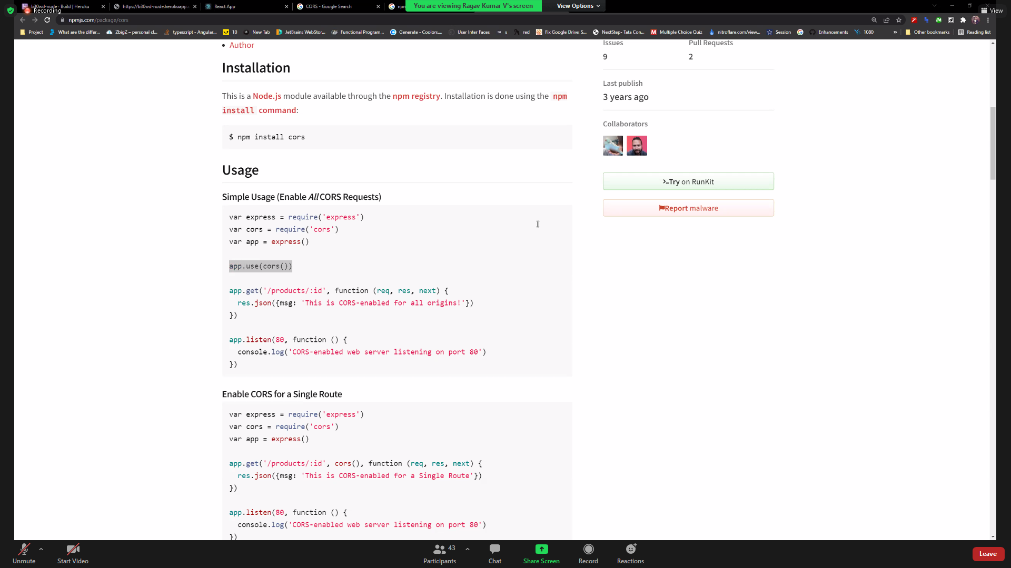

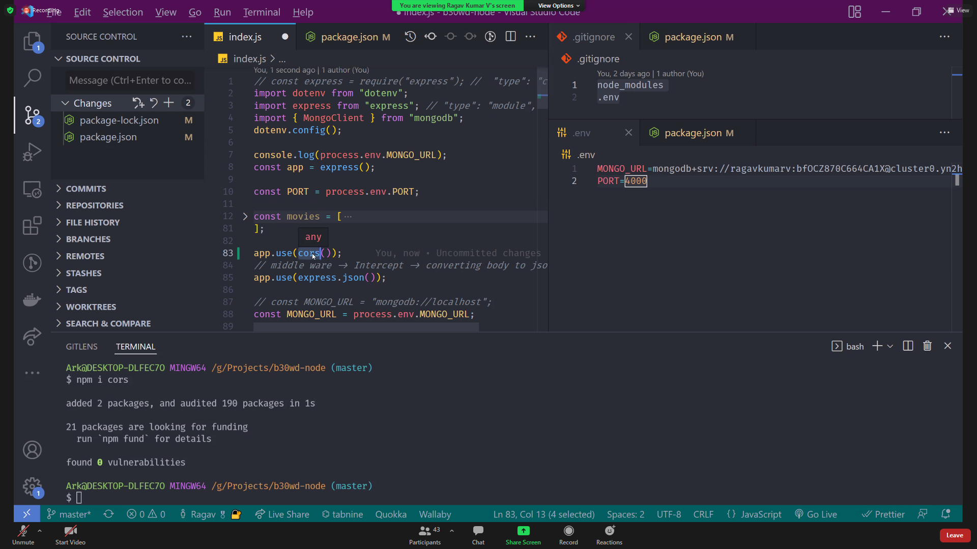

17-3-2022

In node environment to install

Npm I cors

Sir note:

https://www.npmjs.com/package/cors

npm i cors

import cors from "cors";app.use(cors());

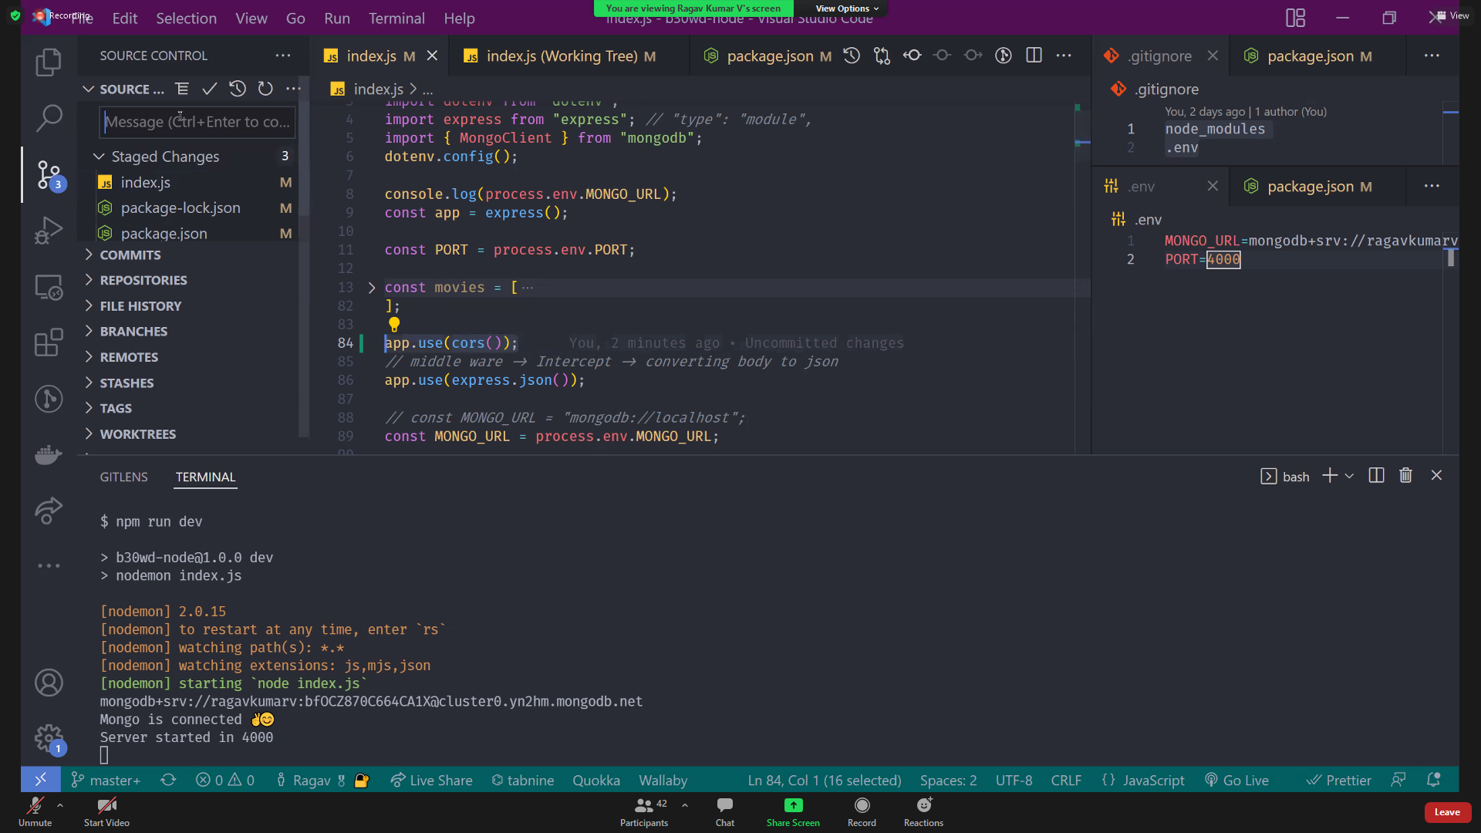

How to githun file download command -screen below

