Thesis Proposal: Simulating the Welfare Impacts of an Earthquake on Vulnerable Populations

Allison Siegel
Rothberg International School, The Hebrew University of Jerusalem
February 3, 2026
Introduction
Earthquakes are famous for the damage they cause, but not for their unseen aftershocks. The capacity of the population to cope with these shocks influences how an affected area recovers, and vulnerable populations such as senior or physically disabled people have lower coping capacity than the general population (Felsenstein & Lichter, 2013). Physical limitations may reduce the ability to respond independently and increase reliance on assistance which may not be available, while institutional barriers such as a lack of prioritization by authorities prevent adequate distribution of aid (Hemingway & Priestley, 2006; Maltais, 2019; Tamura et al., 2006). This proposal advocates for deliberate recovery policies addressing the challenges of vulnerable populations, specifically senior and physically disabled persons, in the aftermath of an earthquake.
While an environmental hazard can disrupt the entire region, its impact varies across the population. Social vulnerability theory emphasizes that disaster vulnerability is shaped by social and economic characteristics such as income, age, and disability (Cutter et al., 2003). In many disaster recovery studies, income is often cited as the first and strongest indicator to define vulnerability (Gilbert, 2010; Harwood, 2025; Paul et al., 2023; Tafti, 2015; Zhang & Peacock, 2009). Scoping reviews of social vulnerability indices find that age is frequently included as an indicator, but analyses lack older populations’ disaster recovery outcomes (Kim et al., 2025; Mah et al., 2023 ). Similarly, disability is included in many social vulnerability indices but is often treated as a secondary component or grouped with other at-risk populations (Fatemi et al., 2017; Hemingway & Priestley, 2006; Maltais, 2019). For this study, use of the terms elderly or senior refer to those over the age of 65, while use of the term disability refers to physical disability. Existing research demonstrates that unique challenges faced by elderly and disabled individuals–such as decreased physical ability and immobility, institutional exclusion, and limited financial means–not only increase their risk of injury and personal harm but also negatively affect their recovery outcomes (Hemingway & Priestley, 2006; Maltais, 2019). These distinct challenges warrant separate investigation; there is a critical need for research to support more equitable recovery.
A common method for understanding the socioeconomic impacts of hazards is an agent-based model, or ABM (Alisjahbana et al., 2022; Costa et al., 2020; Grinberger & Felsenstein, 2014, 2016; Moradi & Nejat, 2020; Xue et al., 2023). ABMs account for the temporal and spatial interactions which are particularly important for recovery, after applying an exogenous shock to pre-disaster conditions (Bhattacharya & Kato, 2021). As agents are autonomous and heterogeneous, ABMs can simulate the behaviors of diverse populations, and encourage a focus on particular groups (Chen, 2012; Crooks et al., 2021; Grinberger & Felsenstein, 2016). ABMs are also ideal for hypothetical policy exploration and testing (Lempert, 2002). However, much like general disaster recovery research, previous ABM studies of post-disaster recovery typically differentiate recovery patterns by income or socioeconomic status, with relatively few directly addressing the specific concerns of elderly and physically disabled populations (e.g. Burton et al., 2019; Costa et al., 2020; Grinberger & Felsenstein, 2014, 2016; Moradi & Nejat, 2020; Xue et al., 2023).
This study aims to address this gap by employing an ABM grounded in traditional microeconomic theory and real-world data, developed by Grinberger and Felsenstein (2017, 2025). This model simulates a foundation of core urban functions to which a variety of exogenous shocks can be easily applied, generating comprehensive data to support the creation of unique metrics. Using the city of Tel Aviv-Yafo as the study location, this study extracts housing and essential service access outcomes from the model to measure households’ ability to remain in their community and resume daily routines. The study caters to the interests of senior and physically disabled persons in particular, testing policies that may mitigate their challenges.
2. Literature Review
2.1 Vulnerable populations
Elderly and disabled populations are some of the most vulnerable groups in society, which can negatively impact their overall welfare. Their specialized and increased care needs make daily activities and independence more challenging than the general population (Yaya et al., 2020). Additionally, physical barriers to accessing spaces–either through lack of accessible facilities or restrictions in mobility–can reduce community participation for both groups, harming social networks and health outcomes (De Almeida Holanda et al., 2015).
Complicating matters, older and disabled populations typically have financial situations different from the general working population. Older adults may rely on retirement funds, pensions or financial support from family members, and have limited disposable income (OECD, 2025; Rahmah & Hikmawati, 2025). People with disabilities, who frequently face barriers to employment, are among the poorest groups globally and may depend heavily on family or government assistance (Hemingway & Priestley, 2006; OECD 2022). Therefore, with the combination of physical and financial constraints, elderly and disabled populations face additional challenges in adapting to sudden changes to their environments.

2.2 Housing decisions
Under normal conditions, older populations’ housing decisions are influenced by a variety of factors. The need to maintain a daily routine and proximity to amenities, as well as health status, housing costs, availability of adapted dwellings that accommodate physical limitations, and family and social connections are main components (Rahmah & Hikmawati, 2025; Roy et al., 2018). Combined with a strong desire to stay in place, these factors narrow their scope of options and search radius for new housing (Rahmah & Hikmawati, 2025). For the disabled, adequate housing requires adapted dwellings and proximity to social networks and essential services (Ho et al., 2007; Rapegno & Ravaud, 2017). Again, with limited financial means, their ability to find suitable housing is restricted.
2.3 Importance of services for elderly and disabled
Consistent access to services and community resources is important for the health and quality of life of older adults and disabled people. For older adults, a lack of healthcare continuity and service accessibility are barriers to independent living, while proximity to diverse amenities can help promote activity and independence (Booth et al., 2000; Brown et al., 1997; Clarke & George, 2005; Levasseur et al., 2015). Similarly for the disabled, direct access to urban destinations (such as stores) and proximity to resources can promote community engagement and mobility, while long distances to destinations can further exclude disabled people from society (Beard et al., 2009; Casas, 2007). For both groups, access to urban amenities and services are crucial in promoting health and social participation, directly connecting to their overall welfare.

2.4 Impacts of earthquakes on housing and services
In the immediate aftermath of a disaster, population welfare is disrupted not only by physical damage but also by structural changes that reshape the spatial distribution of residents and essential economic activity (Chang & Rose, 2012). More specifically, elements of daily life such as housing and access to essential service providers (e.g., supermarkets, pharmacies, and shopping centers) are directly and indirectly affected by disasters (Comerio, 2014; Fothergill & Peek, 2004). From a social vulnerability lens, pre-existing social conditions strongly influence the capacity of groups to cope with and adapt to these changes (Bolin & Stanford, 1998; Cutter et al., 2003). The physical and financial limits of elderly and disabled populations may decrease their ability to cope with such changes to housing and services.
Housing is a fundamental aspect of daily life that is negatively impacted by disasters, making this a crucial component of recovery (Comerio, 2014). The physical destruction or damage from a disaster has broad implications on housing availability and costs beyond simple reduction in supply, and markets often become highly volatile (McIntosh, 2013; Paul et al., 2023; Peacock et al., 2017; Zhang & Peacock, 2009). As the specific impact of earthquakes on housing costs for senior and disabled populations is limited, I discuss the changes to the housing market more generally in the proceeding paragraphs.
Decreases in property values are observed in the short term after earthquakes and flood events due to improved knowledge of risk, however they tend to recover over time. (Beron et al., 1997; Chandra‐Putra & Andrews, 2019; Timar et al., 2018). This instability combined with expenses related to repairs and relocations, place a high financial burden on households (Comerio, 2014; Cutter et al., 2003; Nakashima & Okada, 2018). For renters, the reduced supply of housing after a hazard places upward pressure on rents, reducing affordable housing in general (Best et al., 2023; Harwood, 2025; Peacock et al., 2017). Across various flood events, rents increased at the bottom of the rent distribution, thereby reducing housing affordability for those already paying the lowest possible rents (Brennan et al., 2024). However, Harwood (2025) found that after Hurricane Sandy, rents increased in higher income areas while decreasing in low-income areas, before rebounding within a few years (Harwood 2025). Overall, rental market affordability has been shown to decrease after hazards, with limited supply causing higher rental prices (McIntosh, 2013).
While the impact of a disaster on the housing market is dependent on the nature of the event and areas affected, research suggests that post-disaster housing instability and rising housing costs can disproportionately affect vulnerable populations, including elderly and disabled individuals, whose capacity to absorb housing-related shocks is often constrained (Cutter et al., 2003).
Another crucial aspect of disaster recovery is the availability of essential services. Unavailability of essential goods and services harms welfare for all affected populations and may contribute to multiple relocations post-disaster (Contreras et al., 2017; Logan & Guikema, 2020). Understanding the magnitude of disruption to services can be important in evaluating a community’s recovery, yet it is not commonly measured (Enderami et al., 2024; Logan & Guikema, 2020). However, as services are dependent on business and economic activity, looking at the effects on the local economy can be helpful in assessing a community’s access. Furthermore, research on the impact of business loss on specifically senior and disabled populations is lacking and the following paragraph discusses local economic effects of hazards more generally.
Natural hazards disrupt business and economic activities by damaging physical assets, reducing customer demand, and interrupting labor and supply chains, with smaller and less prepared businesses facing higher risks of closure or relocation than larger firms (Kroll et al., 1991; Tierney, 1997; Wasileski et al., 2011). Despite this, empirical findings suggest that local economies are generally resilient to disasters and eventually recover; however, short-term closures may inhibit nearby populations from accessing the services they need (Chang & Rose, 2012; Swanson & Guikema, 2023). As access to services and amenities is important for the welfare of senior and disabled populations in a non-disaster context, the service disruptions from a disaster may cause additional harm for these groups.
2.5 Impacts of earthquakes on vulnerable populations
It is well documented that elderly and physically disabled individuals are especially vulnerable to harm during and after disasters, resulting in high rates of injury, death, disease, and displacement (Maltais, 2019; Paul et al., 2023; Quaill et al., 2018). For instance, their increased dependence on infrastructure such as electricity and water to maintain health can exacerbate inequalities when these basic services are disrupted (Hemingway & Priestley, 2006).
Furthermore, disruptions to housing severely impact older adults and disabled people through the physical loss of housing and subsequent relocation challenges (Brown & Frahm, 2015; Stough et al., 2015). After displacement by disasters, shelters and temporary housing may not be equipped to handle the increased physical needs of both groups while adaptive dwellings are lacking (Hemingway & Priestley, 2006; Stough et al., 2015). For older adults, the impacts of relocation can also cause declines in health (Brown & Frahm, 2015).
The disruptions to other essential networks (social, healthcare, transportation, etc.) for both groups can increase their risk of negative health outcomes and hinder recovery (Jenkins et al., 2014; Levine et al., 2007; Stough et al., 2015). A lack of transportation options and the changed urban environment can also inhibit disabled individuals from receiving healthcare, accessing employment, and participating in community life (Stough et al., 2015). Shortages in community services and formal resources contribute to the unmet needs of older adults after disasters, causing severe psychological stress and negative health outcomes (Brown & Frahm, 2015). Generally, due to the specialized needs of elderly and disabled population, disasters can drastically harm their overall welfare.
2.6 Policies and impacts
To improve welfare outcomes after hazards, the goals of recovery policy should be to maintain communities socially and economically, not just physically (Levine et al., 2007). Shelters provide temporary housing but can interfere with daily routine maintenance and disrupt social networks (Paul et al., 2023). Relocations in later stages of housing recovery are more successful when informed by accessibility to jobs, services, and public infrastructure, indicating that beyond the physical needs of the displaced, social and economic aspects of living are equally if not more important (Contreras et al., 2017; Tafti, 2015). Elderly people in particular prefer to be sheltered or temporarily housed near amenities, in order to re-establish their daily routines (Phillips, 1998).
Beyond sheltering, the decreased supply of units and subsequent fluctuations in housing costs need to be addressed. Grants that support housing construction may increase supply and relieve rising prices post-disaster, with fast allocation improving outcomes (An et al., 2024). Rental subsidies for low-income populations are effective in combatting increases in rents following massive flooding (Harwood, 2025). Generally, attempts to increase the supply of housing through financially supported reconstruction and concurrent housing assistance can reduce displacement and combat high costs of living for all affected populations. Therefore, housing assistance that prioritizes more disadvantaged groups such as the elderly or disabled may help address their changes in housing affordability.
Hypotheses
While prior research identifies mechanisms of vulnerability and potential policy responses, their implications for housing affordability, service access, and relocation outcomes among elderly and disabled populations remain insufficiently examined. To extend their examination, this study will specifically investigate the question of how the housing and service needs of senior and physically disabled populations are disrupted by an earthquake, and how policies can mitigate these disruptions, by testing the following hypotheses:
H1. Among displaced people after an earthquake, we expect that elderly and disabled households will have fewer affordable housing options in the short term than the general population and therefore will be less likely to relocate within their neighborhood. This is justified by research indicating that affordable housing decreases after disasters and that elderly and disabled people have a more limited scope of housing options (Ho et al., 2017; Peacock et al., 2017; Rahmah & Hikmawati, 2025).
H1.1. We expect that housing subsidies for displaced elderly and disabled households will make housing more affordable in the short term and therefore improve relocation outcomes. This is justified by research indicating that rental vouchers and other financial interventions allow populations to afford potential increases in housing costs and remain in their communities (An et al., 2024; Harwood, 2025).
H1.2. In the long term and without intervention, affordable housing will not recover for disabled and elderly populations. As buildings get built back after disasters, property values and rents may rise due to renovations and retrofitting. This would put a strain on senior and elderly populations as they have more limited housing options.
H2. After an earthquake, elderly and disabled populations will have less access to services than the general population. This is justified by research indicating that services are disrupted after a disaster event and that proximity to services is more important for elderly and disabled populations (Ho et al., 2017; Rahmah & Hikmawati, 2025; Swanson 2023).
H2.1. Sheltering close to commercial areas will increase access to services for displaced elderly and disabled households. This is justified by knowledge that elderly populations prefer to shelter nearby commercial areas and that successful community recovery after a disaster event is dependent on sufficient services (Contreras et al., 2017; Phillips, 1998).
H2.2. In the long term after an earthquake, access to services will improve for elderly and disabled households. This is justified by research indicating that local economies recover from disasters and that disruptions are often temporary (Chang & Rose, 2012).

Methodology
This study is grounded in an agent-based model based on prior works by Grinberger and Felsenstein on urban dynamics in Israeli cities. This model provides a foundation for diverse study applications, with previous research using this model to measure resilience and socioeconomic welfare after an earthquake, analyze COVID’s impact on the business sector, and test data integration techniques (Grinberger & Felsenstein, 2014, 2016; Grinberger et al., 2017, 2025). All works use the same conceptual model of urban dynamics, rooted in three sub models: the housing market, the business market, and the labor market.
In the housing market, households (composed of individual agents) move between different assets (apartments) in residential buildings, while rents change dynamically based on shifts in population, nearby businesses, and housing supply. In the business market, individual agents make decisions about their daily activities and visit businesses in commercial buildings, while in the labor market, working agents form the supply of employees at workplaces. Primary actors in this model are agents, households, and buildings which house assets (residences) and workplaces (businesses and their corresponding jobs). Buildings are defined by their land use and act as quasi-agents that can change land use in response to system dynamics.
These land-use rules interconnect each submodel: businesses may open, close, grow or shrink based on profitability, while empty buildings may become residential based on housing demand, changing building land use. This influences the housing supply, number of businesses, and the availability and number of jobs, while also impacting the location of commercial areas and building values.
The smallest unit in the model is the individual agent, where aggregated actions within the environment, based on behavioral rules and preferences, shape spatial patterns and economic metrics. These baseline conditions are formalized through each submodel and consequent feedback loops before the exogenous shock of an earthquake, as shown through Figure 1.

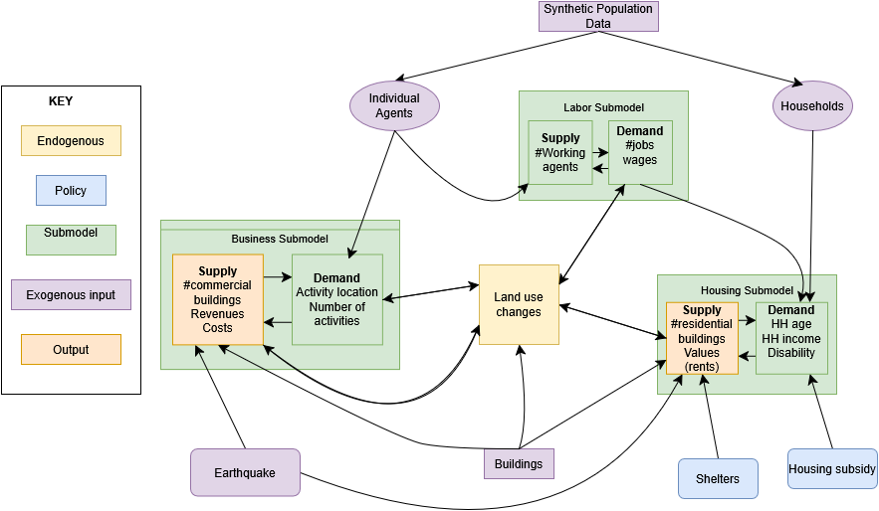
Figure 1. Conceptual Model

This study leaves the labor and business submodels unchanged, while adjusting the housing submodel to specifically analyze housing affordability and service accessibility outcomes, creating novel metrics and indices. The following sections describe in more detail the three submodels and proposed adjustments. Table 1 includes model entities, characteristics, and values and Table 2 includes parameters relevant to proposed changes. Specification of parameters for all submodels can be found in Grinberger et al. 2025.
Table 1. Model entities, characteristics, and values
Entity | Characteristic | Values
Household | Size (agents) | 1-8
Household | Children (agents) | 0-5
Household | Car ownership (# cars) | 0, 1, 2
Household | Income (NIS/month) | 0 to infinity
Household | Asset | Asset ID
Household | Elderly | 0 or 1, based on presence of 2 or more elderly agents
Household | Disabled | 0 or 1, based on presence of 1 or more disabled agents
Agent | Age (years) | 0-99
Agent | Age group | Child (ages 0-17), Adult (ages 18-64), Elderly (ages 65+)
Agent | Disability | Disabled / non-disabled
Agent | Employment status | Not participating in the workforce, unemployed, employed
Agent | Socio-economic decile | 1-10
Agent | Income (NIS/month) | 0 to infinity
Agent | Workplace building | Building ID
Agent | Household | Household ID
Assets | Building | Building ID
Assets | Area (sqm) | 0 to infinity
Assets | Value (NIS) | 0 to infinity
Assets | Rent (NIS/month) | 0 to infinity
Building | Land use | Empty, residential, commercial, industrial, public
Building | Statistical area | Statistical area ID
Building | Settlement | Settlement ID
Building | X,Y coordinates | 0 to infinity
Building | Floors | 1-20
Building | Value per sqm (NIS) | 0 to infinity
Building | Floorspace (sqm) | 0 to infinity
Job | Building | Building ID
Job | Occupation status | Unoccupied / occupied
Job | Salary (NIS) | 0 to infinity

Housing Model
Demand
Housing market dynamics include demand and supply, households being the demand and assets being the supply. In baseline simulations, every “day” each household makes a decision to either relocate or not, based on a probability derived from in/out migration flows for each census tract (Table 2). This follows three decisions - either to relocate within the same neighborhood, to relocate within the city, or to go to another city (i.e. leave the simulation world). Households typically will try to find a suitable asset first within their neighborhood and then move further if they are unable to find a suitable asset. If a household is moving within the neighborhood, a random unoccupied asset is chosen that is affordable for them based on their willingness to pay (this is set as a model parameter, equal to ⅓ of the household income based on a standard heuristic, Table 2).
Table 2. Parameters and sources
Parameters | Values | Source | Comments
Migration probabilities (intra-neighborhood, intra-settlement, other settlement) | Defined per SA | 2022 census data on migration volumes | Migration volumes are divided by total population size at the beginning of the year and by 365 to produce daily migration probabilities
im | Defined per SA | 2022 census data on migration volumes | Defined by the ratio between in-migration and out-migration volumes
Willingness to pay (wtp) | 1/3 | Author determined | A common heuristic defines that households should not spend more than a third of their income on housing
ω_{d} | 0.5 | Author determined | To be set so that commuting distance and social similarity have the same weight in neighborhood score
 | NA | Author determined | To be set to put more weight onto service levels for elderly and disabled households in neighborhood score
Preference threshold for household relocation | NA | Author determined | To be set through sensitivity tests to prevent excessive out migration or intra city migration
tp | 12 | Author determined | Equal to 12 months, transforming the housing prices into monthly rents
Business profitability thresholds | NA | Author determined | To be set through sensitivity tests to prevent over-conversion of residential buildings
Reduction in moving parameter | NA |  | To be set through sensitivity tests to reduce the probability of relocating for vulnerable households
, weight for subsidy calculation | NA |  | To be set through sensitivity tests to increase subsidy amount for vulnerable households
Jobs per m² parameters | NA | Calculation | The total number of jobs per industries associated with each land-use, as per 2022 census data, divided by the total floorspace volume for buildings of that land-use, according to the SoI buildings geodata layer
μ_{V}, σ_{V} | Varies | Calculation | Calculated at the beginning of the simulation based on agent data. μ_{v} changes throughout the simulation

For households that are not able to find a suitable asset in their current neighborhood, the process for choosing a new residency is as follows. A preference score for each household is calculated based on their previous residency, asset a, using the average commuting distance for the household (if members are employed) and the similarity of age and income of that household to the rest of the neighborhood n (equation 1). A corresponding score for each potential neighborhood is then calculated. The spatial unit for households preference scores is their previous asset a, while the potential neighborhood scores use the neighborhood n as the spatial unit.
(1)
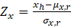 (2)

where:
NS_{n,h} is the score of neighborhood n for household h, (or HP_{a,h} for calculating initial household preference score based on asset a for household h)
ω_{d} is a weight parameter,
I(|w_{h}|>0) is a binary indicator which equals 1 if any of h’s members are employed, 0 otherwise,
is the average commuting distance of h’s members from n to their workplaces,
d_{n,n1} is the distance between two spatial units n and n1, where N is the set of all spatial units
P(x) is the standard normal density value for x,
Z_{age}, Z_{inc} are the standardized values (see eq. 2) for age and income, respectively,
x_{h} is the value of characteristic x of household h (average age group when x=age_g, total income when x=inc)
μ_{x,r} is the mean value of x within region r,
σ_{x,r} is the standard deviation value of x within region r.
For each potential neighborhood where the score is below the preference threshold of the household (Table 2), all affordable and unoccupied assets are considered and one is chosen randomly, including potential assets in empty buildings. If no available neighborhood is within the household’s preference threshold, the household is marked as unable to relocate and is removed from the system along with all its members, and their previous asset becomes vacant.
The model also simulates in-migration, whereby new households move to the simulated city based on multiplying the number of unoccupied assets in each neighborhood by a randomly drawn number from a normal distribution of a neighborhood parameter, ~N(im,im/3) (Table 2). The attributes of new households are duplicates of a randomly chosen household in the city. Households that migrate are assigned an asset that is unoccupied and affordable for the household. If there is no such asset, the household does not migrate. Unoccupied jobs are randomly assigned to employed household agents and routines are generated for each agent.
To better understand differential welfare impacts, this work introduces changes to the housing choice procedure. The preference score for disabled (households with at least 1 disabled member) and/or elderly households (minimum two members older than 65) will include an additional probability downscaling parameter and also consider service ratios as another component with its own weight parameter (equation 3). Additionally, these households will always first try to relocate within their neighborhood. This reflects the tendency to stay in place and the preference for proximity to services. New parameter weights will be determined through sensitivity tests (Table 2).
+
(3)
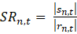 (4)
where:
NS_{n,h} is the score of neighborhood n for household h, (or HP_{a,h} for calculating initial household preference score based on asset a for household h)
is a binary indicator which equals 1 if any of h’s members are disabled or elderly, 0 otherwise,
is a weight parameter,
is the service ratio for neighborhood n at time t
is the number of service buildings (commercial or public) in neighborhood n at time t
is the number of residential buildings in neighborhood n at time t
The remaining process for neighborhood comparison using the preference threshold will remain the same, and all unoccupied and affordable assets from relevant neighborhoods will be considered. One will be picked at random and the household will relocate there.
Supply
The supply for the residential market is the single housing asset, including potential assets in empty buildings. The rental price of an asset is calculated in 3 steps. First, the average housing value for the neighborhood is calculated by multiplying the previous average housing value by the rate of change of the number of households, residential assets, and service buildings (commercial and public) between the previous and current time period (equation 5). After this, the building value is calculated by multiplying the average housing value in the neighborhood, the floorspace of the building, and the change in service buildings in a 400 meter radius from the previous to current time period (equation 6). Lastly, the monthly rent is calculated by multiplying the median household income, the willingness to pay parameter ( ⅓, Table 2) and a standardized relative value of the asset (in relation to the average and standard deviation of all asset values) (equation 7).
$V_{n,t}=V_{n,t-1}*\left(1+ln\left(\frac{{\left|H_{n,t}\right|}/{\left|h_{n,t-1}\right|}+{\left|r_{n,t-1}\right|}/{\left|r_{n,t}\right|}+{\left|s_{n,t}\right|}/{\left|s_{n,t-1}\right|}}{3}\right)\right)$ (5)
$V_{b,t}={fs}_{b}*V_{n,t}*\frac{\left|s_{r,t}\right|}{\left|s_{r,t-1}\right|}$ (6)
$R_{a,t}=\tilde{inc}*wtp*\left(1+\frac{V_{b,t}*{{fs}_{a}}/{{fs}_{b}}-μ_{V}}{σ_{V}*tp}\right)$ (7)

where:
a, b, and n represent asset a located within building b which belongs to neighborhood n,
V_{n,t} is average housing value in neighborhood n at time t,
|h_{n,t}|, |r_{n,t}|, and |s_{n,t}| are respectively the number of households, residential assets, and service (commercial and public) buildings in neighborhood n at time t,
V_{b,t} is the total value of building b at time t,
fs_{b}, fs_{a} are respectively the floorspace volumes of building b and asset a,
r is the set of buildings within a given radius from building b,
is the median income across all households,
wtp is the willingness to pay for housing parameter,
μ_{V}, σ_{V} are the mean asset value and the standard deviation of asset values, respectively,
tp is a time normalizing parameter.
Labor Sub-model
This section describes the labor force submodel. As there will be no adjustments in this study, fully specified submodel equations can be found in prior work (Grinberger et al., 2025). Demand is derived from jobs allocated to businesses, which reside in buildings. The number of possible jobs per building is based on floorspace and the land use of the building–commercial, public, or industrial–which can all employ agents. Initial wages for jobs are drawn from a normal distribution based on real values from city-level census data. After this initialization, wages change dynamically based on the amount of occupied jobs and the available real estate. This influences the average wage within the simulations and potential wages. In addition, a randomly selected group of occupied jobs changes its wages.
The supply for the labor market is individual agents. If the agent is employed, they do not initiate a job search. For unemployed agents, preferences are based on their previous workplace or drawn randomly if they were not previously employed. A score for each job is calculated based on the distance between the agent’s home and the potential workplace, and their previous income. If there are open jobs that meet the preference of the agent, one is randomly assigned. If there are no jobs that meet the agent’s preference, the agent remains unemployed and continues the job search in the subsequent iteration of the simulation.
Business Submodel
This section describes the business sector submodel. Similar to the labor module, no adjustments are made for this study and fully detailed specifications of equations can be found in previous work (Grinberger et al., 2025). Demand comes from the aggregation of visits to buildings made by agents in their daily activity routine. Agent routines are the set of buildings they visit each day, based on their attributes and preferences. First, the length of the visiting sequence is determined by the agent’s employment status, age, car ownership, and disability status. If an agent is employed, the first location in the sequence after their residence is the agent’s workplace. After calculating an activity length, scores are given to each neighborhood, based on the distance to the agent’s home, the same individual agent attributes used for the activity length, and the vibrancy of the neighborhood. This vibrancy measure is calculated through building scores, based on the amount of public, industrial, or commercial buildings, the number of households in the neighborhood, and the building vacancy rate. Once a neighborhood is chosen, individual buildings are randomly chosen for an agent to visit based on these scores.
The supply for the business sector is based on businesses appearing or leaving buildings, or adding or decreasing employees. These dynamics are defined by land use change rules, where a building’s land use may change from residential or empty to commercial, or commercial to empty, based on potential profitability. While revenues are not measured directly in the model, the visits to buildings in agent routines are used as a proxy for business activity, and are included in potential profitability calculations. Businesses may open in residential or empty buildings based on this potential profitability, changing the land use to commercial if the profitability meets a certain threshold (Table 2). Every day in the simulation, a business may decide to increase jobs or reduce the number of jobs. Profitability scores are calculated for every business; if the score for an existing business is below a certain threshold (Table 2), the business removes a job and the agent becomes unemployed, while if the score is above the threshold, the business adds a job. If the number of jobs decreases enough, the business is closed and the building land use becomes empty.
Earthquake and Recovery Module
The model simulates an earthquake through a one-time shock that damages buildings. Building damage assessments come from the Israel Home Front Command and denote the number of damaged buildings in Tel Aviv-Yafo based on three different earthquake epicenters within Israel. For this study, the most severe damage assessment will be used. and while specific buildings will be randomly damaged from the earthquake, total damaged buildings will match damage assessment predictions. If a building is selected to be damaged, the building will shed its land use, becoming empty and temporarily removed from potential land use changes. If the building was industrial, public, or commercial, the workplace will be removed and all employed agents will become unemployed. If the building was residential, agents would become displaced and assigned to shelters. In the next “tick” of the simulation, agents will be able to relocate to new housing or stay in the shelter. The earthquake also triggers a recovery module, where buildings are reconstructed over time. Each day after the earthquake, a percentage of buildings will be “recovered”. While reconstruction varies and is dependent on various institutional and economic factors such as insurance, labor and materials, and potential policy interventions, the focus of this study is not how reconstruction occurs or is improved - therefore recovery will occur at a standard rate reflecting a historical average of building reconstruction rates after earthquakes. After a building is recovered, it becomes part of the building stock with an empty land use. From here, changes in the building stock and population flows will shift system trends.
Policies
The goal of policies in this study will be to improve housing affordability outcomes for elderly and disabled populations and to maintain their access to services. Policies are modeled as ideal-type interventions designed to evaluate their theoretical potential to mitigate post-disaster welfare losses, rather than as implementation-ready policy prescriptions. In addressing housing affordability, housing subsidies will be allocated for all displaced households, allowing them a higher budget towards housing and widening the number of assets within their budget. However, the amount of the subsidy will be determined based on the household’s income, the number of individuals, and if the household is delineated as elderly or disabled, as shown in equation 8. The subsidy calculation will ensure that higher subsidies are given towards senior and disabled households using an additional weighted parameter to be set through sensitivity testing (table 2).
$S_{h}=f\left(I_{h}, N_{h}\right) ×(1+γ(I\left(\left|{ED}_{h}\right|>0\right))$ (8)
where:
$S_{h}$ is the subsidy amount for household h,
$f\left(I_{h}, N_{h}\right)$ is a function of $I_{h}$, income for household h, and $N_{h}$, size of household h
$γ$ is a weight parameter,
$(I\left(\left|{ED}_{h}\right|>0\right)$ is a binary indicator which equals 1 if any of h’s members are disabled or elderly, 0 otherwise

In addressing service accessibility, locating shelters near commercial areas is one policy method. For each neighborhood, the land use of the public building closest to the largest commercial building in the neighborhood will become a shelter. All displaced households will be assigned temporary residence in the shelter within their neighborhood (or within a 400m radius). Households may choose to leave the shelter and find alternate residency or they may choose to stay in the shelter. Once 50% of buildings are recovered, the shelter will become a public building again and households must relocate. If they cannot relocate within the city, they leave the simulation world.
Analytical Framework and Metrics
The analysis will be structured around the comparison of the following scenarios: baseline without any shock, shock and no interventions, shock and subsidy intervention, shock and sheltering intervention, and shock and both interventions. The following metrics will be assessed in all scenarios:
- Availability of affordable housing assets
Housing affordability is assessed by computing the average number of affordable housing assets available to vulnerable households versus non vulnerable households. In the shock scenarios, differentiation will be made for displaced households for vulnerable and non-vulnerable households. Changes from scenario to scenario will be compared within and between subgroups of the population. This metric is evaluated at the city level.
- Housing costs
Average housing costs are measured between scenarios for all vulnerable households, and in the shock scenario, differentiating between vulnerable households that relocate, and comparing them to changes experienced by non-vulnerable households. These changes are evaluated at both the neighborhood and city levels.
- Service accessibility
Access to essential services is assessed using the average service ratio for vulnerable households versus non vulnerable households. In the shock scenarios, differentiation will be made for displaced households for vulnerable and non-vulnerable households, assessing whether relocation results in improved or diminished access to services. Changes from scenario to scenario will be compared within and between subgroups of the population. This metric is evaluated at the city level and neighborhood level.
Specifically in the shock scenarios, the following metrics will be employed:
- Relocation outside the pre-disaster neighborhood
Among all displaced households, the share of vulnerable households that relocate outside their most recent neighborhood is measured and compared to non-vulnerable households, differentiating between intra-city migration and migration out of the simulation city. This metric is calculated at both the citywide level and across neighborhoods to capture spatial variation.
- Impact of sheltering location on service accessibility
The effect of sheltering location is evaluated by comparing changes in service ratios for displaced vulnerable households between earthquake scenarios with and without sheltering interventions. This is calculated at the neighborhood and city levels.
- Impact of housing subsidies on affordability and relocation outcomes
The effect of housing subsidies is assessed by examining changes in the average number of affordable housing assets and relocation rates among displaced vulnerable households relative to the no-intervention scenario. These outcomes are evaluated at both the neighborhood and city levels.
Case Study, Initialization and Data
Individual agent and household attributes and their initial residential locations are derived from a synthetic data generating algorithm. This algorithm uses census-tract level data from the Central Bureau of Statistics to generate a synthetic population of agents allocated to buildings, which equate to census tract demographics. A full specification of this procedure can be found in prior work (Grinberger et al., 2017). This procedure is done once and the same agent population is utilized throughout all simulations. Census data also generates certain model parameters such as commuting and migration probabilities per census tract. Buildings and their locations are based on data from the National Survey of Israel. Real estate transaction data from the Tax Authority of Israel provide the floorspace, number of floors per building, and initial building values. Initial land uses of buildings are allocated based on data from the Planning Authority of Israel.
This study uses Tel Aviv-Yafo (TLV) as the urban environment in which an earthquake occurs. TLV is the second most populated city in Israel, with approximately 500,000 residents, while the TLV metropolitan area is the largest in the country with 3.9 million people (Central Bureau of Statistics, n.d.; Center for Economic and Social Research of Tel-Aviv-Yafo Municipality, n.d.). 15.1% of the population is 65 or older with 28.5% of that population being disabled, while in general 8% of the city is disabled (Central Bureau of Statistics, n.d.). TLV serves as the country’s economic center with 11% of all employees in the country working in TLV (Center for Economic and Social Research of Tel-Aviv-Yafo Municipality, n.d.) While Tel Aviv was founded in 1909 and Yafo is over 3000 years old, the areas were united into one municipal jurisdiction in 1950. This jurisdiction covers an area of 52 square km with 163 statistical areas (Central Bureau of Statistics, n.d.). To balance computation time and sample size, only central statistical areas will be included in the study.
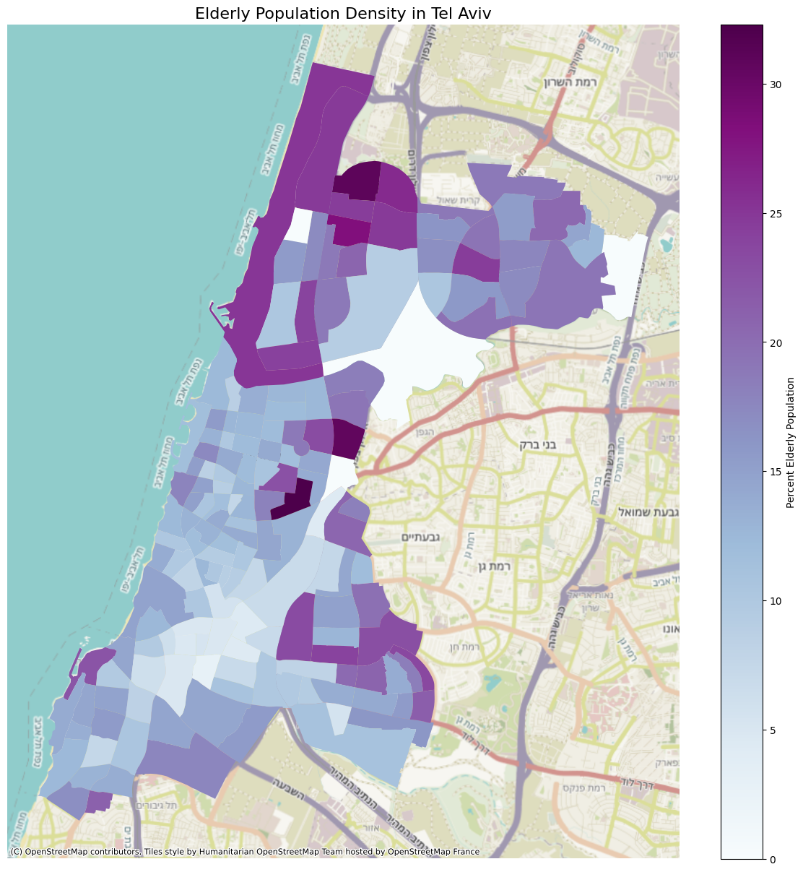
Figure 2. Elderly Population Density in TLV
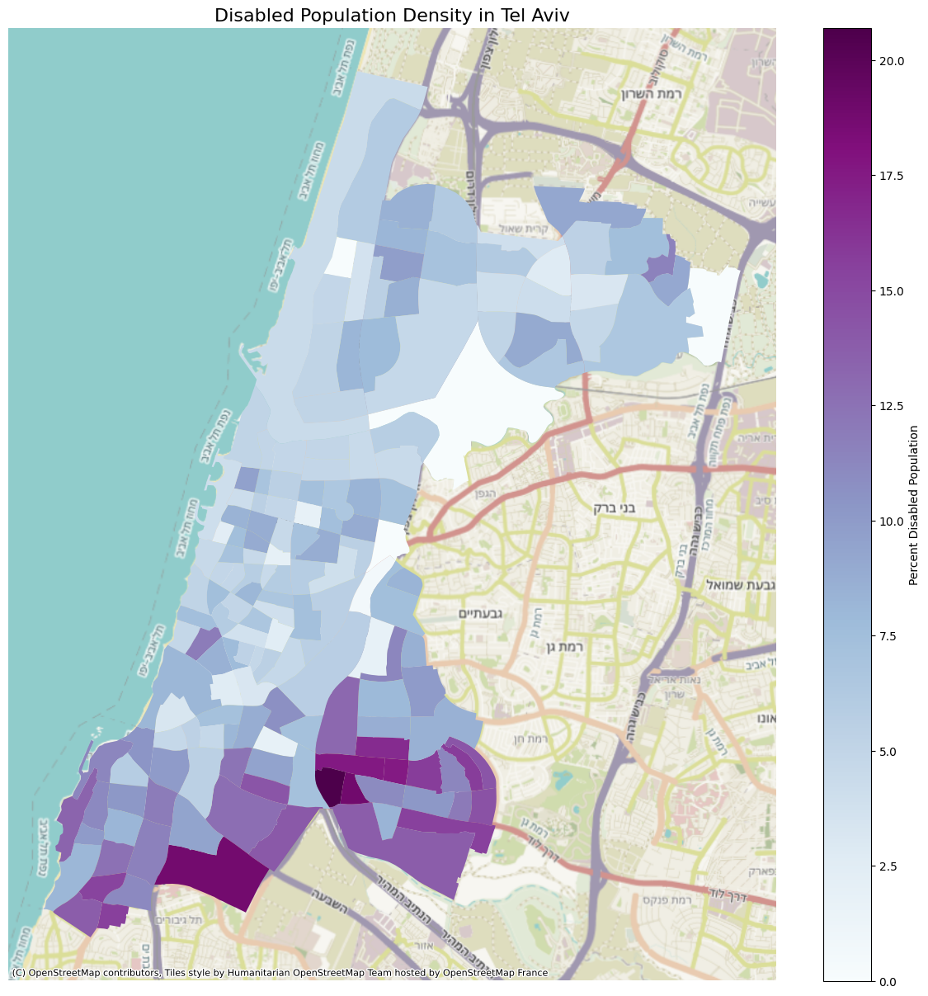
Figure 3. Disabled Population Density in TLV
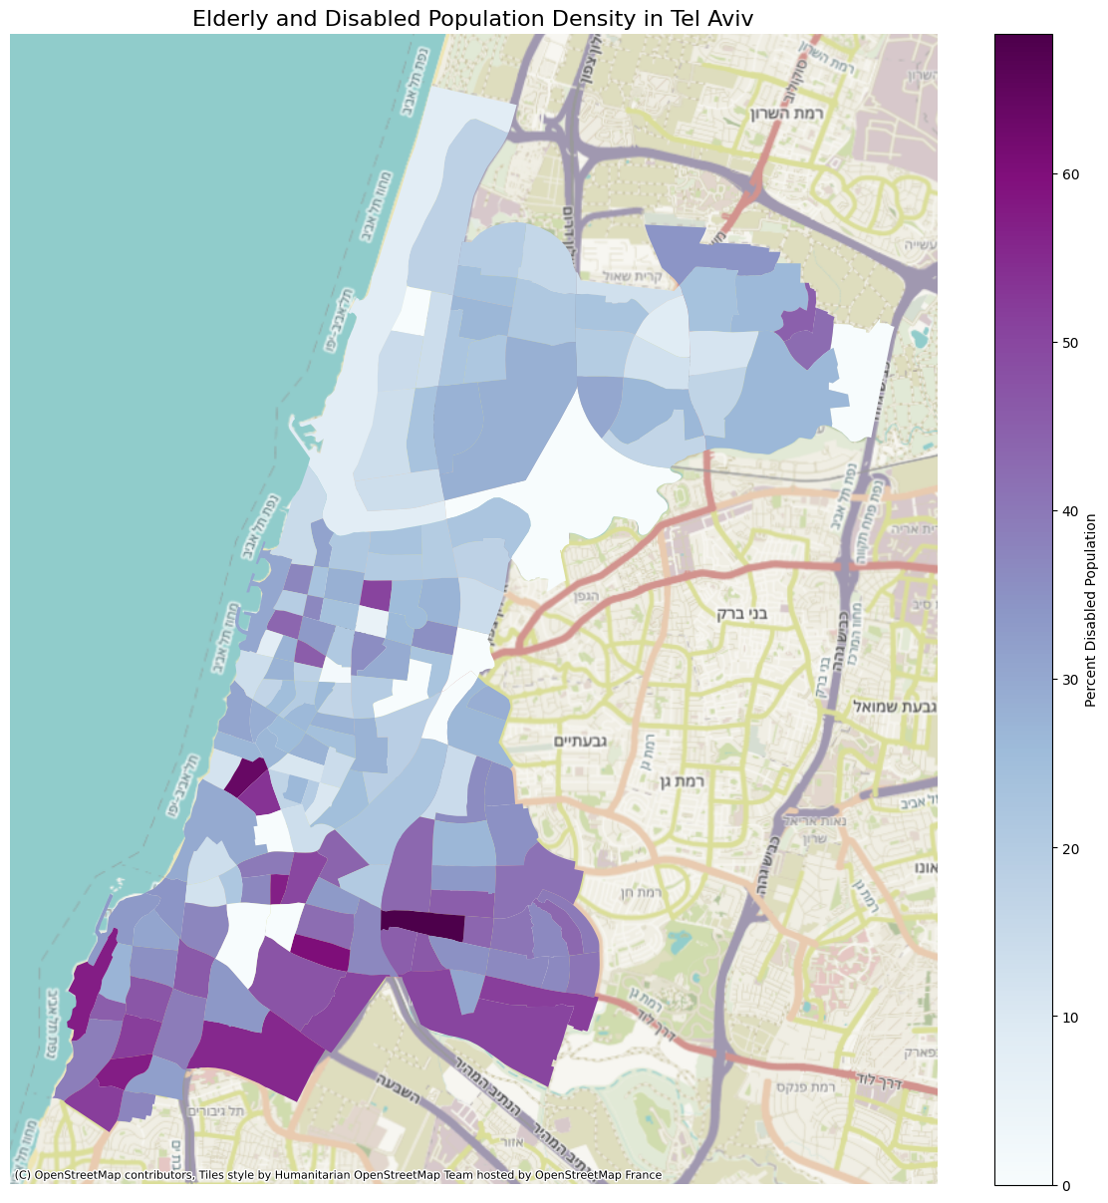
Figure 4. Elderly and Disabled Population Density in TLV
Israel lies along the Dead Sea Transform system, where strong earthquakes have historically occurred and a severe earthquake in the near future is predicted (Lu et al., 2020; Zohar et al., 2016). Israel is both physically and institutionally unprepared for such a disaster, with the rate of seismic retrofitting lagging behind goals and a lack of centralized power to coordinate mitigation and recovery (Shamai & Hananel, 2021; Shmueli et al., 2019). Immediate-response procedures go through multiple government ministries and municipal authorities, with local councils handling implementation (Shmueli et al., 2019). This makes it even more crucial to understand on the urban-level the potential welfare outcomes and the policy structures to which they can be addressed.
The area of current-day TLV has suffered severe damage from earthquakes on at least four occasions from 363 BCE to 1927 CE and has been damaged more than surrounding localities (Zohar et al., 2016). Due to this risk, it is vital to understand the impacts of an earthquake, particularly on vulnerable populations such as the elderly and disabled as they have a greater chance of harm. This study aims to support disaster recovery policy research to help various levels of government act effectively after disasters. Housing and service disruptions will harm entire communities; however, disaster impacts will likely be unequal among the population.
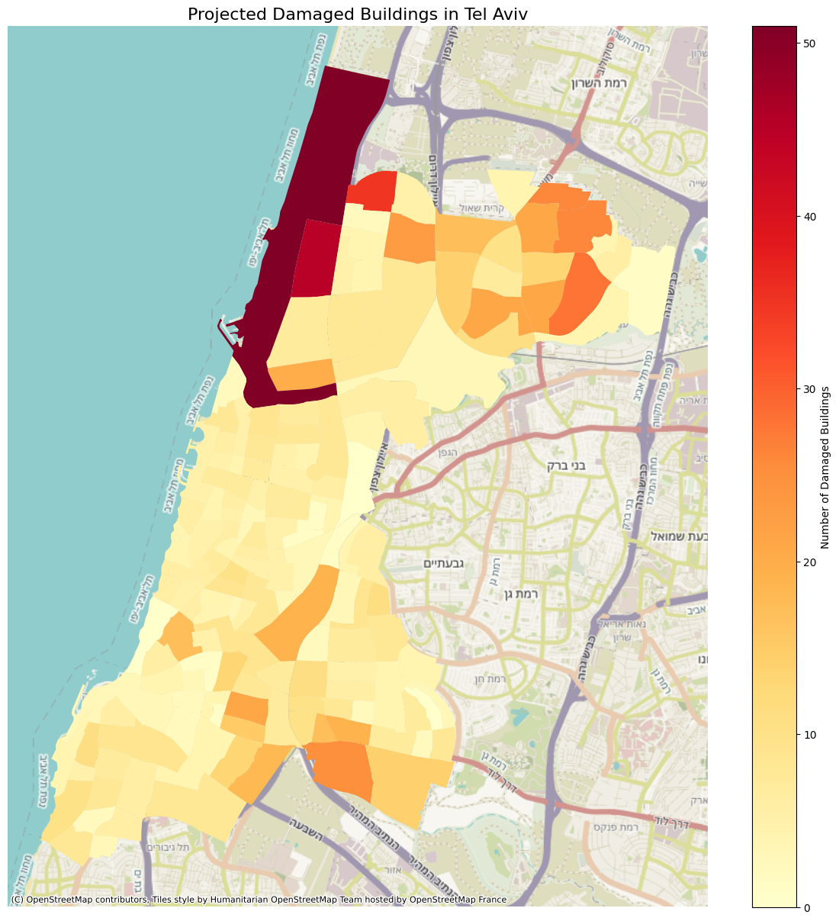
Figure 5. Damage Projections in TLV
Expected Contribution
This research aims to expand knowledge regarding differential vulnerability and resilience to disasters by analyzing the economic conditions faced by elderly and disabled populations in the aftermath of an earthquake. Housing affordability and service accessibility are a tangible way to measure welfare after a major shock and are dimensions not considered in previous urban disaster ABMs. This provides practical utility through the introduction and assessment of policies addressing the `pressures vulnerable households experience as they adjust to a dramatically altered environment.
Methodological contributions include integrating differential relocation behavior based on certain household characteristics and using precise damage estimates grounded in HAZUS damage modeling, adding elements of realism previously absent in this model. Empirically, this research will contribute to social vulnerability discourse by investigating the proportionality of novel welfare impacts of affordability and service accessibility on elderly and disabled populations, informing the extent and dimensions to which local authorities and governments can prioritize recovery for these groups. Contributions to policy research include evaluating the effectiveness of mechanisms that address the specific needs of senior and disabled groups. Examining how discriminatory subsidies based on age and disability status affect welfare outcomes can better inform aid responses by policymakers and potential methods to address systemic exclusion and any disproportionate harm. Exploring the impact of sheltering locations on service accessibility can help inform additional considerations on which buildings should become shelters and their sheltering capacity. Ultimately, this work contributes to understanding how social vulnerability interacts with disaster-related housing and commercial disruptions, and to evaluate potential interventions.

References
An, B., Moody, J., Drew, R., Jakabovics, A., Orlando, A. W., & Rodnyansky, S. (2024). Community Development Block Grants Disaster Recovery, Rental Requirements, and Rental Market Impacts. Cityscape, 26(3), 137–156. https://www.jstor.org/stable/48799253
Beard, J. R., Blaney, S., Cerda, M., Frye, V., Lovasi, G. S., Ompad, D., Rundle, A., & Vlahov, D. (2009). Neighborhood characteristics and disability in older adults. The Journals of Gerontology Series B, 64B(2), 252–257. https://doi.org/10.1093/geronb/gbn018
Beron, K. J., Murdoch, J. C., Thayer, M. A., & Vijverberg, Wim. P. M. (1997). An Analysis of the Housing Market before and after the 1989 Loma Prieta Earthquake. Land Economics, 73(1), 101–113. https://www.jstor.org/stable/3147080
Best, K. B., He, Q., Reilly, A., Tran, N., & Niemeier, D. (2023). Rent affordability after hurricanes: Longitudinal evidence from US coastal states. Risk Analysis, 45(11), 3439–3451. https://doi.org/10.1111/risa.14224
Bhattacharya, Y., & Kato, T. (2021). Development of an Agent-Based Model on the Decision-Making of dislocated people after Disasters. In The urban book series (pp. 387–406). https://doi.org/10.1007/978-3-030-76059-5_20
Bolin, R., & Stanford, L. (1998). The Northridge Earthquake: Community‐based approaches to unmet recovery needs. Disasters, 22(1), 21–38. https://doi.org/10.1111/1467-7717.00073
Booth, M. L., Owen, N., Bauman, A., Clavisi, O., & Leslie, E. (2000). Social–Cognitive and Perceived Environment Influences Associated with Physical Activity in Older Australians. Preventive Medicine, 31(1), 15–22. https://doi.org/10.1006/pmed.2000.0661
Brennan, M., Srini, T., & Steil, J. (2024). High and dry: Rental markets after flooding disasters. Urban Affairs Review, 60(6), 1806–1838. https://doi.org/10.1177/10780874241243355
Brown, J. B., McWilliam, C. L., & Mai, V. (1997). Barriers and facilitators to seniors’ independence. Perceptions of seniors, caregivers, and health care providers. Can Fam Physician, 43, 469–475. https://pmc.ncbi.nlm.nih.gov/articles/PMC2255330/
Brown, L. M., & Frahm, K. A. (2015). The Impact of Disasters: Implications for the Well-Being of Older Adults. In Handbook of Aging and the Social Sciences (8, pp. 357–374). https://doi.org/10.1016/b978-0-12-417235-7.00017-2
Burton, H., Kang, H., Miles, S., Nejat, A., & Yi, Z. (2019). A framework and case study for integrating household decision-making into post-earthquake recovery models. International Journal of Disaster Risk Reduction, 37, 101167. https://doi.org/10.1016/j.ijdrr.2019.101167
Casas, I. (2007). Social Exclusion and the Disabled: an Accessibility approach∗. The Professional Geographer, 59(4), 463–477. https://doi.org/10.1111/j.1467-9272.2007.00635.x
Center for Economic and Social Research of Tel-Aviv-Yafo Municipality. (n.d.). City in Numbers. Tel Aviv Yafo Municipality. https://www.tel-aviv.gov.il/en/abouttheCity/Pages/CityinNumbers.aspx
Central Bureau of Statistics. (n.d.). Population Census 2022 [Dataset]. https://www.cbs.gov.il
Chandra‐Putra, H., & Andrews, C. J. (2019). An integrated model of real estate market responses to coastal flooding. Journal of Industrial Ecology, 24(2), 424–435. https://doi.org/10.1111/jiec.12957
Chang, S. E., & Rose, A. Z. (2012). Towards a Theory of Economic Recovery from Disasters. International Journal of Mass Emergencies & Disasters, 30(2), 171–181. https://doi.org/10.1177/028072701203000202
Chen, L. (2012). Agent-based modeling in urban and architectural research: A brief literature review. Frontiers of Architectural Research, 1(2), 166–177. https://doi.org/10.1016/j.foar.2012.03.003
Clarke, P., & George, L. K. (2005). The role of the built environment in the disablement process. American Journal of Public Health, 95(11), 1933–1939. https://doi.org/10.2105/ajph.2004.054494
Comerio, M. C. (2014). Disaster Recovery and Community Renewal: Housing Approaches. Cityscape, 16(2), 51–68. https://www.jstor.org/stable/26326883
Contreras, D., Blaschke, T., & Hodgson, M. E. (2017). Lack of spatial resilience in a recovery process: Case L’Aquila, Italy. Technological Forecasting and Social Change, 121, 76–88. https://doi.org/10.1016/j.techfore.2016.12.010
Costa, R., Haukaas, T., & Chang, S. E. (2020). Agent-based model for post-earthquake housing recovery. Earthquake Spectra, 37(1), 46–72. https://doi.org/10.1177/8755293020944175
Crooks, A., Heppenstall, A., Malleson, N., & Manley, E. (2021). Agent-Based Modeling and the City: A Gallery of applications. In The urban book series (pp. 885–910). https://doi.org/10.1007/978-981-15-8983-6_46
Cutter, S. L., Boruff, B. J., & Shirley, W. L. (2003). Social vulnerability to environmental hazards*. Social Science Quarterly, 84(2), 242–261. https://doi.org/10.1111/1540-6237.8402002
Danielewicz, A. L., Anjos, J. C. D., Bastos, J. L., Boing, A. C., & Boing, A. F. (2017). Association between socioeconomic and physical/built neighborhoods and disability: A systematic review. Preventive Medicine, 99, 118–127. https://doi.org/10.1016/j.ypmed.2017.02.014
De Almeida Holanda, C. M., De Andrade, F. L. J. P., Bezerra, M. A., Da Silva Nascimento, J. P., Da Fonseca Neves, R., Alves, S. B., & Ribeiro, K. S. Q. S. (2015). Support networks and people with physical disabilities: social inclusion and access to health services. Ciência & Saúde Coletiva, 20(1), 175–184. https://doi.org/10.1590/1413-81232014201.19012013
Enderami, S. A., Sutley, E., Helgeson, J., Dueñas-Osorio, L., Watson, M., & Van De Lindt, J. W. (2024). Measuring post-disaster accessibility to essential goods and services: proximity, availability, adequacy, and acceptability dimensions. Journal of Infrastructure Preservation and Resilience, 5(1). https://doi.org/10.1186/s43065-024-00104-0
Fatemi, F., Ardalan, A., Aguirre, B., Mansouri, N., & Mohammadfam, I. (2016). Social vulnerability indicators in disasters: Findings from a systematic review. International Journal of Disaster Risk Reduction, 22, 219–227. https://doi.org/10.1016/j.ijdrr.2016.09.006
Felsenstein, D., & Lichter, M. (2013). Social and economic vulnerability of coastal communities to sea-level rise and extreme flooding. Natural Hazards, 71(1), 463–491. https://doi.org/10.1007/s11069-013-0929-y
Finucane, M. L., Acosta, J., Wicker, A., & Whipkey, K. (2020). Short-Term solutions to a Long-Term challenge: rethinking disaster recovery planning to reduce vulnerabilities and inequities. International Journal of Environmental Research and Public Health, 17(2), 482. https://doi.org/10.3390/ijerph17020482
Fothergill, A., & Peek, L. A. (2004). Poverty and Disasters in the United States: A review of recent sociological findings. Natural Hazards, 32(1), 89–110. https://doi.org/10.1023/b:nhaz.0000026792.76181.d9
Gilbert, S. W. (2010). Disaster Resilience: A Guide to the Literature. National Institute of Standards and Technology. https://tsapps.nist.gov/publication/get_pdf.cfm?pub_id=906887
Grinberger, A., & Felsenstein, D. (2016). Dynamic agent based simulation of welfare effects of urban disasters. Computers Environment and Urban Systems, 59, 129–141. https://doi.org/10.1016/j.compenvurbsys.2016.06.005
Grinberger, A. Y., & Felsenstein, D. (2014). Bouncing back or bouncing forward? Simulating urban resilience. Proceedings of the Institution of Civil Engineers - Urban Design and Planning, 167(3), 115–124. https://doi.org/10.1680/udap.13.00021
Grinberger, A. Y., Felsenstein, D., & Pinkhasov, R. (2025). Simulating the Effect of Government Assistance to the Business Sector in the Wake of Covid-19.
Grinberger, A. Y., Lichter, M., & Felsenstein, D. (2017). Dynamic agent based simulation of an urban disaster using synthetic big data. In Springer Geography (pp. 349–382). https://doi.org/10.1007/978-3-319-40902-3_20
Harwood, K. W. (2025). The impact of natural disasters on rental markets: heterogeneous effects, rental subsidies and equity in disaster recovery. SSRN Electronic Journal. https://doi.org/10.2139/ssrn.5131720
Hemingway, L., & Priestley, M. (2006). Natural hazards, human vulnerability and disabling societies: a disaster for disabled people? Review of Disability Studies: An International Journal. https://www.rdsjournal.org/index.php/journal/article/view/337
Ho, P., Kroll, T., Kehn, M., Anderson, P., & Pearson, K. M. (2007). Health and Housing among Low-Income Adults with Physical Disabilities. Journal of Health Care for the Poor and Underserved, 18(4), 902–915. https://doi.org/10.1353/hpu.2007.0098
Jenkins, J. L., Levy, M., Rutkow, L., & Spira, A. (2014). Variables Associated with Effects on Morbidity in Older Adults Following Disasters. PLoS Currents, 6. https://doi.org/10.1371/currents.dis.0fe970aa16d51cde6a962b7a732e494a
Kim, K., Kang, J.-Y., & Hwang, C. (2025). Identifying Indicators Contributing to the Social Vulnerability Index via a Scoping Review. Land, 14(2), 263. https://doi.org/10.3390/land14020263
Kroll, C. A., Landis, J. D., Shen, Q., & Stryker, S. (1991). Economic Impacts of the Loma Prieta earthquake: A focus on small business. UC Berkeley: Fisher Center for Real Estate and Urban Economics. https://escholarship.org/uc/item/8kz940rs
Lee, J. Y., & Van Zandt, S. (2018). Housing Tenure and Social Vulnerability to Disasters: A Review of the evidence. Journal of Planning Literature, 34(2), 156–170. https://doi.org/10.1177/0885412218812080
Lempert, R. (2002). Agent-based modeling as organizational and public policy simulators. Proceedings of the National Academy of Sciences, 99(suppl_3), 7195–7196. https://doi.org/10.1073/pnas.072079399
Levasseur, M., Généreux, M., Bruneau, J., Vanasse, A., Chabot, É., Beaulac, C., & Bédard, M. (2015). Importance of proximity to resources, social support, transportation and neighborhood security for mobility and social participation in older adults: results from a scoping study. BMC Public Health, 15(1), 503. https://doi.org/10.1186/s12889-015-1824-0
Levine, J. N., Esnard, A., & Sapat, A. (2007). Population displacement and housing dilemmas due to catastrophic disasters. Journal of Planning Literature, 22(1), 3–15. https://doi.org/10.1177/0885412207302277
Logan, T. M., & Guikema, S. D. (2020). Reframing resilience: equitable access to essential services. Risk Analysis, 40(8), 1538–1553. https://doi.org/10.1111/risa.13492
Lu, Y., Wetzler, N., Waldmann, N., Agnon, A., Biasi, G. P., & Marco, S. (2020). A 220,000-year-long continuous large earthquake record on a slow-slipping plate boundary. Science Advances, 6(48). https://doi.org/10.1126/sciadv.aba4170
Mah, J. C., Penwarden, J. L., Pott, H., Theou, O., & Andrew, M. K. (2023). Social vulnerability indices: a scoping review. BMC Public Health, 23(1), 1253. https://doi.org/10.1186/s12889-023-16097-6
Maltais, D. (2019). Elderly People with Disabilities and Natural Disasters: Vulnerability of seniors and post trauma. Gerontology & Geriatric Medicine, 5(4), 1–7. https://doi.org/10.24966/ggm-8662/100041
McIntosh, J. (2013). The implications of post disaster recovery for affordable housing. In Approaches to Disaster Management - Examining the Implications of Hazards, Emergencies and Disasters. https://doi.org/10.5772/55273
Moradi, S., & Nejat, A. (2020). RECOVUS: an Agent-Based Model of Post-Disaster Household Recovery. Journal of Artificial Societies and Social Simulation, 23(4). https://doi.org/10.18564/jasss.4445
Nakashima, T., & Okada, S. (2018). Financial imbalances in regional disaster recovery following Earthquakes—Case Study concerning Housing-Cost expenditures in Japan. Sustainability, 10(9), 3225. https://doi.org/10.3390/su10093225
OECD. (2022). Disability, work and inclusion: Mainstreaming in All Policies and Practices. OECD Publishing. https://doi.org/10.1787/1eaa5e9c-en
OECD. (2025). Pensions at a Glance 2025: OECD and G20 Indicators. OECD Publishing. https://doi.org/10.1787/e40274c1-en
Paul, N., Galasso, C., & Baker, J. (2023). Household Displacement and Return in Disasters: A review. Natural Hazards Review, 25(1). https://doi.org/10.1061/nhrefo.nheng-1930
Peacock, W. G., Dash, N., Zhang, Y., & Van Zandt, S. (2017). Post-Disaster sheltering, temporary housing and permanent housing recovery. In Handbooks of sociology and social research (pp. 569–594). https://doi.org/10.1007/978-3-319-63254-4_27
Phillips, B. D. (1998). Sheltering and housing of low-income and minority groups in Santa Cruz County after the Loma Prieta earthquake. In The Lorna Prieta, California, Earthquake of October 17, 1989-Recovery, Mitigation, and Reconstruction (pp. 17–28). Department of the Interior, U.S. Geological Survey. https://pubs.usgs.gov/pp/pp1553/pp1553d/pp1553d.pdf#page=19
Quaill, J., Barker, R., & West, C. (2018). Experiences of individuals with physical disabilities in natural disasters: An integrative review. Australian Journal of Emergency Management, 33(3), 58–63. https://beta.informit.org/doi/10.3316/informit.793049280261310
Rahmah, E. M., & Hikmawati, I. (2025). Analysis of factors influencing the decision of the elderly in choosing a place of residence. Proceedings Series on Health & Medical Sciences, 6, 135–145. https://doi.org/10.30595/pshms.v6i.1417
Rapegno, N., & Ravaud, J. F. (2017). Disability, residential environment and social participation: factors influencing daily mobility of persons living in residential care facilities in two regions of France. BMC Health Services Research, 17(1), 683. https://doi.org/10.1186/s12913-017-2602-8
Roy, N., Dubé, R., Després, C., Freitas, A., & Légaré, F. (2018). Choosing between staying at home or moving: A systematic review of factors influencing housing decisions among frail older adults. PLoS ONE, 13(1), e0189266. https://doi.org/10.1371/journal.pone.0189266
Shamai, M., & Hananel, R. (2021). Urban Renewal or Earthquake Preparedness: Lessons from Israel’s National Master Plan for Earthquake Preparedness (TAMA 38). Cityscape, 23(2), 381–407. https://www.huduser.gov/portal/periodicals/cityscpe/vol23num2/ch20.pdf
Shmueli, D. F., Segal, E., Gal, M. B., Feitelson, E., & Reichman, A. (2019). Earthquake readiness in volatile regions: the case of Israel. Natural Hazards, 98, 405–423. https://doi.org/10.1007/s11069-019-03698-x
Stough, L. M., Sharp, A. N., Resch, J. A., Decker, C., & Wilker, N. (2015). Barriers to the long‐term recovery of individuals with disabilities following a disaster. Disasters, 40(3), 387–410. https://doi.org/10.1111/disa.12161
Swanson, T., & Guikema, S. (2023). Using mobile phone data to evaluate access to essential services following natural hazards. Risk Analysis, 44(4), 883–906. https://doi.org/10.1111/risa.14201
Tafti, M. T. (2015). Housing assistance distribution after disasters: does it enable affected households to recover? Environmental Hazards, 14(4), 361–377. https://doi.org/10.1080/17477891.2015.1080655
Tamura, K., Hayashi, H., & Kimura, R. (2006). Clarifying the Disaster Process of the Elderly in the Aspect of Social Welfare. Annuals of Disas. Prev. Res. Ins, 163–170. https://repository.kulib.kyoto-u.ac.jp/dspace/bitstream/2433/26684/1/a49c0p16.pdf
Tierney, K. J. (1997). Business impacts of the Northridge earthquake. Journal of Contingencies and Crisis Management, 5(2), 87–97. https://doi.org/10.1111/1468-5973.00040
Timar, L., Grimes, A., & Fabling, R. (2018). That sinking feeling: The changing price of urban disaster risk following an earthquake. International Journal of Disaster Risk Reduction, 31, 1326–1336. https://doi.org/10.1016/j.ijdrr.2018.01.026
Wasileski, G., Rodríguez, H., & Diaz, W. (2011). Business closure and relocation: a comparative analysis of the Loma Prieta earthquake and Hurricane Andrew. Disasters, 35(1), 102–129. https://doi.org/10.1111/j.1467-7717.2010.01195.x
Xue, J., Park, S., Mondal, W. U., Reia, S. M., Yao, T., & Ukkusuri, S., V. (2023). Supporting Post-disaster Recovery with Agent-based Modeling in Multilayer Socio-physical Networks. arXiv (Cornell University). https://doi.org/10.48550/arxiv.2307.11464
Yaya, S., Idriss-Wheeler, D., Sanogo, N. A., Vezina, M., & Bishwajit, G. (2020). Self-reported activities of daily living, health and quality of life among older adults in South Africa and Uganda: a cross sectional study. BMC Geriatrics, 20(1), 402. https://doi.org/10.1186/s12877-020-01809-z
Zhang, Y., & Peacock, W. G. (2009). Planning for housing recovery? Lessons learned from Hurricane Andrew. Journal of the American Planning Association, 76(1), 5–24. https://doi.org/10.1080/01944360903294556
Zohar, M., Salamon, A., & Rubin, R. (2016). Earthquake damage history in Israel and its close surrounding - evaluation of spatial and temporal patterns. Tectonophysics, 696–697, 1–13. https://doi.org/10.1016/j.tecto.2016.12.015

