Touchstone 4 Template
Interactivity and Client-Side Data
Name: | Allison Benjamin
Course: | Introduction to Web Development
Date: | September 15, 2026
Selected Client: | North Star Bakery

Important: Continue using the same client and website from Touchstone Task 2 and Touchstone 3. Submit this completed template as your single Touchstone file. Your linked project must contain the updated HTML, CSS, and JavaScript files.

Section 1: Project Link
Paste the URL to your public GitHub repository for this project. The repository should include all updated HTML, CSS, and JavaScript files required for this Touchstone.
Working Project Link: | PASTE YOUR PUBLIC GITHUB OR CODESPACES PREVIEW LINK HERE BEFORE SUBMITTING
Repository Link (if different): | PASTE YOUR PUBLIC GITHUB OR CODESPACES PREVIEW LINK HERE BEFORE SUBMITTING

Section 2: Implementation Explanation
Respond to every prompt below. Each response should be 2–4 sentences, refer to a specific element or behavior from your project, and explain how the implementation works. Reference your screenshots where requested.
Feature Purpose
Explain what your interactive feature helps users do and how it supports your client’s goals or audience. Identify the page where the feature appears and describe the user need it addresses.
Reference Screenshot 1 in your response.
Response:
I added a product favorites feature to products.html so visitors can save breads and pastries they may want to order. This supports North Star Bakery’s local customers by helping them compare choices and remember items before completing a preorder. Screenshot 1 shows two selections and the Saved Favorites summary updating immediately.

User Interaction
Describe how a user interacts with the feature step by step. Explain what JavaScript changes on the page after the user clicks, selects, or enters information.
Include the key action and the visible result.
Response:
A visitor clicks Save Favorite on a product card. The toggleFavorite() function adds the product ID to the saved favorites, and renderProducts() changes the button to Remove Favorite and updates the summary without reloading the page. Clicking the button again removes that product and refreshes the visible list.
Form Validation
Identify at least two JavaScript validation checks you added to your form. Explain how invalid submission is prevented and how feedback appears near the relevant fields so users can correct their entries.
Reference Screenshot 2 and quote or summarize at least one error message.
Response:
On contact.html, validateForm() checks the name length, email format, request-type selection, and minimum details length. The submit listener uses event.preventDefault(), so invalid information is not submitted and the visitor’s entries remain available for correction. Screenshot 2 shows messages beside the fields, including “Please enter a valid email address, such as name@example.com.” and “Please choose a request type.”
Data Storage
State whether you used localStorage or sessionStorage. Explain what data is stored, when it is saved, and when it is loaded again. Describe how this improves the user experience.
Reference Screenshot 3 and identify the restored or remembered data.
Response:
I used localStorage for two meaningful pieces of data: selected product IDs under northStarFavorites and the customer’s name under northStarCustomerName. Favorites are saved after every selection, while the name is saved after a valid form submission; both are loaded when their pages open again. Screenshot 3 shows Signature Sourdough and Butter Croissant restored after refresh, which lets a returning customer continue without rebuilding a list.

Technical Design
Explain how functions organize your JavaScript and how arrays or objects manage data. Name at least one function and one array or object, then describe what each does in your implementation.
For Advanced performance, the rubric expects at least two arrays or at least two objects.
Response:
The code is divided among focused functions, including renderProducts(), toggleFavorite(), updateFavoriteSummary(), validateForm(), and prepareForm(). The bakeryProducts array manages four product objects, the storageKeys object keeps storage names consistent, validationRules stores reusable validation requirements, and the errors object groups field-specific feedback. These structures keep the feature, validation, and storage logic readable and easier to maintain.
Challenges Encountered
Describe one specific problem you encountered while building or testing the feature, validation, or storage. Explain what was not working, how you identified the cause, and what change fixed it.
Focus on a real implementation decision rather than a general statement.
Response:
During testing, the favorite buttons changed correctly, but the selections initially disappeared after refresh. I traced the issue to rendering the cards before reading the stored product IDs. I fixed it by having renderProducts() call loadFavorites() before building the cards and by saving the updated array before rendering again.

Section 3: Technical and Submission Checklist
Check each item after testing your project.
☒ One meaningful JavaScript feature responds to a click, selection, or user input.
☒ The feature updates the page dynamically and clearly supports the client’s goals.
☒ JavaScript is organized into multiple functions rather than one large block.
☒ At least one array or object is used to manage data.
☒ For Advanced performance, at least two arrays or at least two objects are used.
☒ At least two JavaScript validation checks are implemented.
☒ Invalid form submission is prevented.
☒ Clear validation feedback appears near the relevant fields.
☒ Users can correct errors without losing the information they already entered.
☒ localStorage or sessionStorage saves at least one meaningful piece of data.
☒ Stored data is loaded when the relevant page opens or reloads.
☒ All previous HTML, CSS, navigation, media, and form functionality still works.
☐ The working project link is included and opens without requiring sign-in.
☒ All six explanation sections are complete and use project-specific examples.
☒ At least three screenshots and captions are included below.

Section 4: Screenshots
Insert at least three clear screenshots. Crop each image so the relevant feature is easy to see, and add a short caption that explains what the screenshot proves.
Screenshot 1: Interactive Feature in Use
Show the feature after a user action and the resulting dynamic update on the page.
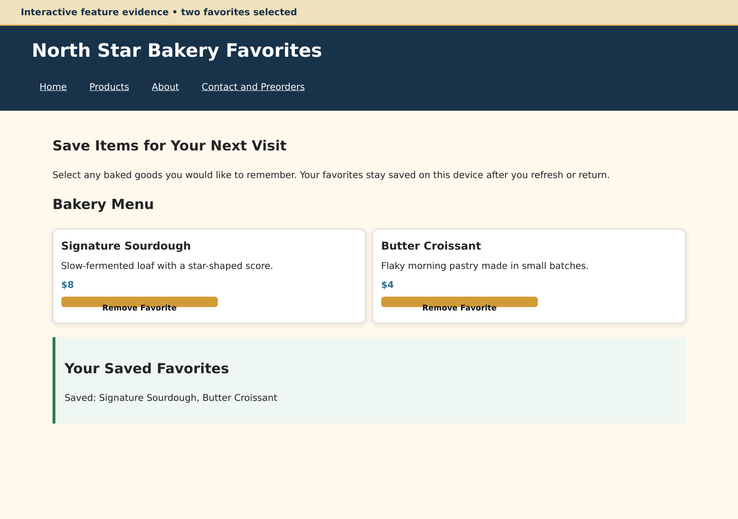
Caption: The two gold Remove Favorite buttons and updated summary show the page responding dynamically to the visitor’s selections.
Screenshot 2: Form Validation Feedback
Show at least two validation messages displayed near the relevant fields while submission is prevented.
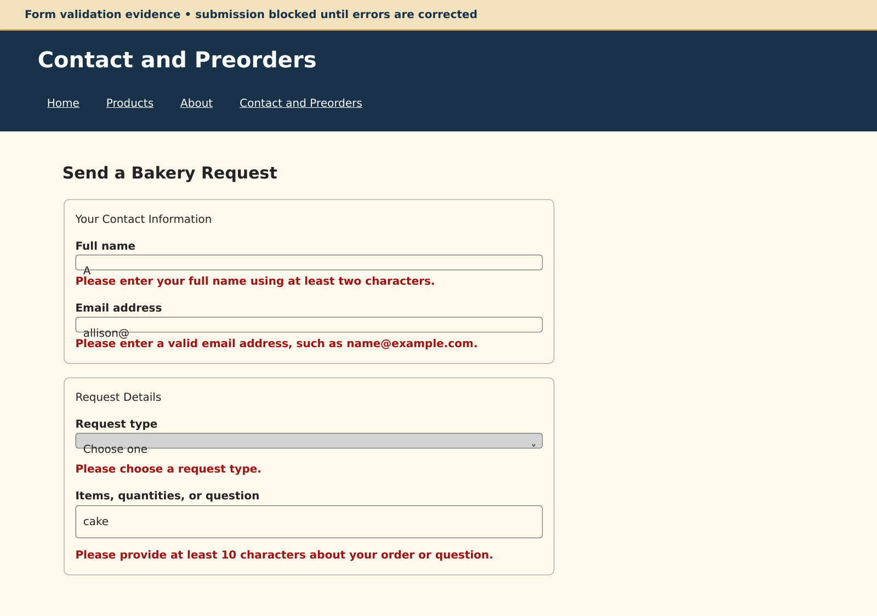
Caption: Four field-specific messages show that JavaScript blocked an invalid request while preserving the entered information for correction.
Screenshot 3: Browser Storage Working
Show data restored after a refresh or return visit, such as a remembered selection, saved favorite, or pre-filled field.
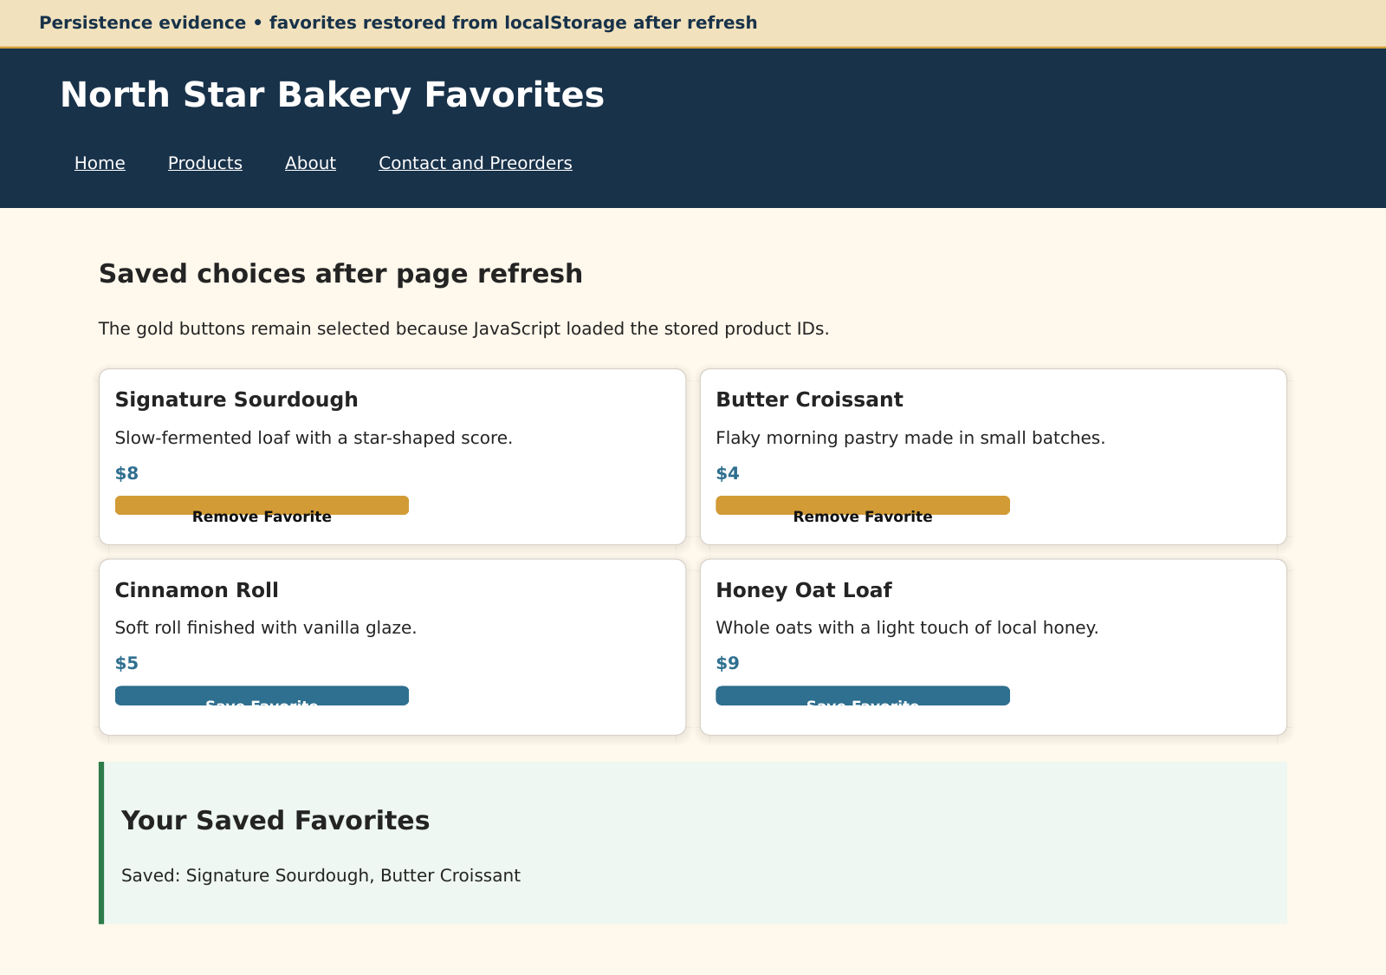
Caption: Signature Sourdough and Butter Croissant remain selected after refresh because their IDs were restored from localStorage.

Section 5: Final Review
☒ The interactive feature works as expected after repeated testing.
☒ The page updates dynamically when the user takes the intended action.
☒ Validation prevents invalid submission and messages appear near fields.
☒ Valid form entries can proceed without unnecessary errors.
☒ Stored data saves and reloads correctly after refreshing or reopening the page.
☒ No JavaScript errors appear in the browser console during normal use.
☒ Navigation and relative file paths work across all pages.
☒ The project remains readable and usable at mobile and desktop widths.
☐ The submitted link and all screenshots match the final version of the project.

Section 1: GitHub Repository
Paste the URL to your public GitHub repository for this project. The repository should include all updated HTML, CSS, and JavaScript files required for this Touchstone.
FINAL STEP: Upload the included website files to your public project, paste its URL in both highlighted link fields, and then check the remaining repository boxes.
Repository URL: PASTE YOUR PUBLIC GITHUB OR CODESPACES PREVIEW LINK HERE BEFORE SUBMITTING

Updated Final Review Items
- ☐ Public GitHub repository link included
- ☐ Repository opens without requiring login
- ☐ Repository contains all updated HTML, CSS, and JavaScript files
- ☒ Interactive feature works as expected
- ☒ Form validation prevents invalid submission
- ☒ Feedback appears near the relevant fields
- ☒ Stored data persists correctly
- ☒ Previous HTML and CSS functionality remains intact

