### The Anonymous Aspirer Application

### Created by:

### Allison Sharpe

Summary

**Name of Application**: The Anonymous Aspirer.

**Intent of Application**: This application will allow users to create/view/edit/delete journal entries at will.

**Reason for Choosing This Application**: I chose to create an application based on creating/viewing/editing/deleting journal entries because I feel as though there aren’t very many websites/application out there that share this same concept and I would like to create something fresh for users to enjoy.

**Distinguishing This Application From Others**: As I stated above, I feel as though there aren’t very many applications that revolve around allowing users to create their own personal journals through a virtual platform. I’m not stating that there aren’t any out there that deserve praise because there are, but my application will stand out amongst them due to the site having advanced features seen on most modern websites. (Many journal/diary websites that I’ve come across appear to have outdated themes and layouts.)

Diagram

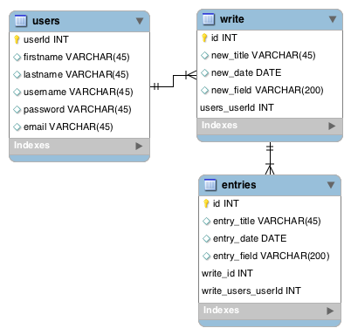

Schedule

**Week 1 Schedule-**

Monday-Tuesday: Setup PRD document & begin required items

Wednesday-Thursday: Continue working on required items

Friday-Sunday: Finalize and submit PRD

**Week 2 Schedule-**

Monday-Tuesday: Setup project & add in version 1 features

Wednesday-Thursday: Continue working on project

Friday-Sunday: Finalize and submit project for version 1

**Week 3 Schedule-**

Monday-Tuesday: Setup project & add in version 2 features

Wednesday-Thursday: Continue working on project

Friday-Sunday: Finalize and submit project for version 2

**Week 4 Schedule-**

Monday-Tuesday: Setup project & add in version 3 features

Wednesday-Thursday: Continue, finalize, and submit project for version 3

Wire Diagrams

1) The Homepage

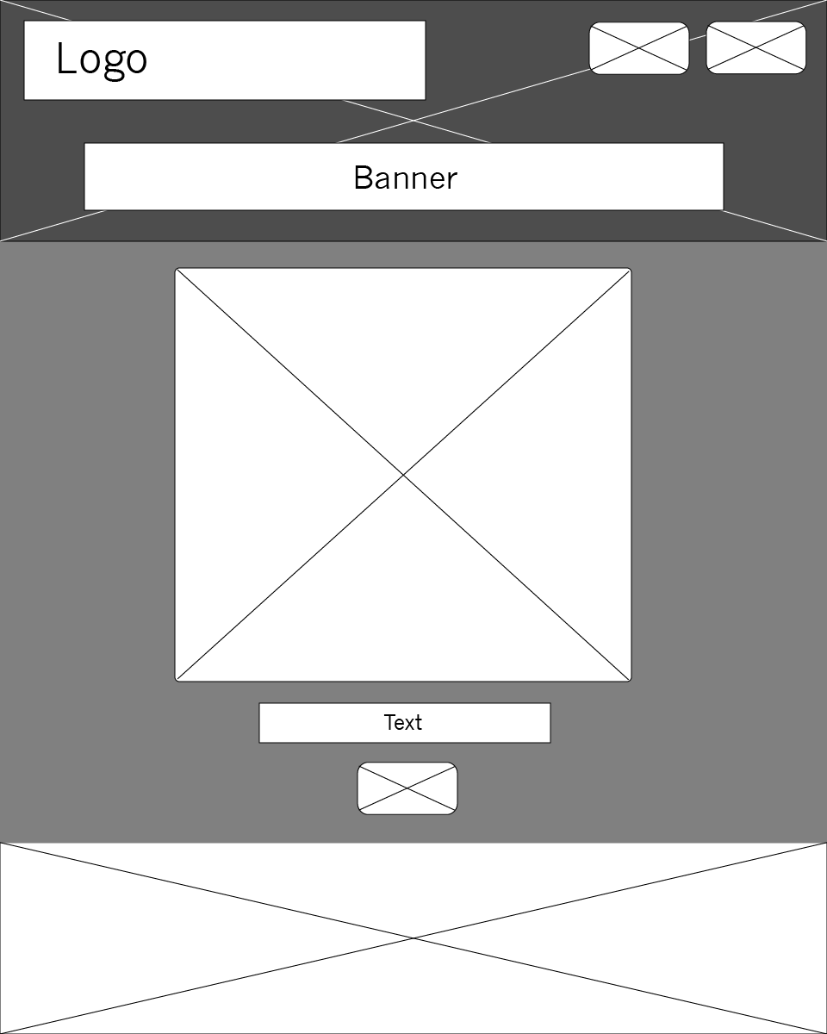

2) The Entry Page

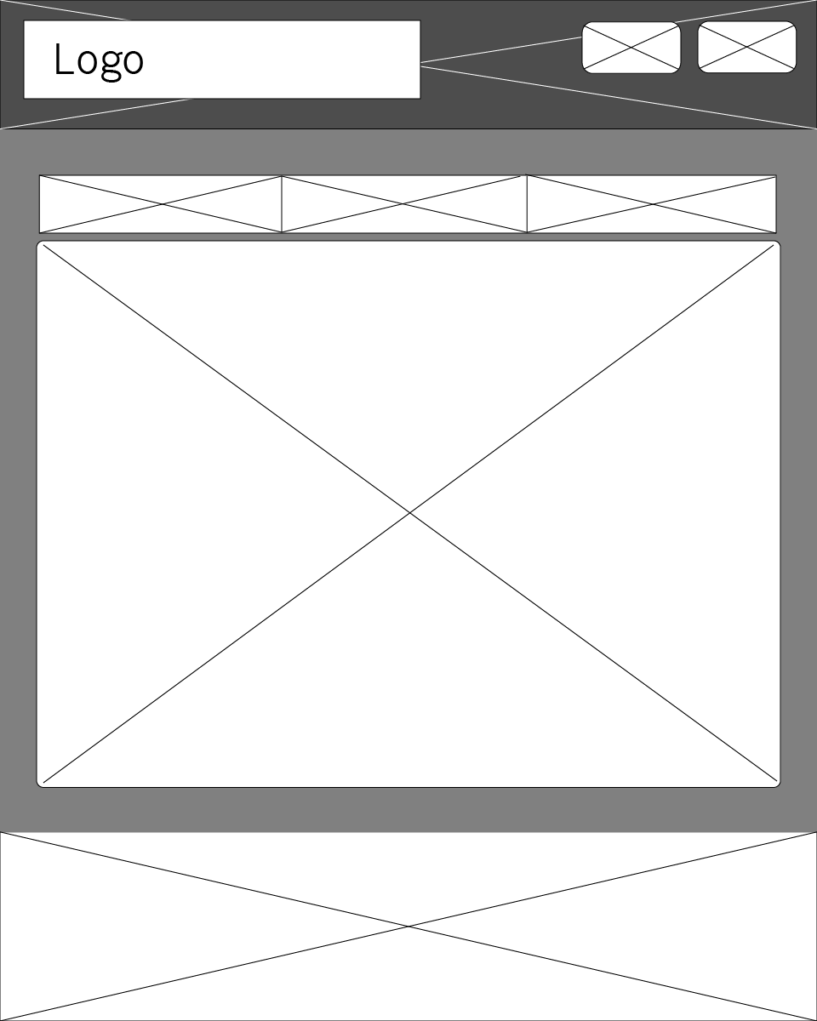

Design Template(s)

1. Design Layout

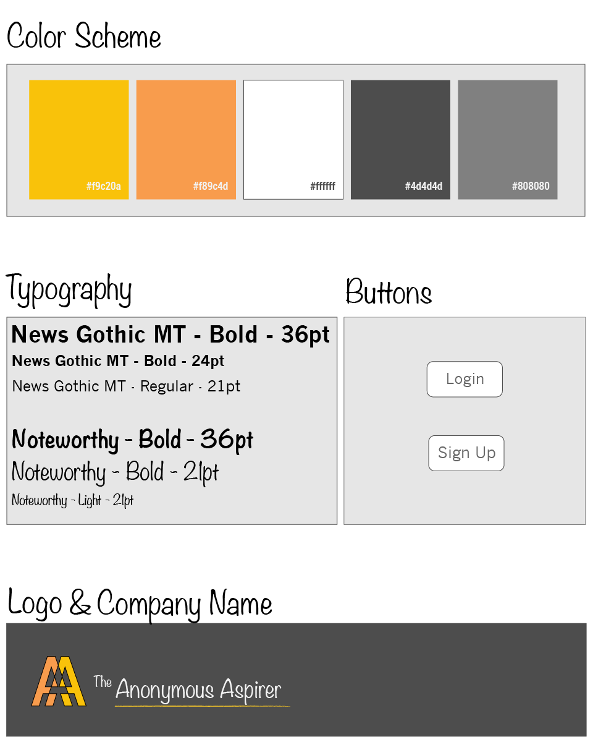

1. The Homepage

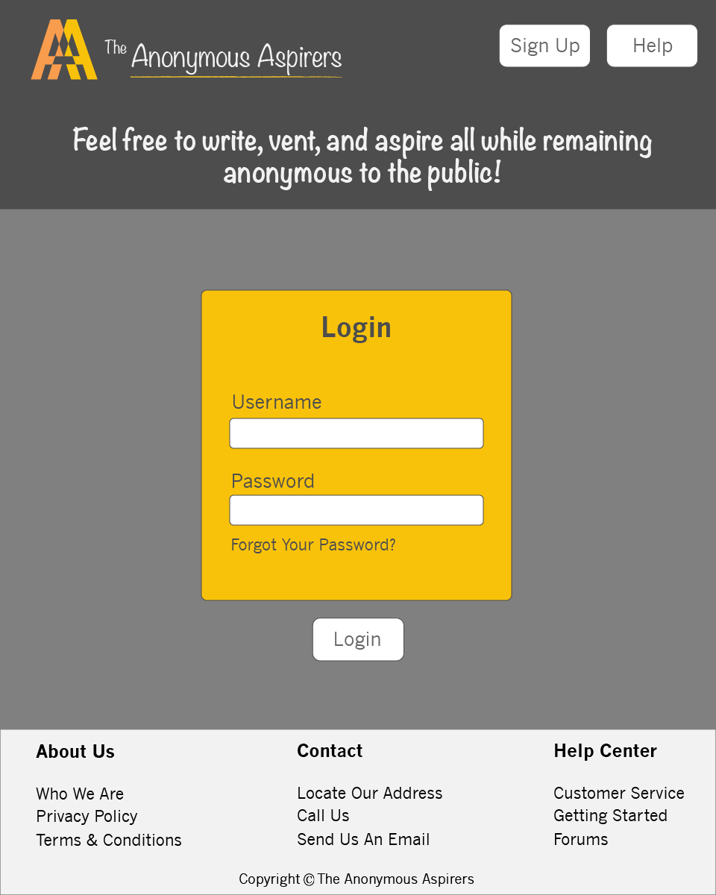

1. The Entry Page

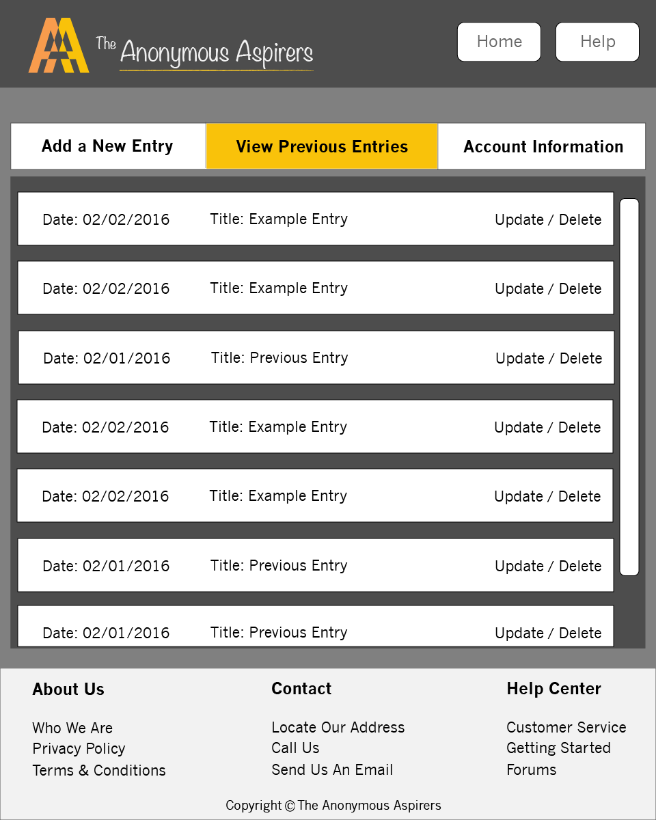

Language & Framework Platform

**Language:** The programming language I am using for this project will be PHP

**Framework:** The framework I am using for this project will be CodeIgniter. The reason I chose this framework is because I’m mostly familiar with using PHP. Some features of this framework include the “email” class & the “calendar” class, both features that I intend on using within my project.

Features – Version 1, Version 2, and Version 3

**Version 1**: I will begin by implementing Login/Sign Up options as well as options for the user to create a new entry, view the entry, update the entry, and delete the entry. (CRUD)

**Version 2**: I will implement both the calendar class and the form validation class from Code Igniter into my code.

**Version 3**: I will finalize my project by implementing an email class from Code Igniter as well as adding in a JavaScript class from Code Igniter.