DBS Lab 3

Name: Allison Sharpe

1. Retrieve the average MPG Highway for all vehicles.
Paste the SQL and results below.

select avg(mpgHighway)
from vehicle;

result = 32.688334334353904

2. Retrieve the top 10 (best) average MPG City values by vehicle model. Group the average MPG values by vehicle model. Exclude vehicles with a MPG city value of 0 as these are electric cars. Example: The average MPG city of all Ford Mustangs across all years would be 1 of the rows returned.
Paste the SQL below.

select model, avg(mpgCity) as avgMpg
from vehicle where mpgCity > 0
group by model
order by avgMpg desc
limit 10;

3. Retrieve the count of models produced by each make in 1997. Order the results by make. Paste the SQL and results below.

select count(model), make
from vehicle
where year = ‘1997’
group by make, year
order by make;

results: (see screenshots below)
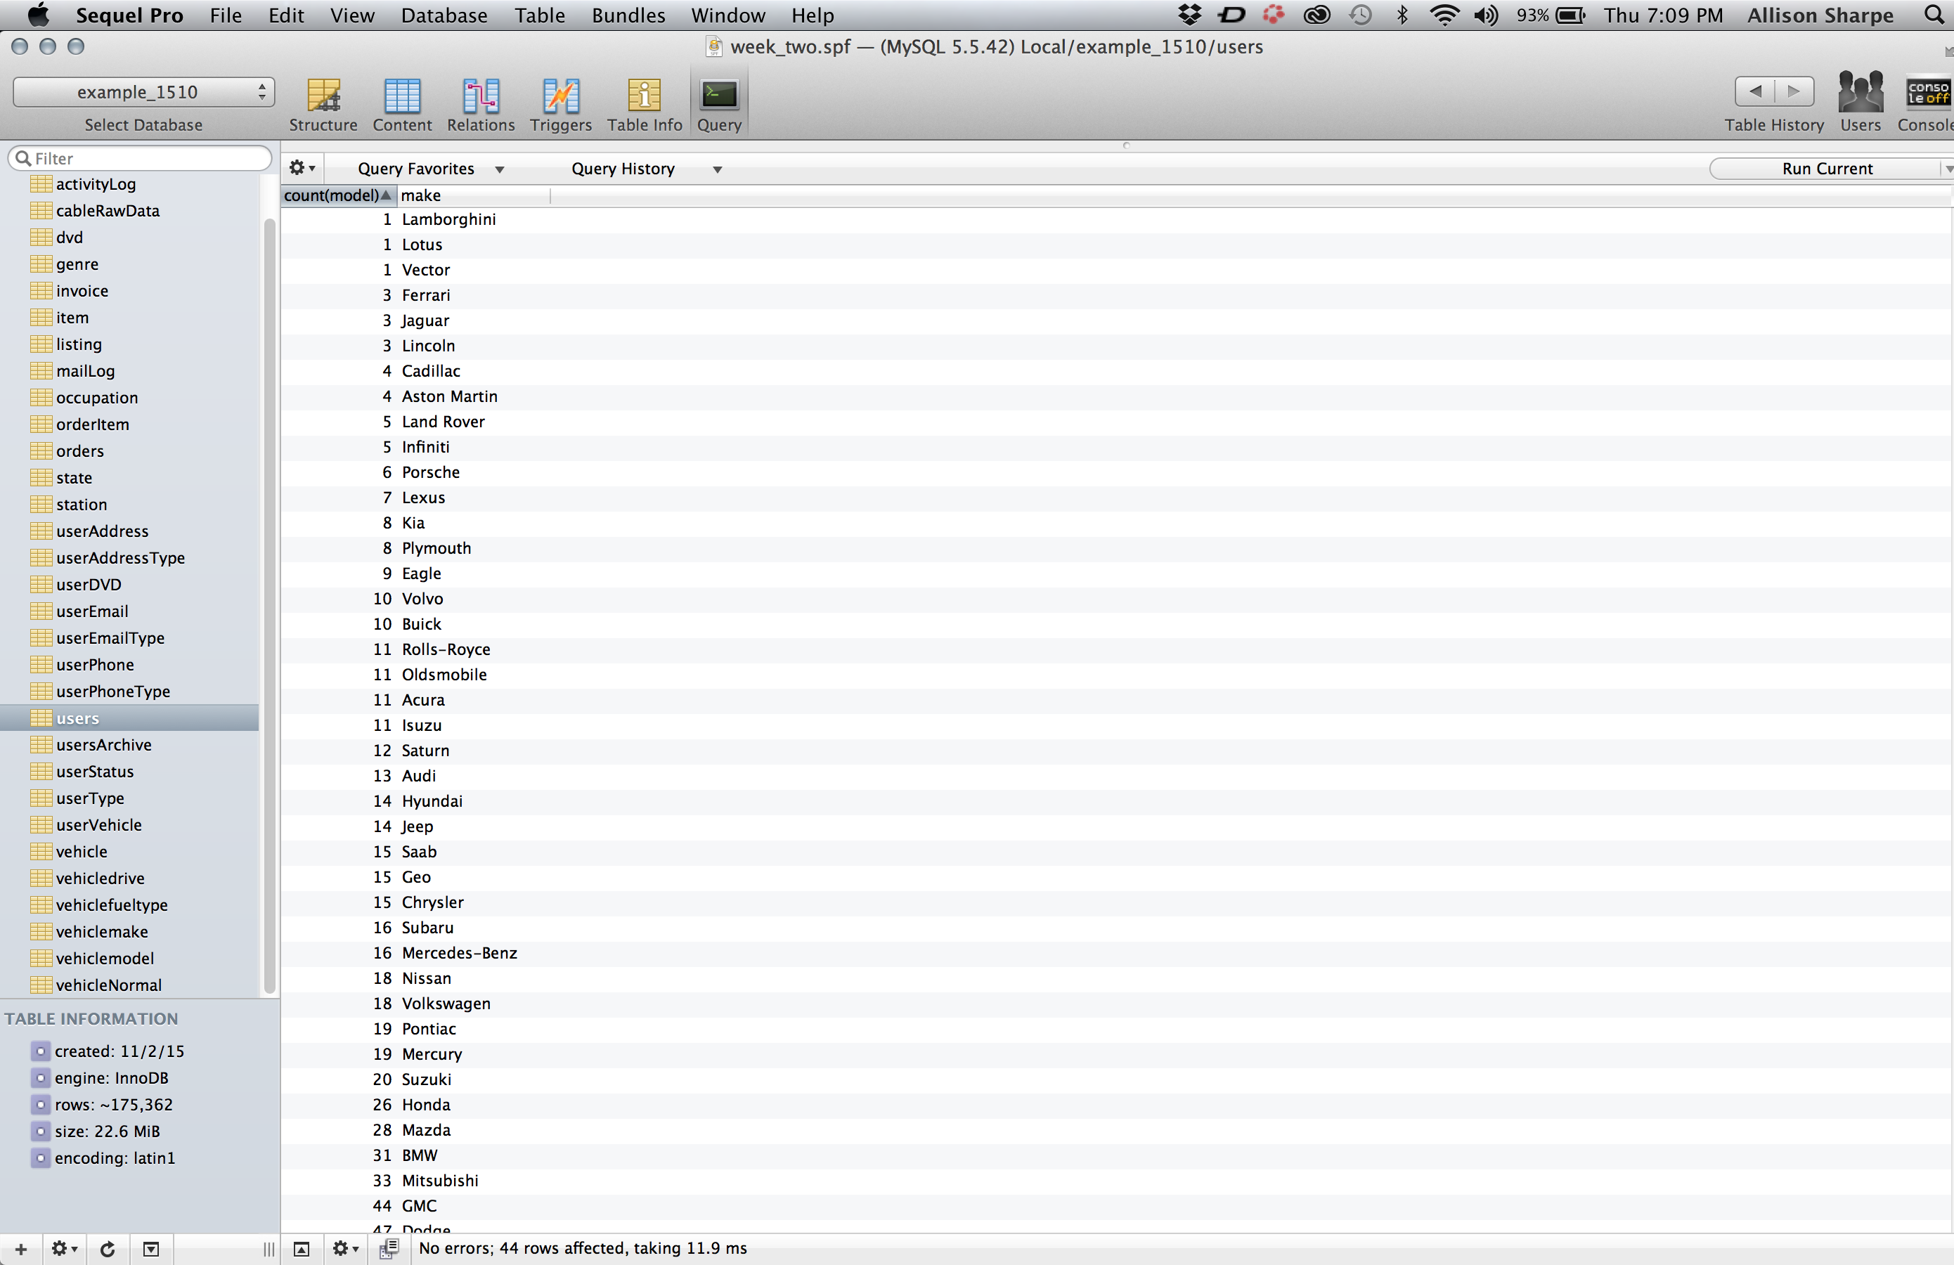

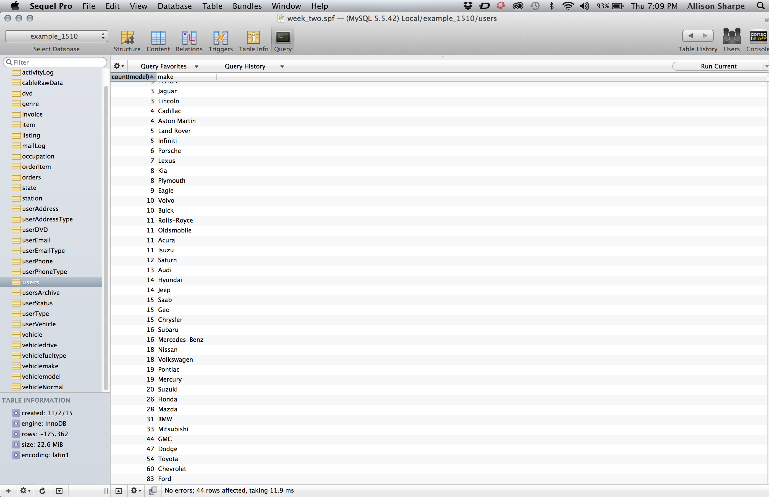

4. Retrieve the count of models produced by each make in only 2002. Order the results by make. Exclude makes who only produce less than 5 models by using a having clause.
Paste the SQL and results below.

select count(model) count, make
from vehicle
where year = ‘2002’
group by make, year
having count > 5
order by make;

results = (see screenshot below)

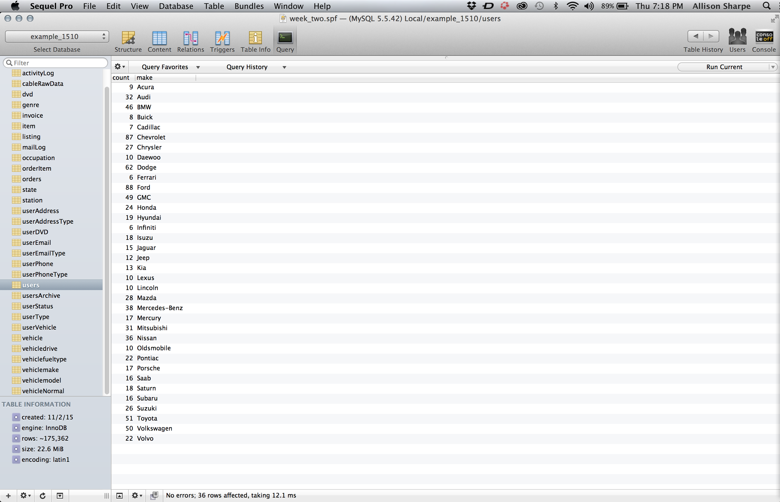

In you example database look at the vehicle table. Like the cableRawData table the data is not normalized. For this section you will be normalizing this table.

5. The columns with repeating data will be moved to separate tables. Create tables for the following columns: make, model, drive, fuelType. Name the tables vehicleMake, vehicleModel, vehicleDrive and vehicleFuelType. Set the id fields of these table auto increment. Table type should be INNOdb.
Paste the SQL below.

create table vehicleMake (
makeId int(11) DEFAULT NULL AUTO_INCREMENT,
make varchar (255) DEFAULT NULL,
PRIMARY KEY (makeId),
UNIQUE KEY make (make)
)ENGINE=InnoDB DEFAULT CHARSET=latin1;

create table vehicleModel (
modelId int(11) DEFAULT NULL AUTO_INCREMENT,
model varchar (255) DEFAULT NULL,
PRIMARY KEY (modelId),
UNIQUE KEY model (model)
)ENGINE=InnoDB DEFAULT CHARSET=latin1;

create table vehicleDrive (
driveId int(11) DEFAULT NULL AUTO_INCREMENT,
drive varchar (255) DEFAULT NULL,
PRIMARY KEY (driveId),
UNIQUE KEY drive (drive)
)ENGINE=InnoDB DEFAULT CHARSET=latin1;

create table vehicleFuelType (
typeId int(11) DEFAULT NULL AUTO_INCREMENT,
type varchar (255) DEFAULT NULL,
PRIMARY KEY (typeId),
UNIQUE KEY type (type)
)ENGINE=InnoDB DEFAULT CHARSET=latin1;

6. Create unique indexes on the name columns for the 4 tables we just created.
Paste the SQL below.

CREATE UNIQUE INDEX vehicle_make_index ON vehicleMake (make);
CREATE UNIQUE INDEX vehicle_model_index ON vehicleModel (model);
CREATE UNIQUE INDEX vehicle_drive_index ON vehicleDrive (drive);
CREATE UNIQUE INDEX vehicle_fuelType_index ON vehicleFuelType (type);

7. Populate the 4 new tables with the appropriate data using the select into statement with the distinct function.
Paste the SQL below.

insert into vehiclemake (make) (
select distinct(make) from vehicle
order by make;

insert into vehiclemodel (model) (
select distinct(model) from vehicle
order by model);

insert into vehicleDrive (drive) (
select distinct(drive) from vehicle
order by drive);

insert into vehiclefueltype (type) (
select distinct(fuelType) from vehicle
order by fuelType);

8. Create a new table called vehicleNormal. Include the following columns: vehicleId, makeId, modelId, Year, cylinders, driveId, mpgHighway, mpgCity and fuelTypeId. Ids should be integers. MPG should be decimals.
Paste the SQL below.
create table vehicleNormal (
vehicleId int(11) DEFAULT NULL AUTO_INCREMENT,
makeId int(11) DEFAULT NULL,
modelId int(11) DEFAULT NULL,
Year int(11) DEFAULT NULL,
cylinders int(11) DEFAULT NULL,
driveId int(11) DEFAULT NULL,
mpgHighway decimal(10,2) DEFAULT NULL,
mpgCity decimal(10,2) DEFAULT NULL,
fuelTypeId int(11) DEFAULT NULL,
PRIMARY KEY (vehicleId)
)ENGINE=InnoDB DEFAULT CHARSET=latin1;

9. To increase the speed of the queries we will run in the next question, create four indexes on the vehicle table for the columns: make, model, drive, fuelType.

create index make_index
on vehicle(make);

create index model_index
on vehicle(model);

create index drive_index
on vehicle(drive);

create index type_index
on vehicle(fuelType);

10. Populate vehicleNormal by joining the vehicle, vehicleMake, vehicleModel, vehicleDrive and vehicleFuelType tables.
Paste the SQL below.

insert into vehicleNormal(makeId, modelId, Year, cylinders, driveId, mpgHighway, mpgCity, fuelTypeId)
(select makeId, modelId, Year, cylinders, driveId, mpgHighway, mpgCity, fuelType
from vehicle
join vehicleDrive on vehicle.drive = vehicleDrive.drive
join vehicleFuelType on vehicle.fuelType = vehiclefuelType.type
join vehicleMake on vehicle.make = vehicleMake.make
join vehicleModel on vehicle.model = vehicleModel.model);

11. Write a select statement to return the following fields: vehicle Id, make, model, year, drive, fuel type. Do not use the vehicle table, instead use the 5 new tables we just created.
Paste the SQL and results below.

select vehicleId, make, model, year, drive, type
from vehicleNormal
join vehicleMake on vehicleNormal.makeId = vehicleMake.makeId
join vehicleModel on vehicleNormal.modelId = vehicleModel.modelId
join vehicleDrive on vehicleNormal.driveId = vehicleDrive.driveId
join vehicleFuelType on vehicleNormal.fuelTypeId = vehicleFuelType.typeId;

To complete this assignment, upload this document to FSO.

