WELCOME!

Dear Representatives:

Welcome to the Thirtieth Annual University of Michigan Engineering Career Fair, sponsored by the Society of Women Engineers (SWE) and Tau Beta Pi (TBP), the National Engineering Honor Society.

For the past nine months, the co-directors and committee chairs have been working hard to prepare for your arrival. They have dedicated many hours to planning a successful event for companies and fellow students alike. Unfortunately, because of the time they will spend overseeing the career fair, they will have limited time to meet you and learn about the opportunities at your company. Please take time to meet each of these individuals wearing pink (directors) or yellow (committee chairs) career fair shirts. For your convenience, their resumes are included at the end of this binder.

If you have any questions or concerns, please feel free to ask any of the career fair directors or committee chairs. This corporate guide should have the answers to many of your questions regarding scheduling and facility information. Thank you for attending, and we hope you have a great time at the SWE / TBP Engineering Career Fair.

Sincerely,

 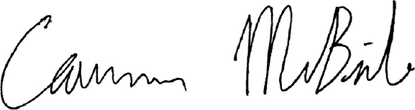

Lauren Bilbo Cameron McBride

SWE Career Fair Director TBP Career Fair Director

 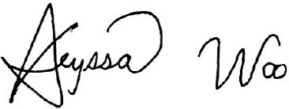

Sarah Yaqub Alyssa Woo

SWE Career Fair Director TBP Career Fair Director

INDEX

Contact Information 2

Agenda 3

General Career Fair Questions 4

Society of Women Engineers Corporate Resource Guide 5

Tau Beta Pi Corporate Resource Guide 7

Map 8

Career Fair Committee Chair Resumes 9

CONTACT INFORMATION

CB Chrysler Basement (below CC)

CC Chrysler Center

CCA Central Collaboration Area (in DC)

CO Pierpont Commons/Duderstadt Connector

BBB Bob and Betty Beyster Building

DC Duderstadt Center

DOW Dow Building

EECS Electrical Engineeringand Computer Science Building

GA Gallery

PC Pierpont Commons

FXB [François-Xavier Bagnoud Building](http://www.engin.umich.edu/college/admissions/visit/maps/buildings/francois-xavier-bagnoud-building)

General Questions and Information

*General questions and information regarding the College of Engineering should be directed toward a University of Michigan volunteer, identified by a career fair shirt.*

Information desk locations

*Information desks are located at our Corporate Registration table outside the Duderstadt Center. Please see the map below for more detailed information.*

Special requests or specific logistics questions

*For special requests or logistics information we ask that you please contact a Career Fair Committee Chair Member, wearing a pink or yellow career fair shirt. If a committee member cannot be located then proceed to an information desk location.*

Emergency Situations

*In case of fire, the fire alarm will sound and all guests will be escorted out of the affected buildings by Career Fair Representatives. For weather-related emergencies, an alarm will sound and all guests will be directed to the basement of their facility or to an approved shelter location by Career Fair Representatives.*

*In any emergency situation please use the following information:*

*Department of Public Safety 734.763.1131 or 911 on Campus*

*Ann Arbor Police Department 734.994.2911 or 911*



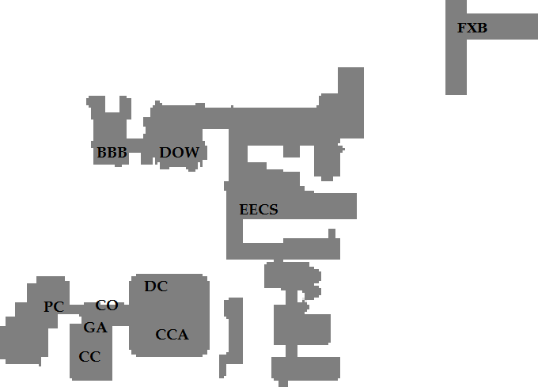



     Registration Table

AGENDA

Agenda for Monday, September 22nd and Tuesday, September 23rd

8:00 - 10:00 a.m. On-site registration outside the Duderstadt Center

Complimentary breakfast located at Hospitality locations in the lobby of the Duderstadt Center (see map on page 7)

10:00 a.m. Career Fair begins

12:00 - 1:00 p.m. Lunch Available outside the Duderstadt Center

1:00 - 4:00 p.m. Light snacks available at Hospitality locations

4:00 p.m. Career Fair ends

FedEx forms should be completed, and packages should be left on top of your table and a Career Fair representative will pick them up for you.

5:00 p.m. FedEx package pick-up

**8:00 a.m. – 4:00 p.m. Corporate lounge (in the Duderstadt Connector Conference Rooms) and hospitality site (in the Bob and Betty Beyster Building) are open**

If you have any questions please ask a volunteer or visit an Information Desk located outside the Duderstadt Center.

GENERAL CAREER FAIR QUESTIONS

Where are my packages?

*Packages will be located at your company’s table upon arrival. If you are missing any packages, please ask a Career Fair Representative or visit one of the Information desks.*

Where are the bathrooms?

*Please refer to either posted signs or the included map. General locations are as follows:*

*Pierpont Commons – up the stairs by the North Campus Information Desk*

*Connector – nearest bathrooms are in Pierpont Commons or in the Duderstadt Center*

*Duderstadt Center – by the doors leading outside to the EECS Building*

*CSE Building – ladies’ room adjacent to computer lab in the hallway connecting to*

*the Dow Building; men’s room at the far end of the Dow Building*

*EECS Building – ladies’ room is located in the hallway on the right side of the*

*elevators (facing the elevators); men’s room is located in the hallway on the left*

*side of the elevators*

Where is the Gallery?

*The Gallery is adjacent to the Connector, near Pierpont Commons.*

When and where is lunch?

*Lunch is served near the Registration table in the Duderstadt Center between 12:00 and 1:00 p.m.*

Where may I use a phone/fax/copy machine?

*Company representatives may use the services of the Engineering Career Resource Center. The ECRC is located in the Chrysler Center (off the Connector, next to the Gallery).*

Where is an ATM?

*There are ATM machines located at the west entrance of Pierpont Commons and near the Duderstadt Center Information Desk.*

Where can I find the location of another company?

*Look up the company in the directory for the building location or ask at the Registration table.*

How do I ship my packages?

*FedEx shipping forms will be in your binder. If they are missing or you need more, please ask a Career Fair Representative or visit the Registration table.*

SOCIETY OF WOMEN ENGINEERS CORPORATE RESOU*RCE GUIDE

**Society of Women Engineers Abridged Corporate Resource Guide - 2014**

On behalf of the Society of Women Engineers (SWE) at the University of Michigan – Ann Arbor, we would like to thank you for your continued support in our organization. SWE strives to promote and support women in engineering, to be a link between students and industry, and to be a knowledge source and leader in the College of Engineering, the University, and the surrounding community. Our SWE section runs numerous events that have the potential to be sponsored by companies such as yours.

**Industry,** swe.ind@umich.edu

*Links students with industry professionals and alumni through networking and career development opportunities*

* Professional Development Day
* SWE Etiquette Dinner
* University of Michigan SWE Section End of Year Banquet and Scholarships
* Winter Career Fair Warm-Up
* Networking Events

**Corporate Information Sessions,** swe.cis@umich.edu

*Facilitates student and recruiter interaction with industry information sessions and networking*

* Information Sessions

**SWE/Tau Beta Pi Engineering Career Fair and Receptions,** http://www.umcareerfair.org

**Public Relations,** swe.pr@umich.edu

*Hosts charitable, social, community and college relations events as well as SWE’s general body meetings*

* SWE Seminar Speaker (at our general body meetings)
* Engineering Welcome Day – College Relations
* Mr. Engineer Competition – College Relations
* SWE/ASME Fun Run – Community Relations
* Michigan Charity Talent Showcase

**Outreach,** swe.out@umich.edu

*Plans engineering outreach events with Girl Scout, middle school, and high school girls in community*

* Summer Engineering Exploration (SEE) Camp
* Girls Research Engineering and Technology (GREAT) Day
* Scout Out Engineering Days for Girl Scouts
* Shadow Days – High School Relations
* Elementary Engineering Exploration (EEE) Day

**Team Tech,** swe. techdirector@umich.edu

**Marketing and Membership,** swe.strplan@umich.edu

**GradSWE,** swe.graduate@umich.edu

**Executive Board,** swe.eboard@umich.edu

* SWE National Convention and Student Conference
* Region H SWE Conference
* General Sponsorship

**Contact Information**

Website: <http://www.swe.engin.umich.edu> Email: swe.info@umich.edu

Location: Cubicle F, 1226 EECS Building Phone: 734-763-5027

1301 Beal Ave. Hours: Monday - Friday 9:30 AM -4:30 PM

Ann Arbor, Michigan 48109-2122 (Sept.-April, Closed Spring & Summer)

TAU BETA PI Corporate Resource Guide

Corporate Opportunities through TBP

There are a number of ways for companies and individuals to be involved on campus. Some examples of involvement include:

* **Chapter Meetings:**
  + Speaking at a meeting is a great way to reach out to a large number of our members.
  + Presentations usually last about twenty minutes and reach a wide range of engineering majors. Meetings this semester will take place at 6:30pm on Tuesday Sept 30, Oct 21, Nov 4, and Dec 2.
  + These should be presentations focusing on topics or skills applicable and interesting to all majors.
  + These are not information sessions, but opportunities to share some exciting aspect of a practical engineers’ work or a new technology being developed.
* **Service or Social Events:**
  + These events provide an informal networking opportunity with our members.
  + In a previous year, we hosted such an event with Habitat for Humanity, which was followed by a networking lunch.
* **Information Sessions/Technical Talks:**These can be informational, instructional, or technical, and either exclusively for our members or open to all students.
* **Professional Development:**Come discuss topics with our students that are relevant in the workplace, but often not taught in the college setting; can be for resume critiquing, interview preparation, etc.

In addition to these ideas, if you have an involvement idea, we would be very willing to help make that a reality.

## WHO DO I TALK TO IN ORDER TO GET INVOLVED WITH TAU BETA PI?

If you would like additional information about Tau Beta Pi, our corporate relations opportunities, or the University of Michigan in general, please do not hesitate to contact us.

Corporate Relations Officer:

Kwesi Rutledge

tbp-corporate@umich.edu

More information about Tau Beta Pi can be found at:

www.tbp.org

More information about the Michigan-Gamma chapter can be found at:

tbp.engin.umich.edu

MAP

**3**

**2**

**10** ♦



**7**

🍽

🚹

🚺

   Information Desk

🚹  Male Restroom

🚺  Female Restroom

🍽  Lunch

♦ Hospitality Site

   Corporate Lounge

**11**

🚺

**1**

**4**

**5**

**6**

**8**

🚹

🚹

🚹

🚹

🚹

🚺

🚺

🚺

🚺

**N**

**9**

🚹

🚺

🚺

🚹



MAP ICONS BUILDINGS

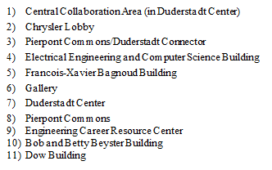

   Information Desk

🚹  Male Restroom

🚺  Female Restroom

🍽  Hospitality

   Corporate Lounge1