ESM 204 HW4: A Climate Change Model

Cameryn Brock and Allison Hacker

5/22/2020

## 1. Plots

### a) Temperature over time

years <- data.frame(  
 year = seq(from = 0, to = 200, by = 1))  
  
# temperature function  
temp_fun = function(t, T){  
 temp = pmin(t*T/100,T)  
 }  
  
temp_time <- years %>%   
 mutate(none = temp_fun(t = year, T = 0),  
 moderate = temp_fun(t = year, T = 2),  
 extreme = temp_fun(t = year, T = 8)) %>%   
 pivot_longer(2:4,  
 values_to = "temp",  
 names_to = "climate_change")

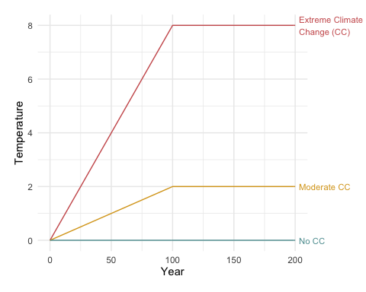

### b) Consumption over time

# economic activity retained function  
econ_fun <- function(temp, B = 0.05){  
 econ = exp(-B*temp^2)  
 }  
  
econ_time <- temp_time %>%   
 mutate(econ = econ_fun(temp = temp))  
   
# total consumption function  
consum_fun <- function(econ, g = 0.01, t){  
 consum = econ*exp(g*t)  
 }   
  
consum_time <- econ_time %>%   
 mutate(consum = consum_fun(t = year, econ = econ))

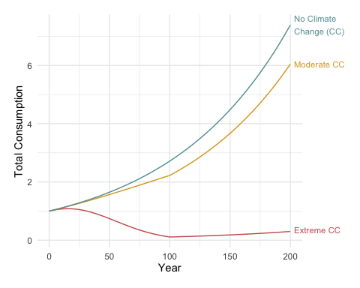

### c) Undiscounted utility over time

# society utility function  
utility_fun <- function(C, n = 0.5){  
 utility = ((C^(1-n))/(1-n))  
 }  
  
utility_time <- consum_time %>%   
 mutate(utility = utility_fun(C = consum))

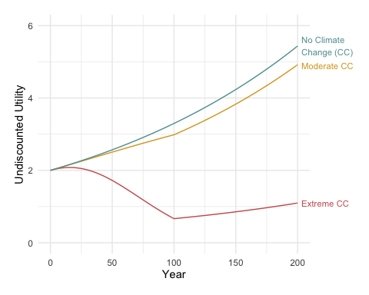

## 2. Analysis

### a) Discounted Utility

# discount rate function  
disc_fun <- function(y = 0.005, n = 0.5, g = 0.01){  
 disc = y + n*g  
}  
  
# T = 4.4  
disc_4.4 <- years %>%   
 mutate(temp = temp_fun(t = year, T = 4.4),  
 econ = econ_fun(temp = temp),  
 consum = consum_fun(t = year, econ = econ),  
 utility = utility_fun(C = consum),  
 disc_utility = utility/((1 + disc_fun())^year))  
  
# NPV under T = 4.4   
npv_4.4 <- sum(disc_4.4$disc_utility)  
npv_4.4

## [1] 198.6612

# T = 0   
disc_0 <- years %>%   
 mutate(temp = temp_fun(t = year, T = 0),  
 econ = econ_fun(temp = temp),  
 consum = consum_fun(t = year, econ = econ),  
 utility = utility_fun(C = consum),  
 disc_utility = utility/((1 + disc_fun())^year))  
  
# NPV under T = 0   
npv_0 <- sum(disc_0$disc_utility)  
npv_0

## [1] 255.2734

# percent loss in PV from climate change (T = 4.4)  
L <- ((npv_0 - npv_4.4)/npv_0)*100  
L

## [1] 22.17709

The present value utility with climate change (T = 4.4) is **198.66**. The present value utility without climate change is **255.27**. The percent loss in present value utility from claimate change (L) is **22.18%**.

### b) Sensitivity Analyses

#### T = 4.84

sens_T <- years %>%   
 mutate(temp = temp_fun(t = year, T = 4.84),  
 econ = econ_fun(temp = temp),  
 consum = consum_fun(t = year, econ = econ),  
 utility = utility_fun(C = consum),  
 disc_utility = utility/((1 + disc_fun())^year))  
  
npv_sens_T <- sum(sens_T$disc_utility)  
  
# L with T = 4.84  
L_sens_T <- ((npv_0 - npv_sens_T)/npv_0)*100  
L_sens_T

## [1] 25.79679

# change in L  
L_sens_T - L

## [1] 3.619695

Increasing T by 10% results in an **increase** in the percent loss in present value utility (L) by **3.62%**.

#### g = 0.011

sens_g <- years %>%   
 mutate(temp = temp_fun(t = year, T = 4.4),  
 econ = econ_fun(temp = temp),  
 consum = consum_fun(t = year, econ = econ, g = 0.011),  
 utility = utility_fun(C = consum),  
 disc_utility = utility/((1 + disc_fun(g = 0.011))^year))  
  
npv_sens_g <- sum(sens_g$disc_utility)  
  
# L with g = 0.011  
L_sens_g <- ((npv_0 - npv_sens_g)/npv_0)*100  
L_sens_g

## [1] 22.14822

# change in L   
L_sens_g - L

## [1] -0.02887278

Increasing g by 10% results in a **decrease** in the percent loss in present value utility (L) by **0.03%**.

#### n = 0.55

sens_n <- years %>%   
 mutate(temp = temp_fun(t = year, T = 4.4),  
 econ = econ_fun(temp = temp),  
 consum = consum_fun(t = year, econ = econ),  
 utility = utility_fun(C = consum, n = 0.55),  
 disc_utility = utility/((1 + disc_fun(n = 0.55))^year))  
  
npv_sens_n <- sum(sens_n$disc_utility)  
  
# L with n = 0.55  
L_sens_n <- ((npv_0 - npv_sens_n)/npv_0)*100  
L_sens_n

## [1] 17.66265

# change in L   
L_sens_n - L

## [1] -4.514441

Increasing n by 10% results in a **decrease** in the percent loss in present value utility (L) by **4.51%**.

#### B = 0.055

sens_b <- years %>%   
 mutate(temp = temp_fun(t = year, T = 4.4),  
 econ = econ_fun(temp = temp, B = 0.055),  
 consum = consum_fun(t = year, econ = econ),  
 utility = utility_fun(C = consum),  
 disc_utility = utility/((1 + disc_fun())^year))  
  
npv_sens_b <- sum(sens_b$disc_utility)  
  
# L with B = 0.055  
L_sens_b <- ((npv_0 - npv_sens_b)/npv_0)*100  
L_sens_b

## [1] 23.93861

# change in L   
L_sens_b - L

## [1] 1.761522

Increasing B by 10% results in an **increase** in the percent loss in present value utility (L) by **1.76%**.

### c)

$$U(C_{4.4})=\frac{(θ*C_{0})^{1-n}}{1-n}$$

$$U(C_{4.4})=θ^{1-n}*\frac{C_{0}^{1-n}}{1-n}$$

$$U(C_{4.4})=θ^{1-n}*U(C_{0})$$

$$θ^{1-n}=\frac{U(C_{4.4})}{U(C_{0})}$$

Assuming n = 0.5,

$$θ=(\frac{U(C_{4.4})}{U(C_{0})})^{2}$$

# Without discounting  
  
U_4.4 <- sum(disc_4.4$utility)  
U_0 <- sum(disc_0$utility)  
  
theta = (U_4.4/U_0)^2  
theta

## [1] 0.4926615

# With discounting  
  
U_4.4_disc <- sum(disc_4.4$disc_utility)  
U_0_disc <- sum(disc_0$disc_utility)  
  
theta_disc = (U_4.4_disc/U_0_disc)^2  
theta_disc

## [1] 0.6056405

Without considering discounting, the

$$θ^{*}$$

= **0.493**. With discounting,

$$θ^{*}$$

= **0.606**.

### d)

# T = 2 (prob = 0.2)  
d_2 <- years %>%   
 mutate(temp = temp_fun(t = year, T = 2),  
 econ = econ_fun(temp = temp),  
 consum = consum_fun(t = year, econ = econ),  
 utility = utility_fun(C = consum),  
 disc_utility = utility/((1 + disc_fun())^year))  
  
# Without discounting  
U_2 <- sum(d_2$utility)  
  
# With discounting  
U_2_disc <- sum(d_2$disc_utility)  
  
# T = 4 (prob = 0.5)  
d_4 <- years %>%   
 mutate(temp = temp_fun(t = year, T = 4),  
 econ = econ_fun(temp = temp),  
 consum = consum_fun(t = year, econ = econ),  
 utility = utility_fun(C = consum),  
 disc_utility = utility/((1 + disc_fun())^year))  
  
# Without discounting  
U_4 <- sum(d_4$utility)  
  
# With discounting  
U_4_disc <- sum(d_4$disc_utility)  
  
# T = 6 (prob = 0.3)  
d_6 <- years %>%   
 mutate(temp = temp_fun(t = year, T = 6),  
 econ = econ_fun(temp = temp),  
 consum = consum_fun(t = year, econ = econ),  
 utility = utility_fun(C = consum),  
 disc_utility = utility/((1 + disc_fun())^year))  
  
# Without discounting  
U_6 <- sum(d_6$utility)  
  
# With discounting  
U_6_disc <- sum(d_6$disc_utility)

# expected theta  
# without discounting  
U_exp <- U_2*0.2 + U_4*0.5 + U_6*0.3  
theta_exp <- (U_exp/U_0)^2  
theta_exp

## [1] 0.5147023

# with discounting  
U_exp_disc <- U_2_disc*0.2 + U_4_disc*0.5 + U_6_disc*0.3  
theta_exp_disc <- (U_exp_disc/U_0)^2  
theta_exp_disc

## [1] 0.08489526