**2018/2019 Aspendell Snowfall & Avalanche Summary**

**Prepared and provided by: Sue Burak, Inyo County Avalanche Forecaster**

The winter of 2018-2019 was a memorable one across much of the western United States. 210” of snowfall was measured in Aspendell from December 1, 2018 through March 31, 2019. Only the winter of 2011 recorded more snowfall, 222” since the County’s avalanche program began in 1998. Early season November and December storms built a relatively weak shallow snowpack that failed under the load of dense new snow and rain during the Martin Luther King weekend. Unusually stormy conditions and very cold temperatures in February and the first-half of March resulted in numerous dry wind slab avalanches. The spring avalanche season continues into the end of June as wet snow avalanches threaten Pacific Crest Trail hikers and delayed the opening of the Tioga Pass Road.

|  |  |  |  |
| --- | --- | --- | --- |
| Dec-March 1998 | 191” | Dec-March 2017 | 174” |
| Dec-March 2011 | 222” | Dec-March 2019 | 210” |

Figure 1. Comparison of snowfall during the “Big Snow Years” in Aspendell since 1998. The month of February saw a series of back to back, unusually cold, windy storms that brought 92” of snowfall to Aspendell, exceeded only by the 124” of snow measured in February 1998. Arctic air outbreaks occurred with unusual frequency and intensity across much of the West, resulting in very cold February temperatures- average daily temperatures in Aspendell averaged 23F. While the news media talked about the polar vortex on the East Coast of the United States, wild winter weather was occurring along the West Coast due to invasions of extremely cold arctic air spilling southward over California that subsequently produced some crazy weather conditions: snow fell in Las Vegas, Nevada, and on beaches along the Northern California coast.

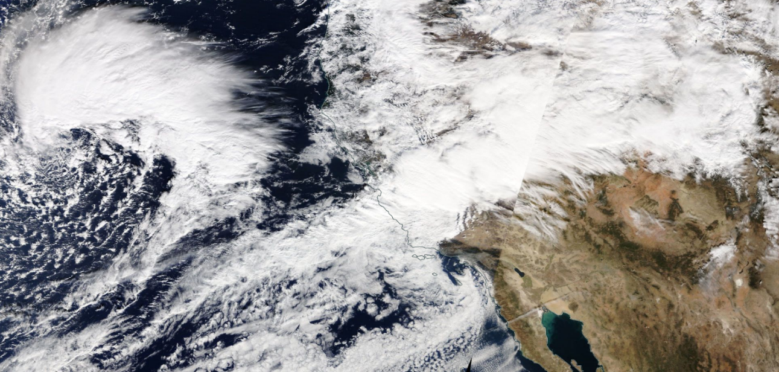

Atmospheric river, Nov 28 2018. This storm dropped 11” of snow at the Schneider study plot on White Pine Drive.

|  |  |  |  |  |  |  |
| --- | --- | --- | --- | --- | --- | --- |
| **Feb and March storms and avalanche concerns** | **storm snow** | **Avalanche concerns** | **Aspendell average daily temperature** | **Inyo Weather station temp** | **Inyo Weather station wind speed and direction** | **Aspendell**  **avg wind speed**  **and direction** |
| **02-Feb** | 20” |  | 28F | 21F | South at 48 mph | SW at 12 mph |
|  |  |  |  |  |  |  |
| **Feb 4-5** | 33” | Code Red | 16F | 8F | SE at 45 mph | SW at 10 mph |
|  |  |  |  |  |  |  |
| **Feb. 9-10** | 14” |  | 22F | 12F | S at 35 | SW at 8 mph |
|  |  |  |  |  |  |  |
| **Feb 13-15** | 21” | Precip intensity low avalanche concerns minimal | 32F | 7F | S at 65 mph | SW at 5 mph |
| **rain** | 0.33” |  |  |  |  |  |
|  |  |  |  |  |  |  |
| **March 5-6** | 37” | spotters on S Fork | 32F | 27F | S at 51 mph | WSW at 10 mph |
|  |  |  |  |  |  |  |