**Scholarly information: a starter exercise [Exercise 1]**

> Do a search for **star formation** on Google

> Do a search for **star formation** on Google Scholar <http://scholar.google.co.uk>

> Compare the 2 lists of results. What differences can you see? Write down your observations below

|  |
| --- |
|  |

**Reflection:**

> Circle either Yes or No to answer the questions below

Have I had to use much scholarly information so far in my course? Yes / No

Have I used Google Scholar before? Yes / No

**Identifying keywords [Exercise 2]**

> Write down your project topic:

> Using lists or a mindmap, use the space below to note down as many keywords as you can think of on your chosen topic.

* This may include acronyms, synonyms, alternative spellings and phrases.
* Remember you may need to search for both broader and narrower terms for concepts.

Remember:

* Not all sources of information will use the same words to describe a subject.
* When you start searching, if you find a useful article, does it use any keywords you hadn't thought of which you can add to your collection here and to your searches?

**Combining keywords & refining your search [Exercise 3]**

> a) Search for **laser mirrors** on Google Scholar <http://google.co.uk/scholar>

> How many results do you get? ……………………

> b) Search for **“laser mirrors”** (in double quotation marks) on Google Scholar

> How many results do you get? ………………………

> c) Why has the number of results changed from a)? (What is the purpose of using quotation marks?)

……………………………………………………………………………………………………………………………………………..

Other techniques you might want to consider are using **AND/OR** to combine keywords (see an example below of AND/OR used to link search terms in Scopus)…

> Circle either OR or AND in the scenarios below:

* If you want to search on two or more keywords which mean the same or similar things

Use OR / AND

* If you want to add in a keyword relating to a further search concept

Use OR / AND

…and using the Advanced Search screen available via search tools, eg Google Scholar:

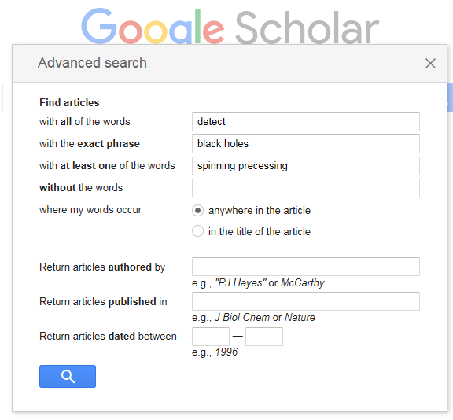

> Go to Google Scholar and check you are able to find the Advanced search option.

> Think about how you might refine your search if you have too many results, or not enough results, or your results are not relevant. Connect techniques 1.-6. below to the situation where you might use them. The first one has been done to show you:

1. Use more specific subject terms

If you’ve found too few references

2. Use broader subject terms

3. Search in narrow fields (eg title)

4. Apply limits (eg publication date)

If you’ve found too many references

5. Use OR to combine alternative terms

6. Search in broad fields, eg keyword, abstract

**Highly recommended search tool: Scopus [Exercise 4]**

> Using the search terms you planned in Exercises 2 & 3, search for some relevant material on your topic using Scopus. Log in to LibrarySearch - http://librarysearch.cardiff.ac.uk - and search for the **Scopus** database. Click on **View Online** to access the database.

> Click the plus button to add a search field. Using the keywords you have identified and linking them into search phrases with the terms 'AND' and 'OR', try searching for articles.

> Keep refining your search until you have a focused set of relevant results.

> You can also use the drop down options on each line to limit your search terms to the title of the article.

> You can use the panel on the left-hand side of the results screen to refine your search by year, by subject area, by document type etc.

MCj04260720000[1]**Locating Review articles**

Review articles can be useful

for giving you an overview of a

topic and for summarising the

current research carried out in

the area. Use the ‘Document type’

refine option in the panel on the left.

> When you see an article which looks useful, click on the article title to view more information such as the abstract, references and assigned keywords.

> The results will be sorted using the default option of Date (Newest). Change the Sort on option to Cited by (highest) to bring the most highly cited articles to the top of the list.

Check to see if you can open the full-text PDF of any articles which look useful. Click on the Check for Full text links to link to Cardiff University subscriptions.

**Additional things to try with search tools [Exercise 5]**

**Saving useful articles** *(Using LibrarySearch as an example but possible with all search tools)*

> Using the search terms you planned in Exercise 2&3, search for some relevant material on your topic using LibrarySearch - <http://librarysearch.cardiff.ac.uk> - Make sure you are signed in (your name should show on the top right).

> Use the **Sort by, Show only** and **Tweak my results** options to refine your results

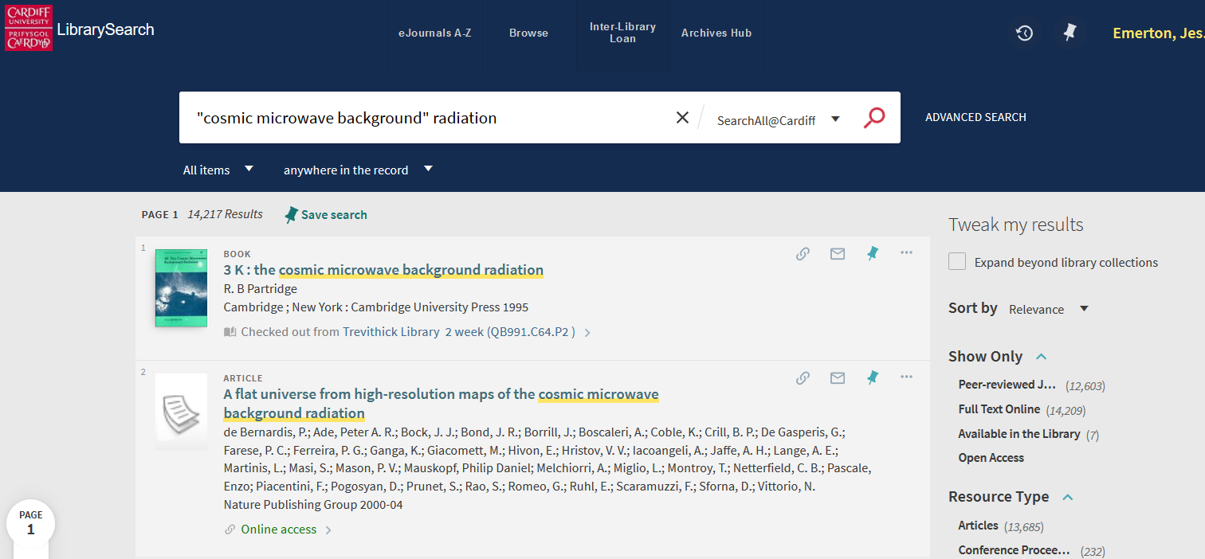

Sort by date to get recent research to top

Explore the search filters

E.g. limit to peer-reviewed journals only

> Select at least 3 items which may be useful for your project, save them and email them to yourself. Do this by clicking on the pin icon next to a record. All your pinned items are saved to your favourites and you can access them when you’re signed in by clicking on the pin icon next to your name. You can then select all results and email them to yourself.

**Setting up alerts / email updates** *(Using ADS as an example but possible with all search tools)*

> Set up an alert using **myADS** https://ui.adsabs.harvard.edu/

You can choose daily or weekly alerts. You will need to set up an individual user account with ADS by clicking on Sign up. Once signed in navigate to the myADS settings page and click the Create button.

If you have finished: work through the tutorial:

[*https://bit.ly/PHYSXlibrary2022*](https://bit.ly/PHYSXlibrary2022) *- Finding and managing information for your research project*