Stoch Homework 3

Suppose X and Y have the following joint pdf

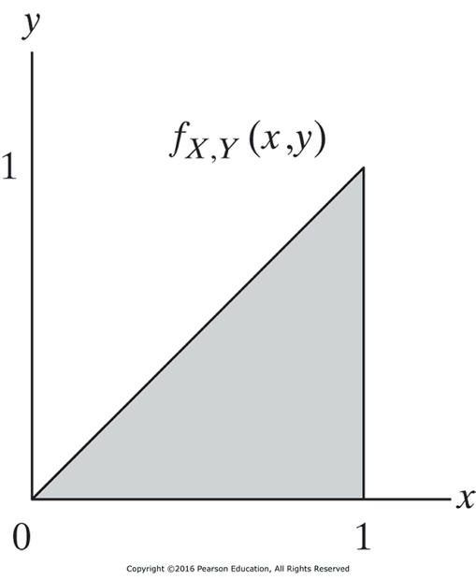

1. Make fully labeled sketches of the densities *f*x(*x*) and *fy|x*(*y*|1/3)
2. Are *X* and *Y* statistically independent?
3. Determine ${\hat{y}}_{mmse}(X)$, the MMSE estimator of Y based on observing X
4. Determine how well the estimator performs on average by computing the overall mean squared error and the bias b associated with the estimator. Note that bias $b=E[{\hat{y}}_{mmse}(X)$– Y]
5. Determine the ${\hat{y}}_{lmmse}(X)$, the linear MMSE estimator of Y and its associated MMSE.
6. Josh is wonderful!!! 😊 <3 😊