Adam Stammer

Homework 5

7.20

a) author(name, address, URL)
book(ISBN, title, year, price, author_name, publisher_name)
stocks(book_ISBN, warehouse_code, quantity)
publisher(name, address, phone, URL)
shopping_basket(basket_id)
contains(shopping_basket_id, book_ISBN, quantity)
warehouse(code, address, phone)
customer(email, name, address, phone, shopping_basket_id)

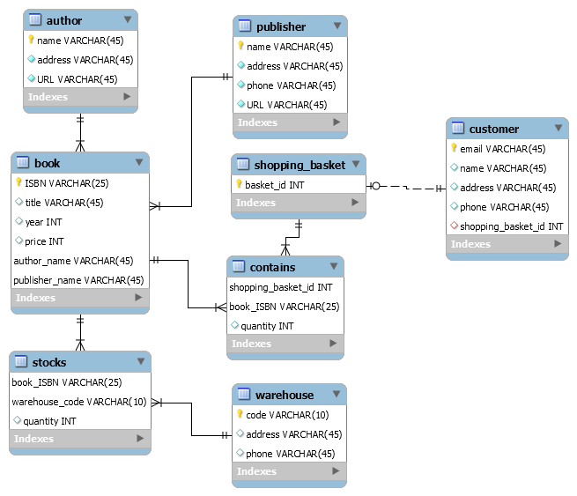
b) author(name, address, URL)
book(ISBN, title, year, price, author_name, publisher_name)
stocks(book_ISBN, warehouse_code, quantity)
publisher(name, address, phone, URL)
shopping_basket(basket_id)
contains(shopping_basket_id, book_ISBN, quantity)
warehouse(code, address, phone)
customer(email, name, address, phone, shopping_basket_id)
video(ISBN, price, year, author_name, publisher_name)
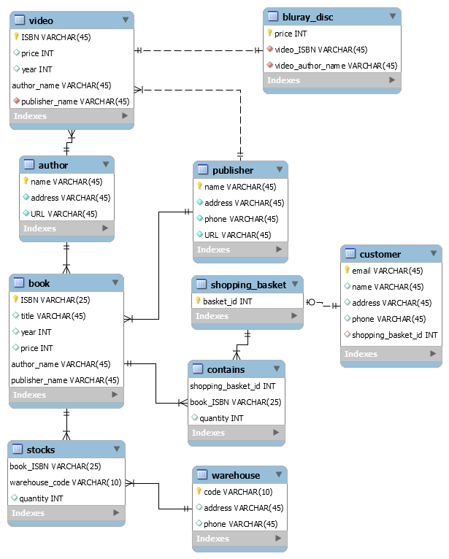
blueray_disc(video_ISBN, video_author_name, price)
c) author(name, address, URL)
book(ISBN, title, year, price, author_name, publisher_name)
stocks(book_ISBN, warehouse_code, quantity)
publisher(name, address, phone, URL)
shopping_basket(basket_id)
contains_book(shopping_basket_id, book_ISBN, quantity)
warehouse(code, address, phone)
customer(email, name, address, phone, shopping_basket_id)
video(ISBN, price, year, author_name, publisher_name)
blueray_disc(video_ISBN, video_author_name, price)
shopping_basket_has_video(shopping_basket_id, video_ISBN, price)
shopping_basket_has_blueray_disc(shopping_basket_id, blueray_disc_ISBN, quantity)
