**Final Report**

**Team Tech Ops**

**Team Members:**

**Jeswin Abraham, Alex bates, Phillip Bouie, Naga Gattupalli**



# Abstract

Parking Monitoring system is a system which is used to monitor parking lot spaces from a high elevated camera. It means that the system will take a few of images and compare them to see if there is any parking slot occupied or not. The system makes use of the images to keep track of the available spaces and display the output of the parking space availability for the potential drivers who intend to park in a selected parking lot. When a parking space is occupied, the system updates the parking lot by removing the occupied space. This helps users in reducing their time to search for an available parking space.

Table of Contents

Abstract 3

Introduction 5

Background 5

Planned Product 5

Current Product 5

Explanation of Differences 6

Technical Documentation 7

Software Design 7

Tools Used 10

Dependencies and Assumptions 10

Testing 11

Software Functionality 11

Accuracy 11

Results of Testing 11

Future Work 12

Further Development 12

Next Steps 12

# Introduction

### Background

The main motivation behind creating a parking lot monitoring system is to facilitate parking in KSU parking lots. Parking in the Marietta campus can be hard at times when there is only one person who displays whether the lot is full or not, which is not accurate. The accuracy of whether a parking lot is full or not, and a way to display how many spaces are available and occupied will better the vehicle traffic around KSU campus. This is because in real time the drivers of vehicles will know ahead whether to turn in to a parking lot based on available spaces. This will also prevent parking lot faculty from standing outside to monitor the parking lots.

### Planned Product

The main purpose of the planned product was a parking monitoring system that monitors available spaces in the parking lot using images of parking lot captured by an elevated camera. The operator will be able to set up defined areas in an image, which will use those defined areas to monitor the parking spaces. The system will display if the defined areas are occupied or available. The system will also store information regarding occupied and available spaces in a file which can be accessed by a user.

### Current Product

The current product monitors a parking lot which will output how many spaces are available and occupied. The operator can add new parking lots to monitor and set up defined areas that needs to be operated. The operator can add, edit, or delete spaces in an existing parking lot that was already in the system. The system will monitor spaces and will draw red rectangles if the space is occupied, and green rectangles if the space is available. The total number of available spaces and occupied spaces are listed in the Graphical User Interface of the system. The system also stores information regarding occupied and available spaces in a file with a timestamp.

### Explanation of Differences

Some of the issues during the development we had were dealing with image processing. The developers did not have knowledge in image processing and did take a huge portion of the time in development trying to figure out libraries that will help with the images.

Another issue we had was the time restraint we had in the project, because we did want to add additional features that could possibly make our product better.

Taking pictures with the camera was another issue we had, because of the angle of the pictures. A more vertical degree of the image would be ideal when taking pictures with a camera or a surveillance camera. This setup was not ideal in our project because it would require extra collaboration from parking services and other services from school to set up a camera.

# Technical Documentation

### Software Design

**Class Diagram**

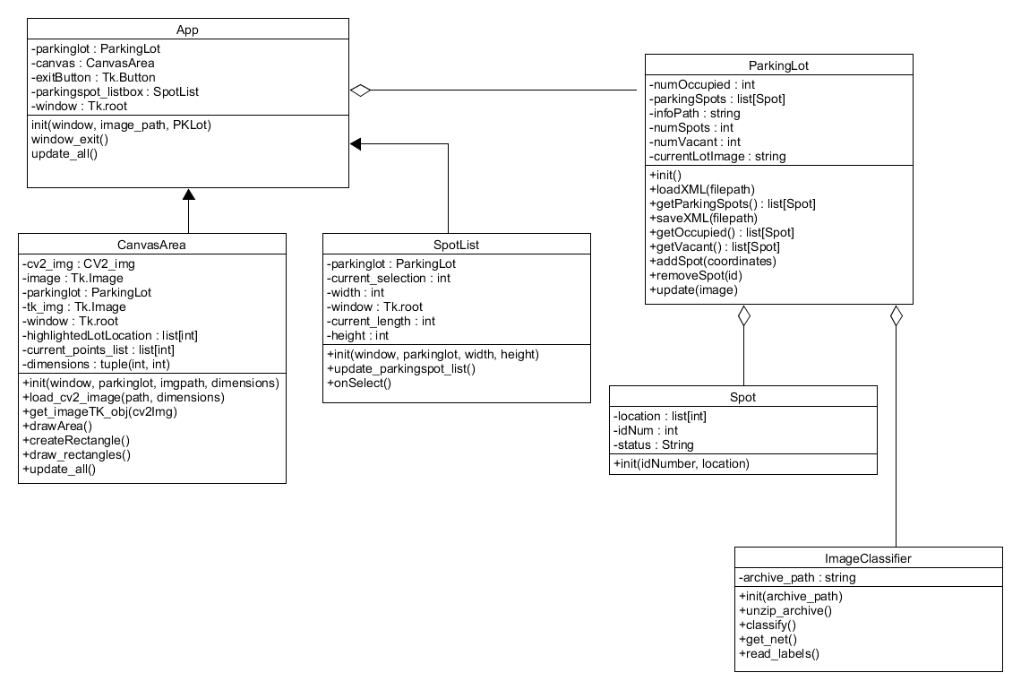

**Use Case Diagram**

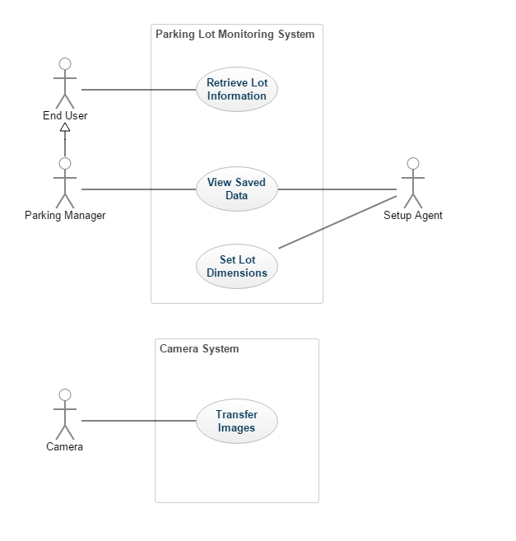

**State Diagram**

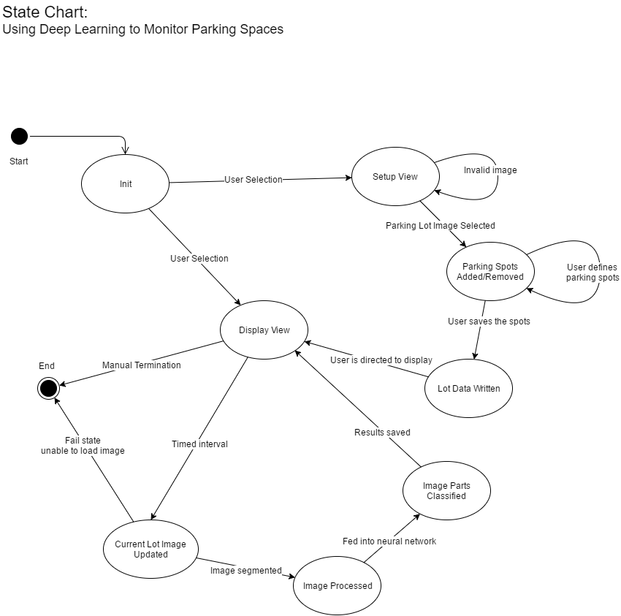

### Tools Used

Tools used during this project include the following:

* Python 2
* Python standard libraries
* Caffe (Berkeley) – Used for Neural Network creation and training
* OpenCV – Image Processing
* Ubuntu
* DIGITS (Nvidia) – Used as an interface for Caffe, aiding in network setup and training

### Dependencies and Assumptions

The software developed during this project assumes a proper operating environment to function. This includes a capable computer, with a CUDA capable graphics card. All dependencies listed in the user manual are correct at the time of writing, but updates by third parties may change this in the future.

It is also assumed that the system will be provided with the appropriate quality and type of images. Very low resolutions or very shallow angled images of parking lots will affect accuracy negatively.

# Testing

### Software Functionality

Testing of software was done as each piece of functionality was added. The tests were primarily to check for general errors and completeness of behavior. As features were added, this included testing of file formatting in the case of saved data, such as parking lot layouts and usage information.

### Accuracy

Testing the accuracy of results was very limited, partly due to time constraints. Generally, it can be said that accuracy can be greatly affected by the angle of the image being used, as well as light levels within the image. Low levels of light and heavy shadows on the ground cause inaccurate results, and low angles cause cars in one parking spot to block the view of parking spaces behind it.

### Results of Testing

Testing revealed that improvements could be made on both fronts. Limitations in the software exist that lead to a less than ideal user experience, and accuracy from images could be improved by retraining the classification network, as well as performing preprocessing to make the image clearer in the case of lighting problems. However, overall the end software does accomplish the tasks that were laid out in the proposal and SRS.

# Future Work

### Further Development

This project can go many ways in the future as new technologies come into play. The design can be different and how we viewed the parking system might as well be changed.

So, change can be having a better statistics tracking, increased accuracy in identifying the exact layout of occupied cars as well as available spaces in the selected parking lot. Doing so requires a monitoring tool which interfaces with a wireless sensor to activate when space is occupied.

Need to improve in developing better UI/UX screens. This app can be developed as a mobile application which can be useful to many drivers who are searching for parking space in the selected parking lot.

### Next Steps

Parking system plays an important role everywhere. The next steps in the project to continue would be to include developing a monitoring system by means of a wireless sensor along with the existing cameras.

The sensor can be used to detect vehicles to find the available space. Sensors must be placed in the parking lot.

Need to develop the software to make it more accurate and faster to get the parking information.

Another advancement is to develop a system where parking space can be reserved online. It saves a lot of time and effort when there is a parking monitoring system which tells when a parking space is available.