TOUCH: In-Memory Spatial Join by Hierarchical Data-Oriented Partitioning
Research project report
Author: Alvis Logins
Group: 074,
Moscow Institute of Physics and Technology and
Skolkovo Institute of Science and Technology
Supervisor: Panagiotis Karras
Advisor: Anastasia Motrenko
Date: 22.09.2014
Table of content
1 Introduction 1
1.1 Project description 1
1.1.1 Abstract 1
1.1.2 Motivation 1
1.1.3 Literature 1
1.2 System architecture 2
1.2.1 Problem statement filename 2
1.2.2 A1 diagram 2
1.2.3 A2 diagram 3
1.3 Project structure 3
1.4 Basic data structures 3
Time series 3
Histogram 4
2 Module interfaces (for synthetic data) 4
2.1 Clusterization algorithms 4
2.2 Error functions 4
3 Real data processing 4
3.1 Data download 4
3.2 Data processing 5
4 Test modules list 5
5 System launch and testing 5
5.1 System launch 5
5.2 System testing 5
5.3 System performance 5
6 Project review 5
Literature 5
Statement 5
IDEF 5
Code 6
Unit-tests 6
Data 6
Tests 6
Profiler 6
Report 6
Web 6
7 The project is located ON: 6

Introduction

Project description

Abstract
The new approach to TOUCH algorithm is going to be introduced. Effective parallelization will significantly improve the execution time of spatial join of two datasets.

Motivation
- Project goal (main purpose of research and development, the expected result)
Main purpose of this project is developing fast spatial join algorithm. Current approach, which was implemented in TOUCH and results in the most effective way of in-memory join suffers of inequality of two datasets and non-uniformly distribution of data in space and, as a result, in the search tree. Our research is aimed on the correction of TOUCH in such way, that it will allow effective parallelization and GPU-acceleration.
- Project application (where and how the project result will be applied)
The algorithm can be applied in the problem of nearest neighbor search and intersection/collision detection. It can be a subtask in several areas: human brain simulation, database join operation, some offline machine learning algorithms.
- Historical data description (timing, formats and structures)
Target data is the data about the positions of axons and dendrites in human brain modeled on BlueGene/P.
- Quality criteria (target functions, error functions, how the project quality is measured)
Quality criteria is the execution time on big datasets with high number of filtering, effective parallelization and correct defining of nearby objects.
- Requirements for the project implementation (must be satisfied for successful project end)
The final product is the command-line program that requires the list of objects and coordinates as an input and the information about the execution time, object operations and nearby objects as an output.
- Feasibility of the project (how to prove the project feasibility, list of possible risks and complications)
Prove of feasibility is the comparison with existing algorithms. In particular, with existing TOUCH approach must be significantly slower than a new one with parallelization.
- Methods and solutions (project roadmap, methods and algorithms)
The difference between two datasets must be omitted and the data structure must be redesigned to make possible the parallelization. One of possible solutions is creating two R-trees at building step and creating the maximum level for assignment step for dataset which is going to be assigned. In this case we will double the time for building R-trees, but probably decrease the time for joining step as the space parts with high density of one type of objects will be placed in according type of R-tree. This will decrease the number of intersection test.

Literature
[1] Sadegh Nobari, Panagiotis Karras et al., TOUCH: In-Memory Spatial Join by Hierarchical
Data-Oriented Partitioning, ACM SIGMOD’13 – main article, the description of base algorithm for parallelization
[2] Thoinus Brinkhoff et al., Efficient Processing of Spatial Joins Using R-trees, SIGMOD’93 – some basic principles of R-trees
[3] Ibrahim Kamel, Parallel R-trees, SIGMOD’92 – the implementation of parallel R-trees
[4] Scott T. Leutenegger, STR: A SIMPLE AND EFFICIENT ALGORITHM FOR R-TREE PACKING, ICASE report 97-14 – description of R-tree boosting, fast creating of tree from known set of data (building from the bottom)
[5] CUDA C BEST PRACTICES GUIDE – manual for GPU API

System architecture

Problem statement filename
The mathematical problem statement can be found at the address
http://sourceforge.net/p/mlalgorithms/code/HEAD/tree/Group174/Logins2014Touch/doc/Logins2014ProblemStatement.pdf

A1 diagram
System architecture is described with the IDEF0 format.
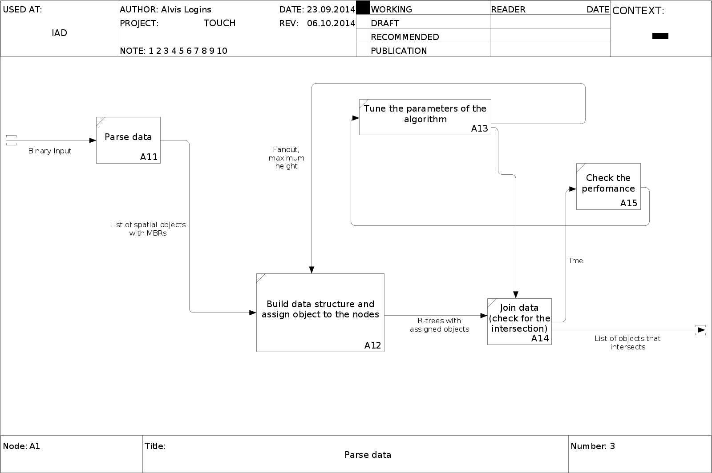

A2 diagram
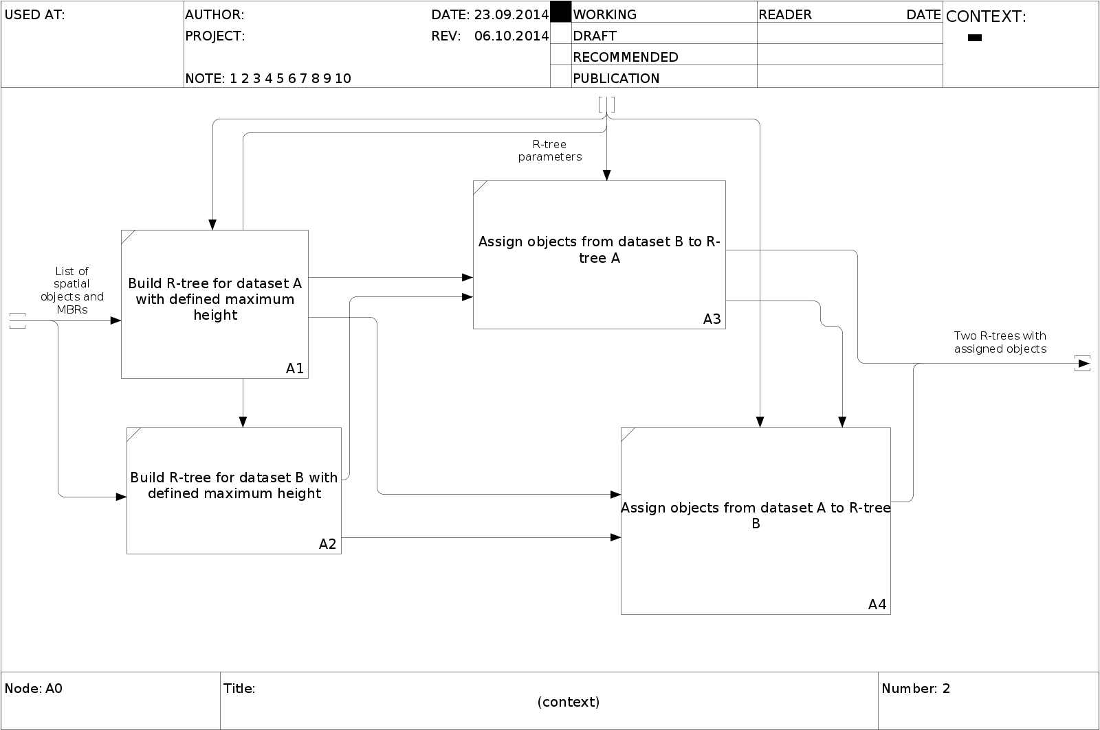

Project structure
System files are located in folders:
- doc – the project documentation;
- code – the model construction procedures;
- web – the web deployment part;
- data – synthetic and real example data, possible data preprocessors and loaders.

Basic data structures
This section provides basic data structures and interfaces that are used by system functions

Spatial objects
Spatial objects are stored in binary files. Each file has the following structure:
Header:
objectType | int32 | Type of object used in the file
objectCount | int64 | Number of objects in dataset
objectByteSize | [string] | Data information (source, formation time etc.)
Body:
Vertex | {x1,x2..xN},  N-dimentions | Point in the N-dimentional space
Box | {Low vertex, High vertex} | Bounding rectangular box in space. Defined by two vertices – lower and upper.
Universe | Box | Minimum bounding box of all data
Axon | Neuron ID(int)  Position (Vertex) | Axons of neurons
Dendrite | Neuron ID(int)  Position (Vertex) | Dendrites of neurons

Module interfaces (for synthetic data)
This section provides list of the basic algorithms. See more detailed description at the section “Algorithms description”.

Indexing algorithm
Folder: ./lib
Algorithm name | Filenames (basic, then optional) | Brief description
Hilbert curve indexing | HilbertRTreeIndex.cpp | Algorithm for MBR indexing according to the spatial position

Real data processing
This section describes modules for real data processing and conversion

Data download
Import from database
File: ImportData.m
Input | Function inputs
dataname | String
parameters | String
Output | Function outputs
data | Struct | Structure description…

Data processing
Subsample extraction for …
Input | Function inputs
selectdata | struct | Structure in format…
ind | [L,1] | Array of object indices
t | [k,1] | Array of time indices
Output | Function outputs
X | [T,N] | “Object-feature” matrix

Test modules list
<TODO> Briefly list the Unit Tests, state where located, how to launch.

System launch and testing

System launch
<TODO> How to launch the system.

System testing
<TODO> How to test the system.

System performance
Profiler report, operating time on test examples.

Project review
Advisor: Anastasia Motrenko

Literature
September 25:

Statement
October 2:

IDEF
October 9:

Code
October 16:

Unit-tests
October 23:

Data
October 30:

Tests
November 6:

Profiler
November 13:

Report
November 20:

Web
November 27:

The project is located ON:
mlalgorithms-code/Group174/Logins2014Touch/doc
September 11 – December 4, 2014; Fall semester

