Lean Java Compiled Class for JVM Optimization

James Basker
Hyderabad, India
E-mail: jamesxbasker@gmail.com

Abstract: Java compiler takes Java file as input and compiles to a byte code format called as class file. The generated byte code class file is then loaded into the Java Virtual Machine for further interpretation to native machine code. Programming language design describe about a component for code optimization in every compiler, for effective lean code to be passed into the processor and memory. With the technique of dead code elimination methodology, the target code for JVM can be reduced to minimum required code for the algorithm to work without reducing the semantics of the original program code or altering the original algorithm. The java program, which have classes and object defined in Java code, can be optimized , Java is the best language for the study because it contain collection of classes.

Keywords: Java, JVM, Dead code elimination, Code Optimization, Java compiler, byte code

- Introduction
Java is a high-level programming language. Java runs on a multiple platforms, as the code can be written once and run anywhere, it means that the code is written only once and the same code can be run on multiple platforms which support Java runtime environment, without any modifications. This is the concept on which Java was built upon, and this feature makes Java most powerful and widely used programming language.
The design of Java language was driven by the increase in the massive computing environments and the porting of the code to these environments for further usability. At the same time the markets were also influenced by the growth of internet and World Wide Web. This growth opened the demand for more application from stand alone application to electronic Commerce, data manipulation, storage and data analysis.
Not only the huge data growth which had to be tamed and dealt with. The environments, on which the Java was to run, were also simultaneously started to grow making way for standard, enterprise, and mobile editions of Java, the Java embedded version targeting the Internet of things. So, operating on these multiple platforms in heterogeneous platforms negates the traditional way of software engineering life cycle, which needs to avoid, the platforms dependencies. For this, the Java programming language designed to be architecture neutral, portable, and dynamically adaptable.
For these features to work, Java abstracts the underlying hardware and software operating system by the use of JVM.
The Fig.1 shows the sequence of execution of java program. 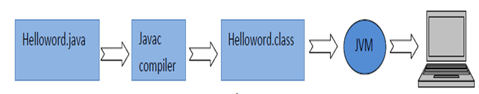
Fig. 1
The Java file instead of translating to machine language of target operating system, which is done in most of the languages, it is translated to an intermediate class file .class file, which is in the byte code specified by JAVA language. The byte code class file is then converted to target machine language by the JVM.
This paper technique is to be implemented while converting the Java to .Class file conversion phase in the Java compiler and based on dead code elimination technique. This technique can be performed at JVM class loader phase.
- Optimization technique
Optimization technique is performed to exploit the efficiency of the code generated by the compiler. The code generator normally would transform the high level language to intermediate language or target machine language, instruction by instruction. The code optimization needs to be performed as well; also, we need to ensure that the optimized code is semantically same as the original program. Second, we need to ensure that the original algorithm of the code is not altered. With the above two point in place, we can plan for the better optimized code.
When the code is optimized from High level language to low level language, the optimizer is called as optimizing compiler, which would also be using the machine registers of target systems. The other technique is source to source optimizer, in this technique the code is targeted at the high level language to high level language conversion.
Normally the best candidate for code optimization is the frequently executed code, and most of the time taken in processing, is this fraction of code. If this part of code is optimized, efficiency is achieved. Most of the time is spent in address calculation, if there are loops and iterated code.
There are two classifications machine dependent and machine independent optimization. Machine dependent technique exploits target machine characteristics. And machine independent has to exploit programming language like language structure, and arithmetic properties and dead code elimination. For example, if there are values in variables, which are unused in the program, then it is considered as dead, and that code can be safely removed.
- Dead code elimination for JVM optimization
As per the compilers theory, the dead code is that part of the code, which is never used anywhere in the program. The variables could be dead if they are not used in the program. In the object oriented programming concept of Java, class is considered to create a new data type and also class form a template for the object instance creation. Most of the classes contain data and the methods which manipulate the data. Fig. 2 is an example of the class, with data and some of the methods defined by the class and the implementation class, which is calling two of the methods from the defined three methods.
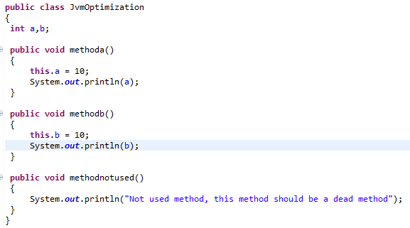
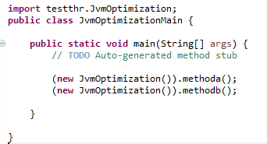
Fig.2
Drawing analogy from the machine independent optimization, we need to find the statement sequence of the code to be executed and, this code should be as minimum, as possible. If we look at the dead code elimination technique, any part of the code, which is never used, could be treated as dead code. However, Java do not tweak in the class after it is created.
Looking at the class file structure as specified in the Oracle site, as in reference [9]. A class file consists of a single ClassFile structure as in Fig 3 below:
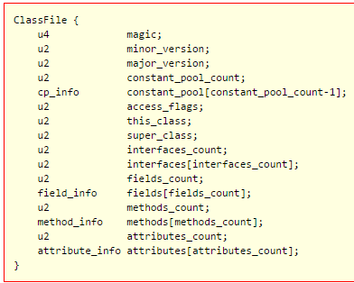
Fig. 3
Discussing only the relevant part of fields in ClassFile structure of Fig. 3, we could see that we have interface count, interface array, methods count and methods array.
Let us take methods into consideration for the study and can apply this for interfaces also.
methods_count: The value of the methods_count item gives the number of method_info structures in the methods table.
methods[]: Each value in the methods table must be a method_info structure in Fig. 4 giving a complete description of a method in this class or interface. If neither of the ACC_NATIVE and ACC_ABSTRACT flags set in the access_flags item of a method_info structure, the Java Virtual Machine instructions implementing the method are also supplied.
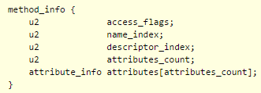
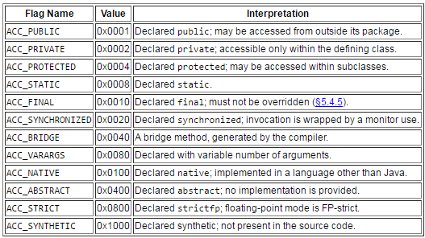
Fig. 4
The method_info structures represent all methods declared by this class or interface type, including instance methods, class methods, instance initialization methods, and any class or interface initialization method. The methods table does not include items representing methods that are inherited from super classes or super interfaces.
As per the structures of method, all the methods in a class are carried to JVM for execution. Some high level languages have a feature of method removal technique, called as attribute removal technique anytime. Below represented example is from Python language (3.4 versions).
class Test:
def __init__(self,r = 0,i = 0):
self.real = r
self.imag = i

def getData(self):
print("{0}+{1}j".format(self.real,self.imag))

Run the code in IDLE:
>>> object1 = Test(5,4)
>>> object1.getData()
5+4j
The result is the complex number 5+4j. We can also delete the method from the class.
>>> del Test.getData
The methods which are not used can be removed from the class, which makes the class lean and this removal of methods could be dynamically performed by the compiler optimization component. The class or the interfaces, are shipped with Java or third party implementation in Java as packages, these normally are designed as per the defined business requirements and not always all the methods are used by the development team or needed in the implementation program.
In the first pass of the compiler, the method JvmOptimization.methodnotused() could be tagged for removal, if the method is not used in forward parsing or the second pass of a two pass compiler, the method can be removed safely as the implementing algorithm is not tampered and also it would be confirmed that the method is not used as per the second pass.
The result .class with byte code should be with only minimum required code without any unused block of code. Binary file of class code, loaded by JVM would be efficient, good to parse for security checking and also interpreting the code block. As the JVM’s are the key virtual machines in Java and targeting heterogeneous systems, the code submitted to JVM should be simple and exact to the problem to solve.
- Conclusion
Dead code elimination technique reduces lot of code; the algorithm should be extended to dynamically modify the byte code class file which is generated by java compiler. The generated .class file would be barely minimum code required as per the implementation classes. This technique would stop the dead methods code entering the JVM.
JVM’s are the famous virtual machines in use. It would always be good to have quality code and lean code entering into the JVM, this way the performance could also be improved. The problem of cleaning JVM’s in system and also on browsers frequently can be reduced. The technique discussed in here can be applied to all object oriented languages, where the dead method code is not eliminated while translation of the high level code.

Abbrevations
JVM: Java Virtual machine.

References
[1] Oracle website,
http://www.oracle.com/technetwork/java/intro-141325.html#334
[2] Oracle website, https://docs.oracle.com/javase/specs/jvms/se7/html/jvms-4.html
[3] Rajini Jindal., “Performance Compilers Construction and Design”, 2001.
[4] Paul Dietel, Harvey Deitel, “Java How to Program, 9th edition”.
[5] Oracle website,
https://docs.oracle.com/javase/tutorial/java/concepts/
[6] Oracle website,
https://docs.oracle.com/javase/specs/jvms/se7/html/jvms-5.html
[7] Python Software Foundation,
https://docs.python.org/2.7/tutorial/classes.html
[8] Programiz,
http://www.programiz.com/python-programming/class
[9] Oracle website,
https://docs.oracle.com/javase/specs/jvms/se7/html/jvms-4.html

Biographies
James Basker, is graduate in engineering from University of Mysore. Previously worked as Assistant professor in department of Computer science, KSRM college of Engineering, He worked in IT industry with Mahindra Satyam, Accenture and major clients like Microsoft. Worked as, engineer consultant for Lumen Infosoft Inc. Member: Python Software foundation, Open research Community ORC, and IEI.

