4.1

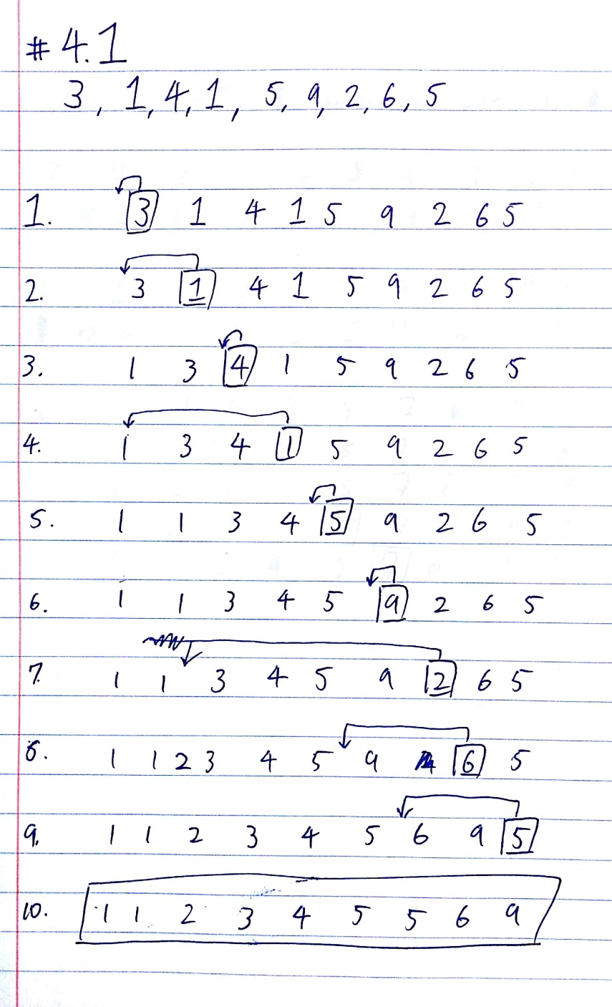

4.2

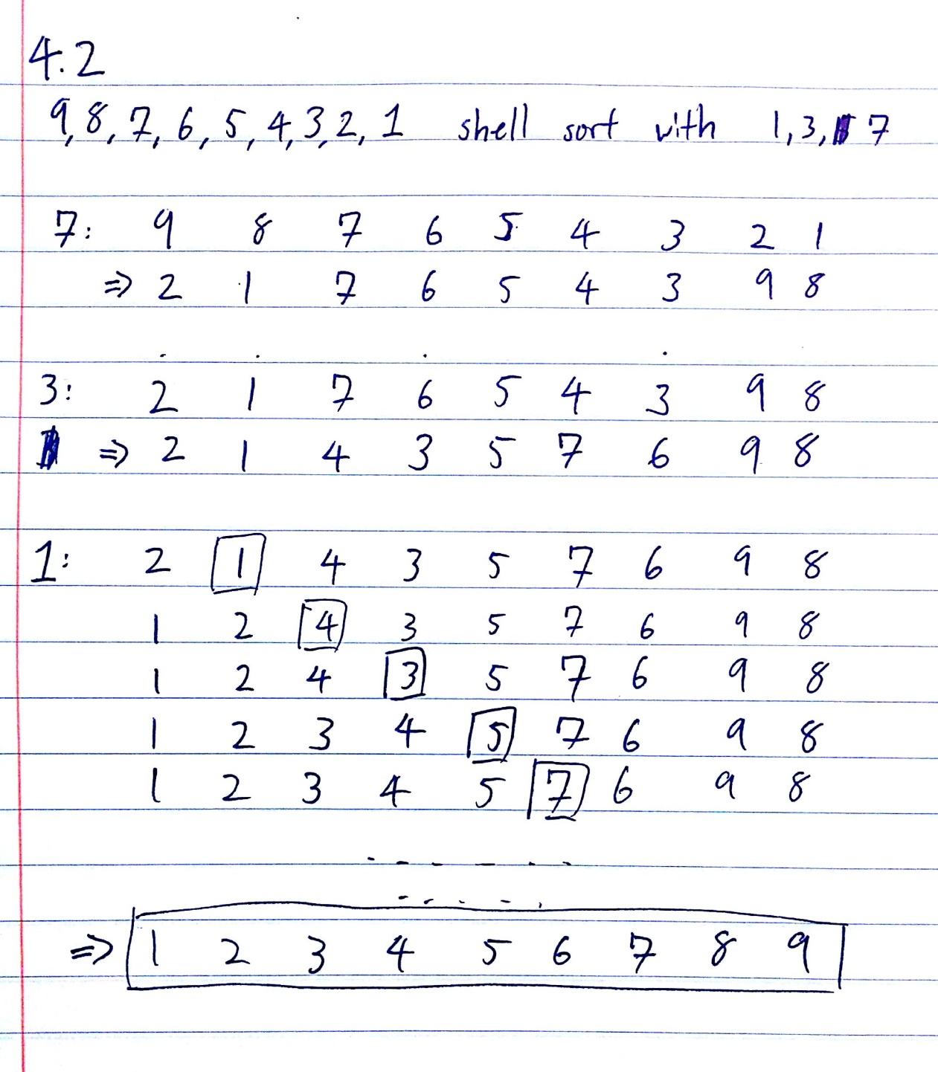

4.3

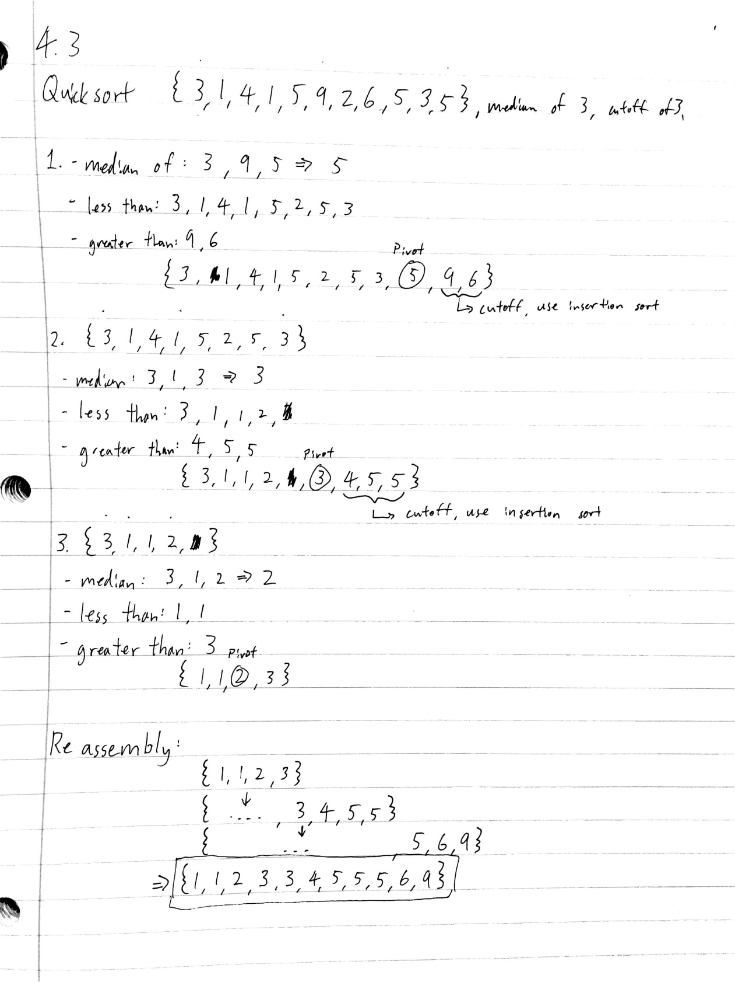

4.4

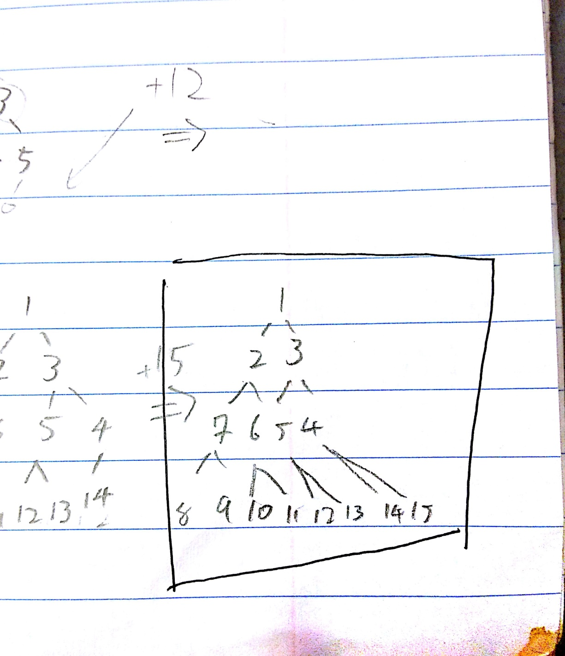

4.5

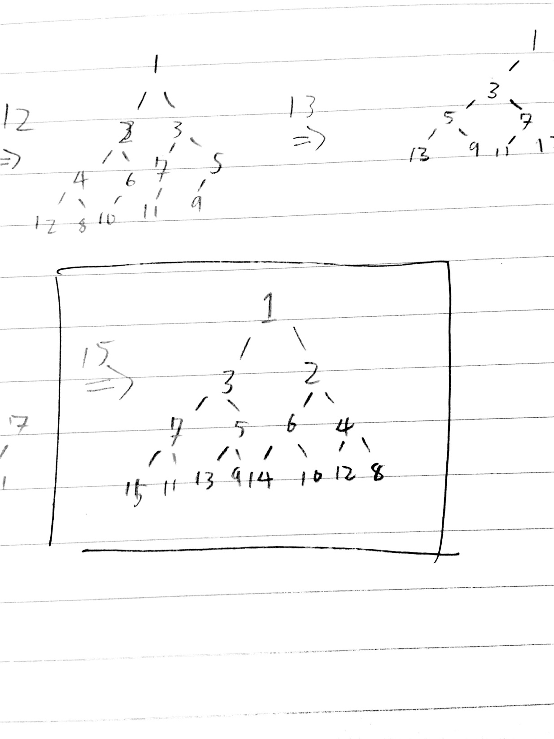

4.6

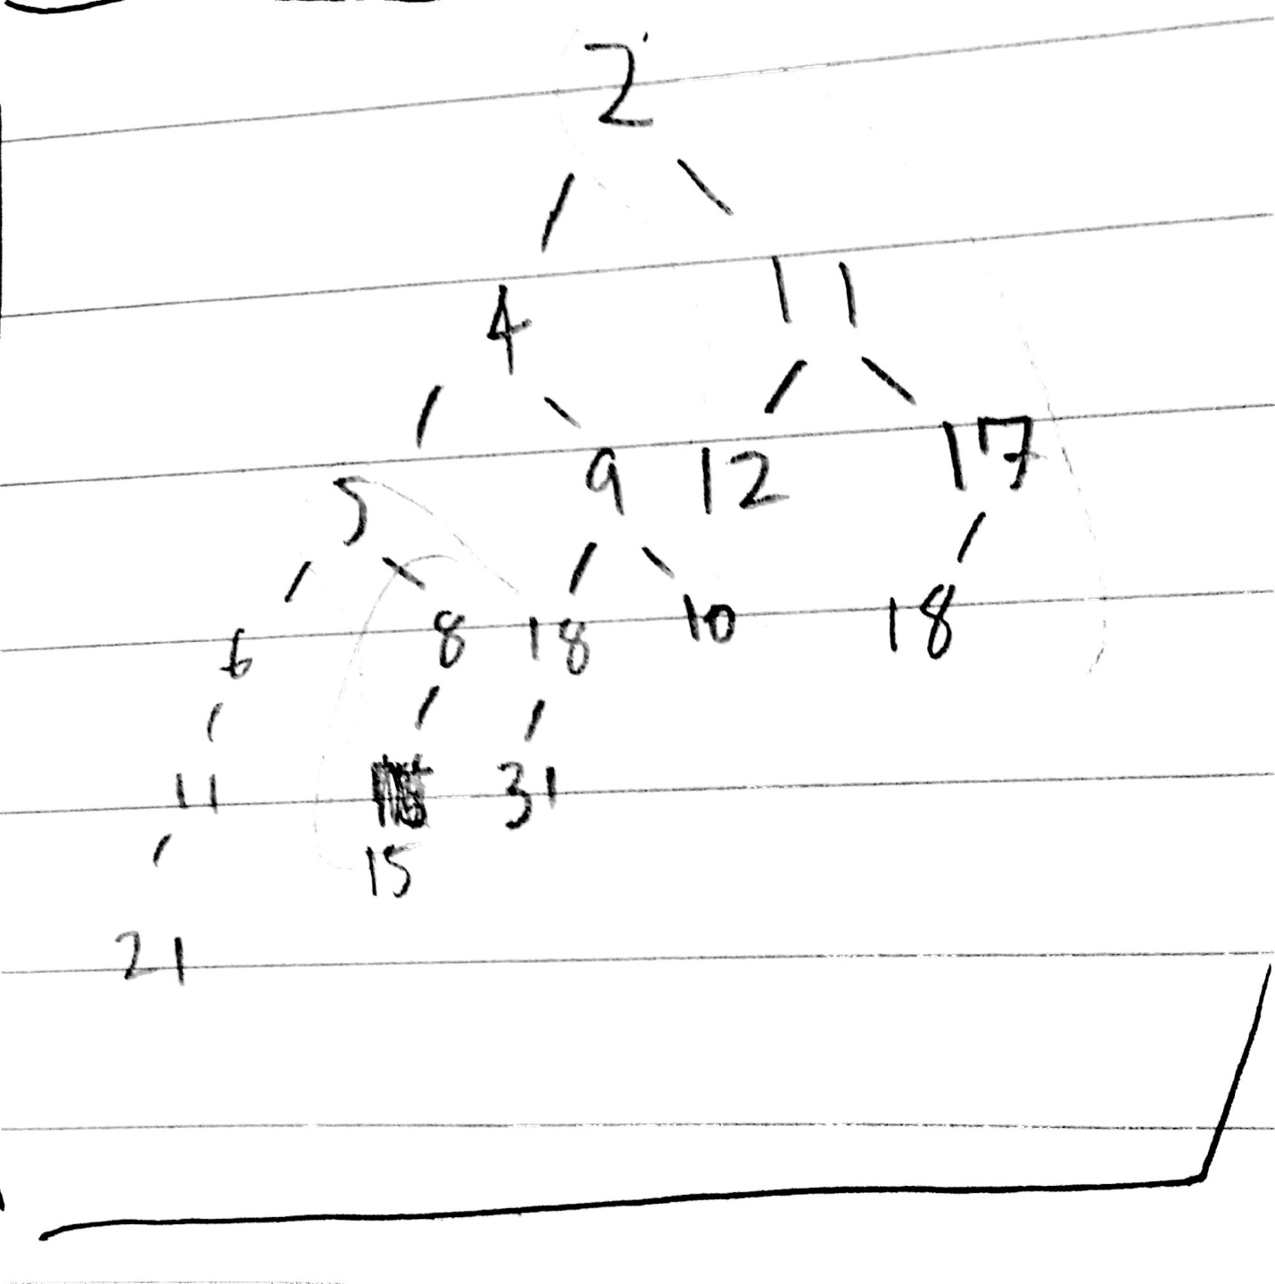

Sorting Results #1

Quicksort-Random:

Comparisons: 78009

Moves: 42257

0.003227 seconds

Quicksort-Increasing:

Comparisons: 107488

Moves: 16142

0.000626 seconds

Quicksort-Decreasing:

Comparisons: 164005

Moves: 24556

0.000721 seconds

Mergesort-Random:

Comparisons: 120444

Moves: 267232

0.00377 seconds

Mergesort-Increasing:

Comparisons: 69008

Moves: 267232

0.001295 seconds

Mergesort-Decreasing:

Comparisons: 64608

Moves: 267232

0.001334 seconds

Heapsort-Random:

Comparisons: 235440

Moves: 124253

0.002789 seconds

Heapsort-Increasing:

Comparisons: 244576

Moves: 131956

0.002754 seconds

Heapsort-Decreasing:

Comparisons: 226720

Moves: 116696

0.001415 seconds

Supoptimal Shell Sort-Random:

Comparisons: 98176009

Moves: 134714

0.063726 seconds

Supoptimal Shell Sort-Increasing:

Comparisons: 98176009

Moves: 0

0.061993 seconds

Supoptimal Shell Sort-Decreasing:

Comparisons: 98176009

Moves: 62560

0.062012 seconds

Insertionsort-Random:

Comparisons: 49995000

Moves: 24800700

0.082299 seconds

Insertionsort-Increasing:

Comparisons: 49995000

Moves: 0

0.004311 seconds

Insertionsort-Decreasing:

Comparisons: 49995000

Moves: 49995000

0.152912 seconds

Sorting Results #2

Quicksort-Random:

Comparisons: 79440

Moves: 42181

0.012533 seconds

Quicksort-Increasing:

Comparisons: 107488

Moves: 16142

0.0034 seconds

Quicksort-Decreasing:

Comparisons: 164005

Moves: 24556

0.009224 seconds

Mergesort-Random:

Comparisons: 120433

Moves: 267232

0.004335 seconds

Mergesort-Increasing:

Comparisons: 69008

Moves: 267232

0.001209 seconds

Mergesort-Decreasing:

Comparisons: 64608

Moves: 267232

0.0012 seconds

Heapsort-Random:

Comparisons: 235438

Moves: 124204

0.002594 seconds

Heapsort-Increasing:

Comparisons: 244576

Moves: 131956

0.001935 seconds

Heapsort-Decreasing:

Comparisons: 226720

Moves: 116696

0.002092 seconds

Supoptimal Shell Sort-Random:

Comparisons: 98176009

Moves: 137493

0.06366 seconds

Supoptimal Shell Sort-Increasing:

Comparisons: 98176009

Moves: 0

0.064571 seconds

Supoptimal Shell Sort-Decreasing:

Comparisons: 98176009

Moves: 62560

0.063173 seconds

Insertionsort-Random:

Comparisons: 49995000

Moves: 24773263

0.088354 seconds

Insertionsort-Increasing:

Comparisons: 49995000

Moves: 0

0.004326 seconds

Insertionsort-Decreasing:

Comparisons: 49995000

Moves: 49995000

0.147716 seconds