Hansen Wu

CS 21A

After launching application:

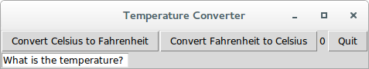

Converting a temperature of 27 from Celsius to Fahrenheit: