Abstract:
Every day we deal with multiple devices that require the correct “key” to be unlocked, let it be the password of a computer or the door finger-scanner unlocking system. Our project, general purpose pin verification system is designed along those lines. It will require a password from the user and will match it with the one stored in its memory. If the password is correct, an LED will start glowing informing the user that the input matches the password stored in its memory.
Introduction:
In order to design this circuit, we started with a decade counter with its outputs going into 7-segment decoder/driver IC that will be driving a 7-segment display. Simultaneously the outputs of the decade counter are also going into a 4-bit register. Furthermore we are using XNOR and AND gates to check if the inputted password is the same as the one stored in the memory of the register. To do this, the output of the 4-bit register is fed to one of the inputs of the XNOR gate with the other input being the user current input and the output of the XNOR gates are the inputs to the AND gates, therefore only when the output of the register and the user input is same will the LED glow.
Rationale behind the project:
Since this is a general purpose pin verification system, the follow up system may contain a lock to be opened, a light to be switched on or perhaps an alarm to be triggered only when the correct password has been fed. Therefore the applications are countless in nature and the circuitry may be used to trigger any follow up network.
Design issues:
There were some design issues faced when assembling the circuit. Due to their nature, these were not apparent when coming up with the theory of the design however when making the circuit some of the problems faced were regarding:
- Chips were very large: in order to make the circuit compact the chips had to be placed very near but due to their large size, the whole of the circuit wasn’t as small in size as previously planned.
- Breadboard cluttered with wires: since there were a number of ICs used, there were a lot of wires present and a lot of effort had to be put in to make sure that the wires weren’t shorting.
- Not very portable: Being a large circuit with a lot of delicate connections, the portability of it is very low because even if a single connection is being damaged the functionality of the whole circuit is drastically affected.
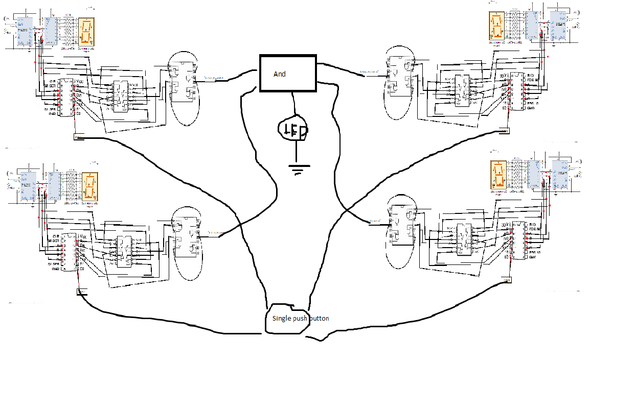
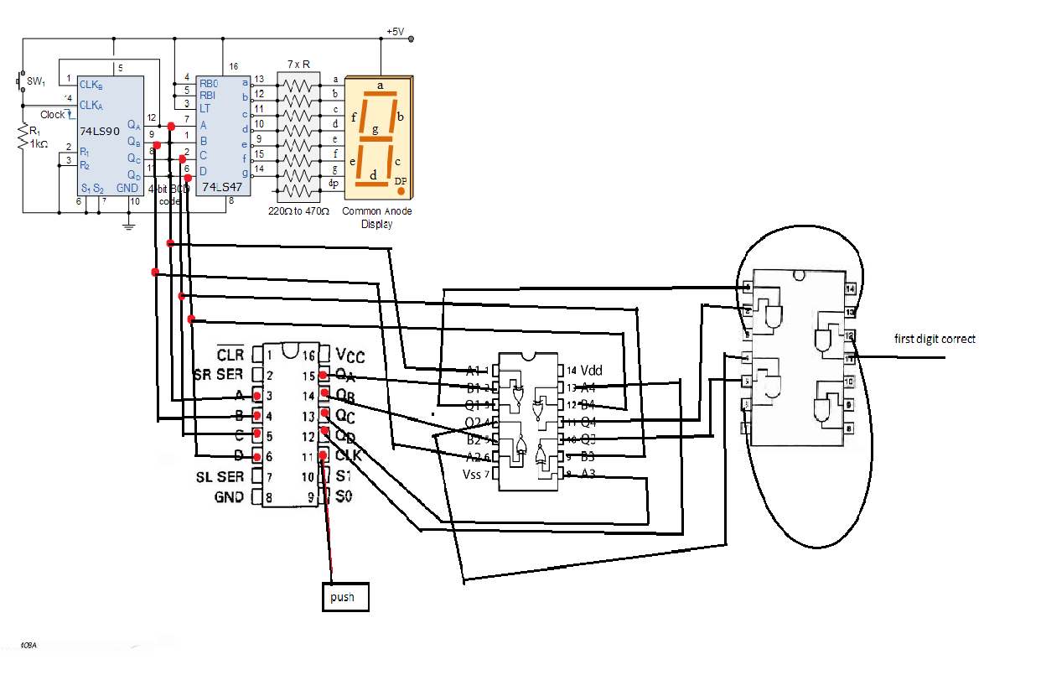
Discussion on choice of ICs
For register, 75hc194 was chosen because the other ICs costed similar but this one had more functionality. A 74ls90 was used because we weren't aware of the functionality and integration of a keypad into a digital circuit without the use of a microcontroller. XNOR were used to compare the pin code bit by bit and the AND gates were used to ensure that all of the bits matched. The decoder was used to show the current number on the seven segment display and facilitate the selection of the pin code.
Discussion on cost effectiveness of project
The project costs a total of PKR 1500 which is a lot. The cost mainly comes from the repetition of ICs which could have been reduced if we had incorporated a Multiplexor and a Demultiplexor to make use of a single decoder but then we would have needed two pulse generators and the cost would rather increase. We could have used a key pad and a microcontroller but that would have been more expensive.
Future direction
The one of the major concerns is the integrity of the system. If anyone has access to the hardware they can easily find out the pin code. To change the saved pin code to the current pin code pressing one button would be enough. In the future we would like to enclose the whole project in a container such that physical penetration would set a flip flop to low and the thing which needs to be opened will be working on an “and” gate from the inside

