Catherine Hall Holiness Christian Church
The Board of Administration

So as your fellow elder and a witness of Christ’s sufferings and as one who shares in the glory that will be revealed, I urge the elders among you: Give a shepherd’s care to God’s flock among you, exercising oversight not merely as a duty but willingly under God’s direction, not for shameful profit but eagerly. And do not lord it over those entrusted to you, but be examples to the flock. Then when the Chief Shepherd appears, you will receive the crown of glory that never fades away.
(1 Peter 5:1-4)

THIS DOCUMENT WITHIN THE BIG PICTURE OF HOLINESS CHRISTIAN CHURCH INC.
The Board of Administration is vested with providing leadership direction in accordance with the policies and programmes and mission of Holiness Christian Church Inc. To this extent, the local church board is responsible for effecting strategies and evaluating same in order that growth (spiritual, physical and numerical) may be facilitated in the local church.

MISSION STATEMENT OF HOLINESS CHRISTIAN CHURCH INC.
The Mission of the Holiness Christian Church is to be a community of perfect love which bears faithful witness to the Gospel of Jesus Christ through the Holy Spirit by: aggressive evangelism. biblical instruction, and. Exemplary holy living.

COMPOSITION OF THE BOARD OF ADMINISTRATION
Pastor
Secretary
Treasurer
Prayer Coordinator
Outreach Director
Evangelism Director
Plant Maintenance Supervisor / Member with responsibility
Member with responsibilities for Sunday School
Member with responsibilities for Youth
Member with responsibilities for Women’s Affair
Member with responsibilities for Men’s Affair

THE BOARD OF ADMINISTRATION : CATHERINE HALL 2019-2020
Pastor – Reverend Trevor Headley
Secretary – Sister Stephanie Edwards
Treasurer – Deaconess Avril Smith
Prayer Coordinator – Deaconess Delva Porter
Outreach Director – Sister Sharon Slowley
Evagelism Director -
Board representative Plant Maintenace – Deaconess Avril Smith
Board representative Sunday School – Sister Sharon Slowley
Board representative Youth Department – Deaconess Alethia Thorpe
Board representative Women’s Department – Deaconess Beverly Headley
Board representative Men’s Department – Deacon Gifford Porter
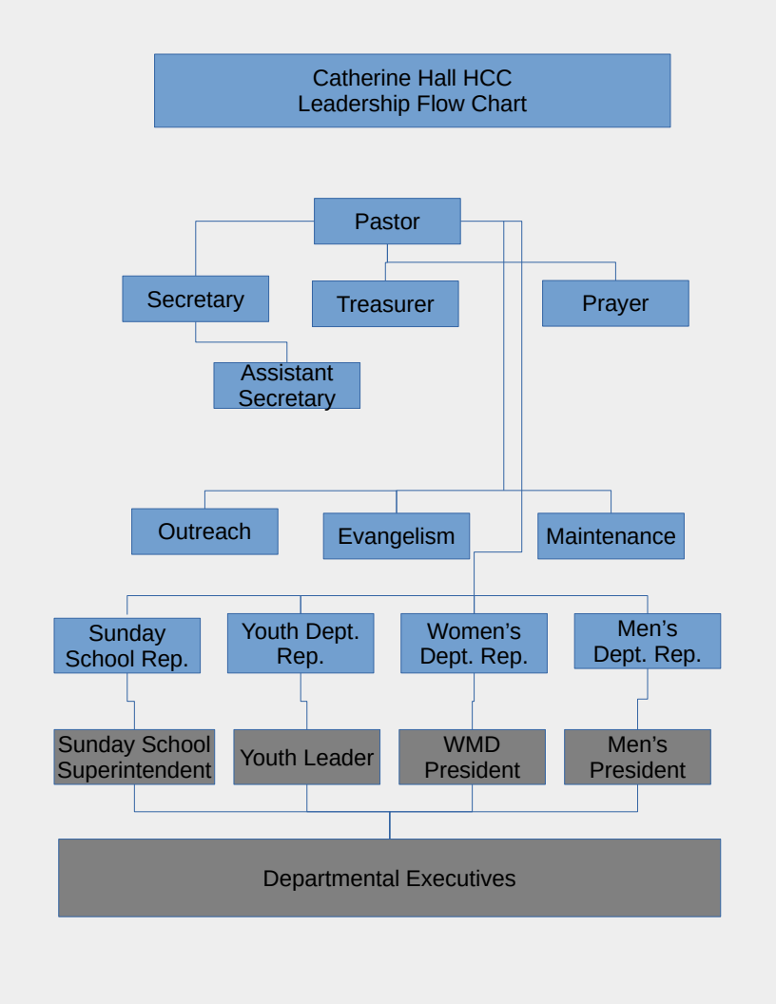
SUNDAY SCHOOL
Statement of Purpose
The Sunday School is tasked with the mandate of teaching the doctrine of Holiness Christian Church Inc. to all. We strive to teach the foundational doctrines of scripture in order that members may develop a vibrant Christian life, understand that God’s word is complete, infallible and authoritative, appreciate the heritage of Holiness Christian Church Inc., thereby becoming loyal members of the local church, and developing Christians who will endeavour to live and teach Christ in their homes and communities.

Leadership Structure
Church Board Representative : Sis. Sharon Slowley
Sunday School Board
Superintendent
Assistant Superintendent
Secretary
Treasurer
Assistant Secretary Treasurer
Public Relations Officer

JOB DESCRIPTION OF THE SUNDAY SCHOOL REPRESENTATIVE TO THE CHURCH BOARD
The Board Representative for the Sunday school serves as liaison between the local church board and the Sunday school board. This person should be a spiritually mature individual who has been a member for five (5) years or more.

ANTICIPATED TIME COMMITMENTS
- Meet with the Sunday School board members once every two months.
- Meet with the Church Board once every two months.

RESPONSIBILITIES / DUTIES
Personal
- Show full support of the Church’s programmes by regular attendance and participation.
- Consistently conduct personal devotions
- Model a Christian life that is consecrated and above reproach.
- Familiarize oneself with current trends of Sunday School ministry; by way of books, magazines, seminars or workshops.

Ministry
- Represent the Sunday School at the board level.
- Assist the Superintendent in ensuring the successful completion of the Sunday School’s mission as set out by the Church Board.
- Assist the Church Board in formulating programmes and policy for the Sunday School.
- Assist the Church Board in vetting the material use in the Sunday School for conformity to the Church’s mission.
- Report any challenges being faced by the Sunday School board
- Work with both boards in formulating the budget for the Sunday School.
- Assist the superintendent with the recruitment of individuals that are able to minister as teachers.
- To assist the Church and Sunday School boards in the timely review of the vision and mission statements of the Sunday School.

PROGRAMME PLANNING
The Sunday School board has the responsibility to plan programmes (which are presented in their 10 Fundamental Elements of an Effective Department) for the effective running of the Sunday School. The following are programme guidelines are set for the Sunday School by the Church board.

- Have at least one major event that is centered on evangelism. This should occur during child’s month each year.
- Have at least one fundraiser during the course of the year.
- Ensue that there is one or more training sessions for teachers.
- Ensure that a ‘share you faith’ workshop for members is conducted during the year.
- Have at least one treat for the Church year.
- Plan and coordinate a Sunday School production for December of each year.

BUDGET DEVELOPMENT
- The figures presented will be review at next Board Meeting
- National Events $35,000
- Training / Workshop $30,000
- Treats / Production $40,000
- Child’s month activities $25,000

PROGRAMME / OPERATIONS EXECUTION
- Keep aware of scheduled Sunday School events and interact with the Superintendent to ensure timely execution.
- Ensure that the resources required by the Sunday School, in order to effect a successful event, are at their disposal.
- Motivate and encourage the Sunday School Board
- Sensitize the Church Board, and by extension the congregation, regarding the upcoming event.

DOCUMENTATION FROM CHURCH BOARD REPRESENTATIVE
- Bi-Monthly reporting to the Church board.
- Sunday School ministry evaluation form every four months.

EVALUATION
The Church board will appraise, in it meetings, the completeness of given duties.

YOUTH DEPARTMENT
Statement of Purpose
The Youth Department is tasked with the mandate of providing ministry to youths aged thirteen (13) to thirty-five years of age. We strive to positively transform the lives of youth, entrusted to our care, by presenting biblical philosophies of thought contrary to the world view on life. We desire that you youth will develop a vibrant Christian life and a deeper understand God’s word; his power to save and preserve humankind, his unfailing love towards us, the infallibility, authoritativeness of his word, and the freedom we have in Christ Jesus; in order that their God give potential may be maximized.

Leadership Structure
Church Board Representative : Deaconess Alethia Thorpe
Youth Department Board
Prisident
Assistant President
Secretary
Treasurer
Assistant Secretary Treasurer
Public Relations Officer

JOB DESCRIPTION OF THE YOUTH DEPARTMENT REPRESENTATIVE TO THE CHURCH BOARD.
The Board Representative for the Youth Department serves as liaison between the local church board and the Youth Department. This person should be a spiritually mature individual who has been a member for five (5) years or more.

ANTICIPATED TIME COMMITMENTS
- Meet with the Youth Department Board members once every two months.
- Meet with the Church Board once every two months.

RESPONSIBILITIES / DUTIES
Personal
- Show full support of the Church’s programmes by regular attendance and participation.
- Consistently conduct personal devotions
- Model a Christian life that is consecrated and above reproach.
- Familiarize oneself with current philosophies of youth ministry; by way of books, magazines, seminars or workshops.

Ministry
- Represent the Youth Department at the board level.
- Assist the Youth Department in ensuring the successful completion of its mission as set out by the Church Board.
- Assist the Church Board in formulating programmes and policy for the Youth Department.
- Report any challenges being faced by the Youth Department Board.
- Work with both boards in formulating the budget for the department.
- To assist the Church and Youth Department boards in the timely review of the vision and mission statements of the Sunday School.

PROGRAMME PLANNING
The Youth Department board has the responsibility to plan programmes (which are presented in their 10 Fundamental Elements of an Effective Department) for the effective running of the Youth Department. The following are programme guidelines are set for the Youth Department by the Church board.

- Have at least one major event that is centered on evangelism. This should take the form of a week of meetings (Youth Week) or a midweek service (Wednesday to Friday.)
- Have at least one fundraiser during the course of the year.
- Ensue that the executive attend the yearly National Youth Department retreat.
- Ensure that members attend National Youth Department events : Sports Day and Youth Camp.
- Ensure members attendance to at least one ‘share you faith’ workshop during the year.
- Host one (1) fellowship outing for the Church year.
- Plan and coordinate programme activities for youth Sundays with is slated for the second Sunday in each month.

BUDGET DEVELOPMENT
The figures presented will be review at next Board Meeting
- National Events $45,000
- Evangelism $30,000
- Training / Workshop $30,000
- Fellowship Outing $40,000
- Outreach $50,000

PROGRAMME / OPERATIONS EXECUTION
- Keep aware of scheduled Youth Department events and interact with the Youth President to ensure timely execution.
- Ensure that the resources required by the Youth Department, in order to effect a successful event, are at their disposal.
- Motivate and encourage the Youth Department Board
- Sensitize the Church Board, and by extension the congregation, regarding the upcoming event.

DOCUMENTATION FROM CHURCH BOARD REPRESENTATIVE
- Bi-Monthly reporting to the Church board.
- Ministry evaluation form every four months.

EVALUATION
The Church board will appraise, in it meetings, the completeness of given duties.

Concerning this document, the following positions on the Church Board are yet to be stated within. These will be completed and appended in subsequent days.
WOMEN’S MISSIONARY DEPARTMENT REP.
MEN’S DEPARTMENT REP.
SECRETARY
TREASURER
PRAYER COORDINATOR
OUTREACH DIRECTOR
EVANGELISM DIRECTOR
PLANT MAINTENANCE SUPERVISOR

Additionally, the ten (10) Fundamental Element of and Effective Department will be appended to this document as they are completed and made available to the Church Board by the following departmental heads.
SUNDAY SCHOOL SUPERINTENDENT
YOUTH PRESIDENT
WOMEN’S MISSIONARY DEPARTMENT PRESIDENT
MEN’S PRESIDENT

Deadline for the completion of the departmental “Ten (10) steps” is February, 18, 2020.
Deadline for the completion of this document, with all its appendages, is February, 21, 2020.

