An Intelligent Aircraft Maintenance Prediction System Using Machine Learning and Real-Time Simulated Data
A Synopsis Submitted
in Partial Fulfillment of the Requirements
for the Degree of
BACHELOR OF TECHNOLOGY
in

Department of CSE - Artificial Intelligence & Machine Learning

by

Soham Chaudhari N42

V Divakar N50

Yug Shah N60

Manjusha Mandhane M49

Guided by

Prof. Soma Joshi


G H Raisoni College of Engineering and Management
Wagholi, Pune
(An Empowered Autonomous Institute, Affiliated to SPPU, Pune,
Affiliated by NAAC A+ Grade)

July, 2026

Synopsis

- Introduction

Aircraft maintenance plays a crucial role in ensuring flight safety, operational reliability, and cost-effective airline operations. Conventional maintenance strategies, such as scheduled and corrective maintenance, often result in unnecessary inspections or unexpected component failures, leading to increased operational costs and aircraft downtime. With advancements in Artificial Intelligence (AI) and Machine Learning (ML), predictive maintenance has emerged as a promising approach for forecasting potential failures before they occur, enabling proactive maintenance planning.

The proposed project, "An Intelligent Aircraft Predictive Maintenance System Using Machine Learning and Real-Time Simulated Data," aims to develop an AI-based predictive maintenance framework capable of monitoring aircraft health and predicting the Remaining Useful Life (RUL) of critical components. The system will compare multiple machine learning models to identify the best-performing model for accurate prediction. To demonstrate real-time system functionality, realistic aircraft sensor data will be simulated and continuously processed through an interactive monitoring dashboard. In addition to failure prediction, the system will generate intelligent maintenance recommendations and maintenance priorities to support informed maintenance decision-making.

The significance of this project lies in its ability to integrate predictive analytics with real-time monitoring and decision support into a unified framework. Unlike conventional predictive maintenance systems that focus primarily on failure prediction, the proposed system emphasizes actionable maintenance insights through maintenance recommendations and prioritization. Furthermore, the modular architecture of the proposed framework enables future integration of additional aircraft subsystems, making it a scalable solution for next-generation intelligent aircraft maintenance systems.

- Literature Review

Table 1: Summary of Literature Review
Sr. No. | Year | Research Paper | Summary of Existing Work | Research Gap / Proposed Contribution
1 | 2025 | A Data-Driven Predictive Maintenance Framework for Aero-Engines Using Trans-LSTM and Bayesian Optimization | The paper proposes a Trans-LSTM model with Bayesian Optimization to predict aircraft engine RUL using the NASA C-MAPSS dataset, improving maintenance cost and availability. | Our project focuses on a broader intelligent aircraft predictive maintenance system that can be extended to multiple aircraft components and support real-time maintenance decisions.
2 | 2025 | Predictive maintenance programs for aircraft engines based on RUL | Developed a hybrid deep learning model that merges LSTM layers with Transformer self-attention mechanisms to process simulated NASA C-MAPSS engine data. The framework uses Bayesian Optimization to tune hyperparameters and establishes optimized, fixed-duration maintenance schedules based on Remaining Useful Life (RUL) targets | Focuses only on aero-engine RUL prediction and fixed maintenance scheduling. Our project aims to develop a scalable aircraft predictive maintenance system that can monitor multiple components and support intelligent maintenance decisions.
3 | 2025 | Predictive maintenance optimization for industrial equipment via reliable prognosis and risk-aware reinforcement learning | Built a two-stage decision pipeline using simulated component degradation streams. First, a Probabilistic Neural Network (PNN) calculates RUL and safety-risk boundaries. Second, a Quantile Regression DQN Reinforcement Learning agent automatically determines. | Focuses on maintenance scheduling for individual components using simulated data. Our project provides a scalable aircraft predictive maintenance system that can be extended to multiple aircraft components with intelligent maintenance.
4 | 2024 | Aircraft Predictive Maintenance: An Application of Machine Learning Algorithms | Integrated traditional physics-based structural wear equations (mass conservation and thermal stress) directly into data-driven Gradient Boosting machine learning algorithms. The model tracks simulated real-time turbine blade telemetry to minimize false alarms and lower unplanned engine ground time. | Limited to turbine blade health prediction using physics-based models. Our project applies machine learning for broader aircraft predictive maintenance across multiple components with intelligent maintenance planning.
5 | 2023 | Predictive Maintenance Analytics and Implementation for Aircraft: Challenges and Opportunities | This paper reviews predictive maintenance techniques, datasets, challenges, and future opportunities in the aircraft industry, highlighting the need for AI, automation, and wider aircraft applications. | Our project implements a machine learning-based predictive maintenance system instead of only reviewing existing research, with emphasis on practical prediction and future real-time integration.

- Problem Statement

Aircraft maintenance is one of the most critical aspects of the aviation industry, as it directly influences flight safety, operational efficiency, and maintenance costs. Conventional maintenance practices are generally based on fixed schedules or performed only after a component failure occurs. Such approaches may lead to unnecessary maintenance activities, increased aircraft downtime, higher operational expenses, and the possibility of unexpected equipment failures.

With the increasing availability of aircraft operational and maintenance data, Machine Learning provides an opportunity to shift from traditional maintenance practices to predictive maintenance. Existing research has demonstrated the effectiveness of predictive models; however, many solutions are limited to specific aircraft components, rely heavily on simulated datasets, or focus only on failure prediction without providing a scalable framework that can support practical maintenance planning.

The primary goal of this project is to develop an Aircraft Predictive Maintenance System Using Machine Learning that can analyze aircraft maintenance data and predict potential component failures before they occur. By identifying maintenance requirements at an early stage, the system aims to improve maintenance planning, reduce unplanned downtime, enhance aircraft reliability, increase operational safety, and minimize maintenance costs.

The project intends to build an intelligent predictive maintenance framework by applying suitable machine learning algorithms to aircraft maintenance data. The proposed system will assist maintenance personnel in making timely and data-driven maintenance decisions, thereby improving overall maintenance efficiency and aircraft availability.

To achieve these goals, the project focuses on collecting and preprocessing aircraft maintenance data, selecting relevant features, training and evaluating machine learning models for failure prediction, identifying components that require maintenance, and generating accurate maintenance predictions. The developed system aims to provide a reliable and scalable solution that can be extended to support future real-time predictive maintenance applications in the aviation industry.

- Methodology
The proposed Aircraft Predictive Maintenance System follows a machine learning-based approach to predict potential aircraft component failures before they occur. The methodology consists of data collection, preprocessing, feature engineering, model training, prediction, and evaluation. The system analyzes aircraft maintenance and sensor data to identify patterns associated with component degradation and provides maintenance recommendations based on prediction results.

  - System Architecture
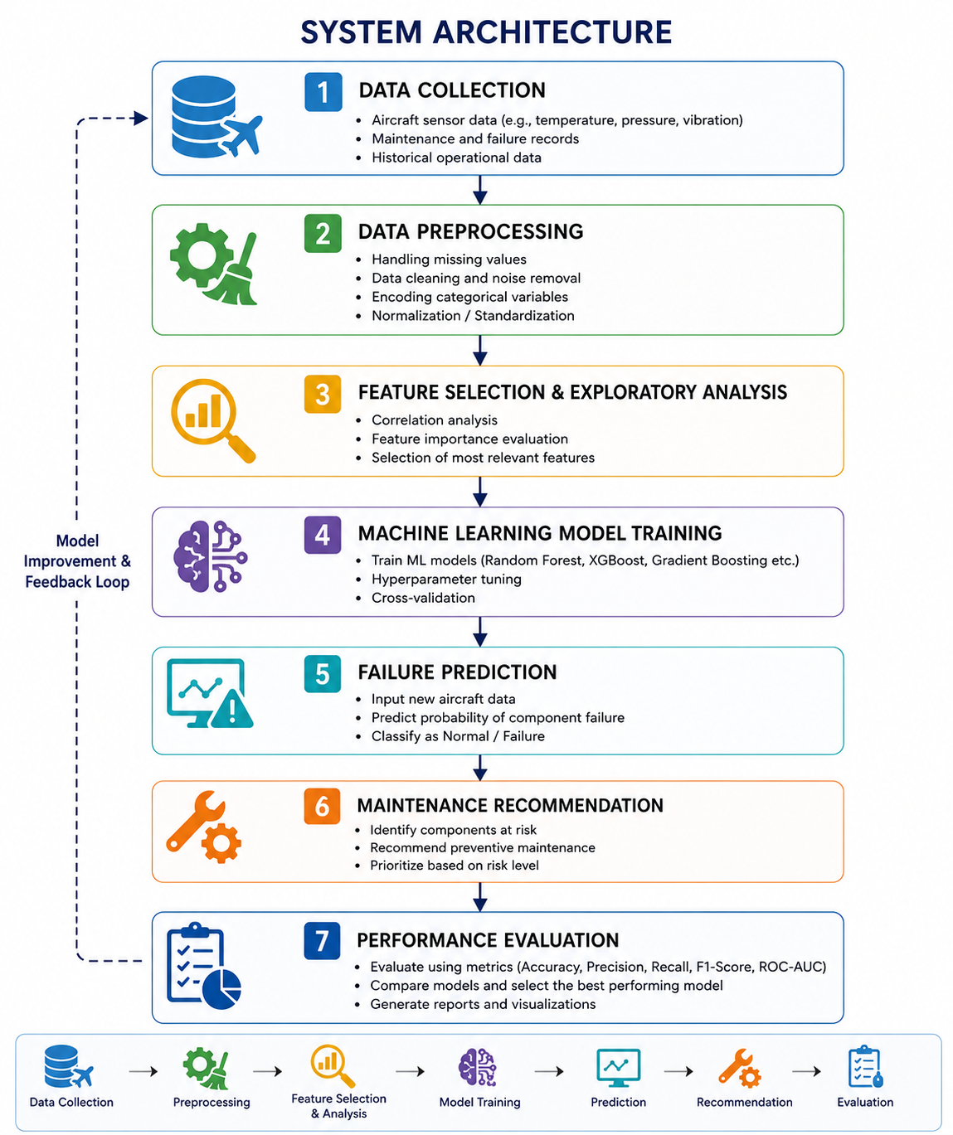
The proposed system consists of the following stages:

Fig 1: System Architecture
  - Algorithms
The project will evaluate suitable supervised machine learning algorithms for predictive maintenance. Algorithms such as Random Forest, XGBoost, and Gradient Boosting will be considered for failure prediction due to their high accuracy and ability to handle complex datasets. The best-performing model will be selected based on evaluation metrics including Accuracy, Precision, Recall, F1-Score, and ROC-AUC.

  - Mathematical Model
The performance of the proposed machine learning model will be evaluated using standard classification metrics based on the confusion matrix.
Let:
- TP = True Positives
- TN = True Negatives
- FP = False Positives
- FN = False Negatives
The evaluation metrics are:
Accuracy
$$\text{Accuracy}=\frac{TP+TN}{TP+TN+FP+FN}$$
Precision
$$\text{Precision}=\frac{TP}{TP+FP}$$
Recall (Sensitivity)
$$\text{Recall}=\frac{TP}{TP+FN}$$

F1-Score
$$\text{F1-Score}=2×\frac{\text{Precision}×\text{Recall}}{\text{Precision}+\text{Recall}}$$
These metrics will be used to compare different machine learning models and determine the best-performing model for aircraft failure prediction.

  - Tools, Technologies and Resources
The implementation will use Python as the programming language with machine learning libraries such as Scikit-learn, Pandas, NumPy, and Matplotlib. Model development and experimentation will be carried out using Jupyter Notebook or Google Colab. Git and GitHub will be used for version control, while publicly available aircraft predictive maintenance datasets (such as NASA C-MAPSS or similar datasets) will be used for model training and testing.

  - Data Collection and Analysis
Aircraft maintenance and sensor datasets will be collected from publicly available repositories. The collected data will undergo preprocessing steps including handling missing values, normalization, feature selection, and data transformation. Exploratory Data Analysis (EDA) will be performed to identify trends, correlations, and patterns associated with aircraft component failures. The processed data will then be divided into training and testing datasets for model development and performance evaluation.

- Project Plan and Timeline

The project will be carried out in a phased manner to ensure systematic development and timely completion. Initially, a literature review and dataset collection will be conducted, followed by data preprocessing and exploratory data analysis. In the next phase, suitable machine learning models will be developed, trained, and evaluated using standard performance metrics. Based on the results, the best-performing model will be selected for predictive maintenance. The final phase will include system validation, documentation, testing, and preparation of the final project report and presentation, ensuring the project is completed within the planned academic timeline.

Table 2: Project Timeline
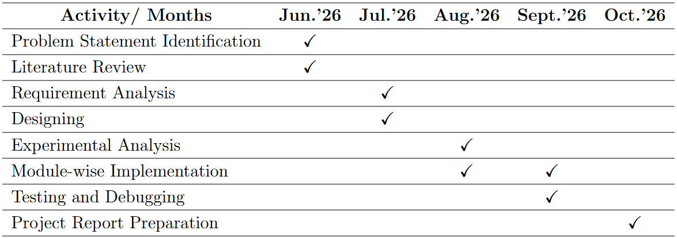

- Expected Outcomes

The proposed project is expected to develop an intelligent Aircraft Predictive Maintenance System Using Machine Learning that can analyze aircraft maintenance records and operational data to predict potential component failures before they occur. By identifying maintenance requirements at an early stage, the system will help maintenance personnel make timely and informed decisions, thereby reducing the risk of unexpected equipment failures and improving overall maintenance efficiency.

The project aims to demonstrate the effectiveness of machine learning algorithms in predictive maintenance by training and evaluating multiple models using standard performance metrics such as Accuracy, Precision, Recall, and F1-Score. The best-performing model will be selected to provide reliable failure predictions and support data-driven maintenance planning. The developed framework is expected to improve maintenance scheduling, reduce unplanned aircraft downtime, optimize resource utilization, and lower operational and maintenance costs.

Another expected outcome is the development of a scalable and flexible predictive maintenance framework that can be extended to monitor multiple aircraft components and accommodate larger datasets. Although the current implementation will utilize publicly available aircraft maintenance datasets, the proposed architecture can be enhanced in the future by integrating real-time sensor data, IoT devices, and advanced predictive analytics. Such enhancements would further improve prediction accuracy and maintenance decision-making.

The project has significant potential applications in the aviation industry, where predictive maintenance can improve aircraft safety, increase fleet availability, and enhance operational reliability. It can assist maintenance engineers and airline operators in adopting proactive maintenance strategies instead of traditional time-based approaches. Overall, the project demonstrates the practical application of Artificial Intelligence and Machine Learning in aircraft maintenance while providing a strong foundation for future research and real-world implementation.

- References

- Wang, J., & Liu, Y. (2025). A data-driven predictive maintenance framework for aero-engines using Trans-LSTM and Bayesian optimization.
- Jin, G., & Zhang, X. (2025). Predictive maintenance programs for aircraft engines based on remaining useful life prediction.
- Xu, Z., & Zhang, Q. (2026). Predictive maintenance optimization for industrial equipment via reliable prognosis and risk-aware reinforcement learning.
- Versha, R. (2024). Aircraft predictive maintenance: An application of machine learning algorithms (Interim Research Report).
- Yildirim, M., & Kaya, O. (2026). Predictive maintenance in aircraft engine maintenance using the C-MAPSS dataset: Performance comparison and evaluation of machine learning classification algorithms.
- Reddy, D., & Sharma, P. (2023). Applications of machine learning and data analytics frameworks for predictive maintenance of aircraft subsystems.
- Stanton, I., Munir, K., Ikram, A., & El-Bakry, M. (2022). Predictive maintenance analytics and implementation for aircraft: Challenges and opportunities.
- Kumar, S., & Raj, A. (2025). A deep learning-based prognostic approach for predicting remaining useful life of aero-engines using simulated data streams.

(Prof. Soma Joshi) (Dr.Shinde B.A) (Dr.Devidas Thosar)
Project Guide Project Coordinator HOD, CSE AI&ML

