A PROJECT REPORT
ON
INTELLIGENT AIRCRAFT PREDICTIVE MAINTENANCE WITH MACHINE LEARNING AND REAL-TIME SIMULATED DATA FOR MAINTENANCE RECOMMENDATION AND PRIORITY
SUBMITTED TO AN AUTONOMOUS INSTITUTE, AFFILIATED TO SAVITRIBAI PHULE PUNE UNIVERSITY, PUNE IN THE PARTIAL FULFILLMENT OF THE REQUIREMENTS
FOR THE AWARD OF THE DEGREE OF
BACHELOR OF TECHNOLOGY
(ARTIFICIAL INTELLIGENCE AND MACHINE LEARNING)
SUBMITTED BY
SOHAM CHAUDHARI | Roll No: N42
V DIVAKAR | Roll No: N50
YUG SHAH | Roll No: N60
MANJUSHA MANDHANE | Roll No: M49
GUIDED BY
PROF. SOMA JOSHI

DEPARTMENT OF CSE ARTIFICIAL INTELLIGENCE AND MACHINE LEARNING
G H RAISONI COLLEGE OF ENGINEERING AND MANAGEMENT
WAGHOLI, PUNE 412207
2026-27


CERTIFICATE
This is to certify that the project report entitled
INTELLIGENT AIRCRAFT PREDICTIVE MAINTENANCE WITH MACHINE LEARNING AND REAL-TIME SIMULATED DATA FOR MAINTENANCE RECOMMENDATION AND PRIORITY
Submitted by
SOHAM CHAUDHARI | Roll No: N42
V DIVAKAR | Roll No: N50
YUG SHAH | Roll No: N60
MANJUSHA MANDHANE | Roll No: M49
are bonafide students of this institute and the work has been carried out by them under the supervision of Prof. Soma Joshi and it is approved for the partial fulfillment of the requirement of An Autonomous Institute, Affiliated to Savitribai Phule Pune University, for the award of the degree of Bachelor of Technology in Artificial Intelligence and Machine Learning in the academic year 2026-27.

(Prof. Soma Joshi) | (Dr. Devidas Thosar)
Guide | HOD CSE-AIML

(……………………….) | (Dr. N. B. Hulle)
External Examiner | I/C Director
GHRCEM, Pune
Date:
Place: Pune

ACKNOWLEDGEMENT
It gives us great pleasure to present “Intelligent Aircraft Predictive Maintenance with Machine Learning and Real-Time Simulated Data for Maintenance Recommendation and Priority” as our B.Tech. project. Words seem inadequate as we try to express our gratitude, at the culmination of this project, to all those who have made it possible.
We are deeply grateful to our project guide, Prof. Soma Joshi, for consistent guidance, encouragement, practical advice and constructive criticism throughout the project, which gave us the impetus to work hard and to keep our claims honest and well supported. We also thank Dr. Devidas Thosar, Head of the Department of CSE Artificial Intelligence and Machine Learning, for continuous support and valuable suggestions.
We take this opportunity to thank our Campus Director Dr. R. D. Kharadkar and I/C Director Dr. N. B. Hulle for their wholehearted support and motivation. We would also like to thank our Project Coordinator Dr. Shinde B. A. for valuable support in providing us with the required information and guidance on the project process.
We acknowledge the researchers and organisations who made the public datasets used in this project available, including the NASA Prognostics Center of Excellence, the UCI Machine Learning Repository and the authors of the aircraft fuel distribution and landing-gear digital-twin datasets.
Finally, we thank all staff members of the Department of CSE Artificial Intelligence and Machine Learning of G H Raisoni College of Engineering and Management, Pune, and our colleagues for their kind support and timely suggestions.

Soham Chaudhari (N42)
V Divakar (N50)
Yug Shah (N60)
Manjusha Mandhane (M49)

ABSTRACT
Aircraft predictive-maintenance research has concentrated on the engine, where the NASA C-MAPSS benchmark is public and well studied. This project extends predictive maintenance to five aircraft subsystems—engine, electrical/battery, hydraulic, fuel and landing gear—by pairing each subsystem with a publicly available dataset and a prediction task suited to that data. The engine module predicts Remaining Useful Life (RUL) on NASA C-MAPSS FD001 with a Random Forest regressor and achieves a mean absolute error (MAE) of 13.80 cycles on 100 unseen test engines. The battery module estimates State of Health (SOH) with linear regression and an experimental RUL with a Random Forest on NASA laboratory battery-ageing data, with MAEs of 2.62 percentage points and 9.36 cycles respectively. The hydraulic module classifies cooler, valve, internal pump leakage and accumulator conditions on the UCI hydraulic test-rig data with accuracies between 83.99% and 96.10% under condition-grouped validation. On physics-informed synthetic digital-twin data, the landing-gear module classifies four shock-strut conditions with a macro F1 of 0.950 and predicts RUL with an MAE of 1.37 percentage points. On the aircraft fuel distribution scenario data, an Extra Trees detector flags 93.13% of abnormal rows but with a high false-alarm rate, so it serves only as a screening signal.
Every model output passes through a rule-based interpretation layer that produces two maintenance decisions—a Maintenance Recommendation and a Maintenance Priority—which a FastAPI backend serves to a React dashboard fed by simulated real-time data. Grouped or chronological validation is used wherever the data have unit or temporal structure, and an automated suite of 232 tests verifies the software. The results demonstrate the feasibility of bringing heterogeneous subsystem models into one maintenance-oriented architecture, while performance varies substantially by dataset and the decision layer still requires validation against real maintenance records.
Keywords: Aircraft predictive maintenance, remaining useful life, state of health, condition monitoring, machine learning, Random Forest, simulated telemetry, maintenance decision support.

TABLE OF CONTENTS
Sr. No. | Title | Page No.
 | CERTIFICATE | i
 | ACKNOWLEDGEMENT | ii
 | ABSTRACT | iii
 | TABLE OF CONTENTS | iv
 | LIST OF FIGURES | viii
 | LIST OF TABLES | ix
 | LIST OF ABBREVIATIONS | xi
 | NOMENCLATURE | xiii
01 | Introduction | 1
 | 1.1 Introduction / Background | 1
 | 1.2 Objectives | 2
 | 1.3 Scope | 2
 | 1.4 Structure of the Report | 3
02 | Literature Review | 4
 | 2.1 Overview | 4
 | 2.2 Maintenance Strategies and Prognostics and Health Management | 4
 | 2.3 Aircraft Engine Prognostics | 6
 | 2.4 Battery Health Estimation and Prognostics | 7
 | 2.5 Hydraulic System Condition Monitoring | 9
 | 2.6 Fuel System Fault Detection | 10
 | 2.7 Landing Gear and Actuator Health Monitoring | 10
 | 2.8 Machine Learning Algorithms for Tabular Sensor Data | 11
 | 2.9 Validation, Data Leakage and Evaluation Metrics | 12
 | 2.10 Maintenance Decision Support | 13
 | 2.11 Public Data Availability for Aircraft Subsystems | 14
 | 2.12 Summary of Literature Survey | 16
 | 2.13 Research Gaps and Opportunities | 19
03 | Methodology | 21
 | 3.1 Research/Development Framework | 21
 | 3.2 Data Collection or Development Process | 23
 | 3.2.1 Dataset Selection Criteria | 23
 | 3.2.2 Engine: NASA C-MAPSS FD001 | 24
 | 3.2.3 Electrical/Battery: NASA PCoE Battery Data Set | 25
 | 3.2.4 Hydraulic: UCI Condition Monitoring of Hydraulic Systems | 25
 | 3.2.5 Fuel: Aircraft Fuel Distribution System Dataset | 27
 | 3.2.6 Landing Gear: Physics-Informed Digital Twin Dataset | 28
 | 3.2.7 Data Validation and Preprocessing | 29
 | 3.2.8 Feature Engineering | 30
 | 3.2.9 Model Development Process | 31
 | 3.3 Tools/Software/Technologies Used | 31
 | 3.3.1 Machine Learning Algorithms | 32
 | 3.4 Validation/Testing Methods | 33
 | 3.4.1 Leakage-Safe Validation Protocols | 33
 | 3.4.2 Regression Metrics | 35
 | 3.4.3 Classification and Detection Metrics | 36
 | 3.4.4 Confidence-Based Acceptance Rule | 37
 | 3.4.5 Software Testing and Reproducibility | 37
04 | Project Design / Implementation | 39
 | 4.1 System Design/Architecture | 39
 | 4.1.1 Architectural Layers | 41
 | 4.1.2 Backend Design | 42
 | 4.1.3 Frontend Design | 42
 | 4.1.4 Key Design Decisions | 43
 | 4.2 Process Flow | 44
 | 4.2.1 Offline Training Flow | 44
 | 4.2.2 Online Prediction Flow | 45
 | 4.2.3 Simulated Real-Time Telemetry | 46
 | 4.3 Key Components/Modules | 46
 | 4.3.1 Data Validation and Manifest Module | 47
 | 4.3.2 Engine RUL Module | 47
 | 4.3.3 Electrical/Battery Module | 48
 | 4.3.4 Hydraulic Condition Module | 48
 | 4.3.5 Fuel Anomaly Module | 49
 | 4.3.6 Landing Gear Module | 49
 | 4.3.7 Maintenance Interpretation Layer | 50
 | 4.3.8 Model Bundles and Release Management | 52
 | 4.3.9 Dashboard Module | 52
 | 4.4 Challenges and Solutions | 52
 | 4.4.1 Further Model Improvement Experiments | 54
05 | Result and Observation | 56
 | 5.1 Data/Results/Screenshots | 56
 | 5.2 Interpretation of Results | 59
 | 5.3 Comparison with Existing Solutions/Approaches | 60
 | 5.4 Limitations and Constraints | 62
06 | Concluding Remarks and Scope for the Future Work | 63
 | 6.1 Achievements | 63
 | 6.2 Future Scope | 64
 | REFERENCES | 66
 | APPENDIX A: TECHNICAL SPECIFICATIONS | 74
 | APPENDIX B: DATASET SCHEMA REFERENCE | 77

LIST OF FIGURES
Figure No. | Illustration | Page No.
1.1 | Evolution of maintenance strategies from reactive to predictive maintenance | 1
2.1 | Distribution of the works cited in this report by topic | 4
3.1 | Phases of the project development framework | 21
3.2 | Mapping of aircraft subsystems to datasets, prediction tasks and selected models | 23
3.3 | Piecewise-linear RUL target with a cap of 125 cycles | 24
3.4 | Causal rolling window: only past samples are used at time t | 30
3.5 | Grouped hold-out schemes used for each subsystem | 35
4.1 | Overall architecture of the proposed system | 40
4.2 | Layered software architecture of the system | 41
4.3 | Offline model training and release flow | 45
4.4 | Online prediction flow from sensor input to dashboard | 46
4.5 | Confidence-based acceptance rule for the hydraulic valve and accumulator classifiers | 49
4.6 | Decision logic of the maintenance interpretation layer | 51
5.1 | Accuracy of the hydraulic and landing-gear classifiers | 57
5.2 | Share of late engine RUL predictions near failure | 58
5.3 | AI Predictions workspace showing a backend engine RUL prediction | 58
5.4 | Maintenance Recommendation and Priority for a subsystem prediction | 58
5.5 | FastAPI backend documentation page | 59

LIST OF TABLES
Table No. | Illustration | Page No.
2.1 | Public data sources examined for the aircraft subsystems | 15
2.2 | Summary of the literature survey | 16
3.1 | Sensors of the UCI hydraulic test rig | 26
3.2 | Condition labels of the UCI hydraulic dataset | 26
3.3 | Fields of the landing-gear digital-twin dataset | 28
3.4 | Data validation checks applied to every dataset | 29
3.5 | Tools, software and technologies used | 31
3.6 | Validation protocol applied to each subsystem | 34
4.1 | Key design decisions and their rationale | 43
4.2 | Summary of the subsystem modules | 47
4.3 | Mapping from health state to maintenance outputs | 50
4.4 | Challenges encountered and solutions adopted | 52
4.5 | Summary of later retraining experiments (research candidates, not promoted to serving) | 54
5.1 | Regression results for engine, battery and landing-gear tasks | 56
5.2 | Hydraulic condition classification results (condition-grouped validation) | 56
5.3 | Landing-gear fault classification and fuel anomaly detection results | 57
5.4 | Engine RUL on the C-MAPSS FD001 test set compared with published models | 60
5.5 | Qualitative comparison with typical existing approaches | 61
A.1 | Specification of the subsystem models | 74
A.2 | Software environment and project assets | 75
B.1 | Column structure of the C-MAPSS FD001 files | 77
B.2 | Files of the UCI hydraulic dataset | 77
B.3 | Files of the Aircraft Fuel Distribution System dataset | 77
B.4 | Record types of the NASA PCoE battery dataset | 78

LIST OF ABBREVIATIONS
Abbreviation | Full Form
AI | Artificial Intelligence
AIML | Artificial Intelligence and Machine Learning
API | Application Programming Interface
BiLSTM | Bidirectional Long Short-Term Memory
C-MAPSS | Commercial Modular Aero-Propulsion System Simulation
CBM | Condition-Based Maintenance
CI | Continuous Integration
CIRA | Italian Aerospace Research Centre
CNN | Convolutional Neural Network
CSV | Comma-Separated Values
CV | Cross-Validation
DT | Digital Twin
EDA | Exploratory Data Analysis
EMA | Electro-Mechanical Actuator
EOL | End of Life
FAA | Federal Aviation Administration
FD001 | C-MAPSS subset with one operating condition and one fault mode
GPR | Gaussian Process Regression
HOD | Head of Department
IVHM | Integrated Vehicle Health Management
JSON | JavaScript Object Notation
LOBO | Leave-One-Battery-Out
LSTM | Long Short-Term Memory
MAE | Mean Absolute Error
ML | Machine Learning
MRO | Maintenance, Repair and Overhaul
NASA | National Aeronautics and Space Administration
PCoE | Prognostics Center of Excellence
PdM | Predictive Maintenance
PHM | Prognostics and Health Management
R² | Coefficient of Determination
RF | Random Forest
RMSE | Root Mean Square Error
RUL | Remaining Useful Life
RVM | Relevance Vector Machine
SDR | Service Difficulty Report
SHA-256 | Secure Hash Algorithm (256-bit)
SHAP | SHapley Additive exPlanations
SOH | State of Health
UCI | University of California, Irvine (Machine Learning Repository)
UI | User Interface

NOMENCLATURE
Symbol | Description
n | Number of test samples
y_{i} | True value of the target for sample i
ŷ_{i} | Predicted value of the target for sample i
ȳ | Mean of the true target values
T_{i} | Final (failure) cycle of engine i
t | Current cycle or time step
RUL_{i,t} | Remaining useful life of unit i at cycle t
R_{max} | RUL cap of the piecewise-linear target (125 cycles)
r_{crit} | Configured RUL threshold for Immediate Maintenance
C_{k} | Discharge capacity of a battery cell at cycle k (Ah)
C₀ | Initial discharge capacity of the cell (Ah)
SOH_{k} | State of health at cycle k (%)
w | Length of the causal rolling window (samples)
x_{t} | Sensor value at time t
μ_{t} | Causal rolling mean at time t
d_{t} | Deviation of x_{t} from the rolling mean
β_{j} | Coefficient of feature j in linear regression
K | Number of classes
B | Number of trees in a tree ensemble
T_{b}(x) | Prediction of tree b for input x
P(y = k | x) | Predicted probability of class k for input x
τ | Confidence threshold of the acceptance rule
TP, TN, FP, FN | True positives, true negatives, false positives, false negatives

CHAPTER 1: INTRODUCTION

1.1 Introduction / Background
Aircraft maintenance is safety-critical and one of the largest controllable costs in airline operations. Every flight depends on interacting subsystems—propulsion, electrical power, hydraulics, fuel distribution and landing gear—and a failure in any of them can ground an aircraft or compromise safety. Unscheduled maintenance is particularly costly: Gerdes, Scholz and Galar studied delay records for an Airbus fleet system and concluded that many delay-causing maintenance actions could have been anticipated with suitable condition monitoring [15].
Maintenance has evolved from reactive repair after failure, through preventive replacement at fixed intervals, to condition-based and predictive maintenance, which forecasts future health so that work can be planned before a failure occurs (Figure 1.1). Jardine, Lin and Banjevic described this as three linked steps: data acquisition, data processing and maintenance decision making [23].
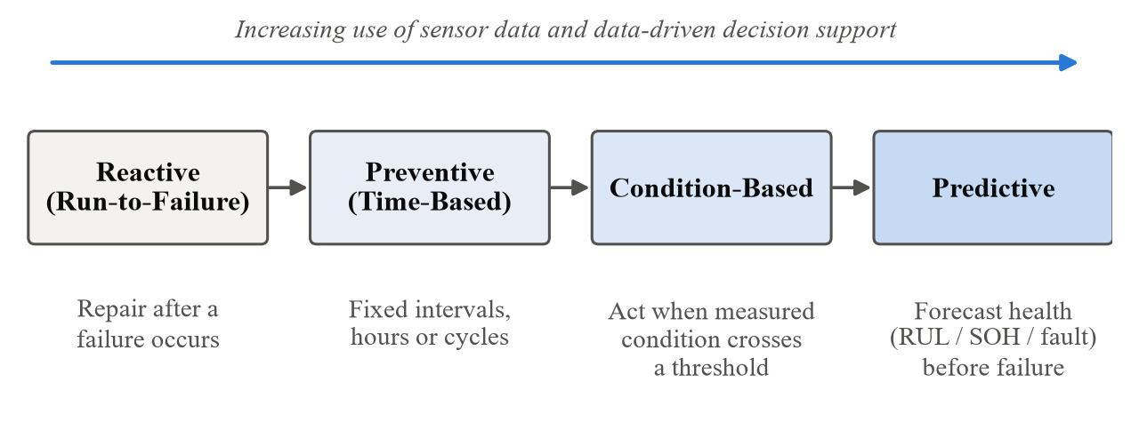
Figure 1.1: Evolution of maintenance strategies from reactive to predictive maintenance
Machine learning (ML) has become the standard tool for the data-processing step [14], [32], but aircraft predictive-maintenance research is dominated by engine studies built on the public NASA C-MAPSS turbofan dataset [49], [57]. Public data for other subsystems is scarcer and heterogeneous, and many studies stop at a numerical prediction such as Remaining Useful Life (RUL) without turning it into an action for a maintenance planner [8].
This project, “Intelligent Aircraft Predictive Maintenance with Machine Learning and Real-Time Simulated Data for Maintenance Recommendation and Priority”, responds to these observations. It covers five subsystems—Engine, Electrical/Battery, Hydraulic, Fuel and Landing Gear—each paired with a public dataset and a suitable prediction task. Every prediction passes through a rule-based interpretation layer that produces two decision outputs, a Maintenance Recommendation and a Maintenance Priority. The models are served by a FastAPI backend to a React dashboard; “real-time” refers to simulated telemetry, not live aircraft data.

1.2 Objectives
- To develop an ML-based predictive-maintenance system covering five aircraft subsystems: Engine, Electrical/Battery, Hydraulic, Fuel and Landing Gear.
- To select a defensible public dataset for each subsystem and state clearly whether it is simulated, experimental, test-rig or synthetic data.
- To build leakage-safe preprocessing and causal feature-engineering pipelines, and to train and compare suitable models for RUL, State of Health (SOH), condition classification and anomaly detection, evaluated on unseen units wherever the data allow.
- To convert every model output into a Maintenance Recommendation and a Maintenance Priority through a transparent, configurable decision layer.
- To integrate the models into a FastAPI backend and a React dashboard driven by simulated data, verified by automated tests.

1.3 Scope
In scope. Five subsystems and datasets: Engine (NASA C-MAPSS FD001; RUL), Electrical/Battery (NASA PCoE battery ageing data; SOH and experimental RUL), Hydraulic (UCI hydraulic test rig; four condition classifications), Fuel (Aircraft Fuel Distribution System scenarios; anomaly detection) and Landing Gear (physics-informed digital twin of a Dornier 228 shock strut; fault classification and RUL). The decision outputs are limited to Maintenance Recommendation and Maintenance Priority; cost, downtime, spares and technician assignment were deliberately excluded.
Limitations. Avionics was excluded because the only public dataset examined describes approach-phase operational anomalies, not avionics component health. No live aircraft telemetry or airline maintenance records are used. The datasets are heterogeneous and partly simulated or synthetic, so the results describe behaviour on benchmark data rather than operational readiness, and the rule-based decision layer has not been validated against real maintenance actions (Section 5.4).

1.4 Structure of the Report
Chapter 2 reviews the literature for each subsystem, maintenance decision support, validation practice and public data availability, and identifies the research gaps. Chapter 3 describes the development framework, the datasets, the tools and algorithms, and the validation and testing methods. Chapter 4 presents the system architecture, process flows, key modules and the challenges met during implementation. Chapter 5 reports, interprets and compares the results and states the limitations. Chapter 6 summarises the achievements and the scope for future work. The references, ordered alphabetically by first author, and two appendices follow.

CHAPTER 2: LITERATURE REVIEW

2.1 Overview
This chapter reviews the research that informs the project. It begins with maintenance strategies and the general field of Prognostics and Health Management (PHM), then examines prior work on each of the five aircraft subsystems covered by the project: engine, electrical/battery, hydraulic, fuel and landing gear. It then reviews the machine-learning algorithms commonly used for tabular sensor data, the validation practices needed to avoid optimistic results, and the literature on turning predictions into maintenance decisions. Because the project depends on public data, the chapter also examines which public data sources exist for each subsystem and which of them are suitable for component health prediction. The chapter closes with a summary table of the literature and a statement of the research gaps that the project addresses.
The review draws on journal articles, conference papers, public dataset documentation and recent preprints. Figure 2.1 shows how the works cited in this report are distributed across topics. The spread reflects a deliberate attempt to look beyond the engine, which dominates the aircraft predictive-maintenance literature, and to give the non-engine subsystems comparable attention.
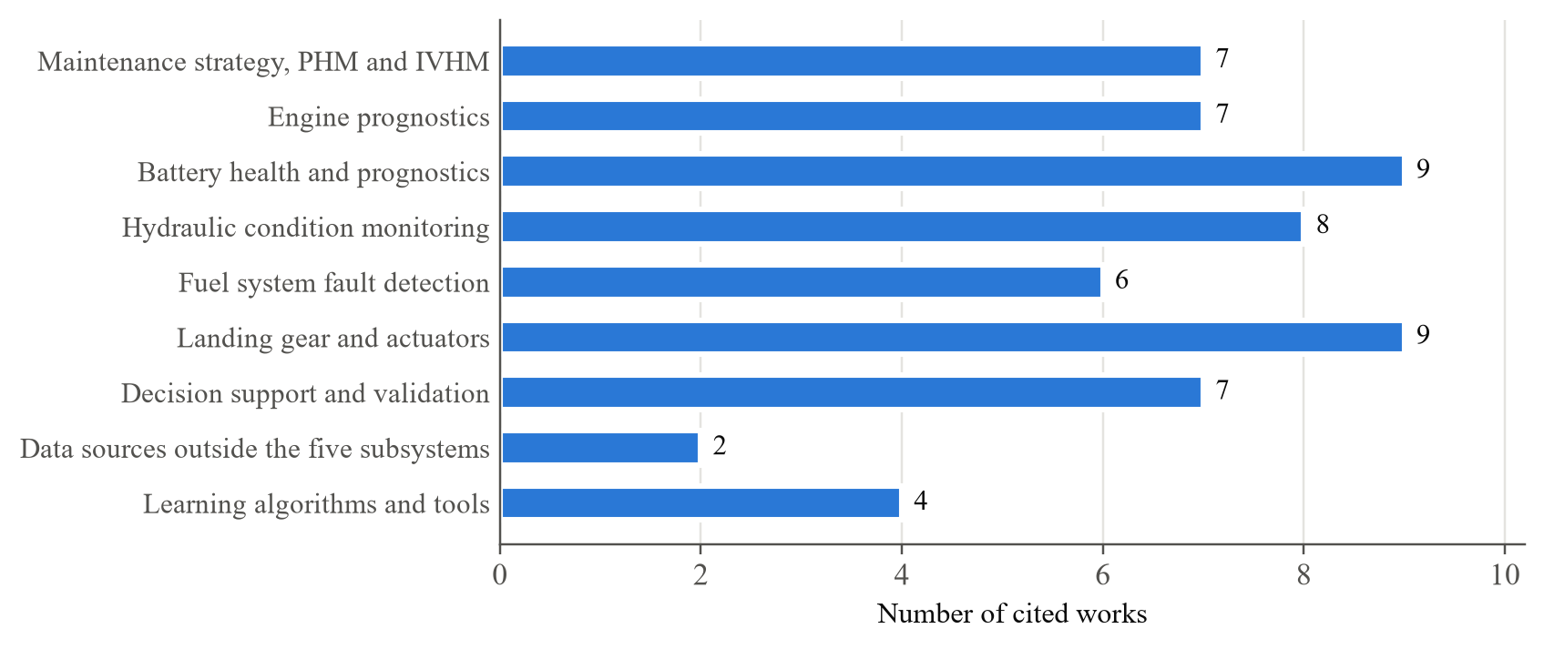
Figure 2.1: Distribution of the works cited in this report by topic

2.2 Maintenance Strategies and Prognostics and Health Management
Maintenance strategies are usually grouped into reactive (run-to-failure), preventive (time- or usage-based), condition-based and predictive maintenance. In their widely cited review, Jardine, Lin and Banjevic framed Condition-Based Maintenance (CBM) as three linked steps—data acquisition, data processing and maintenance decision making—and separated diagnostics, which detects, isolates and identifies a fault that has already occurred, from prognostics, which predicts a fault before it occurs and estimates how much time remains before failure [23]. This distinction is central to the present project: the hydraulic, fuel and landing-gear classifiers perform diagnostic tasks, while the engine, battery and landing-gear regressors perform prognostic tasks.
Lei et al. organised the machinery prognostics literature into four technical processes: data acquisition, construction of a health indicator, division of the degradation process into health stages, and RUL prediction [32]. They grouped RUL prediction approaches into physics model-based, statistical model-based, artificial-intelligence and hybrid approaches, and documented the rapid growth of data-driven methods. Fink et al. later reviewed deep learning for PHM and identified both its potential and its practical obstacles, including the scarcity of labelled fault data, the difficulty of transferring models between operating conditions and the need for interpretable outputs in safety-critical settings [14].
In aviation, Integrated Vehicle Health Management (IVHM) extends the CBM view to the whole aircraft and aims to bring every subsystem under one health-management picture. Esperon-Miguez, John and Jennions reviewed IVHM tools for legacy platforms and discussed the technical and organisational challenges of retrofitting health monitoring to existing aircraft [13]. The economic motivation is documented by Gerdes, Scholz and Galar, who analysed delay-causing maintenance actions for an aircraft system and concluded that a large proportion could have been anticipated with suitable condition monitoring [15].
Two systematic reviews describe the state of aircraft predictive maintenance specifically. Stanton et al. reviewed predictive-maintenance analytics and implementation for aircraft and observed that most published work concentrates on engines, a pattern they linked to the limited availability of public data for other aircraft systems [57]. Scott et al. reached a similar conclusion for defence fixed-wing aircraft sustainment and operations [52]. Both reviews motivate the multi-subsystem scope of this project.
Two health quantities are used repeatedly in this report. Remaining Useful Life (RUL) is the time—measured here in operating or flight cycles, charge–discharge cycles or a percentage of life—that remains before a component reaches a defined failure or end-of-life condition. State of Health (SOH) is a normalised measure of a component’s present condition relative to its new condition; for a battery it is commonly defined as the present capacity divided by the initial capacity. Classification tasks, in contrast, assign a sensor observation to a discrete condition, such as “normal” or “severe leakage”.

2.3 Aircraft Engine Prognostics
The NASA C-MAPSS dataset was produced by Saxena, Goebel, Simon and Eklund, who simulated the degradation of a large commercial turbofan by progressively changing the flow and efficiency of its rotating modules and recording the resulting sensor responses until failure [49]. The public release contains four subsets, FD001 to FD004, which differ in the number of operating conditions and fault modes [48]. FD001 has a single operating condition and a single fault mode, which makes it the cleanest subset and the one most often used for a first study. The same authors introduced an asymmetric scoring function that penalises late RUL predictions more heavily than early ones, because a late prediction can leave a degraded engine in service, whereas an early prediction only brings maintenance forward [49]. Saxena et al. later formalised a broader set of offline metrics for evaluating prognostic algorithms, emphasising that the accuracy of a prognostic should be assessed with respect to time and to the direction of the error [50].
Heimes trained a recurrent neural network for the original PHM 2008 data challenge and is usually credited with the piecewise-linear RUL target, in which the RUL label is held constant early in an engine’s life and allowed to decrease only once degradation becomes observable [20]. The rationale is that the sensors carry almost no information about remaining life while the engine is healthy, so asking a model to distinguish, for example, 300 remaining cycles from 250 remaining cycles is not meaningful. This convention was carried into the deep convolutional neural network of Babu, Zhao and Li, which applied convolution along the time axis of multivariate sensor windows [4], and into the Long Short-Term Memory (LSTM) network of Zheng et al., which modelled the temporal dependence of the sensor sequence [59]. Both studies evaluated their models on C-MAPSS and helped establish deep learning as a common choice for engine RUL.
Tree ensembles nevertheless remain competitive on this benchmark. Alomari, Andó and Baptista compared Random Forest, gradient-boosted and neural regressors on C-MAPSS and proposed an aggregated feature-importance procedure that retains a small number of informative features, improving interpretability without a large loss of accuracy [2]. Interpretability matters in maintenance because an engineer must be able to justify an action taken on the basis of a model. At fleet level, Hartwell et al. described distributed digital twins of aero-engines that update during flight and prioritise the transmission of anomalous data under resource constraints, illustrating how engine prognostics can be embedded in an operational architecture [19].
Three lessons from this literature shaped the engine module of the project. First, the piecewise-linear target with a cap is standard practice, and the project uses a cap of 125 cycles. Second, the direction of the error matters as much as its size, so the project examines late predictions near failure separately from the overall error. Third, a well-tuned Random Forest on carefully engineered features is a reasonable and interpretable baseline. The project does not attempt to propose a new engine model; the engine module is one component of a larger multi-subsystem system.

2.4 Battery Health Estimation and Prognostics
The NASA PCoE battery dataset records charge, discharge and electrochemical impedance measurements on 18650-format lithium-ion cells that were cycled until they reached a capacity-fade criterion [44]. Each discharge record contains terminal voltage, current, temperature, the current and voltage measured at the load, time and the discharge capacity, while the impedance records contain quantities such as electrolyte resistance and charge-transfer resistance. The dataset is a laboratory battery-ageing dataset: it is not a record of an aircraft electrical bus, and it contains no aircraft electrical-fault labels. It is, however, the most widely used public dataset for battery prognostics.
Saha et al. used this data to develop a Bayesian framework that combined relevance vector machines with particle filtering to estimate battery state and predict RUL together with uncertainty bounds [45]. Later studies have applied most of the machine-learning toolbox to the same problem. Li et al. estimated SOH from incremental-capacity features using Gaussian process regression [33]; Ren et al. combined an autoencoder with a deep neural network for RUL prediction [43]; and Swain et al. compared Random Forest and support vector regressors for battery RUL [58]. Mbagaya, Reddy and Botes reviewed these families of models and observed that sequence-aware neural networks tend to outperform classical regressors when enough cycles are available for training [36].
Evaluation protocol is particularly important for battery data because consecutive cycles of the same cell are highly correlated. A random split that places neighbouring cycles of one cell in both the training and the test set can produce optimistic results. Mohamud et al. evaluated a hybrid bidirectional LSTM and Random Forest framework under leave-one-battery-out cross-validation [37], which ensures that the model is always tested on a cell it has never seen. The project adopts this leave-one-battery-out protocol for its experimental battery RUL task.
The connection to aircraft is direct for more-electric and electric aircraft. Goebel et al. argued that the remaining flight time of an electric aircraft depends on battery age as much as on its state of charge [18], and Kulkarni, Roychoudhury and Schumann demonstrated on-board battery monitoring and prognostics on an electric-propulsion test aircraft [30]. These works justify grouping battery health under the Electrical/Battery subsystem of the dashboard, while the project is careful to describe the underlying data as laboratory battery-ageing data.
A known difficulty with this dataset is capacity regeneration: after a rest period the measured capacity of a cell can briefly increase before the downward ageing trend resumes. A model built on discharge-curve features may read such a temporary recovery as a genuine improvement in health, which tends to produce isolated large errors. This phenomenon is one reason why the SOH results of the project show a root-mean-square error noticeably larger than the mean absolute error (see Section 5.2).

2.5 Hydraulic System Condition Monitoring
The hydraulic dataset used in this project was collected by Helwig, Pignanelli and Schütze on an instrumented hydraulic test rig and released through the UCI Machine Learning Repository [22]. The rig consists of a primary working circuit and a secondary cooling and filtration circuit, and the condition of four components—the cooler, the switching valve, the internal pump and the hydraulic accumulator—was varied systematically while pressure, flow, temperature, vibration and power were recorded. The original paper applied multivariate statistical methods to detect and quantify the induced faults [21], and a follow-up by Schneider, Helwig and Schütze automated feature extraction and selection for such cyclical time-series data [51].
The dataset has since become a common benchmark. Alenany, Helmi and Nasef reported that a Random Forest trained on a small set of time-domain statistics per sensor performs well on all four targets, with the accumulator target being the hardest [1]. König and Helmi applied convolutional neural networks directly to the raw signals and used occlusion-based sensitivity analysis to rank the importance of the sensors [29]. Kim and Heo compared eight classifiers after Boruta feature selection [28]. These studies show that simple per-cycle summary statistics already carry much of the information needed for classification, which is the approach followed in this project.
An important methodological warning comes from a recent preprint by Shamim et al., who showed that random or sliding-window splits on time-ordered condition-monitoring data can produce unstable and inflated results, and argued for leakage-robust evaluation [53]. Because the hydraulic rig visits each combination of component conditions in a structured sequence, the project keeps cycles that share a condition combination together on one side of the split rather than splitting rows at random.
Aviation-specific hydraulic diagnosis has been explored with one-dimensional multichannel convolutional neural networks by Shen and Zhao [54]. Khan et al. surveyed predictive maintenance for aircraft engines and hydraulic systems and noted that dedicated work on aircraft hydraulics remains limited compared with engines [27]. The UCI rig is an industrial test rig rather than an aircraft system, so the project treats it as hydraulic condition-monitoring data representative of the type of signals and faults found in hydraulic circuits, not as aircraft operational data.

2.6 Fuel System Fault Detection
Public data for aircraft fuel systems is rare. The dataset used in this project was published by Aslansefat et al. and describes a simplified aircraft fuel distribution system in which two tanks feed two engines, with tank-level, temperature and flow sensors [3]. It originates from the Safety+AI work of Gheraibia et al., who combined fault-tree analysis with machine learning so that safety models could be updated from operational data [17]. The dataset provides one normal scenario and four abnormal scenarios as separate files, which makes it suitable for scenario-level anomaly detection but provides only a narrow picture of normal operation.
Earlier laboratory work at Cranfield University used a bench-top fuel rig to design IVHM sensor placement and diagnostic rules for an unmanned aerial vehicle fuel system [38] and to detect valve faults with Bayesian change-point detection [39]. More recently, Skaf et al. emulated filter clogging on a similar rig using a direct-acting proportional valve, defined five clogging severity classes and compared neural-network, nearest-neighbour, naive Bayes and decision-tree classifiers [55]. A publicly downloadable version of their measurements was not found during this project, so that paper serves as a literature reference rather than a data source. Jigajinni modelled a four-tank fuel system and used neural and neuro-fuzzy techniques to detect leakage and pump faults [24].
The fuel literature therefore shows that fault detection is feasible on instrumented rigs and simulations, but that public, labelled fuel-system data with many independent normal and faulty runs is scarce. This scarcity directly limits what any model trained on the available public data can achieve, as the fuel results in Chapter 5 confirm.

2.7 Landing Gear and Actuator Health Monitoring
Landing-gear research is divided between structural fatigue assessment and component-level diagnosis. El Mir and Perinpanayagam reviewed the certification issues that arise when machine learning is used for safe-life assessment of landing gear, highlighting the evidence that regulators would require before such models could be relied upon [12]. Pinello et al. built a preliminary digital twin of a nose landing gear and tested diagnostic algorithms on the steering, retraction and oleo-pneumatic shock-absorber subsystems [42].
Simulation is widely used because real landing-gear fault data is rarely published. Li, Chen and Qin generated a simulation-based training database from a multibody model and trained a deep network to detect changes in orifice area, gas pressure and gas volume of the shock absorber from accelerometer signals [34]. Chen et al. addressed retraction and extension faults with a one-dimensional dilated convolutional network [11], and Kadripathi et al. proposed a two-tier classifier that corrects irregular sensor readings before performing diagnosis [25].
NASA’s electro-mechanical actuator (EMA) programme, relevant to actuation systems including landing gear, produced both an experimental fault-injection test bed with nominal and fault data [6] and a diagnostic approach based on failure-mode analysis [5]. During this project, however, those resources were found to be available mainly as research papers rather than as a directly usable raw dataset, so they are used here as background literature.
A physics-informed digital twin of a Dornier 228 oleo-pneumatic shock strut has been described in a preprint by Sani and Uhiah [47], and a companion dataset is available on Kaggle [46]. The dataset provides per-landing features such as maximum deflection, maximum velocity, settling time, aircraft mass, stiffness and damping, a fault code (normal, nitrogen gas leak with reduced stiffness, worn seal with reduced damping, and early structural degradation) and an RUL percentage. It forms the basis of the landing-gear module of this project. Because the data is generated by a model, it is described throughout this report as physics-informed synthetic landing-gear data and not as real aircraft operational data.

2.8 Machine Learning Algorithms for Tabular Sensor Data
After feature engineering, most of the project’s data takes a tabular form: each row describes an engine cycle, a battery discharge, a hydraulic cycle, a fuel-system time step or a landing event. For such data the literature favours a small set of well-understood algorithms.
Linear regression models a continuous target as a weighted sum of the input features. It is fast, transparent and difficult to overfit when the number of features is moderate, and it is an appropriate baseline whenever the relationship between features and target is close to linear—as is often the case for battery SOH, which tracks discharge-curve features closely. Logistic regression extends the linear model to classification by passing a linear score through the logistic (or, for several classes, the softmax) function to produce class probabilities. Its probabilistic outputs are useful for confidence-based decision rules.
Random Forests, introduced by Breiman, train many decision trees on bootstrap samples of the data and choose each split from a random subset of features; the trees’ predictions are averaged for regression or voted for classification [9]. Averaging decorrelated trees reduces variance, captures non-linear relationships and interactions without manual specification, and provides feature-importance estimates. Extremely randomised trees (Extra Trees), proposed by Geurts, Ernst and Wehenkel, go further by choosing split thresholds at random and, in the standard formulation, training each tree on the full sample; the additional randomisation often reduces variance further and speeds up training [16]. Gradient boosting, and in particular XGBoost by Chen and Guestrin, builds trees sequentially so that each new tree corrects the residual errors of the ensemble, with explicit regularisation [10].
Deep-learning models such as CNNs and LSTMs [4], [59] can learn features directly from raw sequences but typically require more training data, more tuning and more effort to explain. For datasets as small as some of those used here—the fuel dataset contains 855 rows and the battery dataset only a few tens of cells—well-regularised classical models are a defensible choice. The project uses the scikit-learn library [41], which provides consistent implementations of these algorithms.

2.9 Validation, Data Leakage and Evaluation Metrics
Kaufman et al. defined data leakage as the introduction of information into model training that would not be legitimately available at prediction time, and proposed a strict separation between the data used to learn and the data used to predict [26]. In predictive maintenance, leakage commonly arises when rows from the same engine, battery cell, test-rig condition or scenario appear in both training and test sets, or when preprocessing statistics such as scaling parameters are computed on the full dataset before splitting. Bergmeir and Benítez showed that ordinary k-fold cross-validation can be misleading for time-series data and argued for blocked schemes that respect temporal order [7]. Shamim et al. reported similar effects for condition-monitoring benchmarks [53].
The choice of metric is equally important. For classification with imbalanced classes, Sokolova and Lapalme showed that plain accuracy can hide poor performance on minority classes and recommended macro-averaged measures that give each class equal weight [56]. Balanced accuracy—the average recall across classes—and macro F1 are therefore preferred to accuracy alone. For prognostics, Saxena et al. argued for metrics that consider the timing and direction of errors, because late predictions are more dangerous than early ones [49], [50]. For regression, the mean absolute error (MAE) and root-mean-square error (RMSE) are reported in the unit of the target, and the coefficient of determination R² describes the share of variance explained. R² is not a percentage accuracy and is not described as such in this report.
These principles determined the validation design of the project: engine-grouped validation for C-MAPSS, leave-one-battery-out evaluation for battery RUL, condition-grouped validation for the hydraulic rig, scenario-level hold-out for the fuel data and mass-regime hold-out for the landing-gear data. They are described in detail in Section 3.4.

2.10 Maintenance Decision Support
Producing a health estimate is not the same as deciding what to do. Bougacha, Varnier and Zerhouni reviewed post-prognostic decision making in PHM and found that most studies stop at prediction and leave the translation into maintenance actions to the reader [8]. Their review separates health assessment from the subsequent decision problem, which may involve maintenance scheduling, resource planning or mission adaptation. This separation is reflected in the design of the project, where the decision layer is a distinct component that consumes model outputs.
The introduction of data-driven maintenance into airline operations also carries risks. Lee et al. used agent-based modelling and hazard identification to identify twenty hazards that data-driven predictive aircraft maintenance can introduce into operations, ranging from data-quality problems to over-reliance on model outputs [31]. Their findings support two design choices in this project: predictions that the model is not confident about are flagged for human review rather than silently accepted, and the decision thresholds are stored as configuration so that they can be reviewed and tuned by domain experts.
Digital twins and simulated telemetry are increasingly used to exercise such decision pipelines before real data is available. Hartwell et al. illustrate this for aero-engine fleets [19], and the IVHM literature emphasises the value of a common health picture across subsystems [13]. At the same time, a rule-based decision layer is only as good as its thresholds: without records of actual maintenance actions, the operational correctness of the recommendations cannot be validated. This report therefore distinguishes clearly between the experimentally evaluated ML predictions and the rule-based maintenance decisions derived from them.

2.11 Public Data Availability for Aircraft Subsystems
Selecting the five subsystems required examining several public data sources, some of which serve a different purpose from component health prediction. Table 2.1 summarises the sources that were examined and the decision taken for each. C-MAPSS models turbofan module degradation and therefore belongs to the engine module only; although it contains fuel-flow-related parameters, it is not a fuel-system dataset [49]. A centrifugal pump dataset published on Zenodo by the Italian Aerospace Research Centre (CIRA) concerns industrial pumps supplying demineralised water to boilers rather than aircraft fuel pumps. The fuel-rig measurements of Skaf et al. are described but not released [55].
For landing gear, the FAA Service Difficulty Reports (SDR) were examined. They are narrative incident records with fields such as part name, part condition and a free-text discrepancy description; they are suited to text mining, as Niraula et al. showed for depressurisation events [40], but they are not sensor time series and cannot support RUL modelling. NASA’s electro-mechanical actuator work is available mainly as papers [5], [6], and a Microsoft Flight Simulator 2020 runway dataset concerns runway images for computer vision rather than landing-gear health.
For avionics, the NASA DASHlink Sample Flight Data project offers a curated anomaly-detection dataset of roughly 99,000 commercial regional-jet flights on final approach, labelled as nominal or as one of three operational anomalies—speed high, path high and flaps late setting [35]. It is a valuable aviation anomaly dataset, but it describes how an approach was flown rather than the condition of an avionics component. It cannot support avionics component RUL, degradation or failure prediction. Avionics is therefore treated in this project as part of the data gap rather than as an implemented module.
Table 2.1: Public data sources examined for the aircraft subsystems
Data source | Subsystem considered | Nature of the data | Decision in this project
NASA C-MAPSS (FD001) | Engine | Simulated turbofan degradation, run-to-failure | Used for engine RUL
NASA PCoE Battery Data Set | Electrical / Battery | Laboratory Li-ion cell ageing (charge, discharge, impedance) | Used for SOH and experimental RUL
UCI Hydraulic Systems (ID 447) | Hydraulic | Test-rig condition monitoring, 2,205 cycles | Used for four condition classifications
Aircraft Fuel Distribution System | Fuel | Simplified fuel-system scenarios: one normal, four abnormal | Used for binary anomaly detection
Landing Gear Digital Twin (Dornier 228) | Landing Gear | Physics-informed synthetic landing events | Used for fault classification and RUL
Zenodo centrifugal pump data (CIRA) | Fuel | Industrial boiler-feed pumps (demineralised water) | Rejected: not an aircraft fuel pump
Skaf et al. fuel-rig data | Fuel | Filter-clogging rig experiments | Not publicly released; literature only
FAA Service Difficulty Reports | Landing Gear | Narrative incident records (HTML table export) | Rejected for RUL; suitable for text mining
NASA EMA resources | Landing Gear | Research papers on actuator test beds | No raw dataset verified; literature only
MSFS 2020 runway dataset | Landing Gear | Runway images and segmentation masks | Rejected: not health data
NASA DASHlink Sample Flight Data | Avionics | Final-approach operational anomaly labels | Rejected: avionics excluded from scope

2.12 Summary of Literature Survey
Table 2.2 summarises the most relevant works reviewed in this chapter, the data and methods they used, and their relevance to this project.
Table 2.2: Summary of the literature survey
Sr. No. | Author(s) and Year | Data and Method | Key Findings and Relevance
1 | Jardine, Lin and Banjevic (2006) [23] | Review of machinery diagnostics and prognostics | Framed CBM as data acquisition, processing and decision making; basis of the project pipeline
2 | Lei et al. (2018) [32] | Systematic review of machinery prognostics | Four processes from data to RUL; documents the growth of data-driven methods
3 | Gerdes, Scholz and Galar (2016) [15] | Delay records of an Airbus fleet system; cost analysis | Many delay-causing actions could be anticipated with condition monitoring
4 | Stanton et al. (2023) [57] | Systematic review of aircraft predictive maintenance | Engines dominate the literature; data for other systems is limited
5 | Saxena et al. (2008) [49] | C-MAPSS turbofan damage-propagation simulation | Created the engine benchmark and an asymmetric score penalising late predictions
6 | Heimes (2008) [20] | Recurrent neural network on PHM08 data | Introduced the piecewise-linear RUL target used in this project
7 | Babu, Zhao and Li (2016) [4] | CNN regression on C-MAPSS sensor windows | Deep learning for engine RUL; uses a capped RUL target
8 | Zheng et al. (2017) [59] | LSTM network on C-MAPSS | Sequence modelling of engine degradation
9 | Alomari, Andó and Baptista (2023) [2] | Random Forest, gradient boosting and neural regressors with aggregated feature importance | Tree ensembles remain competitive; interpretable feature sets
10 | Saha et al. (2009) [45] | NASA battery data; RVM with particle filter | Battery RUL with uncertainty bounds
11 | Li et al. (2020) [33] | Incremental-capacity features; Gaussian process regression | Accurate SOH estimation from capacity-curve features
12 | Ren et al. (2018) [43] | Autoencoder with deep neural network | Deep-learning battery RUL prediction
13 | Mohamud et al. (2026) [37] | Hybrid BiLSTM–Random Forest; leave-one-battery-out CV | Unseen-cell validation protocol adopted for battery RUL
14 | Helwig, Pignanelli and Schütze (2015) [21] | Hydraulic test rig; multivariate statistics | Origin of the UCI hydraulic dataset and its four fault targets
15 | Alenany, Helmi and Nasef (2021) [1] | Random Forest on time-domain statistics per sensor | Summary statistics suffice; accumulator is the hardest target
16 | König and Helmi (2020) [29] | CNN on raw hydraulic signals; occlusion analysis | Ranks sensor importance for each target
17 | Shamim et al. (2026) [53] | Leakage-robust evaluation of multi-task models | Random or sliding-window splits can inflate results
18 | Gheraibia et al. (2019) [17] | Safety+AI: fault-tree analysis with machine learning | Origin of the aircraft fuel distribution dataset
19 | Skaf et al. (2023) [55] | Fuel rig with emulated filter clogging; NN, kNN, naive Bayes, decision tree | Five clogging classes; data not publicly released
20 | Pinello et al. (2024) [42] | Nose landing gear digital twin | Diagnostics for steering, retraction and shock absorber
21 | Li, Chen and Qin (2025) [34] | Multibody simulation database; deep network | Detects orifice and gas changes in the shock absorber
22 | Sani and Uhiah (2026) [47] | Physics-informed digital twin of a Dornier 228 shock strut | Basis of the synthetic landing-gear dataset used here
23 | Bougacha, Varnier and Zerhouni (2020) [8] | Review of post-prognostic decision making | Most PHM work stops at prediction; motivates the decision layer
24 | Lee et al. (2023) [31] | Agent-based modelling and hazard identification | Twenty hazards of data-driven aircraft maintenance; supports human review of uncertain outputs
25 | Kaufman et al. (2012) [26] | Formulation of data leakage | Learn–predict separation; basis of the validation design

2.13 Research Gaps and Opportunities
The review identifies five gaps that are relevant to this project:
- Engine dominance. Most aircraft predictive-maintenance studies address a single subsystem, and engines dominate because of the availability of C-MAPSS [52], [57]. Non-engine subsystems receive comparatively little attention.
- Prediction without decision. Few studies carry a prediction through to a maintenance recommendation and priority that a planner can act upon [8].
- Heterogeneous data. The public datasets available for different subsystems differ in origin, format, sampling rate and prediction task, which makes it difficult to bring them into one framework.
- Optimistic evaluation. Random row-level splits on data with repeated units or temporal structure can inflate reported performance [7], [26], [53].
- Limited end-to-end demonstration. Studies rarely show how trained subsystem models would be served, interpreted and displayed in an integrated software system fed by streaming data.
This project addresses these gaps at the level of a working implementation. It integrates five subsystems with heterogeneous public datasets into a common predictive-maintenance pipeline, applies grouped or chronological validation wherever the data have unit or temporal structure, extends model outputs to a Maintenance Recommendation and a Maintenance Priority, and serves the models through a FastAPI backend to a React dashboard driven by simulated data. The project does not claim to close these gaps: it does not propose a new learning algorithm, the datasets are not real airline data, and the decision layer has not been validated against recorded maintenance actions. Its contribution is to demonstrate the feasibility of bringing heterogeneous subsystem models into one maintenance-oriented architecture and to report honestly where the available data limits performance.

CHAPTER 3: METHODOLOGY
This chapter describes the methods, procedures and approaches used to achieve the objectives stated in Chapter 1. It covers the overall development framework, the collection and preparation of data for each subsystem, the tools, software and algorithms used, and the validation and testing methods applied to both the machine-learning models and the software.

3.1 Research/Development Framework
The project follows an incremental, evidence-driven development framework in which each subsystem passes through the same sequence of phases before it is integrated into the system. Figure 3.1 shows the eight phases. A phase is considered complete only when its outputs have been verified—for example, a dataset is used for modelling only after its schema, dimensions and checksums have been recorded, and a model is integrated into the backend only after it has been evaluated on held-out units and saved as a reproducible bundle. When a validation or test check fails, the work returns to the modelling phase rather than proceeding with an unverified component.
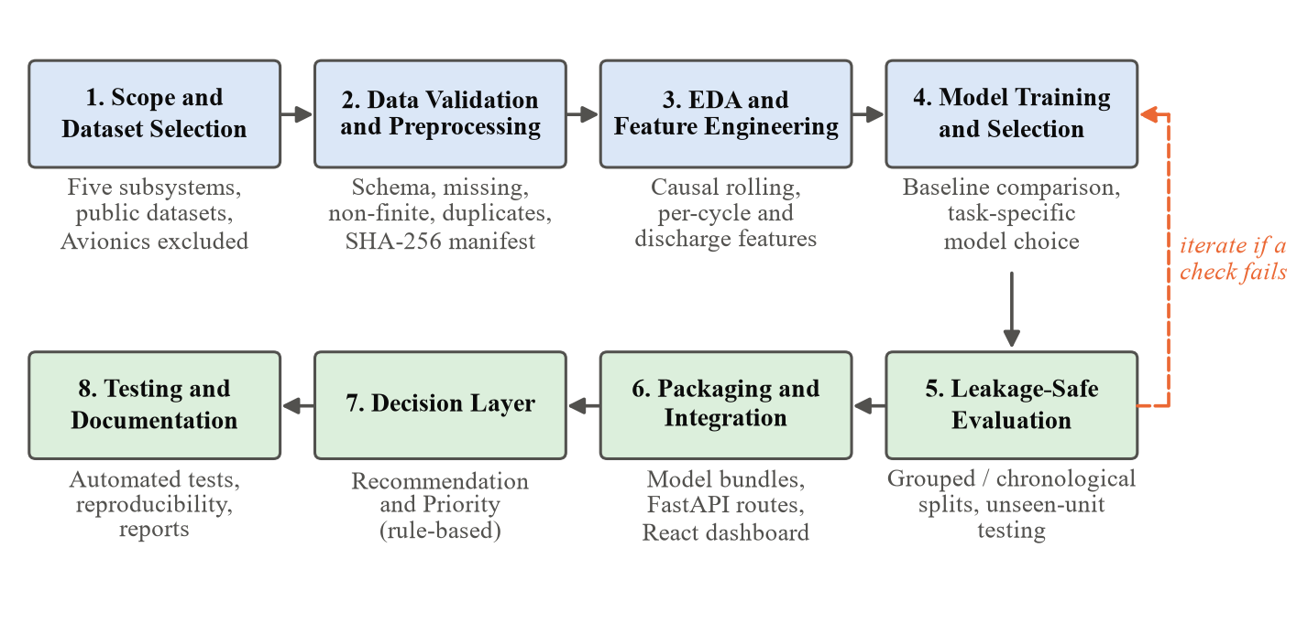
Figure 3.1: Phases of the project development framework
Six design principles guided every phase:
- The task fits the data. Each subsystem is given the prediction task that its dataset can support—RUL, SOH, condition classification or anomaly detection—rather than forcing one target across all subsystems.
- The model is chosen on evidence. For each task, candidate models are compared under the same validation scheme, and the selected model is the one that performs best on held-out data, not the one used elsewhere in the project.
- Validation is leakage-safe. Wherever the data contains repeated units, temporal dependence or scenario grouping, the split keeps each group entirely on one side, and all preprocessing statistics are fitted on training data only.
- Features are causal. Rolling features at time t use only observations up to t, so that the same feature pipeline can run on streaming data.
- Training and serving use the same pipeline. The estimator, its feature list and its scaler are saved together as one bundle, so that the API serves exactly the pipeline that was evaluated.
- Uncertainty is reported honestly. Low-confidence or out-of-range predictions are flagged for review, and the limitations of each dataset are stated explicitly.
Figure 3.2 summarises how the five aircraft subsystems are mapped to datasets, prediction tasks and the models finally selected. The diversity of the mapping is intentional: the five subsystems together cover continuous RUL regression, continuous SOH regression, multi-class condition classification and binary anomaly detection, which allows the common pipeline and decision layer to be exercised on very different kinds of output.
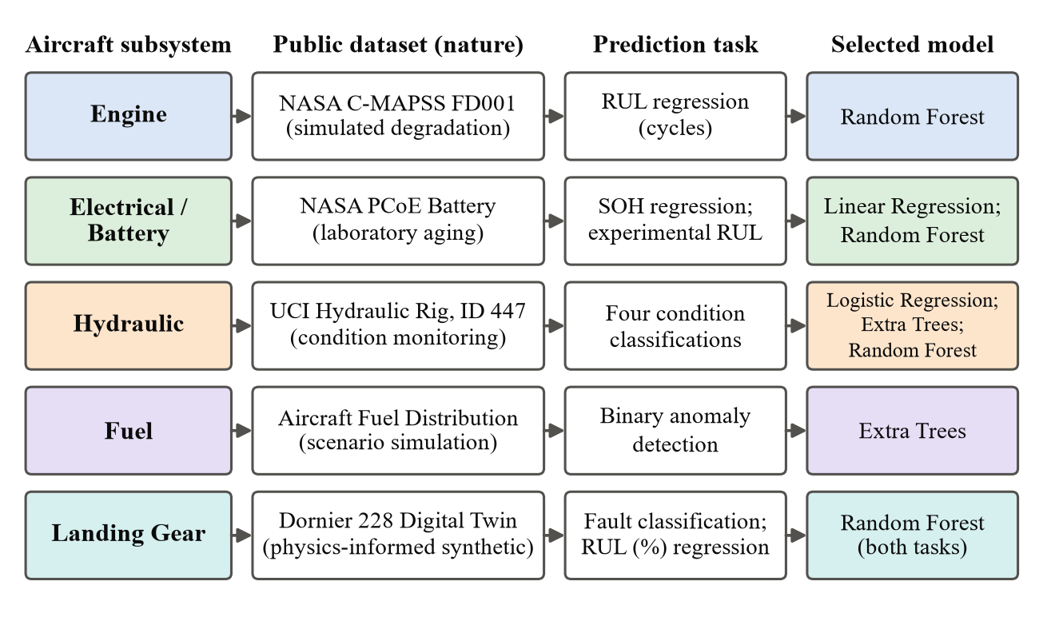
Figure 3.2: Mapping of aircraft subsystems to datasets, prediction tasks and selected models

3.2 Data Collection or Development Process

3.2.1 Dataset Selection Criteria
Because the project has no access to airline maintenance records or live aircraft telemetry, all training data comes from public repositories. A dataset was accepted for a subsystem only if it met the following criteria:
- it is publicly available from an identifiable source and has documentation describing how it was produced;
- it relates to the health, degradation or fault condition of the subsystem in question, rather than to a different engineering question;
- it provides labels or targets that support a defensible prediction task, such as run-to-failure trajectories, measured capacity or documented fault conditions;
- its nature—simulated, experimental, test-rig or synthetic—can be stated accurately in academic writing.
Several alternative sources failed these criteria and were rejected; they are listed in Table 2.1 of Chapter 2. In particular, avionics was excluded because the only suitable-looking public dataset describes operational anomalies on final approach rather than avionics component health.

3.2.2 Engine: NASA C-MAPSS FD001
The engine module uses the FD001 subset of the NASA C-MAPSS turbofan degradation simulation dataset [48], [49]. FD001 contains 100 training engines that are run to failure and 100 test engines whose records are truncated at an unknown point before failure; the true RUL of each test engine at its last recorded cycle is supplied in a separate file. Each row describes one operating cycle of one engine and contains the engine identifier, the cycle number, three operational settings and 21 sensor channels. FD001 uses a single operating condition and a single fault mode, which makes it the cleanest subset for a first module.
For each training engine i with final cycle T_{i}, the RUL label at cycle t is the number of cycles remaining before failure. Following the piecewise-linear convention [20], [59], the label is capped at R_{max} = 125 cycles, as defined in Equation (3.1) and illustrated in Figure 3.3.
 | ${RUL}_{i,t} = min\left(T_{i} − t, R_{max}\right), R_{max} = 125$ | (3.1)

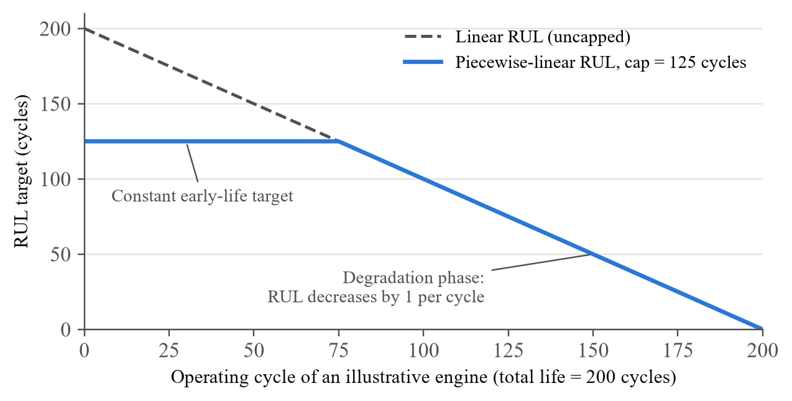
Figure 3.3: Piecewise-linear RUL target with a cap of 125 cycles
Sensor channels with zero variance in FD001 carry no information and were removed. Standardisation statistics (mean and standard deviation) were computed on the training engines only and then applied unchanged to validation and test engines, so that no information from held-out engines influenced the scaling.

3.2.3 Electrical/Battery: NASA PCoE Battery Data Set
The battery module uses the NASA PCoE Battery Data Set [44], which records repeated charge, discharge and impedance experiments on lithium-ion cells. The measured quantities include terminal voltage, current, temperature, the current and voltage measured at the charger or load, time, discharge capacity and impedance quantities such as electrolyte resistance and charge-transfer resistance. The dataset is a laboratory ageing dataset; it is grouped under Electrical/Battery in the dashboard but is never described as aircraft electrical-bus data.
Charge, discharge and impedance records were parsed and ordered chronologically for each cell. During a source review the recorded capacity field was confirmed to be the discharge capacity measured down to the cut-off voltage: integrating the measured current over time reproduced all 21 inspected recorded capacities to within 0.0000044 Ah. The State of Health of a cell at discharge cycle k is defined in Equation (3.2) as the ratio of the current discharge capacity C_{k} to the initial capacity C₀, expressed in percent.
 | ${SOH}_{k} = \frac{C_{k}}{C_{0}} × 100 \%$ | (3.2)

Approximately 21 features were extracted from each discharge curve. They describe the shape and duration of the discharge, the behaviour of voltage and temperature during discharge and the charge delivered, and they are computed from the discharge cycle itself so that no future information is used. For the experimental RUL task, each cycle was labelled with the number of cycles remaining until the cell reached its labelled end-of-life condition.

3.2.4 Hydraulic: UCI Condition Monitoring of Hydraulic Systems
The hydraulic module uses dataset 447 of the UCI Machine Learning Repository [21], [22]. The dataset contains 2,205 load cycles of 60 seconds each and 43,680 raw values per cycle, recorded by the sensors listed in Table 3.1. Each sensor file was validated against its documented sampling rate, so that, for example, every pressure file contains 6,000 values per cycle (100 Hz × 60 s) and every temperature file contains 60 values per cycle.
Table 3.1: Sensors of the UCI hydraulic test rig
Sensor | Physical quantity | Unit | Sampling rate
PS1 – PS6 | Pressure | bar | 100 Hz
EPS1 | Motor power | W | 100 Hz
FS1 – FS2 | Volume flow | l/min | 10 Hz
TS1 – TS4 | Temperature | °C | 1 Hz
VS1 | Vibration | mm/s | 1 Hz
CE | Cooling efficiency (virtual) | % | 1 Hz
CP | Cooling power (virtual) | kW | 1 Hz
SE | System efficiency factor (virtual) | % | 1 Hz

The dataset provides five condition labels per cycle, shown in Table 3.2. The project keeps the dataset’s own label names and values throughout and does not rename them with informal terms. Four of the labels are prediction targets; the fifth, the stable flag, indicates whether the rig had reached static conditions during the cycle and is used to analyse performance separately on stable and unstable cycles.
Table 3.2: Condition labels of the UCI hydraulic dataset
Label | Values | Meaning
Cooler condition (%) | 3, 20, 100 | Close to total failure; reduced efficiency; full efficiency
Valve condition (%) | 100, 90, 80, 73 | Optimal switching behaviour; small lag; severe lag; close to total failure
Internal pump leakage | 0, 1, 2 | No leakage; weak leakage; severe leakage
Hydraulic accumulator (bar) | 130, 115, 100, 90 | Optimal pressure; slightly reduced; severely reduced; close to total failure
Stable flag | 0, 1 | Conditions were stable; static conditions might not have been reached yet

After validation for missing and non-finite values, each sensor signal was reduced to per-cycle summary statistics such as the mean, standard deviation, slope and extreme values, in line with the features that Alenany et al. found sufficient for this rig [1].

3.2.5 Fuel: Aircraft Fuel Distribution System Dataset
The fuel module uses the Aircraft Fuel Distribution System dataset [3], which originates from the Safety+AI work of Gheraibia et al. [17]. The modelled system has a front tank feeding the port engine and a rear tank feeding the starboard engine, instrumented with tank-level and temperature sensors, valve-flow sensors and pipe-flow sensors. The data is provided as five CSV files: one normal scenario and four abnormal scenarios.
The inspection carried out in this project established the following facts: the five files contain 855 rows in total; eight numerical sensor columns are shared by all files; and there are no missing values, no non-finite values and no duplicate sensor rows. Causal rolling statistics were computed within each scenario file, never across file boundaries, yielding 32 model features from the eight raw sensors. The fuel preprocessing was later regenerated from the raw files in a separate directory, and all 855 rows, columns and values matched the stored processed file exactly, confirming that the preprocessing is reproducible.
The prediction task is binary anomaly detection: each row is labelled normal if it belongs to the normal scenario and abnormal if it belongs to one of the four abnormal scenarios. A public-source audit confirmed that this scenario-level membership is supported by the published descriptions. However, the exact row at which each fault begins within an abnormal file, and the mapping of the time axis, could not be verified from the public sources. Rows recorded before the onset of a fault in an abnormal file may therefore look normal, which introduces label noise. This limitation is acknowledged in the results.

3.2.6 Landing Gear: Physics-Informed Digital Twin Dataset
The landing-gear module uses the Aircraft Landing Gear Digital Twin Dataset [46], generated from a physics-informed digital twin of a Dornier 228 oleo-pneumatic shock strut [47]. Each row describes one simulated landing event and contains the fields listed in Table 3.3. The public release describes 1,500 to 10,000 simulated landing events; its published CSV file contains 1,500 events, with 300, 500, 500 and 200 events for fault codes 0 to 3 respectively, so the classes are not perfectly balanced.
Table 3.3: Fields of the landing-gear digital-twin dataset
Field | Description
RunID | Identifier of the simulated landing run
Max_Deflection | Maximum stroke (deflection) of the shock strut during the landing
Max_Velocity | Maximum stroke velocity of the strut
Settling_Time | Time taken for the strut response to settle
Mass | Aircraft mass for the simulated landing
K_Stiffness | Effective stiffness parameter of the strut model
B_Damping | Effective damping parameter of the strut model
Fault_Code | 0 = Normal; 1 = Nitrogen gas leak / reduced stiffness; 2 = Worn seal / reduced damping; 3 = Early structural degradation
RUL (%) | Remaining useful life as a percentage: 100 = new, 0 = failure

The data is synthetic: it is generated by a simulation model and is not real aircraft operational sensor data. During provenance checks the mass range of the locally stored copy was found to differ from the range stated in the published description, so the exact archive version is still being confirmed with the source. The data was validated for schema, missing values and duplicates before use, and the mass variable was used to define the groups for validation (see Section 3.4).

3.2.7 Data Validation and Preprocessing
Every dataset passes through the same validation stage before any modelling. Table 3.4 lists the checks applied. The results are recorded in a processed-data manifest that stores, for every processed file, its dimensions, a description and a SHA-256 checksum. The checksum makes it possible to detect any later change to a data file and to confirm that a model was trained on exactly the data described in the report.
Table 3.4: Data validation checks applied to every dataset
Check | Purpose
Schema and column names | Confirm that the expected fields exist with the expected types
Dimensions and sampling rate | Confirm row counts, cycle counts and per-cycle sample counts (e.g. 6,000 values for a 100 Hz, 60 s hydraulic cycle)
Missing and non-finite values | Detect empty, NaN or infinite values before feature computation
Duplicate rows | Detect repeated sensor rows that could bias training or leak between splits
Label consistency | Confirm that labels are reproducible from the source (e.g. RUL from final cycle, SOH from capacity)
SHA-256 checksum | Fingerprint raw and processed files in the manifest for reproducibility

Preprocessing is subsystem-specific but follows a common rule: any statistic that is learned from data—scaling parameters, feature-selection decisions or imputation values—is fitted on the training portion of each split only. For C-MAPSS this means that standardisation is fitted on training engines; for the battery data, chronological ordering is preserved within each cell; for the hydraulic data, summary statistics are computed per cycle; and for the fuel data, rolling statistics are computed within each scenario file.

3.2.8 Feature Engineering
Rolling features are computed causally, which means that a feature at time t uses only observations at or before t (Figure 3.4). This matters because the same pipeline runs on simulated streaming telemetry, where only past samples are available, and because a non-causal feature (for example, a centred moving average) would leak future information into training. For a signal x and a window of w samples, the causal rolling mean and the deviation of the current value from that mean are given by Equation (3.3) and Equation (3.4).
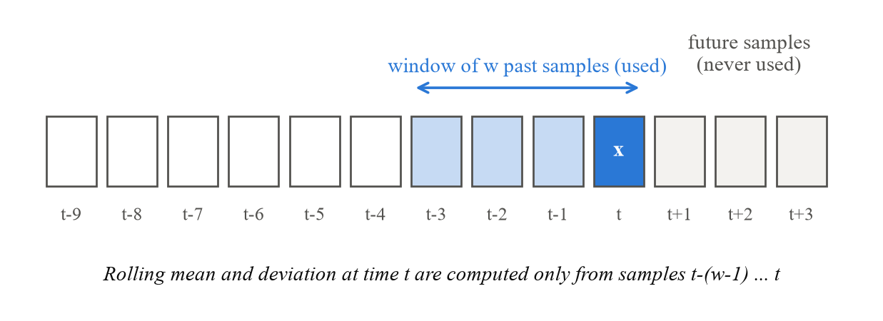
Figure 3.4: Causal rolling window: only past samples are used at time t
 | $μ_{t} = \frac{1}{w}\sum_{j=0}^{w−1}{x_{t−j}}$ | (3.3)

 | $d_{t} = x_{t} − μ_{t}$ | (3.4)

The feature sets used for each subsystem are as follows:
- Engine: standardised operational settings and informative sensors, together with causal rolling means and rolling deviations computed within each engine’s cycle history.
- Battery: approximately 21 discharge-curve features describing the duration and shape of each discharge, voltage and temperature behaviour, and the charge delivered.
- Hydraulic: per-cycle statistics of each sensor channel, such as mean, standard deviation, slope and extreme values.
- Fuel: 32 causal features derived from the eight shared sensor columns by rolling statistics computed within each scenario file.
- Landing gear: the per-landing response features and parameters provided by the digital twin (deflection, velocity, settling time, mass, stiffness and damping).

3.2.9 Model Development Process
For each prediction task, a small set of candidate models appropriate to the task type was trained and compared under the subsystem’s grouped or chronological validation scheme. Regression candidates included linear models and tree ensembles; classification candidates included logistic regression and tree ensembles; later engine and battery RUL experiments also evaluated gradient boosting with XGBoost [10], equal-unit sample weighting, log-transformed targets and fixed ensembles. Hyperparameters, such as the number of trees and tree depth for the engine Random Forest, were tuned only within the training groups. The selected model for each task, together with its feature list and scaler, was saved as a versioned model bundle. The final selections are shown in Figure 3.2 and justified in Section 3.3.1.

3.3 Tools/Software/Technologies Used
Table 3.5 lists the tools and technologies used in the project and the purpose of each.
Table 3.5: Tools, software and technologies used
Category | Tool / Technology | Purpose in the project
Programming language | Python | Data processing, model development, backend and tests
Data processing | Pandas, NumPy | Loading, validating and transforming sensor data
Machine learning | Scikit-learn [41] | Linear and logistic regression, Random Forest, Extra Trees, metrics and validation utilities
Gradient boosting | XGBoost [10] | Additional candidate models in later RUL experiments
Visualisation | Matplotlib, Plotly | Exploratory data analysis and result plots
Experimentation | Jupyter Notebook | Interactive EDA and model experiments
Backend | FastAPI (Python) | Prediction API serving all five subsystem models
Frontend framework | React with Vite | Single-page dashboard application and production build
Styling and charts | Tailwind CSS, Recharts, Lucide React | Dashboard layout, charts and icons
Testing | pytest | Automated regression suite for data, features, models and endpoints
Integrity | SHA-256 checksums | Fingerprinting of datasets, model artefacts and releases
Version control and IDE | Git / GitHub, VS Code | Source control, documentation and development

3.3.1 Machine Learning Algorithms
Linear Regression predicts a continuous target as a weighted sum of the p input features, with coefficients chosen to minimise the squared error on the training data (Equation (3.5)). It was selected for battery SOH because the target is continuous, the discharge-curve features track it closely, and the linear model matched or outperformed more flexible alternatives on held-out data while remaining easy to explain.
 | $ŷ = β_{0} + \sum_{j=1}^{p}{β_{j}x_{j}}$ | (3.5)

Logistic Regression models the probability of each class k among K classes through the softmax of linear scores (Equation (3.6)). It was selected for the hydraulic cooler and valve targets, which are multi-class problems with clear separation in the per-cycle summary features. Its calibrated class probabilities also support the confidence-based acceptance rule described in Section 3.4.4.
 | $P(y = k | x) = \frac{exp(w_{k}·x + b_{k})}{\sum_{m=1}^{K}{exp(w_{m}·x + b_{m})}}$ | (3.6)

Random Forest [9] trains B decision trees on bootstrap samples, choosing each split from a random subset of features, and averages their outputs for regression (Equation (3.7)) or takes a majority vote for classification. It captures non-linear relationships in tabular data with little preprocessing and was selected for engine RUL, battery RUL, hydraulic accumulator pressure, landing-gear fault classification and landing-gear RUL.
 | $ŷ(x) = \frac{1}{B}\sum_{b=1}^{B}{T_{b}(x)}$ | (3.7)

Extra Trees (extremely randomised trees) [16] differ from Random Forests in that split thresholds are drawn at random rather than optimised. The extra randomisation reduces variance and often helps on noisy, non-linear classification tasks. Extra Trees gave the best result on internal pump leakage and were selected for fuel anomaly detection after comparison with a Random Forest baseline.

3.4 Validation/Testing Methods

3.4.1 Leakage-Safe Validation Protocols
Grouped or chronological splits were used wherever the data have unit or temporal structure, so that every reported score reflects performance on units that the model did not see during training [7], [26]. Before choosing a protocol, each dataset was examined for repeated units, temporal dependence, scenario grouping and component identifiers. Table 3.6 and Figure 3.5 summarise the protocols applied.
Table 3.6: Validation protocol applied to each subsystem
Subsystem | Grouping unit | Protocol
Engine | Engine | Engine-grouped cross-validation on the training engines for model selection and tuning; a single final evaluation on the official FD001 test set of 100 unseen engines
Battery | Cell | SOH: chronological handling within each cell. RUL: leave-one-battery-out, so a cell never contributes to both training and testing
Hydraulic | Condition combination | Condition-grouped validation: cycles that share a combination of condition settings are kept together; unstable cycles are also evaluated separately
Fuel | Scenario file | Each fold holds out one complete abnormal scenario together with a contiguous block of the normal trajectory; no row of a held-out scenario is seen in training
Landing Gear | Aircraft-mass regime | Five-fold grouped validation in which each fold holds out complete mass regimes, for both the fault classifier and the RUL regressor

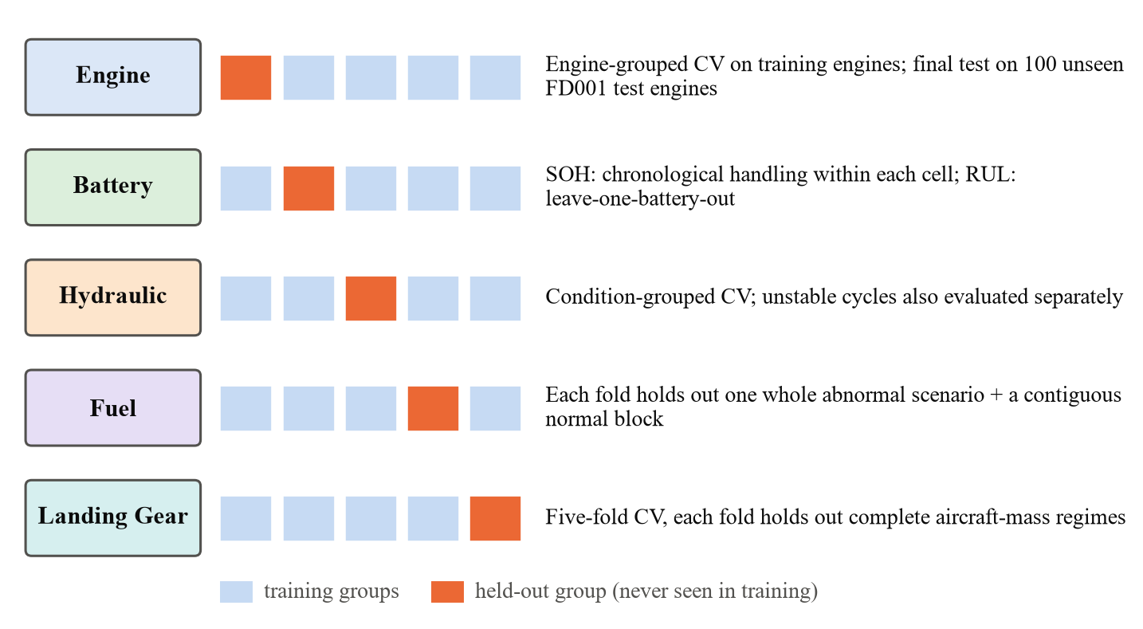
Figure 3.5: Grouped hold-out schemes used for each subsystem
It should be noted that the battery SOH evaluation uses chronological handling within each cell, so, unlike the battery RUL experiment, it does not by itself demonstrate performance on an entirely unseen cell.

3.4.2 Regression Metrics
For the regression tasks (engine RUL, battery SOH, battery RUL and landing-gear RUL) three metrics are reported. For n test samples with true values y_{i}, predictions ŷ_{i} and mean true value ȳ, they are defined in Equation (3.8), Equation (3.9) and Equation (3.10).
 | $MAE = \frac{1}{n}\sum_{i=1}^{n}{|y_{i} − ŷ_{i}|}$ | (3.8)

 | $RMSE = \sqrt{\frac{1}{n}\sum_{i=1}^{n}{{\left(y_{i} − ŷ_{i}\right)}^{2}}}$ | (3.9)

 | $R^{2} = 1 − \frac{\sum_{i}{{\left(y_{i} − ŷ_{i}\right)}^{2}}}{\sum_{i}{{\left(y_{i} − ȳ\right)}^{2}}}$ | (3.10)

MAE and RMSE are expressed in the unit of the target (cycles or percentage points). RMSE penalises large errors more heavily than MAE, so a large gap between the two indicates that a few predictions carry much larger errors than the rest. R² is the proportion of variance in the target explained by the model; it is not an accuracy percentage, and a value of 0.80 does not mean “80 percent accurate”.
For engine RUL, the direction of the error is also examined. A prediction is late when the predicted RUL exceeds the true RUL, meaning the model believes more life remains than is actually the case. Late predictions near failure are the most safety-relevant errors [49], [50], so the late-prediction rate among engines close to failure is reported in addition to MAE and RMSE.

3.4.3 Classification and Detection Metrics
Classification results are derived from the confusion matrix, which counts true positives (TP), true negatives (TN), false positives (FP) and false negatives (FN) for each class. Accuracy, precision, recall and F1 score are defined in Equation (3.11) to Equation (3.13).
 | $Accuracy = \frac{TP + TN}{TP + TN + FP + FN}$ | (3.11)

 | $Precision = \frac{TP}{TP + FP}, Recall = \frac{TP}{TP + FN}$ | (3.12)

 | $F1 = \frac{2 × Precision × Recall}{Precision + Recall}$ | (3.13)

For multi-class problems, the macro F1 score is the unweighted mean of the per-class F1 scores, and balanced accuracy is the mean of the per-class recalls (Equation (3.14)). Both give every class equal weight, so a model cannot score well simply by predicting the majority class [56].
 | $Balanced Accuracy = \frac{1}{K}\sum_{k=1}^{K}{{Recall}_{k}}$ | (3.14)

For the binary fuel task, two operational rates are reported in addition to balanced accuracy: the detection rate, the share of abnormal rows that are flagged, and the false-alarm rate, the share of normal rows that are flagged (Equation (3.15)).
 | $Detection rate = \frac{TP}{TP + FN}, False-alarm rate = \frac{FP}{FP + TN}$ | (3.15)

3.4.4 Confidence-Based Acceptance Rule
For the hydraulic valve-condition and accumulator-pressure targets, which proved harder than the cooler and pump targets, a confidence rule is applied at inference. A prediction is accepted only if the model’s highest class probability reaches a calibrated threshold τ—0.8889 for the valve and 0.5781 for the accumulator—and the input values fall inside the range seen during training (Equation (3.16)). Otherwise the cycle is flagged for review, so that the maintainer always sees an honest confidence level instead of a forced prediction. Accuracy is then reported both on all cycles and on the accepted predictions.
 | $accept ⇔ \max_{k} P(y = k | x) ≥ τ and x ∈ training range$ | (3.16)

3.4.5 Software Testing and Reproducibility
The software is verified by an automated pytest regression suite that covers data loading and validation, feature construction, model replay (confirming that saved bundles reproduce their stored predictions), checksum verification and API endpoint behaviour. On 17 October 2026 the full suite of 232 tests passed both in the configured development environment and in a fresh virtual environment created from the pinned dependency file requirements-lock.txt, confirming that the project can be set up cleanly from its declared dependencies. A continuous-integration workflow and a clean-setup procedure have been documented; the workflow is configured but has not yet been run on the project’s GitHub repository. The React frontend was verified with a successful Vite production build on 26 September 2026.
To protect validated models during later experimentation, every serving model is stored with a checksum-verified copy, and new candidates must pass predeclared non-regression gates on the fitting data and on an outer audit set before they could replace a serving model. Candidates that do not pass are kept separately as research results, and the active release pointer and all serving artefacts are verified to be unchanged after each experiment.

CHAPTER 4: PROJECT DESIGN / IMPLEMENTATION
This chapter provides the technical details of how the system was designed and implemented. It presents the overall architecture and its layers, the process flows for model training and for prediction, the key software components—including the five subsystem modules and the maintenance decision layer—and the main challenges encountered during implementation together with the solutions adopted.

4.1 System Design/Architecture
Figure 4.1 shows the architecture of the Intelligent Aircraft Predictive Maintenance System. Data for every subsystem—whether it comes from a stored public dataset or from the telemetry simulator—passes through the same sequence of stages: data validation, preprocessing, causal feature engineering, a subsystem-specific model, health-state interpretation and finally the two maintenance outputs. The subsystem models differ; the surrounding stages are shared. The results are delivered by a FastAPI backend to a React dashboard.
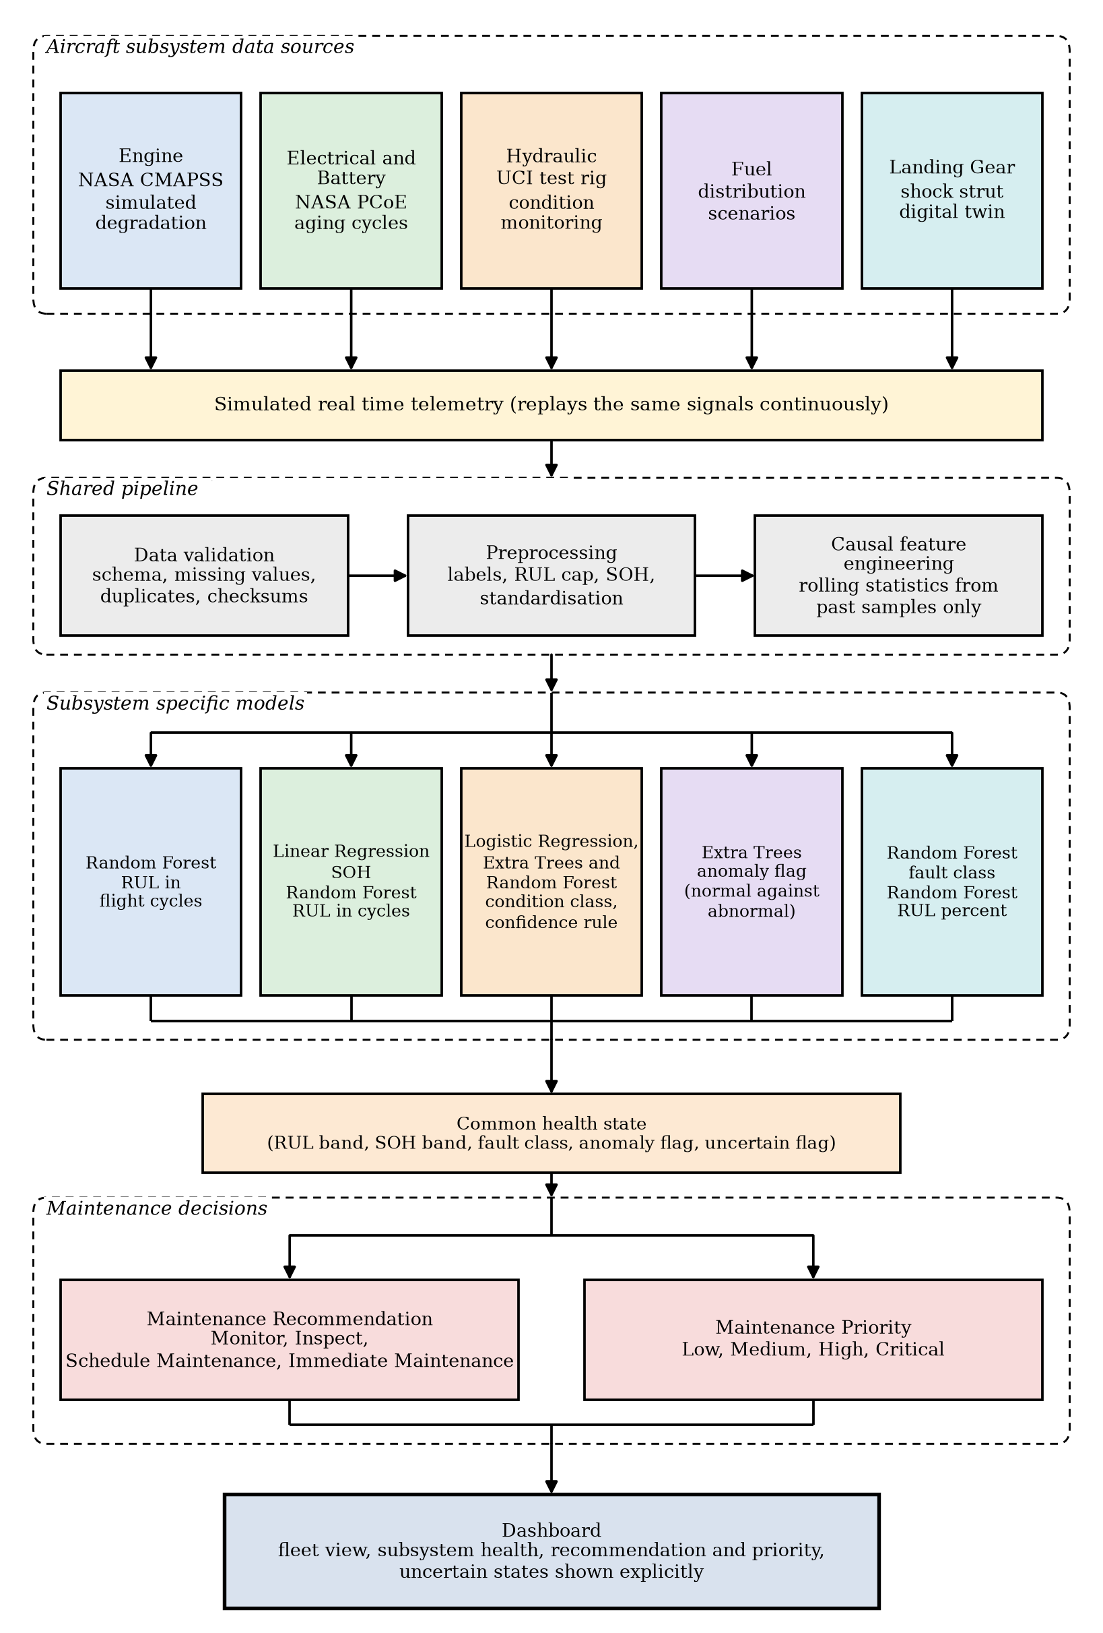
Figure 4.1: Overall architecture of the proposed system
The architecture has three important properties. First, it is modular: each subsystem is an independent module with its own data adapter, features and model bundle, so a subsystem can be retrained or replaced without changing the others, and a new subsystem (for example avionics, if a suitable dataset becomes available) could be added in the same way. Second, it separates prediction from decision: the models produce RUL, SOH, class or anomaly outputs, and a distinct interpretation layer turns those outputs into maintenance decisions. Third, it keeps training and serving consistent: the backend loads the same bundles that were evaluated, so a prediction shown on the dashboard comes from exactly the pipeline reported in Chapter 5.

4.1.1 Architectural Layers
The software is organised into the five layers shown in Figure 4.2. Each layer communicates only with the layers directly above and below it.
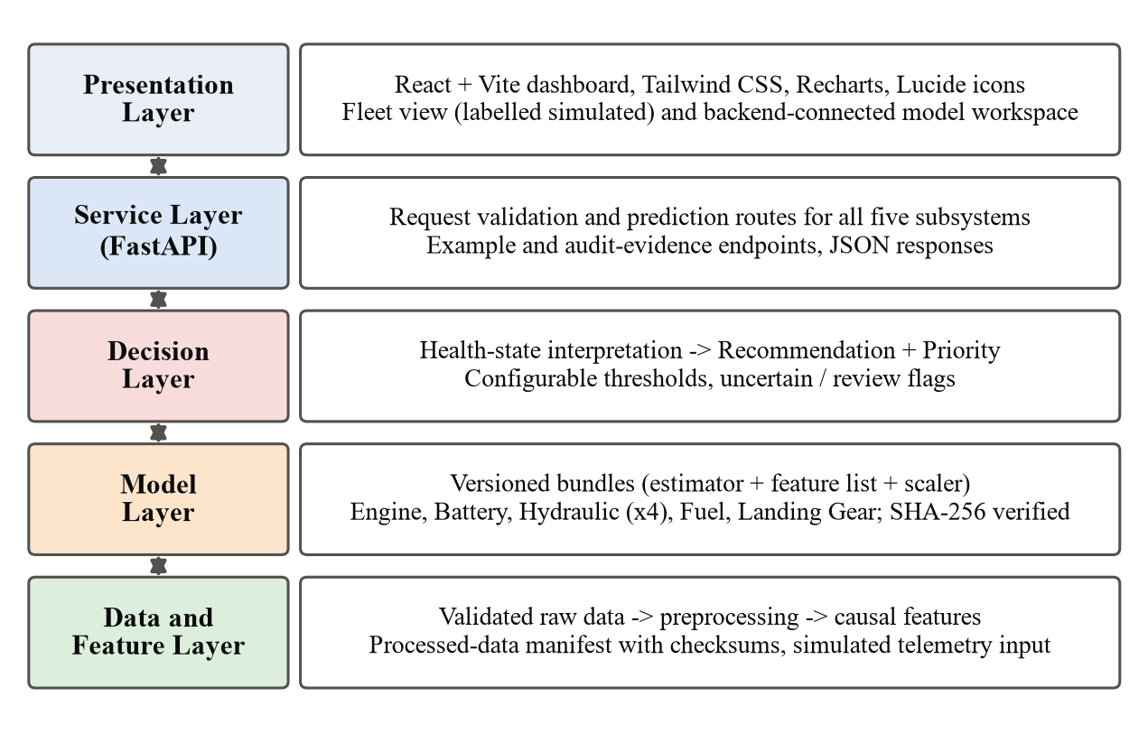
Figure 4.2: Layered software architecture of the system
- Data and feature layer – loads raw files, runs the validation checks, records the processed-data manifest and computes causal features. It is also the entry point for simulated telemetry.
- Model layer – holds the versioned model bundles for all subsystems: one engine RUL model, a battery SOH model and a battery RUL model, four hydraulic condition classifiers, one fuel anomaly detector and the landing-gear fault and RUL models. The active release is identified by a release pointer and verified with SHA-256 checksums.
- Decision layer – maps each model output to a health state and then to a Maintenance Recommendation and a Maintenance Priority using configurable thresholds, and propagates uncertainty and review flags.
- Service layer – a FastAPI application that validates requests, invokes the correct pipeline and returns structured JSON responses.
- Presentation layer – a React single-page application that calls the backend and displays predictions, decisions and supporting information.

4.1.2 Backend Design
The backend is written in Python using the FastAPI framework. It loads the model bundles of the active versioned release, whose checksums are verified by the automated tests. It exposes prediction routes for all five subsystem models, as well as routes that return worked example inputs and the audit evidence behind each model, so that the dashboard can show not only a prediction but also how the underlying model was evaluated.
Each prediction request follows the same steps: the input is validated against the expected schema and value ranges; the subsystem’s causal feature pipeline is applied using the feature list and scaler stored in the bundle; the model produces its output; and the decision layer attaches the health state, the Maintenance Recommendation, the Maintenance Priority and any review flags. The response is returned as JSON. Earlier in the project, the engine endpoints were implemented first and used to establish this pattern, which was then extended to the other subsystems.
The original dashboard design, supplied as a React prototype, documented intended endpoints such as GET /api/fleet, GET /api/aircraft/:id, GET /api/component/:id/history and a WebSocket stream /ws/telemetry. These were design intentions of the prototype. The implemented backend instead centres on subsystem prediction routes; fleet-level history and streaming endpoints remain part of future work.

4.1.3 Frontend Design
The frontend is a React application built with Vite and styled with Tailwind CSS, using Recharts for charts and Lucide React for icons. It began as a prototype dashboard, provided as a single JSX file, that generated a fleet of aircraft with random sensor values and simulated live updates on a timer. That prototype also listed Avionics as a component. Three main changes were made during integration:
- Avionics was removed as an active subsystem so that the dashboard represents the five implemented subsystems only.
- Tailwind CSS was configured through the @tailwindcss/vite plugin so that the prototype’s utility classes render as designed.
- The internal random generation was replaced, in the main model workspace, by calls to the FastAPI backend, and every view that still uses simulated values is explicitly labelled as simulated.
The current console, titled AeroPredict – Predictive Maintenance Console, provides three views selected from a navigation bar: AI Predictions, a research model workspace whose results are returned by the FastAPI backend for all five subsystems; Fleet, a fleet health snapshot; and Maintenance, a component-attention review. Views are loaded on demand to keep the initial page light. The footer of each view states its data source—for example, that fleet and maintenance views contain research outputs and that no live aircraft telemetry or maintenance records are connected. For the engine, the workspace displays a prototype RUL risk band together with a safety note stating that the band is a demonstration threshold and not an approved maintenance limit.

4.1.4 Key Design Decisions
Table 4.1 records the main design decisions and the reasons for them.
Table 4.1: Key design decisions and their rationale
Design decision | Rationale
Subsystem-specific tasks and models | The datasets support different targets; forcing one model or one target across all of them would be unjustified
Separate decision layer | Keeps evaluated ML predictions distinct from rule-based maintenance decisions, and lets thresholds be tuned without retraining
Only two decision outputs | Maintenance Recommendation and Maintenance Priority are supported by the available evidence; cost, downtime and spares were excluded
Causal features | The same pipeline must work on streaming telemetry, where future samples are unavailable
Model bundles with checksums | Guarantees that the API serves exactly the evaluated pipeline and makes any change detectable
Review flags for uncertain outputs | Avoids presenting low-confidence or out-of-range predictions as facts
Avionics excluded | No public dataset of avionics component health was found
Simulated data clearly labelled | The system must never imply that it receives live aircraft telemetry

4.2 Process Flow

4.2.1 Offline Training Flow
Figure 4.3 shows the offline flow used to produce each model bundle. A raw public dataset is validated and recorded in the manifest; labels are derived and the data is preprocessed; causal features are computed; candidate models are compared under the subsystem’s grouped validation scheme; the selected model is evaluated on held-out units; and the final pipeline is saved as a bundle. All fitted quantities—scaling statistics, feature choices and hyperparameters—come from training groups only. A candidate replaces a serving model only if it passes the non-regression checks described in Section 3.4.5.
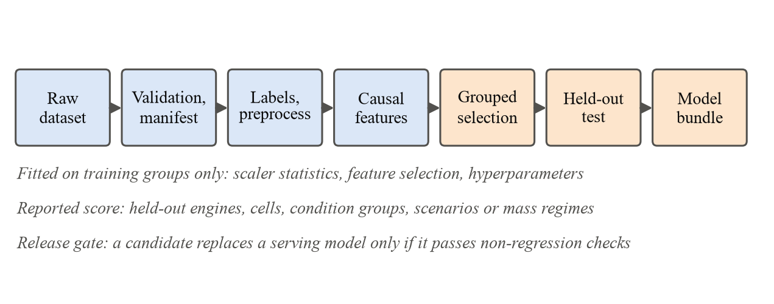
Figure 4.3: Offline model training and release flow

4.2.2 Online Prediction Flow
Figure 4.4 shows what happens when the dashboard, or the telemetry simulator, sends sensor values for a subsystem. The FastAPI route validates the message; the same causal feature pipeline used in training is applied with the bundle’s scaler and feature list; the model produces a prediction; the decision layer interprets it; and the JSON response—containing the prediction, the health state, the Maintenance Recommendation, the Maintenance Priority and any flags—is displayed by the dashboard. Inputs outside the range seen in training, and class predictions whose confidence is below the calibrated threshold, are flagged for review rather than silently accepted.
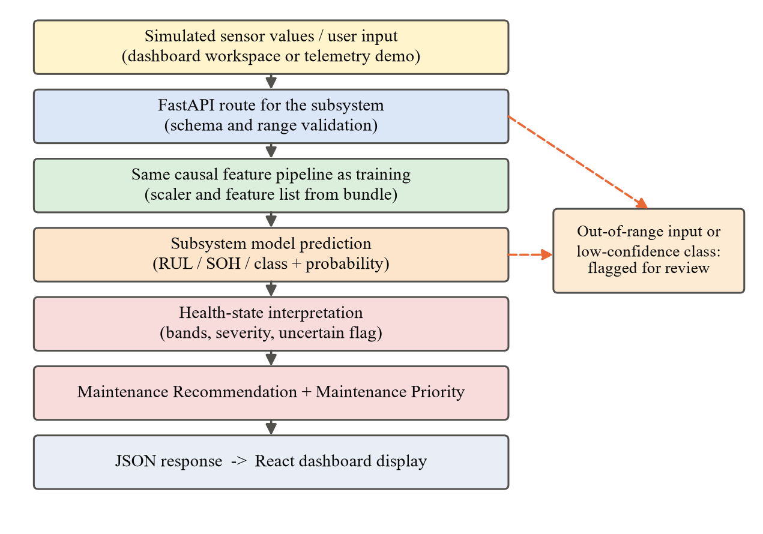
Figure 4.4: Online prediction flow from sensor input to dashboard

4.2.3 Simulated Real-Time Telemetry
The words “real-time” in the project title refer to simulated telemetry. The simulation component produces or replays sensor values for each subsystem at a configurable rate, so that the full pipeline can be exercised end to end and degradation scenarios can be replayed on demand. Simulated values are drawn from, or patterned on, the same public datasets used for training, which ensures that they are in the range the models expect. The system does not receive live aircraft data, and every view that relies on simulated values is labelled accordingly. Quantitative measurements of latency and throughput under sustained telemetry have not yet been made; they are listed as future work in Chapter 6.

4.3 Key Components/Modules
Table 4.2 summarises the inputs, models and outputs of the five subsystem modules. The following subsections describe each module and the shared components.
Table 4.2: Summary of the subsystem modules
Module | Input | Model | Output
Engine | Cycle history: 3 operational settings and informative sensors | Random Forest regressor | RUL in cycles (capped at 125)
Electrical / Battery | Discharge-curve features (about 21) | Linear Regression; Random Forest | SOH (%); experimental RUL in cycles
Hydraulic | Per-cycle sensor statistics | Logistic Regression (cooler, valve); Extra Trees (pump); Random Forest (accumulator) | Four condition classes with probabilities and review flags
Fuel | 32 causal features from 8 sensors | Extra Trees classifier | Normal / abnormal flag (screening)
Landing Gear | Per-landing response and model parameters | Random Forest classifier and regressor | Fault code (0–3); RUL (%)

4.3.1 Data Validation and Manifest Module
This module implements the checks of Table 3.4 for every dataset. It produces a processed-data manifest listing each processed file with its dimensions, description and SHA-256 checksum. The manifest is used by the tests to confirm that the data on disk is the data the models were trained on, and it allowed problems to be traced precisely—for example, a malformed numeric field in one fuel scenario file was located to a specific line before any data was changed.

4.3.2 Engine RUL Module
The engine module receives the cycle history of an engine, removes zero-variance channels, standardises the remaining inputs with the training-set statistics stored in the bundle and computes causal rolling means and deviations within the engine’s history. A Random Forest regressor, tuned under engine-grouped validation, predicts the RUL in cycles, capped at 125. The prediction is mapped to a risk band for display. A raw-input adapter allows the API to accept engine data in the original C-MAPSS column format.
Because a late prediction near failure is the most dangerous kind of error, the module was also used for a safety-oriented calibration study, in which predictions in the low-RUL region were adjusted downwards. This study was carried out on an earlier version of the engine model and is reported separately from the final model’s accuracy in Chapter 5.

4.3.3 Electrical/Battery Module
The battery module parses charge, discharge and impedance records, orders them chronologically within each cell and extracts approximately 21 features from each discharge curve. A Linear Regression model estimates SOH in percent, and a Random Forest model, evaluated with leave-one-battery-out validation, estimates the experimental RUL in cycles. The module’s output is presented under Electrical/Battery on the dashboard, while the documentation makes clear that the underlying data is laboratory battery-ageing data.

4.3.4 Hydraulic Condition Module
The hydraulic module contains four independent classifiers, one for each condition label: Logistic Regression for the cooler and the valve, Extra Trees for internal pump leakage and Random Forest for accumulator pressure. Each classifier receives the per-cycle summary statistics of the sensor channels and returns a class together with its probability. For the valve and accumulator classifiers, the confidence-based acceptance rule shown in Figure 4.5 is applied: the prediction is accepted only if the input lies within the training range and the class probability reaches the calibrated threshold; otherwise the cycle is flagged for review. The dashboard displays this flag so that a maintainer can see how much confidence stands behind each class.
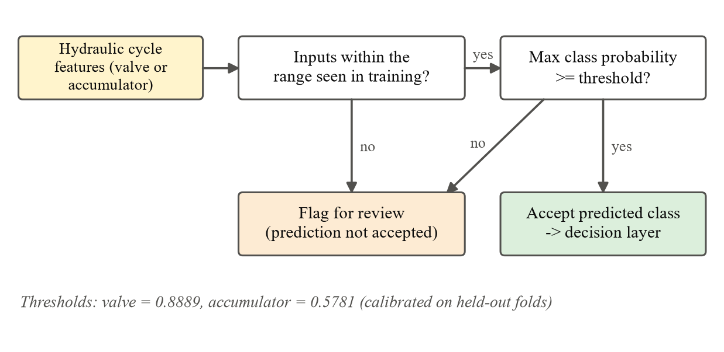
Figure 4.5: Confidence-based acceptance rule for the hydraulic valve and accumulator classifiers

4.3.5 Fuel Anomaly Module
The fuel module computes 32 causal features from the eight shared sensor columns and passes them to an Extra Trees classifier that labels each time step as normal or abnormal. Because the training data contains only one normal scenario, the model has a narrow view of normal operation and produces many false alarms (see Chapter 5). The decision layer therefore treats an abnormal fuel output as a screening signal that raises attention for inspection, not as confirmation of a fault. For the same reason, the fuel route is excluded from the project’s production-readiness check.

4.3.6 Landing Gear Module
The landing-gear module receives the per-landing features produced by the digital twin. One Random Forest classifier predicts the fault code—normal, nitrogen gas leak, worn seal or early structural degradation—and a second Random Forest regressor predicts the remaining useful life as a percentage. Both were evaluated under five-fold validation that holds out complete aircraft-mass regimes. The module demonstrates that the pipeline can carry landing-gear data from raw features to a fault class, an RUL estimate and a maintenance decision; its scores reflect clean synthetic data and are not evidence of performance on real landing-gear sensors.

4.3.7 Maintenance Interpretation Layer
The interpretation layer converts every subsystem output into a common health-state interpretation and then into the two decision outputs. It standardises the interpretation of outputs; it does not convert them into a single physical health quantity, because RUL, SOH, condition classes and anomaly flags measure different things. The Maintenance Recommendation takes one of four values—Monitor, Inspect, Schedule Maintenance or Immediate Maintenance—and the Maintenance Priority takes one of four levels—Low, Medium, High or Critical. Table 4.3 shows the mapping.
Table 4.3: Mapping from health state to maintenance outputs
Health state | Maintenance Recommendation | Maintenance Priority
RUL above 50 cycles; SOH high; normal or fully functional class | Monitor | Low
RUL between 20 and 50 cycles; SOH reduced; mildly degraded class; fuel anomaly flag | Inspect | Medium
RUL of 20 cycles or below; seriously degraded class | Schedule Maintenance | High
Most severe fault class; RUL near zero | Immediate Maintenance | Critical

The RUL bands apply to the engine and battery RUL outputs, and the SOH bands to the battery health output. For the hydraulic, fuel and landing-gear classifiers, the predicted class is placed on the same rows by severity: a normal or fully functional class maps to Monitor and the most severe class maps to Immediate Maintenance. The cut-off values are stored as configuration so that an operator could tune them for a fleet without changing the architecture. Figure 4.6 shows the decision logic as a flowchart, and Algorithm 4.1 gives it in pseudo-code.
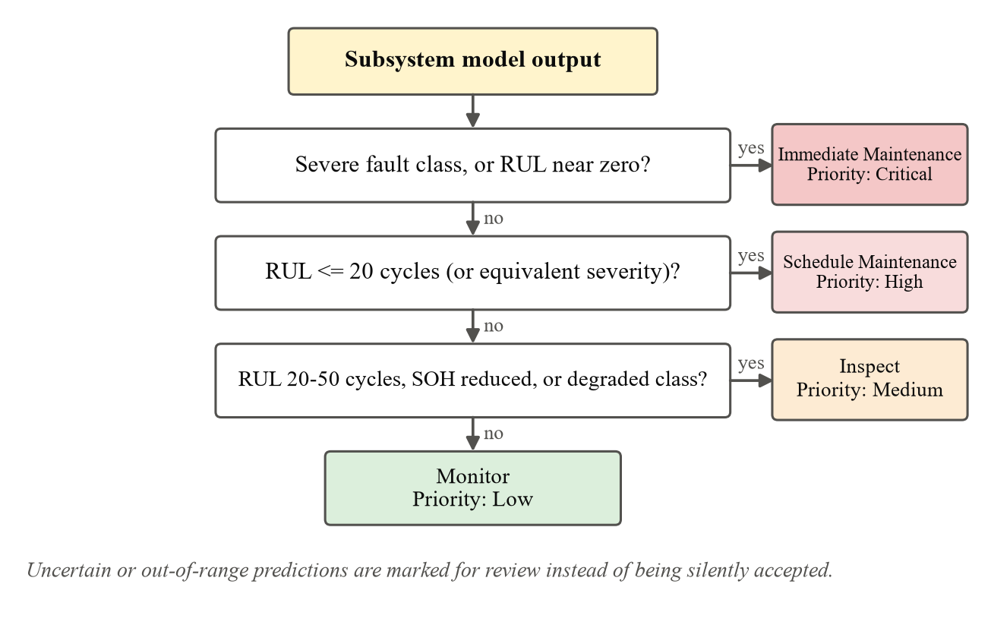
Figure 4.6: Decision logic of the maintenance interpretation layer
Algorithm 4.1: Maintenance interpretation layer
1: Input: subsystem output (RUL r, SOH h, or class c with probability p), configured thresholds
2: Output: Maintenance Recommendation, Maintenance Priority, review flag
3: flag ← (input outside training range) or (p < τ for gated classifiers)
4: if output is RUL then
5: if r ≤ r_{crit} then return (Immediate Maintenance, Critical, flag)
6: else if r ≤ 20 then return (Schedule Maintenance, High, flag)
7: else if r ≤ 50 then return (Inspect, Medium, flag)
8: else return (Monitor, Low, flag)
9: else if output is SOH then return row of the configured SOH band for h
10: else if output is fuel anomaly then return (Inspect, Medium, flag) if abnormal, else (Monitor, Low, flag)
11: else place class c on the rows by severity: normal → (Monitor, Low); most severe → (Immediate Maintenance, Critical)

The thresholds of Table 4.3 are configured rules, not values learned from maintenance records. No dataset available to the project pairs sensor conditions with the maintenance actions actually taken, so the operational correctness of the recommendations cannot be validated experimentally. The ML predictions are evaluated with standard metrics in Chapter 5; the decision outputs derived from them are rule-based and would require validation against maintenance records and expert-defined procedures before operational use.

4.3.8 Model Bundles and Release Management
Every trained model is stored as a bundle that contains the estimator, the ordered feature list and the fitted scaler, so that the API always serves the complete pipeline that was evaluated. The serving models—11 artefacts in total—belong to a versioned research release identified by a release pointer, and their SHA-256 checksums are verified by the tests. Experimental candidates are saved separately and never overwrite serving artefacts; after every experiment the project verifies that all serving artefacts and the release pointer are unchanged.

4.3.9 Dashboard Module
The dashboard module consists of the AI Predictions workspace, the Fleet view and the Maintenance view described in Section 4.1.3. The workspace lets a user select a subsystem, load an example input, send it to the backend and see the prediction together with its health state, recommendation, priority and flags. Charts are drawn with Recharts and status information uses icons together with text labels, so that meaning is not conveyed by colour alone. Per-prediction explanations of the sensor features that drove a decision, and trend charts over time, are planned extensions.

4.4 Challenges and Solutions
Table 4.4 lists the main challenges encountered during the project and the solutions adopted.
Table 4.4: Challenges encountered and solutions adopted
Challenge | Solution adopted
Heterogeneous datasets with different formats, sampling rates and targets | Subsystem-specific tasks and models within a common pipeline of validation, causal features, bundles and decision interpretation
Risk of data leakage and optimistic scores | Grouped or chronological validation for every subsystem; preprocessing fitted on training groups only; causal features
Datasets that were unsuitable or easily misdescribed (avionics anomaly data, industrial pump data, incident reports) | Explicit selection criteria; documented rejection of unsuitable sources; avionics excluded from the implemented scope
Late engine predictions near failure | Direction of error analysed separately; safety-oriented calibration studied; RUL band shown with a safety note
Low accuracy on hydraulic valve and accumulator targets | Confidence-based acceptance rule with calibrated thresholds; uncertain cycles flagged for review
Only one normal fuel scenario and unverified fault-onset rows | Scenario-level hold-out to expose the limitation; fuel output used only as a screening signal; request for annotations prepared for the dataset authors
Battery capacity regeneration and label questions | Source review confirmed the capacity definition; labels left unchanged until the source issues are resolved
Landing-gear provenance: local mass range differs from the published description | Recorded as an open issue; data consistently described as synthetic
Malformed numeric field in one fuel file caused two test failures | Raw data left untouched; later verified against its checksum; preprocessing regenerated identically and both tests now pass
Avoiding regressions while retraining | Checksum-verified champion copies, non-regression gates and separate storage of candidates
Prototype dashboard used random data, listed Avionics and needed Tailwind CSS | Tailwind configured; Avionics removed; model workspace connected to the backend; simulated views labelled
Test temporary files could not be written to the default Windows temp folder in a restricted shell | pytest temporary directory redirected into the project workspace

4.4.1 Further Model Improvement Experiments
After the first complete set of models had been evaluated, several rounds of targeted retraining were carried out in September 2026 to see whether the weaker tasks could be improved. These rounds used a fixed internal split into fitting, calibration and audit groups, so that model selection used fitting units only and each candidate was scored on the same held-back audit groups. More than 100 configurations were compared across the rounds, including tuned Random Forests, XGBoost, equal-unit sample weighting, robust causal battery trends, log-transformed targets and fixed ensembles. Table 4.5 summarises the outcome.
Table 4.5: Summary of later retraining experiments (research candidates, not promoted to serving)
Task | Metric (audit groups) | Serving model | Best candidate | Status
Engine RUL | MAE / RMSE (cycles) | 25.40 / 37.98 | 17.04 / 28.19 | Research candidate; audit targets unmet
Battery SOH | MAE (percentage points) | 3.18 | 1.39 | Target met; integration pending
Battery RUL | MAE (cycles) | 13.75 | 11.20 | Target of 10 cycles unmet
Hydraulic valve | Balanced accuracy (%) | 75.57 | 100.00 | Needs waveform input integration
Hydraulic accumulator | Balanced accuracy (%) | 84.46 | 97.25 | Needs waveform input integration

The audit figures in Table 4.5 are measured on a different, internal evaluation split from the results reported in Chapter 5, so the two sets of numbers should not be compared directly. On the official FD001 test set, the engine research candidate reached an MAE of 10.63 cycles and an RMSE of 16.27 cycles, compared with 13.80 and 18.61 cycles for the serving model. It was nevertheless kept as a research candidate because it did not meet the project’s broader audit targets and its calibration is unresolved. The audit results are also reused development-data evaluations rather than fresh external tests, the hydraulic candidates have limited support coverage, and the battery uncertainty intervals remain under-calibrated. No serving model was replaced, and checksum checks after each round confirmed that the serving artefacts and the release pointer were unchanged. These experiments show that some tasks can be improved, but the improvements need independent validation before they can be adopted.

CHAPTER 5: RESULT AND OBSERVATION
This chapter presents the results of the evaluated serving models, each measured under its subsystem’s validation protocol (Table 3.6). Later research candidates, measured on a different internal split, are summarised separately in Section 4.4.1.

5.1 Data/Results/Screenshots
Table 5.1 lists the regression results, Table 5.2 the hydraulic classification results and Table 5.3 the landing-gear and fuel results. Figure 5.1 compares the classification accuracies.
Table 5.1: Regression results for engine, battery and landing-gear tasks
Task (unit) | Model | MAE | RMSE | R² | Evaluation
Engine RUL (cycles) | Random Forest | 13.80 | 18.61 | 0.799 | 100 unseen FD001 test engines
Battery SOH (percentage points) | Linear Regression | 2.62 | 5.17 | 0.950 | Chronological, within cell
Battery RUL (cycles) | Random Forest | 9.36 | 12.32 | 0.862 | Leave-one-battery-out
Landing-gear RUL (percentage points) | Random Forest | 1.37 | 2.63 | 0.992 | Held-out mass regimes

Table 5.2: Hydraulic condition classification results (condition-grouped validation)
Target (UCI label) | Model | Accuracy, all cycles (%) | Accuracy, accepted (%)
Cooler condition | Logistic Regression | 96.10 | –
Valve condition | Logistic Regression | 83.99 | 91.86
Internal pump leakage | Extra Trees | 95.50 | –
Hydraulic accumulator | Random Forest | 88.82 | 92.33

Accuracy on all cycles covers all 2,205 cycles, stable and unstable, with each condition combination kept on one side of the split. Accuracy on accepted predictions covers only the predictions that pass the acceptance rule (probability of at least 0.8889 for the valve and 0.5781 for the accumulator); the other cycles are flagged for review.
Table 5.3: Landing-gear fault classification and fuel anomaly detection results
Task (validation) | Model | Result
Landing-gear fault, four classes (held-out mass regimes) | Random Forest | Accuracy 95.07%; balanced accuracy 95.36%; macro F1 0.950
Fuel anomaly, normal vs abnormal (held-out scenario files) | Extra Trees | Detection rate 93.13%; false-alarm rate 71.35%; balanced accuracy 60.89%

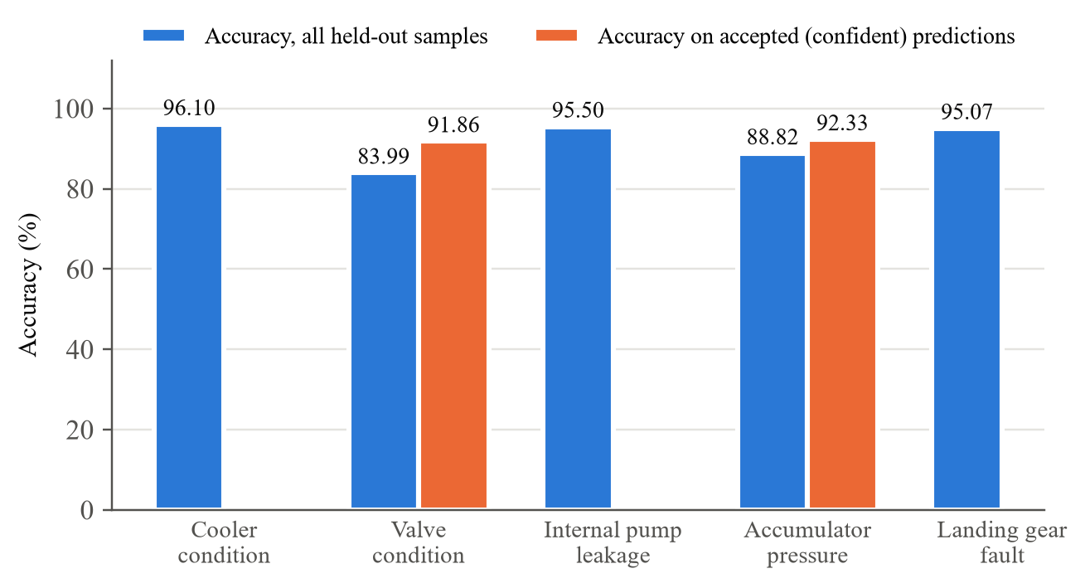
Figure 5.1: Accuracy of the hydraulic and landing-gear classifiers
Among engines close to failure, the final engine model predicts late—more remaining life than is true—for 72.42% of cases before calibration. On an earlier model version, a safety-oriented calibration reduced this share from approximately 72% to 35.3% (Figure 5.2); it has not yet been applied to the final model.
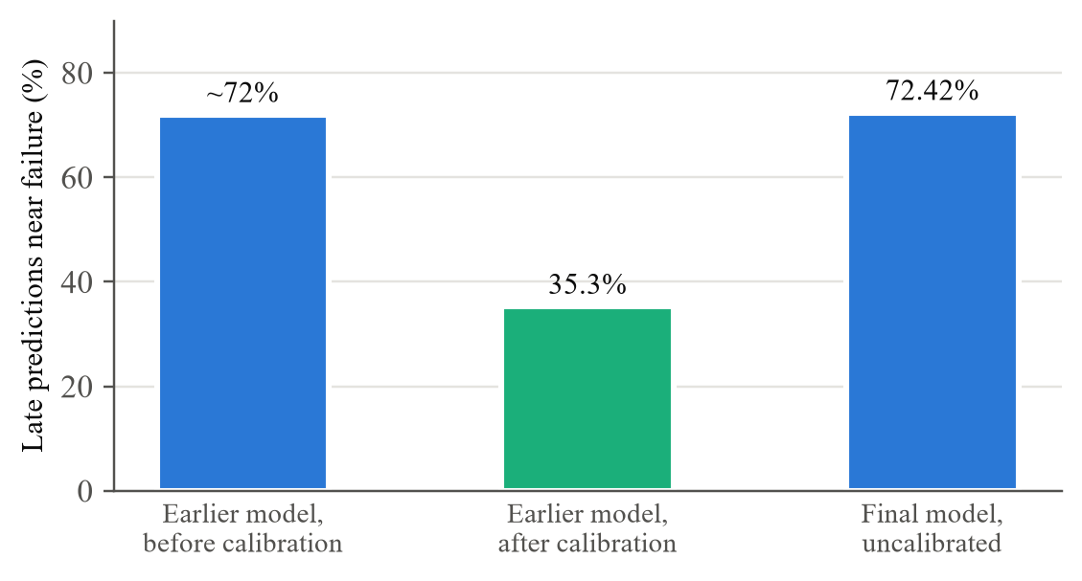
Figure 5.2: Share of late engine RUL predictions near failure
Figure 5.3 to Figure 5.5 show the running system.
[ PASTE SCREENSHOT HERE ]
AeroPredict – AI Predictions workspace: engine RUL prediction with prototype risk band and safety note
Figure 5.3: AI Predictions workspace showing a backend engine RUL prediction
[ PASTE SCREENSHOT HERE ]
Prediction with health state, Maintenance Recommendation, Maintenance Priority and review flag
Figure 5.4: Maintenance Recommendation and Priority for a subsystem prediction
[ PASTE SCREENSHOT HERE ]
FastAPI interactive documentation listing the five subsystem prediction routes
Figure 5.5: FastAPI backend documentation page

5.2 Interpretation of Results
Engine. On 100 unseen FD001 test engines the Random Forest is off by about 14 cycles on average and explains about 80% of the variance of the capped RUL target (R² 0.799, which is not an accuracy). RMSE is clearly above MAE, so most engines are predicted closely while a few carry larger errors—expected with a capped target, since sensors change little early in life. The 72.42% late-prediction rate near failure shows optimism where safety matters most; the earlier calibration study shows this can be traded for a few extra early predictions, but the trade-off must still be shown on the final model, with error reported separately for RUL above 50, 20–50 and at or below 20 cycles.
Battery. SOH is typically estimated within about three percentage points (MAE 2.62, R² 0.950). RMSE close to twice the MAE indicates a few larger errors, most likely around capacity-regeneration events. Because SOH was evaluated chronologically within cells, it does not by itself show performance on a new cell; the experimental RUL model, evaluated leave-one-battery-out, achieves an MAE of 9.36 cycles on cells it never saw.
Hydraulic. The cooler and pump-leakage targets have clear signatures in the temperature, cooling-efficiency, flow and pressure channels. The valve and accumulator are harder because their signatures are subtler, depend on whether the rig had settled, and must be recognised under unseen condition combinations. The confidence rule raises accuracy on accepted predictions to above 91%, but this must be read together with the share of cycles accepted.
Landing gear. Nearly equal accuracy (95.07%) and balanced accuracy (95.36%) show that all four classes are recognised about equally well, and the RUL R² is 0.992. These are the highest scores in the project because the digital twin produces clean, consistent fault signatures; they show that the pipeline identifies the defined fault patterns under simulated conditions, not that similar performance would be achieved on real landing-gear sensors.
Fuel. The detector flags 93.13% of abnormal rows but also 71.35% of normal rows; its balanced accuracy of 60.89% is only moderately above the 50% chance level. It therefore offers high sensitivity but is suitable only for preliminary screening, not fault confirmation. The cause is the single normal scenario and the unverified fault-onset rows; a random row split would have hidden this weakness. Further experiments with 36 temporal feature configurations did not give a reliable improvement.
Overall. The simplest model won three tasks (SOH, cooler, valve), which also aids explanation. Performance varies substantially by dataset, from near-perfect on synthetic landing-gear data to a noisy fuel screen. The results demonstrate the feasibility of one validation discipline, feature convention, interpretation layer and dashboard across five heterogeneous datasets; they do not show that integration itself improves accuracy, which would need a dedicated comparative experiment.

5.3 Comparison with Existing Solutions/Approaches
Numerical comparison is possible mainly for the engine, since C-MAPSS FD001 is a common benchmark (Table 5.4). It is approximate because studies differ in RUL cap (125 here, about 130 in the cited works) and preprocessing.
Table 5.4: Engine RUL on the C-MAPSS FD001 test set compared with published models
Study / model | Method | RMSE (cycles) | Note
Babu, Zhao and Li (2016) [4] | Deep CNN | 18.45 | Cap near 130
Zheng et al. (2017) [59] | LSTM | 16.14 | Cap 130; as reported
This project – serving model | Random Forest | 18.61 | Cap 125
This project – research candidate | Random Forest (retrained) | 16.27 | Not promoted

The serving model is close to the published CNN and behind the LSTM, consistent with the finding that well-engineered tree ensembles remain competitive [2]. For the hydraulic rig, the accumulator and valve being the hardest targets agrees with earlier work [1]. For the other modules, differences in splits and task definitions make numerical comparison unreliable. Table 5.5 compares the overall approach with typical existing studies.
Table 5.5: Qualitative comparison with typical existing approaches
Aspect | Typical existing studies | This project
Subsystems | Usually one, mostly the engine | Five subsystems in one framework
Prediction tasks | Usually RUL or a fault class | RUL, SOH, condition classes and anomaly detection
Validation | Random splits sometimes used | Grouped or chronological, unseen units
Decision output | Usually stops at prediction | Rule-based Recommendation and Priority
Deployment | Mostly offline experiments | FastAPI and React with simulated data
Novelty and data | New architectures on benchmark data | Established models on benchmark data; no new algorithm

5.4 Limitations and Constraints
- Heterogeneous, non-operational data. The datasets are simulated, laboratory, test-rig or synthetic; no airline telemetry, maintenance records or independent aircraft-representative test data were available.
- Dataset-specific issues. The battery data is laboratory ageing data and SOH was evaluated within cells; the landing-gear data is synthetic and its archive version is unconfirmed; the fuel data has one normal scenario and unverified fault-onset rows.
- Avionics. No public avionics component-health dataset was found, so avionics is excluded.
- Real-time behaviour. Demonstrated with simulated telemetry only; latency, throughput and stability have not been measured.
- Decision layer. Recommendations and priorities come from configured rules not validated against maintenance actions or expert procedures.
- Engine safety. Calibration was shown only on an earlier model; the final model is late for 72.42% of engines near failure.
- Selective prediction. Accepted-prediction accuracy for the hydraulic valve and accumulator must be reported with its coverage.
- Unfinished features. Per-prediction explanations and trend charts are pending, some views use labelled simulated values, and the CI workflow has not yet run on the repository.

CHAPTER 6: CONCLUDING REMARKS AND SCOPE FOR THE FUTURE WORK
This project asked whether predictive maintenance for aircraft can be taken beyond the engine, where most published work is concentrated, and applied to the other subsystems that keep an aircraft flying. To answer it, a common pipeline of data validation, leakage-safe preprocessing and causal feature engineering was built; five public datasets of very different origin were passed through it; the model best suited to each subsystem’s task was selected on held-out data; and every model output was mapped by a rule-based interpretation layer onto a Maintenance Recommendation and a Maintenance Priority, served by a FastAPI backend and displayed on a React dashboard driven by simulated data.
The key findings are as follows. The engine Random Forest achieved an MAE of 13.80 cycles and an R² of 0.799 on 100 unseen FD001 test engines. Battery SOH was estimated with an MAE of 2.62 percentage points, and battery RUL with an MAE of 9.36 cycles on unseen cells. The hydraulic classifiers achieved accuracies between 83.99% and 96.10% under condition-grouped validation, rising to above 91% on accepted predictions for the two hardest targets. The landing-gear module achieved 95.07% fault accuracy and an RUL error of 1.37 percentage points on synthetic data, and the fuel detector caught 93.13% of abnormal rows but with a 71.35% false-alarm rate. The results demonstrate that the proposed pipeline can be applied across five heterogeneous subsystem datasets, although performance varies substantially by dataset and task.

6.1 Achievements
The major contributions of the project are:
- A five-subsystem predictive-maintenance framework covering engine, electrical/battery, hydraulic, fuel and landing gear, in which heterogeneous datasets with different formats, sampling rates and targets are brought into one pipeline of preprocessing, prediction and decision interpretation.
- Defensible dataset selection, with each dataset described accurately as simulated, laboratory, test-rig or synthetic, and with unsuitable sources—including the avionics anomaly data—documented and excluded.
- Trained and evaluated models for all five subsystems—engine RUL, battery SOH and experimental RUL, four hydraulic condition classifiers, landing-gear fault classification and RUL, and fuel anomaly detection—each validated with grouped or chronological splits wherever the data have unit or temporal structure.
- Safety-aware evaluation, including analysis of late engine predictions near failure, a calibration study on an earlier model, and a confidence-based acceptance rule that flags uncertain hydraulic predictions for review.
- A maintenance interpretation layer that converts every subsystem output into a Maintenance Recommendation and a Maintenance Priority using transparent, configurable rules.
- An integrated software system: a FastAPI backend with prediction routes for all five subsystems and a React dashboard whose AI Predictions workspace is connected to the backend, with simulated views clearly labelled.
- Reproducibility and software quality: a checksum-based data manifest, versioned model bundles, non-regression gates for retraining, and an automated suite of 232 tests that passed in both the configured environment and a fresh environment built from pinned dependencies.

6.2 Future Scope
The following work would strengthen the project and address the limitations identified in Section 5.4:
- Final-model engine calibration. Apply the safety-oriented calibration to the final engine model, report the late-prediction rate before and after calibration together with the MAE, RMSE and R² trade-off, and report error separately for true RUL above 50, between 20 and 50, and at or below 20 cycles.
- Baselines, ablation and validation comparison. Compare every subsystem model with simple baselines, compare raw and engineered features, and quantify the difference between random and grouped splits to show the effect of leakage-safe validation.
- Real-time performance testing. Stream a fixed number of simulated telemetry messages (for example, 1,000) through the system and measure average and 95th-percentile latency, throughput and stability under sustained load.
- Decision-layer validation. Review the thresholds with maintenance experts, test their sensitivity, and, if maintenance records become available, compare recommended actions with the actions actually taken.
- Robustness testing. Add noise, drift and missing values to the simulated telemetry and measure how performance degrades.
- Explainability and trends. Add per-prediction explanations, such as feature importance or SHAP values, and trend charts to the dashboard so that a maintainer can see which sensors drove each decision.
- Better fuel and landing-gear data. Obtain verified fault-onset annotations and additional independent normal runs for the fuel system, and confirm the exact landing-gear archive version or obtain test-rig data.
- Battery uncertainty. Resolve the remaining source questions in the battery data and produce well-calibrated uncertainty intervals for battery RUL.
- Independent validation and model promotion. Evaluate the research candidates of Section 4.4.1 on independent, aircraft-representative data and promote them only if they pass.
- Extended scope and integration. Add avionics if a public component-health dataset becomes available, implement fleet-level history and streaming endpoints, run the continuous-integration workflow on the project repository, and explore sequence models such as LSTMs where enough data exists.
In conclusion, the project shows that a single, carefully validated predictive-maintenance pipeline can serve five very different aircraft subsystem datasets and turn their outputs into maintenance-oriented decisions. The natural next step is validation on operator data: the modular architecture is designed to support future integration with aircraft fleet data, subject to retraining and validation on operator-specific data. The wider release of non-engine aircraft datasets by the research community would be the most direct route towards a genuinely whole-aircraft predictive-maintenance system.

REFERENCES
References are listed in alphabetical order of the last name of the first author, as required by the report guidelines, and are cited in the text by their number in this list.
[1] A. Alenany, A. M. Helmi, and B. M. Nasef, “Comprehensive analysis for sensor-based hydraulic system condition monitoring,” International Journal of Advanced Computer Science and Applications, vol. 12, no. 6, pp. 133–140, 2021, doi: 10.14569/IJACSA.2021.0120615.
[2] Y. Alomari, M. Andó, and M. L. Baptista, “Advancing aircraft engine RUL predictions: An interpretable integrated approach of feature engineering and aggregated feature importance,” Scientific Reports, vol. 13, art. 13466, 2023, doi: 10.1038/s41598-023-40315-1.
[3] K. Aslansefat, Y. Gheraibia, S. Kabir, I. Sorokos, and Y. Papadopoulos, “Aircraft fuel distribution system,” IEEE DataPort, 2020, doi: 10.21227/c0kw-c455; also distributed via Kaggle, 2021. [Online]. Available: https://www.kaggle.com/datasets/kooaslansefat/aircraft-fuel-distribution-system
[4] G. S. Babu, P. Zhao, and X.-L. Li, “Deep convolutional neural network based regression approach for estimation of remaining useful life,” in Database Systems for Advanced Applications (DASFAA 2016), Lecture Notes in Computer Science, vol. 9642. Cham, Switzerland: Springer, 2016, pp. 214–228, doi: 10.1007/978-3-319-32025-0_14.
[5] E. Balaban, P. Bansal, P. Stoelting, A. Saxena, K. F. Goebel, and S. Curran, “A diagnostic approach for electro-mechanical actuators in aerospace systems,” in Proc. IEEE Aerospace Conf., Big Sky, MT, USA, 2009, pp. 1–13, doi: 10.1109/AERO.2009.4839661.
[6] E. Balaban, A. Saxena, K. Goebel, C. S. Byington, M. Watson, S. Bharadwaj, and M. Smith, “Experimental data collection and modeling for nominal and fault conditions on electro-mechanical actuators,” in Proc. Annual Conf. PHM Society, vol. 1, no. 1, 2009. [Online]. Available: https://papers.phmsociety.org/index.php/phmconf/article/view/1530
[7] C. Bergmeir and J. M. Benítez, “On the use of cross-validation for time series predictor evaluation,” Information Sciences, vol. 191, pp. 192–213, 2012, doi: 10.1016/j.ins.2011.12.028.
[8] O. Bougacha, C. Varnier, and N. Zerhouni, “Review of post-prognostics decision-making in prognostics and health management,” International Journal of Prognostics and Health Management, vol. 11, no. 2, 2020, doi: 10.36001/ijphm.2020.v11i2.2928.
[9] L. Breiman, “Random forests,” Machine Learning, vol. 45, no. 1, pp. 5–32, 2001, doi: 10.1023/A:1010933404324.
[10] T. Chen and C. Guestrin, “XGBoost: A scalable tree boosting system,” in Proc. 22nd ACM SIGKDD Int. Conf. Knowledge Discovery and Data Mining, San Francisco, CA, USA, 2016, pp. 785–794, doi: 10.1145/2939672.2939785.
[11] J. Chen, Q. Xu, Y. Guo, and R. Chen, “Aircraft landing gear retraction/extension system fault diagnosis with 1-D dilated convolutional neural network,” Sensors, vol. 22, no. 4, art. 1367, 2022, doi: 10.3390/s22041367.
[12] H. El Mir and S. Perinpanayagam, “Certification of machine learning algorithms for safe-life assessment of landing gear,” Frontiers in Astronomy and Space Sciences, vol. 9, art. 896877, 2022, doi: 10.3389/fspas.2022.896877.
[13] M. Esperon-Miguez, P. John, and I. K. Jennions, “A review of integrated vehicle health management tools for legacy platforms: Challenges and opportunities,” Progress in Aerospace Sciences, vol. 56, pp. 19–34, 2013, doi: 10.1016/j.paerosci.2012.04.003.
[14] O. Fink, Q. Wang, M. Svensén, P. Dersin, W.-J. Lee, and M. Ducoffe, “Potential, challenges and future directions for deep learning in prognostics and health management applications,” Engineering Applications of Artificial Intelligence, vol. 92, art. 103678, 2020, doi: 10.1016/j.engappai.2020.103678.
[15] M. Gerdes, D. Scholz, and D. Galar, “Effects of condition-based maintenance on costs caused by unscheduled maintenance of aircraft,” Journal of Quality in Maintenance Engineering, vol. 22, no. 4, pp. 394–417, 2016, doi: 10.1108/JQME-12-2015-0062.
[16] P. Geurts, D. Ernst, and L. Wehenkel, “Extremely randomized trees,” Machine Learning, vol. 63, no. 1, pp. 3–42, 2006, doi: 10.1007/s10994-006-6226-1.
[17] Y. Gheraibia, S. Kabir, K. Aslansefat, I. Sorokos, and Y. Papadopoulos, “Safety+AI: A novel approach to update safety models using artificial intelligence,” IEEE Access, vol. 7, pp. 135855–135869, 2019, doi: 10.1109/ACCESS.2019.2941566.
[18] K. Goebel, G. Gorospe, C. Kulkarni, J. Schumann, C. C. Quach, and E. Hogge, “Health monitoring and prognostics for more electric aircrafts,” NASA Technical Reports Server, Doc. ID 20180007743, 2018. [Online]. Available: https://ntrs.nasa.gov/citations/20180007743
[19] A. Hartwell, F. Montana, W. Jacobs, V. Kadirkamanathan, N. Ameri, and A. R. Mills, “Distributed digital twins for health monitoring: Resource constrained aero-engine fleet management,” The Aeronautical Journal, vol. 128, no. 1325, pp. 1556–1575, 2024, doi: 10.1017/aer.2024.23.
[20] F. O. Heimes, “Recurrent neural networks for remaining useful life estimation,” in Proc. Int. Conf. Prognostics and Health Management (PHM), Denver, CO, USA, 2008, pp. 1–6, doi: 10.1109/PHM.2008.4711422.
[21] N. Helwig, E. Pignanelli, and A. Schütze, “Condition monitoring of a complex hydraulic system using multivariate statistics,” in Proc. IEEE Int. Instrumentation and Measurement Technology Conf. (I2MTC), Pisa, Italy, 2015, pp. 210–215, doi: 10.1109/I2MTC.2015.7151267.
[22] N. Helwig, E. Pignanelli, and A. Schütze, “Condition monitoring of hydraulic systems,” UCI Machine Learning Repository, dataset 447, 2015, doi: 10.24432/C5CW21. [Online]. Available: https://archive.ics.uci.edu/dataset/447/condition+monitoring+of+hydraulic+systems
[23] A. K. S. Jardine, D. Lin, and D. Banjevic, “A review on machinery diagnostics and prognostics implementing condition-based maintenance,” Mechanical Systems and Signal Processing, vol. 20, no. 7, pp. 1483–1510, 2006, doi: 10.1016/j.ymssp.2005.09.012.
[24] V. S. Jigajinni, “Health monitoring of an aircraft fuel system using artificial intelligence techniques,” in Fuzzy Systems: Theory and Applications, C. Voloşencu, Ed. London, UK: IntechOpen, 2021, doi: 10.5772/intechopen.99665.
[25] K. N. Kadripathi, D. Ignatyev, A. Tsourdos, and A. Perrusquia, “Advancing fault diagnosis in aircraft landing gear: An innovative two-tier machine learning approach with intelligent sensor data management,” in Proc. AIAA SciTech Forum, Orlando, FL, USA, 2024, AIAA 2024-0759, doi: 10.2514/6.2024-0759.
[26] S. Kaufman, S. Rosset, C. Perlich, and O. Stitelman, “Leakage in data mining: Formulation, detection, and avoidance,” ACM Transactions on Knowledge Discovery from Data, vol. 6, no. 4, art. 15, 2012, doi: 10.1145/2382577.2382579.
[27] K. Khan, M. Sohaib, A. Rashid, S. Ali, H. Akbar, A. Basit, and T. Ahmad, “Recent trends and challenges in predictive maintenance of aircraft’s engine and hydraulic system,” Journal of the Brazilian Society of Mechanical Sciences and Engineering, vol. 43, art. 403, 2021, doi: 10.1007/s40430-021-03121-2.
[28] D. Kim and T.-Y. Heo, “Anomaly detection with feature extraction based on machine learning using hydraulic system IoT sensor data,” Sensors, vol. 22, no. 7, art. 2479, 2022, doi: 10.3390/s22072479.
[29] C. König and A. M. Helmi, “Sensitivity analysis of sensors in a hydraulic condition monitoring system using CNN models,” Sensors, vol. 20, no. 11, art. 3307, 2020, doi: 10.3390/s20113307.
[30] C. S. Kulkarni, I. Roychoudhury, and J. Schumann, “On-board battery monitoring and prognostics for electric-propulsion aircraft,” in Proc. AIAA/IEEE Electric Aircraft Technologies Symposium (EATS), Cincinnati, OH, USA, 2018, doi: 10.2514/6.2018-5034.
[31] J. Lee, M. Mitici, H. A. P. Blom, P. Bieber, and F. Freeman, “Analyzing emerging challenges for data-driven predictive aircraft maintenance using agent-based modeling and hazard identification,” Aerospace, vol. 10, no. 2, art. 186, 2023, doi: 10.3390/aerospace10020186.
[32] Y. Lei, N. Li, L. Guo, N. Li, T. Yan, and J. Lin, “Machinery health prognostics: A systematic review from data acquisition to RUL prediction,” Mechanical Systems and Signal Processing, vol. 104, pp. 799–834, 2018, doi: 10.1016/j.ymssp.2017.11.016.
[33] X. Li, C. Yuan, X. Li, and Z. Wang, “State of health estimation for Li-ion battery using incremental capacity analysis and Gaussian process regression,” Energy, vol. 190, art. 116467, 2020, doi: 10.1016/j.energy.2019.116467.
[34] C. Li, W. Chen, and W. Qin, “A deep learning on-board health monitoring method for landing gear shock-absorbing systems,” Sensors, vol. 25, no. 9, art. 2767, 2025, doi: 10.3390/s25092767.
[35] B. Matthews, “Curated 4 class anomaly detection data set,” Sample Flight Data project, NASA DASHlink, NASA Ames Research Center, updated Dec. 2022. [Online]. Available: https://c3.ndc.nasa.gov/dashlink/resources/1018
[36] L. Mbagaya, K. Reddy, and A. Botes, “Machine learning techniques for battery state of health prediction: A comparative review,” World Electric Vehicle Journal, vol. 16, no. 11, art. 594, 2025, doi: 10.3390/wevj16110594.
[37] N. M. Mohamud, S. M. Ayob, S. M. Saimon, A. M. Nahhas, Z. A. Arfeen, M. I. Masud, and M. Aman, “Lithium-ion battery state of health prediction using a hybrid BiLSTM-random forest framework,” Batteries, vol. 12, no. 6, art. 210, 2026, doi: 10.3390/batteries12060210.
[38] O. Niculita, P. Irving, and I. K. Jennions, “Use of COTS functional analysis software as an IVHM design tool for detection and isolation of UAV fuel system faults,” in Proc. Annual Conf. PHM Society, vol. 4, no. 1, 2012, doi: 10.36001/phmconf.2012.v4i1.2116.
[39] O. Niculita, Z. Skaf, and I. K. Jennions, “The application of Bayesian change point detection in UAV fuel systems,” Procedia CIRP, vol. 22, pp. 115–121, 2014, doi: 10.1016/j.procir.2014.07.119.
[40] N. B. Niraula, H. Nguyen, J. Kansal, S. Hafner, L. Branscum, E. Brown, and R. Garcia, “Discovering depressurization events in service difficulty reports using machine learning,” in Proc. IEEE Int. Conf. Prognostics and Health Management (ICPHM), Montreal, QC, Canada, 2023, pp. 48–52, doi: 10.1109/ICPHM57936.2023.10194079.
[41] F. Pedregosa et al., “Scikit-learn: Machine learning in Python,” Journal of Machine Learning Research, vol. 12, pp. 2825–2830, 2011.
[42] L. Pinello, O. Hassan, M. Giglio, and C. Sbarufatti, “Preliminary nose landing gear digital twin for damage detection,” Aerospace, vol. 11, no. 3, art. 222, 2024, doi: 10.3390/aerospace11030222.
[43] L. Ren, L. Zhao, S. Hong, S. Zhao, H. Wang, and L. Zhang, “Remaining useful life prediction for lithium-ion battery: A deep learning approach,” IEEE Access, vol. 6, pp. 50587–50598, 2018, doi: 10.1109/ACCESS.2018.2858856.
[44] B. Saha and K. Goebel, “Battery data set,” NASA Prognostics Data Repository, NASA Ames Research Center, Moffett Field, CA, USA, 2007. [Online]. Available: https://www.nasa.gov/intelligent-systems-division/discovery-and-systems-health/pcoe/pcoe-data-set-repository/
[45] B. Saha, K. Goebel, S. Poll, and J. Christophersen, “Prognostics methods for battery health monitoring using a Bayesian framework,” IEEE Transactions on Instrumentation and Measurement, vol. 58, no. 2, pp. 291–296, 2009, doi: 10.1109/TIM.2008.2005965.
[46] M. B. Sani, “Aircraft landing gear digital twin dataset: PdM/SHM,” Kaggle, 2026. [Online]. Available: https://www.kaggle.com/datasets/mohammedbellosani/aircraft-landing-gear-digital-twin-datasetpdmshm
[47] M. B. Sani and O. Uhiah, “Physics-informed digital twin for predictive maintenance of aircraft landing gear systems,” SSRN preprint, 2026. [Online]. Available: https://papers.ssrn.com/sol3/papers.cfm?abstract_id=6080365
[48] A. Saxena and K. Goebel, “Turbofan engine degradation simulation data set,” NASA Prognostics Data Repository, NASA Ames Research Center, Moffett Field, CA, USA, 2008. [Online]. Available: https://www.nasa.gov/intelligent-systems-division/discovery-and-systems-health/pcoe/pcoe-data-set-repository/
[49] A. Saxena, K. Goebel, D. Simon, and N. Eklund, “Damage propagation modeling for aircraft engine run-to-failure simulation,” in Proc. Int. Conf. Prognostics and Health Management (PHM), Denver, CO, USA, 2008, pp. 1–9, doi: 10.1109/PHM.2008.4711414.
[50] A. Saxena, J. Celaya, B. Saha, S. Saha, and K. Goebel, “Metrics for offline evaluation of prognostic performance,” International Journal of Prognostics and Health Management, vol. 1, no. 1, 2010, doi: 10.36001/ijphm.2010.v1i1.1336.
[51] T. Schneider, N. Helwig, and A. Schütze, “Automatic feature extraction and selection for classification of cyclical time series data,” tm - Technisches Messen, vol. 84, no. 3, pp. 198–206, 2017, doi: 10.1515/teme-2016-0072.
[52] M. J. Scott, W. J. C. Verhagen, M. T. Bieber, and P. Marzocca, “A systematic literature review of predictive maintenance for defence fixed-wing aircraft sustainment and operations,” Sensors, vol. 22, no. 18, art. 7070, 2022, doi: 10.3390/s22187070.
[53] M. M. R. Shamim, M. Nuruzzaman, Z. Ferdus, M. R. Ahmed, A. N. Anward, M. Tooneer, J. U. Khan, and K. Hossen, “Leakage-robust evaluation and data-scale sensitivity of attention-enhanced multi-task learning for joint fault diagnosis and remaining useful life estimation,” arXiv preprint arXiv:2607.16493, 2026.
[54] K. Shen and D. Zhao, “Fault diagnosis for aircraft hydraulic systems via one-dimensional multichannel convolution neural network,” Actuators, vol. 11, no. 7, art. 182, 2022, doi: 10.3390/act11070182.
[55] Z. Skaf, H. Abdulmouti, S. Alblooshi, A. Alkaabi, and R. Almarzooqi, “Fault detection for aircraft fuel system with machine learning techniques,” in Proc. Advances in Science and Engineering Technology Int. Conf. (ASET), Dubai, UAE, 2023, doi: 10.1109/ASET56582.2023.10180668.
[56] M. Sokolova and G. Lapalme, “A systematic analysis of performance measures for classification tasks,” Information Processing and Management, vol. 45, no. 4, pp. 427–437, 2009, doi: 10.1016/j.ipm.2009.03.002.
[57] I. Stanton, K. Munir, A. Ikram, and M. El-Bakry, “Predictive maintenance analytics and implementation for aircraft: Challenges and opportunities,” Systems Engineering, vol. 26, no. 2, pp. 216–237, 2023, doi: 10.1002/sys.21651.
[58] D. Swain, M. Kumar, A. Nour, K. Patel, A. Bhatt, B. Acharya, and A. Bostani, “Remaining useful life predictor for EV batteries using machine learning,” IEEE Access, vol. 12, pp. 134418–134426, 2024, doi: 10.1109/ACCESS.2024.3461802.
[59] S. Zheng, K. Ristovski, A. Farahat, and C. Gupta, “Long short-term memory network for remaining useful life estimation,” in Proc. IEEE Int. Conf. Prognostics and Health Management (ICPHM), Dallas, TX, USA, 2017, pp. 88–95, doi: 10.1109/ICPHM.2017.7998311.

APPENDIX A: TECHNICAL SPECIFICATIONS
This appendix summarises the technical specification of each subsystem model and of the software environment.
Table A.1: Specification of the subsystem models
Subsystem / task | Input features | Model | Validation | Primary metric
Engine RUL | Settings and informative sensors with causal rolling mean and deviation | Random Forest regressor | Engine-grouped CV; official FD001 test | MAE, RMSE, R², late-prediction rate
Battery SOH | About 21 discharge-curve features | Linear Regression | Chronological within cell | MAE, RMSE, R²
Battery RUL | About 21 discharge-curve features | Random Forest regressor | Leave-one-battery-out | MAE, RMSE, R²
Hydraulic cooler | Per-cycle sensor statistics | Logistic Regression | Condition-grouped | Accuracy
Hydraulic valve | Per-cycle sensor statistics | Logistic Regression + acceptance rule (τ = 0.8889) | Condition-grouped | Accuracy (all, accepted)
Hydraulic pump leakage | Per-cycle sensor statistics | Extra Trees | Condition-grouped | Accuracy
Hydraulic accumulator | Per-cycle sensor statistics | Random Forest + acceptance rule (τ = 0.5781) | Condition-grouped | Accuracy (all, accepted)
Fuel anomaly | 32 causal features from 8 sensors | Extra Trees classifier | Held-out scenario files | Detection rate, false-alarm rate, balanced accuracy
Landing-gear fault | Per-landing features | Random Forest classifier | Five-fold, held-out mass regimes | Accuracy, balanced accuracy, macro F1
Landing-gear RUL | Per-landing features | Random Forest regressor | Five-fold, held-out mass regimes | MAE, RMSE, R²

Table A.2: Software environment and project assets
Component | Specification
Language and libraries | Python with Pandas, NumPy, scikit-learn and XGBoost; Matplotlib and Plotly for analysis
Backend | FastAPI application serving prediction, example and audit-evidence routes for all five subsystems
Frontend | React with Vite; Tailwind CSS through the @tailwindcss/vite plugin; Recharts; Lucide React
Dependencies | Pinned in requirements-lock.txt; fresh-environment installation verified on 17 October 2026
Automated tests | pytest regression suite: 232 tests passed in the configured and in a fresh environment
Model assets | Versioned research release of 11 serving model artefacts, each a bundle of estimator, feature list and scaler
Integrity | SHA-256 checksums for processed data files, model artefacts and the release
Documentation | README with setup, run, test and build instructions; architecture, results and limitations documents; demonstration runbook

APPENDIX B: DATASET SCHEMA REFERENCE
This appendix records the structure of the raw datasets as used in the project. The landing-gear fields are listed in Table 3.3 and the hydraulic sensors and labels in Table 3.1 and Table 3.2.
Table B.1: Column structure of the C-MAPSS FD001 files
Columns | Content
1 | Engine (unit) number
2 | Time in operating cycles
3 – 5 | Operational settings 1 to 3
6 – 26 | Sensor measurements 1 to 21
Separate RUL file | True RUL of each test engine at its last recorded cycle (100 values for FD001)

Table B.2: Files of the UCI hydraulic dataset
File(s) | Content (one row per 60-second cycle)
PS1 – PS6 | Pressure, 6,000 values per row (100 Hz)
EPS1 | Motor power, 6,000 values per row (100 Hz)
FS1, FS2 | Volume flow, 600 values per row (10 Hz)
TS1 – TS4, VS1, CE, CP, SE | Temperature, vibration and virtual signals, 60 values per row (1 Hz)
profile | Five condition labels: cooler, valve, internal pump leakage, accumulator and stable flag

Table B.3: Files of the Aircraft Fuel Distribution System dataset
File | Role in the project
Scenario_Normal | The single normal scenario (label: normal)
Scenario_One – Scenario_Four | Four abnormal scenarios (label: abnormal)
All files | 855 rows in total; 8 shared numerical sensor columns; 32 causal features derived within each file

Table B.4: Record types of the NASA PCoE battery dataset
Record type | Measured quantities
Charge | Measured terminal voltage, current and temperature; charger current and voltage; time
Discharge | Measured terminal voltage, current and temperature; load current and voltage; time; discharge capacity
Impedance | Impedance measurements including electrolyte resistance and charge-transfer resistance

