A PROJECT REPORT
ON
INTELLIGENT AIRCRAFT PREDICTIVE MAINTENANCE WITH MACHINE LEARNING AND REAL-TIME SIMULATED DATA FOR MAINTENANCE RECOMMENDATION AND PRIORITY
SUBMITTED TO AN AUTONOMOUS INSTITUTE, AFFILIATED TO SAVITRIBAI PHULE PUNE UNIVERSITY, PUNE IN THE PARTIAL FULFILLMENT OF THE REQUIREMENTS
FOR THE AWARD OF THE DEGREE OF
BACHELOR OF TECHNOLOGY
(ARTIFICIAL INTELLIGENCE AND MACHINE LEARNING)
SUBMITTED BY
SOHAM CHAUDHARI | Roll No: N42
V DIVAKAR | Roll No: N50
YUG SHAH | Roll No: N60
MANJUSHA MANDHANE | Roll No: M49
GUIDED BY
PROF. SOMA JOSHI

DEPARTMENT OF CSE ARTIFICIAL INTELLIGENCE AND MACHINE LEARNING
G H RAISONI COLLEGE OF ENGINEERING AND MANAGEMENT
WAGHOLI, PUNE 412207
2026-27


CERTIFICATE
This is to certify that the project report entitled
INTELLIGENT AIRCRAFT PREDICTIVE MAINTENANCE WITH MACHINE LEARNING AND REAL-TIME SIMULATED DATA FOR MAINTENANCE RECOMMENDATION AND PRIORITY
Submitted by
SOHAM CHAUDHARI | Roll No: N42
V DIVAKAR | Roll No: N50
YUG SHAH | Roll No: N60
MANJUSHA MANDHANE | Roll No: M49
are bonafide students of this institute and the work has been carried out by them under the supervision of Prof. Soma Joshi and it is approved for the partial fulfillment of the requirement of An Autonomous Institute, Affiliated to Savitribai Phule Pune University, for the award of the degree of Bachelor of Technology in Artificial Intelligence and Machine Learning in the academic year 2026-27.

(Prof. Soma Joshi) | (Dr. Devidas Thosar)
Guide | HOD CSE-AIML

(……………………….) | (Dr. N. B. Hulle)
External Examiner | I/C Director
GHRCEM, Pune
Date:
Place: Pune

ACKNOWLEDGEMENT
It gives us great pleasure to present “Intelligent Aircraft Predictive Maintenance with Machine Learning and Real-Time Simulated Data for Maintenance Recommendation and Priority” as our B.Tech. project. Words seem inadequate as we try to express our gratitude, at the culmination of this project, to all those who have made it possible.
We are deeply grateful to our project guide, Prof. Soma Joshi, for consistent guidance, encouragement, practical advice and constructive criticism throughout the project, which gave us the impetus to work hard and to keep our claims honest and well supported. We also thank Dr. Devidas Thosar, Head of the Department of CSE Artificial Intelligence and Machine Learning, for continuous support and valuable suggestions.
We take this opportunity to thank our Campus Director Dr. R. D. Kharadkar and I/C Director Dr. N. B. Hulle for their wholehearted support and motivation. We would also like to thank our Project Coordinator Dr. Shinde B. A. for valuable support in providing us with the required information and guidance on the project process.
We acknowledge the researchers and organisations who made the public datasets used in this project available, including the NASA Prognostics Center of Excellence, the UCI Machine Learning Repository and the authors of the aircraft fuel distribution and landing-gear digital-twin datasets.
Finally, we thank all staff members of the Department of CSE Artificial Intelligence and Machine Learning of G H Raisoni College of Engineering and Management, Pune, and our colleagues for their kind support and timely suggestions.

Soham Chaudhari (N42)
V Divakar (N50)
Yug Shah (N60)
Manjusha Mandhane (M49)

ABSTRACT
Most research on aircraft predictive maintenance focuses on the engine, because a well-known public engine dataset (NASA C-MAPSS) is available. This project extends predictive maintenance to five aircraft subsystems—engine, electrical/battery, hydraulic, fuel and landing gear—by pairing each one with a suitable public dataset and machine-learning model. The engine model predicts Remaining Useful Life (RUL) with a Random Forest and is off by 13.80 cycles on average on 100 unseen test engines. The battery models predict State of Health (SOH) with an average error of 2.62 percentage points and remaining life with an average error of 9.36 cycles, using NASA laboratory battery data. The hydraulic models classify the condition of four components of a test rig with accuracies between 83.99% and 96.10%. On simulated landing-gear data, the fault type is predicted with 95.07% accuracy. The fuel model detects 93.13% of abnormal readings but also raises many false alarms, so it is used only as an early warning.
Every prediction is converted by simple rules into a Maintenance Recommendation and a Maintenance Priority. The models are served by a FastAPI backend to a React dashboard that uses simulated real-time data. All models were tested on data they had not seen, and the software is checked by 232 automated tests. The results show that one common pipeline can handle five very different subsystems, while performance depends strongly on each dataset and the decision rules still need checking against real maintenance records.
Keywords: Aircraft predictive maintenance, remaining useful life, state of health, machine learning, Random Forest, simulated real-time data, maintenance recommendation.

TABLE OF CONTENTS
Sr. No. | Title | Page No.
 | CERTIFICATE | i
 | ACKNOWLEDGEMENT | ii
 | ABSTRACT | iii
 | TABLE OF CONTENTS | iv
 | LIST OF FIGURES | viii
 | LIST OF TABLES | ix
 | LIST OF ABBREVIATIONS | x
 | NOMENCLATURE | xi
01 | Introduction | 1
 | 1.1 Introduction / Background | 1
 | 1.2 Objectives | 2
 | 1.3 Scope | 2
 | 1.4 Structure of the Report | 3
02 | Literature Review | 4
 | 2.1 Overview | 4
 | 2.2 Maintenance Strategies and Health Management | 4
 | 2.3 Machine Learning for Predictive Maintenance | 6
 | 2.4 Aircraft Engine Prognostics | 7
 | 2.5 Battery Health and Life Prediction | 8
 | 2.6 Hydraulic System Condition Monitoring | 9
 | 2.7 Fuel System Fault Detection | 10
 | 2.8 Landing Gear Health Monitoring | 10
 | 2.9 Testing Models Fairly | 11
 | 2.10 From Prediction to Maintenance Decisions | 11
 | 2.11 Public Data Availability for Aircraft Subsystems | 11
 | 2.12 Summary of Literature Survey | 13
 | 2.13 Research Gaps | 15
03 | Methodology | 17
 | 3.1 Research/Development Framework | 17
 | 3.2 Data Collection or Development Process | 18
 | 3.2.1 Choosing the Datasets | 18
 | 3.2.2 Engine Data: NASA C-MAPSS FD001 | 19
 | 3.2.3 Battery Data: NASA Battery Data Set | 20
 | 3.2.4 Hydraulic Data: UCI Hydraulic Test Rig | 20
 | 3.2.5 Fuel Data: Aircraft Fuel Distribution System | 21
 | 3.2.6 Landing Gear Data: Digital Twin Dataset | 22
 | 3.2.7 Data Checking and Preparation | 23
 | 3.2.8 Exploratory Data Analysis | 23
 | 3.2.9 Feature Engineering | 24
 | 3.3 Tools/Software/Technologies Used | 24
 | 3.3.1 Machine Learning Models Used | 25
 | 3.3.2 Software Requirements | 26
 | 3.4 Validation/Testing Methods | 27
 | 3.4.1 Keeping Test Data Separate | 27
 | 3.4.2 Evaluation Metrics | 28
 | 3.4.3 Confidence Check for the Harder Hydraulic Targets | 29
 | 3.4.4 Software Testing | 29
04 | Project Design / Implementation | 31
 | 4.1 System Design/Architecture | 31
 | 4.1.1 Layers of the System | 33
 | 4.1.2 Backend Design | 33
 | 4.1.3 Frontend Design | 34
 | 4.1.4 How a User Works with the System | 34
 | 4.1.5 Key Design Decisions | 35
 | 4.2 Process Flow | 36
 | 4.2.1 Training Flow | 36
 | 4.2.2 Prediction Flow | 37
 | 4.2.3 Simulated Real-Time Data | 37
 | 4.3 Key Components/Modules | 37
 | 4.3.1 Engine RUL Module | 38
 | 4.3.2 Electrical/Battery Module | 38
 | 4.3.3 Hydraulic Condition Module | 39
 | 4.3.4 Fuel Anomaly Module | 39
 | 4.3.5 Landing Gear Module | 39
 | 4.3.6 Maintenance Decision Layer | 40
 | 4.3.7 Dashboard Module | 41
 | 4.3.8 Testing the Integrated System | 41
 | 4.4 Challenges and Solutions | 42
05 | Result and Observation | 44
 | 5.1 Data/Results/Screenshots | 44
 | 5.2 Interpretation of Results | 47
 | 5.3 Comparison with Existing Solutions/Approaches | 48
 | 5.4 Limitations and Constraints | 49
06 | Concluding Remarks and Scope for the Future Work | 51
 | 6.1 Achievements | 51
 | 6.2 Future Scope | 52
 | REFERENCES | 53

LIST OF FIGURES
Figure No. | Illustration | Page No.
1.1 | Evolution of maintenance strategies from reactive to predictive maintenance | 1
2.1 | Distribution of the works cited in this report by topic | 4
3.1 | Phases of the project development framework | 17
3.2 | Subsystems, datasets, prediction tasks and selected models | 18
3.3 | RUL target capped at 125 cycles | 20
3.4 | Rolling window that uses only past readings | 24
3.5 | How test groups were held out for each subsystem | 28
4.1 | Overall architecture of the proposed system | 32
4.2 | Layers of the software system | 33
4.3 | Model training flow | 36
4.4 | Prediction flow from sensor input to dashboard | 37
4.5 | Confidence check for the hydraulic valve and accumulator | 39
4.6 | Decision rules shown as a flowchart | 40
5.1 | Accuracy of the hydraulic and landing-gear classifiers | 45
5.2 | Share of late engine predictions near failure | 46
5.3 | AI Predictions screen showing an engine RUL prediction | 46
5.4 | Maintenance Recommendation and Priority for a prediction | 46
5.5 | FastAPI backend documentation page | 47

LIST OF TABLES
Table No. | Illustration | Page No.
2.1 | Comparison of maintenance strategies | 5
2.2 | Types of machine-learning tasks used in this project | 6
2.3 | Public data sources examined for the aircraft subsystems | 12
2.4 | Summary of the literature survey | 13
3.1 | Summary of the datasets used | 19
3.2 | Sensors of the hydraulic test rig | 21
3.3 | Condition labels of the hydraulic dataset | 21
3.4 | Fields of the landing-gear dataset | 22
3.5 | Checks applied to every dataset | 23
3.6 | Tools, software and technologies used | 25
3.7 | Machine-learning models used in the project | 26
3.8 | Software needed to run the system | 27
3.9 | Testing method for each subsystem | 27
4.1 | Information exchanged for one prediction | 35
4.2 | Key design decisions and the reasons for them | 35
4.3 | Summary of the subsystem modules | 38
4.4 | Rules for the maintenance decisions | 40
4.5 | Examples of maintenance decisions | 41
4.6 | Challenges and solutions | 42
5.1 | Results of the RUL and SOH prediction tasks | 44
5.2 | Hydraulic condition classification results | 44
5.3 | Landing-gear fault and fuel anomaly results | 45
5.4 | Engine RUL compared with published models on FD001 | 48
5.5 | Comparison with typical existing approaches | 49

LIST OF ABBREVIATIONS
Abbreviation | Full Form
AI | Artificial Intelligence
API | Application Programming Interface
C-MAPSS | Commercial Modular Aero-Propulsion System Simulation
CNN | Convolutional Neural Network
CSV | Comma-Separated Values
FAA | Federal Aviation Administration
FD001 | First subset of the C-MAPSS engine dataset
FN / FP | False Negative / False Positive
IVHM | Integrated Vehicle Health Management
JSON | JavaScript Object Notation
LSTM | Long Short-Term Memory
MAE | Mean Absolute Error
ML | Machine Learning
NASA | National Aeronautics and Space Administration
R² | Coefficient of Determination
RMSE | Root Mean Square Error
RUL | Remaining Useful Life
SOH | State of Health
TN / TP | True Negative / True Positive
UCI | University of California, Irvine (Machine Learning Repository)

NOMENCLATURE
Symbol | Description
n | Number of test samples
y_{i} | True value for sample i
ŷ_{i} | Predicted value for sample i
T | Cycle at which an engine fails
t | Current cycle
RUL | Remaining useful life (cycles or %)
SOH | State of health (%)
b₀ … b_{p} | Coefficients of the linear regression model
x₁ … x_{p} | Input features of a model
TP, TN, FP, FN | True positives, true negatives, false positives, false negatives

CHAPTER 1: INTRODUCTION

1.1 Introduction / Background
Aircraft maintenance is safety-critical and one of the largest controllable costs in airline operations. Every flight depends on interacting subsystems—propulsion, electrical power, hydraulics, fuel distribution and landing gear—and a failure in any of them can ground an aircraft or compromise safety. Unscheduled maintenance is particularly costly: Gerdes, Scholz and Galar studied delay records for an Airbus fleet system and concluded that many delay-causing maintenance actions could have been anticipated with suitable condition monitoring [11].
Maintenance has evolved from reactive repair after failure, through preventive replacement at fixed intervals, to condition-based and predictive maintenance, which forecasts future health so that work can be planned before a failure occurs (Figure 1.1). Jardine, Lin and Banjevic described this as three linked steps: data acquisition, data processing and maintenance decision making [18].
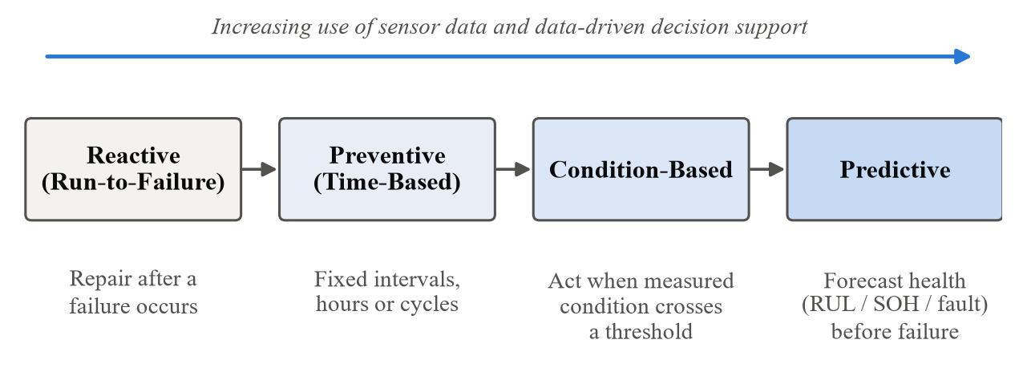
Figure 1.1: Evolution of maintenance strategies from reactive to predictive maintenance
Machine learning (ML) has become the standard tool for the data-processing step [10], [25], but aircraft predictive-maintenance research is dominated by engine studies built on the public NASA C-MAPSS turbofan dataset [39], [46]. Public data for other subsystems is scarcer and heterogeneous, and many studies stop at a numerical prediction such as Remaining Useful Life (RUL) without turning it into an action for a maintenance planner [6].
This project, “Intelligent Aircraft Predictive Maintenance with Machine Learning and Real-Time Simulated Data for Maintenance Recommendation and Priority”, responds to these observations. It covers five subsystems—Engine, Electrical/Battery, Hydraulic, Fuel and Landing Gear—each paired with a public dataset and a suitable prediction task. Every prediction passes through a rule-based interpretation layer that produces two decision outputs, a Maintenance Recommendation and a Maintenance Priority. The models are served by a FastAPI backend to a React dashboard; “real-time” refers to simulated telemetry, not live aircraft data.

1.2 Objectives
- To develop an ML-based predictive-maintenance system covering five aircraft subsystems: Engine, Electrical/Battery, Hydraulic, Fuel and Landing Gear.
- To select a defensible public dataset for each subsystem and state clearly whether it is simulated, experimental, test-rig or synthetic data.
- To build leakage-safe preprocessing and causal feature-engineering pipelines, and to train and compare suitable models for RUL, State of Health (SOH), condition classification and anomaly detection, evaluated on unseen units wherever the data allow.
- To convert every model output into a Maintenance Recommendation and a Maintenance Priority through a transparent, configurable decision layer.
- To integrate the models into a FastAPI backend and a React dashboard driven by simulated data, verified by automated tests.

1.3 Scope
In scope. Five subsystems and datasets: Engine (NASA C-MAPSS FD001; RUL), Electrical/Battery (NASA PCoE battery ageing data; SOH and experimental RUL), Hydraulic (UCI hydraulic test rig; four condition classifications), Fuel (Aircraft Fuel Distribution System scenarios; anomaly detection) and Landing Gear (physics-informed digital twin of a Dornier 228 shock strut; fault classification and RUL). The decision outputs are limited to Maintenance Recommendation and Maintenance Priority; cost, downtime, spares and technician assignment were deliberately excluded.
Limitations. Avionics was excluded because the only public dataset examined describes approach-phase operational anomalies, not avionics component health. No live aircraft telemetry or airline maintenance records are used. The datasets are heterogeneous and partly simulated or synthetic, so the results describe behaviour on benchmark data rather than operational readiness, and the rule-based decision layer has not been validated against real maintenance actions (Section 5.4).

1.4 Structure of the Report
Chapter 2 reviews the literature for each subsystem, maintenance decision support, validation practice and public data availability, and identifies the research gaps. Chapter 3 describes the development framework, the datasets, the tools and algorithms, and the validation and testing methods. Chapter 4 presents the system architecture, process flows, key modules and the challenges met during implementation. Chapter 5 reports, interprets and compares the results and states the limitations. Chapter 6 summarises the achievements and the scope for future work. The references, ordered alphabetically by first author, and two appendices follow.

CHAPTER 2: LITERATURE REVIEW

2.1 Overview
This chapter reviews earlier work related to the project. It first explains the main maintenance strategies and the idea of predicting the health of a component. It then looks at previous research on each of the five aircraft subsystems covered by the project—engine, electrical/battery, hydraulic, fuel and landing gear. After that, it discusses how machine-learning models should be tested fairly, how predictions can be turned into maintenance decisions, and which public datasets are available for aircraft subsystems. The chapter ends with a summary table of the literature and the research gaps that this project addresses.
Figure 2.1 shows how the works cited in this report are spread across topics. A deliberate effort was made to look beyond the engine, which dominates aircraft predictive-maintenance research, and to cover the other subsystems as well.
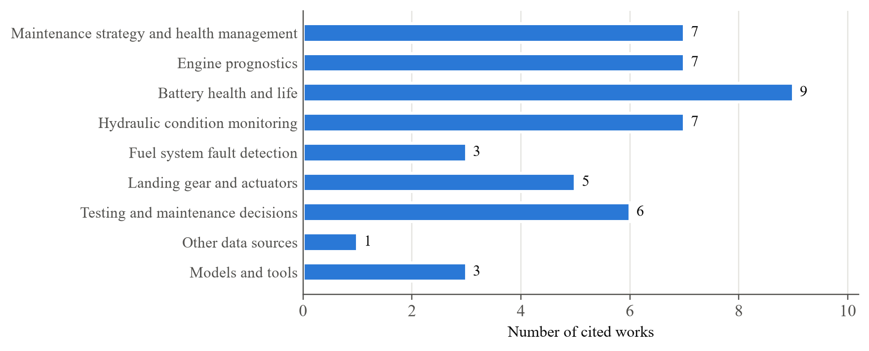
Figure 2.1: Distribution of the works cited in this report by topic

2.2 Maintenance Strategies and Health Management
Maintenance strategies are usually grouped into four types. Reactive maintenance repairs a part only after it fails. Preventive maintenance replaces or inspects parts at fixed intervals, whether or not they are worn. Condition-based maintenance acts when a measured value, such as vibration or temperature, crosses a limit. Predictive maintenance goes one step further and estimates how the condition will change in the future, so that work can be planned before a failure happens.
Table 2.1 compares the four strategies.
Table 2.1: Comparison of maintenance strategies
Strategy | When work is done | Advantage | Disadvantage
Reactive | After a failure | No planning or monitoring cost | Unexpected failures, delays and safety risk
Preventive | At fixed intervals | Simple to plan | Parts may be replaced while still healthy
Condition-based | When a measured value crosses a limit | Work only when needed | Gives little warning time
Predictive | Before the predicted failure | Planned, timely maintenance | Needs data, models and validation

Jardine, Lin and Banjevic described condition-based maintenance as three linked steps: collecting data, processing the data, and making a maintenance decision [18]. They also separated diagnostics, which identifies a fault that already exists, from prognostics, which predicts a fault before it occurs. Both appear in this project: the hydraulic, fuel and landing-gear classifiers perform diagnosis, while the engine, battery and landing-gear life predictors perform prognosis.
Lei et al. reviewed many prognostics studies and showed that data-driven methods, especially machine learning, have become very common for predicting remaining life [25]. Fink et al. discussed deep learning for health management and noted practical problems, such as the shortage of real fault data and the need for results that engineers can understand and trust [10].
In aviation, the idea of monitoring the health of the whole aircraft is called Integrated Vehicle Health Management (IVHM) [9]. The economic value is real: Gerdes, Scholz and Galar found that many delay-causing maintenance actions on an Airbus fleet could have been anticipated with suitable condition monitoring [11]. However, two reviews of aircraft predictive maintenance—by Stanton et al. for commercial aircraft [46] and by Scott et al. for defence aircraft [41]—found that most published work focuses on engines, mainly because public data for other aircraft systems is limited.
Two health measures are used throughout this report. Remaining Useful Life (RUL) is how much life is left before a part reaches failure, measured in cycles or as a percentage. State of Health (SOH) compares a part’s present condition with its condition when new; for a battery it is the present capacity divided by the original capacity.

2.3 Machine Learning for Predictive Maintenance
Most predictive-maintenance studies use supervised learning: a model is trained on past examples where the correct answer is known, and then used to predict the answer for new data. Two kinds of supervised task are common. In regression, the model predicts a number, such as the remaining life of an engine in cycles. In classification, the model predicts a category, such as whether a valve is working normally or has a severe lag. A special case of classification is anomaly detection, where the model only has to decide whether readings look normal or abnormal.
Before a model can learn, the raw sensor readings are usually turned into features—simple numbers that summarise the readings, such as an average over the last few cycles or the highest value in a test. Good features often matter more than the choice of model, which is why many studies spend most of their effort on data preparation [25]. Table 2.2 shows how these task types appear in this project.
Table 2.2: Types of machine-learning tasks used in this project
Task type | Question answered | Example in this project | Main measure
Regression | How much life or health is left? | Engine RUL, battery SOH and RUL, landing-gear RUL | MAE, RMSE, R²
Classification | Which condition is the part in? | Hydraulic components, landing-gear fault type | Accuracy, F1
Anomaly detection | Do the readings look normal? | Fuel system | Detection and false-alarm rates

Common model families include linear models, decision-tree ensembles such as Random Forest, and deep neural networks. Deep networks can learn directly from raw signals but usually need large amounts of data and are harder to explain. Tree ensembles and linear models work well on the moderate-sized, table-shaped data used in this project and are easier to explain to maintenance engineers [2].

2.4 Aircraft Engine Prognostics
The most widely used engine dataset is NASA C-MAPSS, created by Saxena, Goebel, Simon and Eklund. They used a computer simulation of a large turbofan engine, gradually degraded its internal components, and recorded sensor readings until each engine failed [39]. The dataset has four subsets, FD001 to FD004, with different numbers of operating conditions and fault types [38]. FD001 is the simplest, with one operating condition and one fault type, which is why it is commonly used for a first study and is used in this project.
Saxena et al. also pointed out that a late prediction—saying an engine has more life left than it really has—is more dangerous than an early prediction, because a late prediction may keep a worn engine in service. They therefore proposed a scoring method that penalises late predictions more heavily [39], [40]. This idea is used in the project, where late predictions near failure are checked separately.
Heimes introduced the common practice of capping the RUL target: while an engine is healthy, its RUL label is held at a fixed maximum value, and it only starts to decrease once wear becomes visible in the sensors [15]. The reason is simple—when the engine is still healthy, the sensors give almost no clue about how many hundreds of cycles remain. Later studies used deep-learning models such as convolutional neural networks (Babu, Zhao and Li [4]) and Long Short-Term Memory networks (Zheng et al. [48]) on the same dataset.
Simpler models are still competitive. Alomari, Andó and Baptista showed that tree-based models such as Random Forest perform well on C-MAPSS when good features are used, and that the most useful features can be identified to make the model easier to explain [2]. This supports the project’s choice of a Random Forest model for engine RUL.
Relevance to this project. The engine module uses the FD001 subset, caps the RUL at 125 cycles, uses a Random Forest model and checks late predictions near failure separately, following the lessons from these studies.

2.5 Battery Health and Life Prediction
The NASA battery dataset contains repeated charging, discharging and impedance measurements of lithium-ion cells, recorded until the cells lost a set amount of capacity [34]. Each discharge record includes voltage, current, temperature, time and the capacity delivered. It is a laboratory battery-ageing dataset; it is not data from an aircraft’s electrical system, and this report never describes it as such.
Saha et al. used this data to predict battery life together with a range of uncertainty [35]. Later studies applied many machine-learning methods: Li et al. estimated battery health from features of the charging curve [26], Ren et al. used deep learning to predict remaining life [33], and Swain et al. compared Random Forest with other regression models [47]. Mbagaya, Reddy and Botes reviewed these methods and found that more complex sequence models help mainly when a lot of data is available [29].
Testing method is very important for battery data. Consecutive cycles of the same cell are very similar, so if some cycles of a cell are used for training and others for testing, the test becomes too easy. Mohamud et al. avoided this by testing each battery with a model trained only on the other batteries, called leave-one-battery-out testing [30]. This project uses the same approach for its battery RUL experiment.
Battery health matters for aircraft too. Goebel et al. explained that the remaining flight time of an electric aircraft depends on battery age [14], and Kulkarni, Roychoudhury and Schumann demonstrated battery health monitoring on an electric test aircraft [23]. These works justify placing battery health under the Electrical/Battery subsystem of the dashboard.
Relevance to this project. The battery module uses the NASA data to predict SOH and remaining life, tests remaining life on batteries the model has never seen, and always describes the data as laboratory battery-ageing data.

2.6 Hydraulic System Condition Monitoring
The hydraulic dataset used in this project was recorded by Helwig, Pignanelli and Schütze on a hydraulic test rig and published in the UCI Machine Learning Repository [17]. The rig has sensors for pressure, flow, temperature, vibration and motor power. The researchers deliberately changed the condition of four components—the cooler, the valve, the pump and the accumulator—and recorded how the sensor readings changed [16].
Many studies have used this dataset. Alenany, Helmi and Nasef showed that a Random Forest trained on simple statistics of each sensor, such as the mean and standard deviation, works well for all four components, with the accumulator being the hardest to classify [1]. König and Helmi used deep learning on the raw signals and identified which sensors were most useful [22], and Kim and Heo compared eight different classifiers [21].
A recent study by Shamim et al. warned that splitting this kind of time-ordered data randomly into training and test sets can make results look better than they really are [42]. For this reason, the project keeps cycles that share the same combination of component conditions together, either all in training or all in testing.
Shen and Zhao applied deep learning to fault diagnosis in aircraft hydraulic systems [43], and Khan et al. noted that dedicated research on aircraft hydraulics is still limited compared with engines [20]. The UCI rig is an industrial test rig, so the project describes it as hydraulic condition-monitoring data and not as aircraft flight data.
Relevance to this project. Following these studies, the hydraulic module uses simple per-cycle statistics of each sensor, trains one classifier for each of the four components, and keeps cycles with the same condition settings together during testing.

2.7 Fuel System Fault Detection
Public data for aircraft fuel systems is rare. The dataset used here was published by Aslansefat et al. and describes a simplified aircraft fuel distribution system with two tanks feeding two engines, measured by level, temperature and flow sensors [3]. It comes from the work of Gheraibia et al., who combined safety analysis with machine learning [13]. The dataset contains one normal scenario and four abnormal scenarios.
Other fuel-system studies used laboratory rigs. Skaf et al. simulated filter clogging at five severity levels on a fuel rig and compared several classifiers [44]; however, their data does not appear to be publicly available, so it is used here only as a reference. Overall, the literature shows that fuel-system fault detection is possible, but public data with many normal and faulty runs is scarce.
Relevance to this project. The fuel module treats the task as anomaly detection, tests on whole scenario files that the model has not seen, and uses the output only as an early warning because the dataset contains just one normal scenario.

2.8 Landing Gear Health Monitoring
Because real landing-gear fault data is rarely published, researchers often use simulations and digital twins—computer models that behave like the real system. Pinello et al. built a digital twin of a nose landing gear to test fault-detection methods [32]. Li, Chen and Qin used a simulation of a shock absorber to train a deep-learning model that detects changes such as gas leakage [27]. Chen et al. used deep learning to diagnose faults in the landing-gear retraction and extension system [8].
The landing-gear data used in this project comes from a digital twin of a Dornier 228 shock strut described by Sani and Uhiah [37], with the dataset published on Kaggle [36]. It gives, for every simulated landing, values such as maximum deflection, settling time, aircraft mass, stiffness and damping, together with a fault code and an RUL percentage. Because it is generated by a computer model, this report always calls it synthetic (simulated) landing-gear data.
Relevance to this project. The landing-gear module predicts both the fault type and the remaining life from this synthetic data, and the report makes clear that its high scores come from clean simulated data.

2.9 Testing Models Fairly
A model must be tested on data it has never seen. Kaufman et al. described data leakage, which happens when information from the test data accidentally reaches the model during training, making results look better than they really are [19]. In predictive maintenance, leakage often happens when readings from the same engine, battery or test scenario appear in both the training set and the test set. Bergmeir and Benítez showed that for time-ordered data, ordinary random splitting can be misleading [5].
The choice of score also matters. If one class is much more common than the others, plain accuracy can hide poor performance on the rare classes. Sokolova and Lapalme therefore recommended measures that treat every class equally, such as the average of the per-class scores [45]. For RUL and SOH, the common measures are the mean absolute error (MAE), root mean square error (RMSE) and R²; these are explained in Chapter 3.

2.10 From Prediction to Maintenance Decisions
Predicting the health of a part is not the same as deciding what to do about it. Bougacha, Varnier and Zerhouni reviewed this topic and found that most health-management studies stop at the prediction and do not explain how it should lead to a maintenance action [6]. This project adds a separate decision step that turns every prediction into a maintenance recommendation and a priority level.
Lee et al. studied the risks of data-driven maintenance in airline operations and identified twenty possible hazards, such as poor data quality or trusting a model too much [24]. This supports two choices in the project: predictions that the model is unsure about are flagged for a human to review, and the decision limits are kept as settings that experts can review and change. It also means that, without real maintenance records, the recommendations cannot yet be proven correct in practice.

2.11 Public Data Availability for Aircraft Subsystems
Choosing the datasets required checking several public sources, some of which turned out to be unsuitable. Table 2.3 lists the sources examined and the decision taken for each. For example, C-MAPSS contains fuel-flow readings but is an engine dataset, so it is used only for the engine. A pump dataset on Zenodo turned out to describe industrial water pumps rather than aircraft fuel pumps. The FAA Service Difficulty Reports are written incident reports, useful for text analysis but not for predicting remaining life. NASA research on electro-mechanical actuators, which move parts such as landing gear, is available mainly as papers rather than as a ready-to-use dataset.
For avionics, NASA’s Sample Flight Data project offers about 99,000 flights labelled as normal or as one of three approach problems (speed high, path high, late flap setting) [28]. These labels describe how the aircraft was flown, not the health of avionics equipment, so they cannot be used to predict avionics failures. Avionics is therefore treated as a data gap and is not part of the implemented system.
Table 2.3: Public data sources examined for the aircraft subsystems
Data source | Subsystem | Nature of the data | Decision
NASA C-MAPSS (FD001) | Engine | Simulated engine degradation | Used for engine RUL
NASA Battery Data Set | Electrical / Battery | Laboratory battery ageing | Used for SOH and battery RUL
UCI Hydraulic Systems | Hydraulic | Test-rig condition monitoring | Used for four condition classifications
Aircraft Fuel Distribution System | Fuel | Simplified fuel-system scenarios | Used for anomaly detection
Landing Gear Digital Twin | Landing Gear | Synthetic simulated landings | Used for fault type and RUL
Zenodo pump data (CIRA) | Fuel | Industrial water pumps | Rejected: not aircraft fuel pumps
Skaf et al. fuel rig | Fuel | Filter-clogging experiments | Not public; reference only
FAA Service Difficulty Reports | Landing Gear | Written incident reports | Rejected: not sensor data
NASA actuator (EMA) work | Landing Gear | Research papers | No dataset found; reference only
NASA Sample Flight Data | Avionics | Approach-phase flight anomalies | Rejected: avionics excluded

2.12 Summary of Literature Survey
Table 2.4 summarises the most relevant works and how they relate to this project.
Table 2.4: Summary of the literature survey
Sr. No. | Author(s) and Year | Focus and Method | Findings and Relevance
1 | Jardine et al. (2006) [18] | Review of condition-based maintenance | Data collection, processing and decision steps; basis of our pipeline
2 | Lei et al. (2018) [25] | Review of prognostics | Machine learning is now common for life prediction
3 | Gerdes et al. (2016) [11] | Cost study of aircraft delays | Many delays could be avoided with condition monitoring
4 | Stanton et al. (2023) [46] | Review of aircraft predictive maintenance | Most work is on engines; other systems lack data
5 | Saxena et al. (2008) [39] | C-MAPSS engine simulation | Standard engine dataset; late predictions are riskier
6 | Heimes (2008) [15] | Neural network for engine RUL | Introduced the capped RUL target used here
7 | Zheng et al. (2017) [48] | LSTM network on C-MAPSS | Deep learning for engine RUL
8 | Alomari et al. (2023) [2] | Tree models and feature importance | Random Forest is competitive and explainable
9 | Saha et al. (2009) [35] | NASA battery data | Battery life prediction with uncertainty
10 | Mohamud et al. (2026) [30] | Hybrid model, leave-one-battery-out | Testing method adopted for battery RUL
11 | Helwig et al. (2015) [16] | Hydraulic test rig | Source of the hydraulic dataset and its four targets
12 | Alenany et al. (2021) [1] | Random Forest on sensor statistics | Simple statistics work well; accumulator is hardest
13 | Shamim et al. (2026) [42] | Fair testing of time-ordered data | Random splits can inflate results
14 | Gheraibia et al. (2019) [13] | Safety analysis with machine learning | Origin of the fuel dataset
15 | Skaf et al. (2023) [44] | Fuel rig with filter clogging | Five fault levels; data not public
16 | Pinello et al. (2024) [32] | Nose landing gear digital twin | Digital twins help where real fault data is rare
17 | Sani and Uhiah (2026) [37] | Dornier 228 shock-strut digital twin | Source of our synthetic landing-gear data
18 | Bougacha et al. (2020) [6] | Review of maintenance decisions | Most studies stop at prediction
19 | Lee et al. (2023) [24] | Risks of data-driven maintenance | Uncertain outputs need human review
20 | Kaufman et al. (2012) [19] | Data leakage | Test data must stay separate from training
21 | Babu et al. (2016) [4] | Deep CNN on C-MAPSS | Deep learning for engine RUL; useful comparison point
22 | Li et al. (2020) [26] | Battery charging-curve features | Health can be estimated from curve features
23 | König and Helmi (2020) [22] | Deep learning on hydraulic signals | Shows which sensors matter most
24 | Li, Chen and Qin (2025) [27] | Simulated shock-absorber data | Simulation can train landing-gear fault models
25 | Sokolova and Lapalme (2009) [45] | Classification measures | Use measures that treat all classes equally

2.13 Research Gaps
The review shows the following gaps:
- Engine focus. Most aircraft predictive-maintenance studies cover only one subsystem, usually the engine [41], [46].
- No decision step. Few studies turn a prediction into a maintenance recommendation and priority [6].
- Different kinds of data. Public datasets for different subsystems differ in format and purpose, which makes it hard to combine them in one system.
- Unfair testing. Random splitting of time-ordered or grouped data can give results that are too optimistic [19], [42].
- Little end-to-end demonstration. Studies rarely show models working inside a complete software system with a dashboard.
This project addresses these gaps in a working system: it combines five subsystems in one pipeline, tests every model on data it has not seen, adds a recommendation and priority for every prediction, and connects the models to a backend and dashboard using simulated data. It does not claim to fully solve these gaps—it uses public benchmark data rather than airline data, it does not propose a new algorithm, and its maintenance decisions have not been checked against real maintenance records.

CHAPTER 3: METHODOLOGY
This chapter explains how the project was carried out: the overall development framework, how the data for each subsystem was collected and prepared, the tools and machine-learning models used, and how the models and software were tested.

3.1 Research/Development Framework
The project was built step by step. Every subsystem went through the same eight phases shown in Figure 3.1, from choosing a dataset to testing and documentation. A phase was finished only after its result had been checked—for example, a model was added to the backend only after it had been tested on data it had never seen. If a check failed, the work went back to the modelling phase.
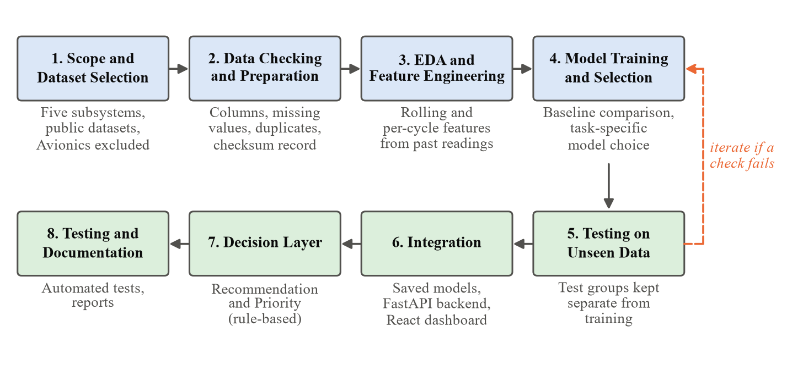
Figure 3.1: Phases of the project development framework
Five simple rules guided the work:
- The task should fit the data. Each subsystem is given the type of prediction its dataset can support—remaining life, health percentage, condition class or anomaly flag.
- Choose the model by testing. Several models are compared for each task, and the one that performs best on unseen data is selected.
- Keep test data separate. All data from the same engine, battery, test condition or scenario stays either in training or in testing, never in both.
- Use only past readings. Features are calculated only from past and current readings, so that the same calculation works on live (simulated) data.
- Be honest about uncertainty. Predictions the model is unsure about are flagged for review, and the limits of each dataset are stated clearly.
Figure 3.2 shows how each subsystem is matched to its dataset, prediction task and final model.
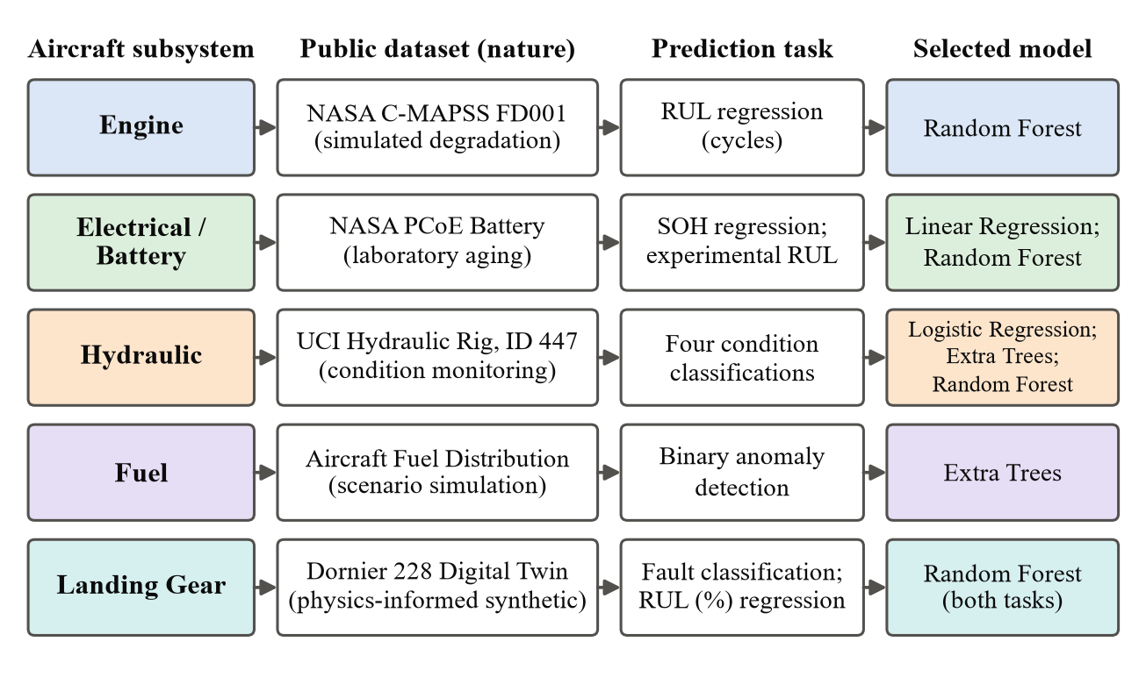
Figure 3.2: Subsystems, datasets, prediction tasks and selected models

3.2 Data Collection or Development Process

3.2.1 Choosing the Datasets
The project does not have access to airline maintenance records or live aircraft data, so all data comes from public sources. A dataset was accepted only if (1) it is publicly available with documentation, (2) it relates to the health or faults of the subsystem, (3) it has labels that support a clear prediction task, and (4) its nature—simulated, laboratory, test-rig or synthetic—can be described accurately. Sources that failed these checks are listed in Table 2.3.
Table 3.1 gives a short summary of the five datasets used.
Table 3.1: Summary of the datasets used
Subsystem | Dataset | Size | Target
Engine | NASA C-MAPSS FD001 | 100 training and 100 test engines | Remaining life in cycles
Battery | NASA Battery Data Set | Repeated test cycles of several cells | SOH (%) and remaining life
Hydraulic | UCI Hydraulic Systems | 2,205 test cycles | Four component conditions
Fuel | Aircraft Fuel Distribution System | 855 rows in 5 files | Normal or abnormal
Landing Gear | Landing Gear Digital Twin | 1,500 simulated landings (published file) | Fault type and RUL (%)

3.2.2 Engine Data: NASA C-MAPSS FD001
The engine module uses the FD001 subset of NASA C-MAPSS [38]. It contains 100 training engines that run until failure and 100 test engines whose records stop some time before failure; the true remaining life of each test engine is given in a separate file. Each row describes one operating cycle of one engine, with three operating settings and 21 sensor readings.
For a training engine that fails at cycle T, the remaining useful life at cycle t is T − t. Following common practice [15], this value is capped at 125 cycles (Equation (3.1) and Figure 3.3), because a healthy engine’s sensors give little information about exactly how much life is left.
 | $RUL = min\left(T − t, 125\right)$ | (3.1)

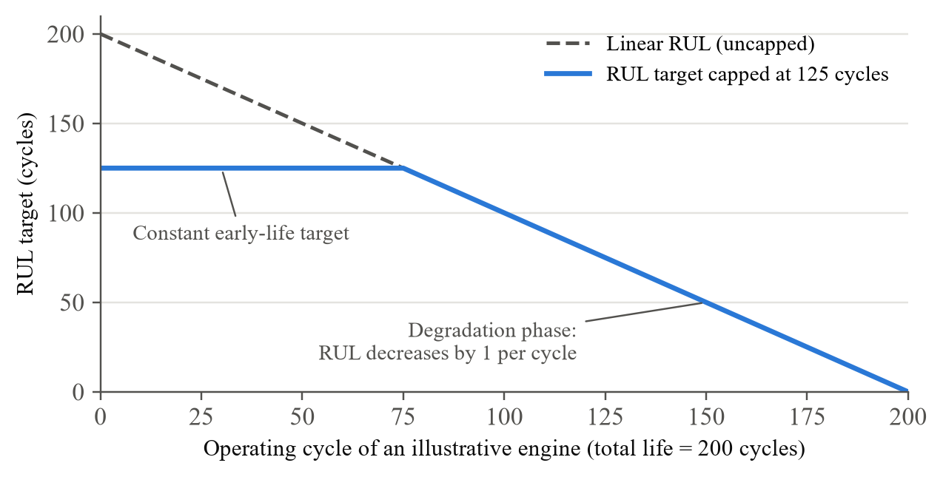
Figure 3.3: RUL target capped at 125 cycles
Sensors that never change in FD001 carry no information and were removed. The remaining values were scaled using statistics calculated from the training engines only.

3.2.3 Battery Data: NASA Battery Data Set
The battery module uses the NASA battery dataset [34], which records repeated charge, discharge and impedance tests on lithium-ion cells. Each discharge record contains voltage, current, temperature, time and the capacity delivered. The records were arranged in time order for each cell. The battery’s State of Health at cycle k is its capacity at that cycle compared with its first capacity (Equation (3.2)). About 21 features describing the shape and length of each discharge curve were extracted. For the remaining-life experiment, each cycle was labelled with the number of cycles left until the cell reached its end-of-life point.
 | $SOH = \frac{capacity at cycle k}{initial capacity} × 100 \%$ | (3.2)

3.2.4 Hydraulic Data: UCI Hydraulic Test Rig
The hydraulic module uses dataset 447 from the UCI repository [17]. It has 2,205 test cycles, each lasting 60 seconds, recorded by the sensors in Table 3.2. Each cycle has four condition labels, shown in Table 3.3, plus a “stable” flag showing whether the rig had settled during that cycle. The dataset’s own label names are used throughout.
Table 3.2: Sensors of the hydraulic test rig
Sensor | Measures | Unit | Readings per second
PS1 – PS6 | Pressure | bar | 100
EPS1 | Motor power | W | 100
FS1 – FS2 | Flow | l/min | 10
TS1 – TS4 | Temperature | °C | 1
VS1 | Vibration | mm/s | 1
CE, CP, SE | Cooling efficiency, cooling power, system efficiency (calculated) | %, kW, % | 1

Table 3.3: Condition labels of the hydraulic dataset
Label | Values | Meaning
Cooler condition (%) | 3, 20, 100 | Close to failure; reduced efficiency; full efficiency
Valve condition (%) | 100, 90, 80, 73 | Optimal; small lag; severe lag; close to failure
Internal pump leakage | 0, 1, 2 | No leakage; weak leakage; severe leakage
Hydraulic accumulator (bar) | 130, 115, 100, 90 | Optimal pressure; slightly reduced; severely reduced; close to failure

Each sensor signal was summarised per cycle using simple statistics such as the mean, standard deviation, slope and highest and lowest values.

3.2.5 Fuel Data: Aircraft Fuel Distribution System
The fuel module uses the Aircraft Fuel Distribution System dataset [3]. The modelled system has a front tank feeding the left engine and a rear tank feeding the right engine, with level, temperature and flow sensors. The data comes as five CSV files—one normal scenario and four abnormal scenarios—with 855 rows, 8 sensor columns, and no missing, invalid or duplicate rows. Rolling statistics calculated within each file produced 32 features.
The task is anomaly detection: each row is labelled normal if it comes from the normal file and abnormal otherwise. One limitation is that the exact moment each fault starts inside an abnormal file could not be confirmed, so some early rows in those files may actually look normal.

3.2.6 Landing Gear Data: Digital Twin Dataset
The landing-gear module uses a digital-twin dataset of a Dornier 228 shock strut [36]. Each row is one simulated landing, described by the fields in Table 3.4. The published file contains 1,500 landings: 300 normal, 500 with a gas leak, 500 with a worn seal and 200 with early structural damage. Because the data is simulated, it is described as synthetic data and not real aircraft data. The mass range of our local copy differs from the published description, so the exact version is still being confirmed.
Table 3.4: Fields of the landing-gear dataset
Field | Description
Max_Deflection, Max_Velocity | Largest compression of the strut and its fastest movement during landing
Settling_Time | Time taken for the strut to settle after touchdown
Mass | Aircraft mass for that landing
K_Stiffness, B_Damping | Stiffness and damping values of the strut model
Fault_Code | 0 = Normal; 1 = Nitrogen gas leak; 2 = Worn seal; 3 = Early structural degradation
RUL (%) | Remaining useful life: 100 = new, 0 = failure

3.2.7 Data Checking and Preparation
Every dataset was checked before use, as listed in Table 3.5. A record of every processed file—its size, description and a checksum (a digital fingerprint that changes if the file changes)—was kept so that the data used for each model can always be confirmed.
Table 3.5: Checks applied to every dataset
Check | Purpose
Columns and data types | Confirm the expected fields are present
Row and cycle counts | Confirm the dataset is complete
Missing or invalid values | Find empty or impossible values before use
Duplicate rows | Avoid repeated data that could bias the model
Labels | Confirm labels can be recreated from the source data
Checksum | Detect any later change to a data file

Any value learned from data, such as the scaling settings, was calculated from the training portion only, so that the test data stayed truly unseen.

3.2.8 Exploratory Data Analysis
Before training any model, each dataset was explored with simple plots and summaries to understand it. The main questions asked were:
- Which sensors change as the part wears? For the engine, sensor values were plotted against the cycle number; sensors that never change were removed because they cannot help the model.
- How many examples does each class have? For example, the published landing-gear file has 300, 500, 500 and 200 landings for the four fault codes, so measures that treat all classes equally were used.
- Are there missing, invalid or repeated values? These checks are listed in Table 3.5.
- How are the data grouped? Identifying engines, battery cells, hydraulic condition combinations, fuel scenario files and landing-gear mass ranges decided how the data had to be split for testing.
These observations guided the choice of features, models and testing methods described in the rest of this chapter.

3.2.9 Feature Engineering
Features are calculated only from past and current readings (Figure 3.4). For example, a rolling average at time t uses the last few readings up to t, never readings that come after it. This matters because, when the system runs on streaming data, future readings are not yet available.
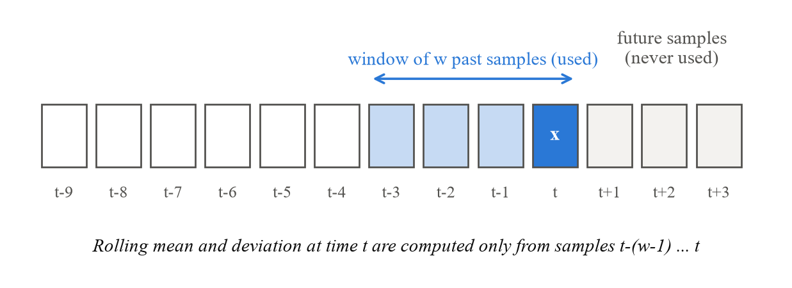
Figure 3.4: Rolling window that uses only past readings
- Engine: scaled sensor values plus rolling averages and deviations over each engine’s history.
- Battery: about 21 features describing each discharge curve.
- Hydraulic: per-cycle statistics of every sensor.
- Fuel: 32 rolling features from the 8 sensors.
- Landing gear: the per-landing values provided by the digital twin.

3.3 Tools/Software/Technologies Used
Table 3.6 lists the tools and technologies used in the project.
Table 3.6: Tools, software and technologies used
Category | Tool | Use in the project
Language | Python | Data processing, models, backend and tests
Data handling | Pandas, NumPy | Loading and preparing sensor data
Machine learning | Scikit-learn [31] | Training and evaluating the models
Charts | Matplotlib, Plotly | Data analysis and result plots
Notebooks | Jupyter Notebook | Experiments and data exploration
Backend | FastAPI | Serving predictions to the dashboard
Frontend | React, Vite, Tailwind CSS, Recharts, Lucide React | Web dashboard, layout, charts and icons
Testing | pytest | Automated tests
Version control | Git, GitHub, VS Code | Code management and development

3.3.1 Machine Learning Models Used
Linear Regression predicts a number as a weighted sum of the input features (Equation (3.3)). It was chosen for battery SOH because the health value follows the discharge features closely, the model performed best on unseen data, and it is easy to explain.
 | $ŷ = b_{0} + b_{1}x_{1} + b_{2}x_{2} + … + b_{p}x_{p}$ | (3.3)

Logistic Regression is a classification model that gives the probability of each class. It was chosen for the hydraulic cooler and valve targets, where the classes are well separated by the sensor statistics, and its probabilities are used for the confidence check described in Section 3.4.3.
Random Forest [7] builds many decision trees, each trained on a random sample of the data, and combines their answers—by averaging for numbers or by voting for classes. It handles complex relationships well and was chosen for engine RUL, battery RUL, the hydraulic accumulator, and both landing-gear tasks.
Extra Trees [12] is similar to Random Forest but chooses the tree split points more randomly, which often makes it more stable on noisy data. It gave the best result for internal pump leakage and was chosen for fuel anomaly detection.
Table 3.7 summarises the four models, why each was chosen and where it is used.
Table 3.7: Machine-learning models used in the project
Model | Type | Why it was chosen | Used for
Linear Regression | Regression | Simple, fast and easy to explain; best on unseen data for SOH | Battery SOH
Logistic Regression | Classification | Gives class probabilities; classes were well separated | Hydraulic cooler and valve
Random Forest | Both | Handles complex patterns in table data with little tuning | Engine RUL, battery RUL, accumulator, landing gear
Extra Trees | Classification | Stable on noisy data; best result in testing | Pump leakage, fuel anomaly

3.3.2 Software Requirements
The system runs on a standard laptop or desktop computer; no graphics card is needed because the models are classical machine-learning models. Table 3.8 lists the software needed to run it.
Table 3.8: Software needed to run the system
Software | Purpose
Python with the listed packages | Runs the data preparation, models, backend and tests (versions fixed in requirements-lock.txt)
Node.js with npm | Installs and builds the React dashboard
A modern web browser | Opens the dashboard
Git | Downloads and manages the project code

3.4 Validation/Testing Methods

3.4.1 Keeping Test Data Separate
Each subsystem was tested so that the model never saw any data from the test engine, battery, condition group or scenario during training [19]. Table 3.9 and Figure 3.5 summarise the testing method for each subsystem.
Table 3.9: Testing method for each subsystem
Subsystem | Kept together | Testing method
Engine | Each engine | Model chosen using groups of training engines; final test on the 100 official test engines
Battery | Each cell | SOH: data kept in time order within each cell. RUL: each battery tested by a model trained on the others
Hydraulic | Each condition combination | Cycles with the same condition settings kept together; unstable cycles also checked separately
Fuel | Each scenario file | Each test removes one whole abnormal scenario and a block of normal data
Landing Gear | Each mass range | Five-fold testing; each fold holds out complete aircraft-mass ranges

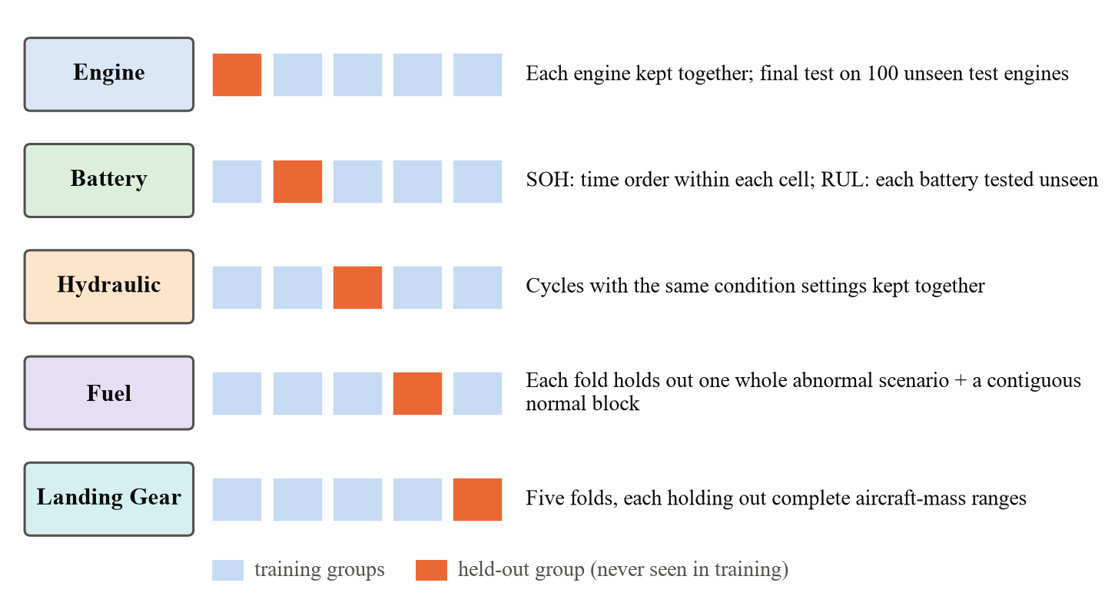
Figure 3.5: How test groups were held out for each subsystem

3.4.2 Evaluation Metrics
For number predictions (engine RUL, battery SOH, battery RUL and landing-gear RUL), three measures are used. For n test samples, with true value y_{i} and predicted value ŷ_{i}:
 | $MAE = \frac{1}{n}\sum_{i=1}^{n}{|y_{i} − ŷ_{i}|}$ | (3.4)

 | $RMSE = \sqrt{\frac{1}{n}\sum_{i=1}^{n}{{\left(y_{i} − ŷ_{i}\right)}^{2}}}$ | (3.5)

 | $R^{2} = 1 − \frac{sum of squared prediction errors}{sum of squared differences from the mean}$ | (3.6)

MAE is the average size of the error, in the same unit as the target. RMSE also measures error but gives more weight to large mistakes, so if RMSE is much larger than MAE, a few predictions have big errors. R² shows how much of the variation in the target the model explains (1.0 is perfect). R² is not a percentage accuracy.
For classification, the results are based on true positives (TP), true negatives (TN), false positives (FP) and false negatives (FN):
 | $Accuracy = \frac{TP + TN}{TP + TN + FP + FN}$ | (3.7)

 | $Precision = \frac{TP}{TP + FP}, Recall = \frac{TP}{TP + FN}$ | (3.8)

 | $F1 = \frac{2 × Precision × Recall}{Precision + Recall}$ | (3.9)

Balanced accuracy is the average recall over all classes, and macro F1 is the average F1 over all classes; both treat every class equally, so a model cannot look good just by predicting the most common class [45]. For the fuel task, the detection rate is the share of abnormal rows correctly flagged, and the false-alarm rate is the share of normal rows wrongly flagged.
For the engine, the share of late predictions near failure—where the model says more life is left than is true—is also reported, because these are the most dangerous errors [39].

3.4.3 Confidence Check for the Harder Hydraulic Targets
The valve and accumulator targets were harder to classify than the cooler and pump. For these two, a prediction is accepted only if the model is confident enough—its probability for the chosen class is at least 0.8889 for the valve and 0.5781 for the accumulator—and the input values are within the range seen during training. Otherwise the cycle is marked for human review. Accuracy is reported both for all cycles and for the accepted predictions only.

3.4.4 Software Testing
The software is checked by an automated test suite written with pytest. The tests cover data loading, feature calculation, saved models (confirming that they give the same predictions as when they were saved), data checksums and the API endpoints. On 17 October 2026 all 232 tests passed, both in the normal development environment and in a fresh environment installed from the project’s fixed list of package versions (requirements-lock.txt). The React dashboard was also built successfully for production.

CHAPTER 4: PROJECT DESIGN / IMPLEMENTATION
This chapter describes how the system was designed and built: the overall architecture, the flow of data during training and prediction, the main modules including the maintenance decision layer, and the challenges faced during the project with the solutions adopted.

4.1 System Design/Architecture
Figure 4.1 shows the overall architecture of the system. Data for every subsystem—whether from a stored dataset or from the simulated data source—passes through the same stages: data checking, preprocessing, feature engineering, a subsystem-specific model, health interpretation, and finally the two maintenance outputs. The models differ from subsystem to subsystem, but the stages around them are shared. A FastAPI backend sends the results to a React dashboard.
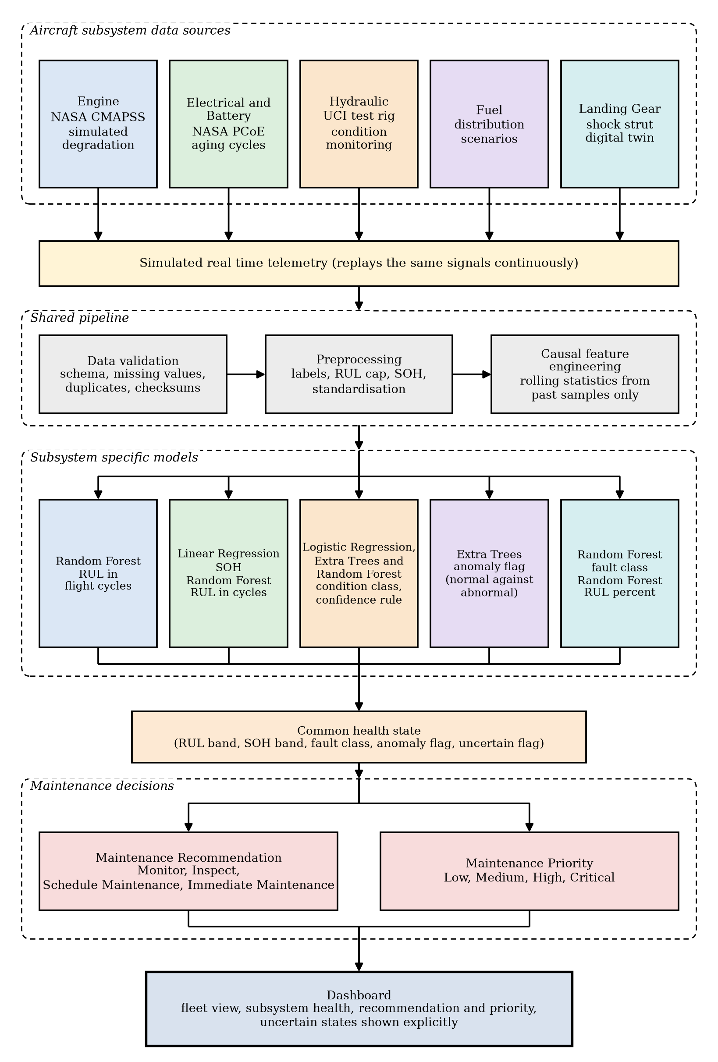
Figure 4.1: Overall architecture of the proposed system
The design has three useful properties. It is modular: each subsystem has its own data handling, features and saved model, so one subsystem can be changed without affecting the others, and a new subsystem could be added later in the same way. It separates prediction from decision: the models only predict, and a separate layer turns the predictions into maintenance decisions. It uses the same pipeline for training and prediction, so the dashboard shows results from exactly the models that were tested.

4.1.1 Layers of the System
The software is organised in five layers (Figure 4.2). Each layer talks only to the layer directly above or below it.
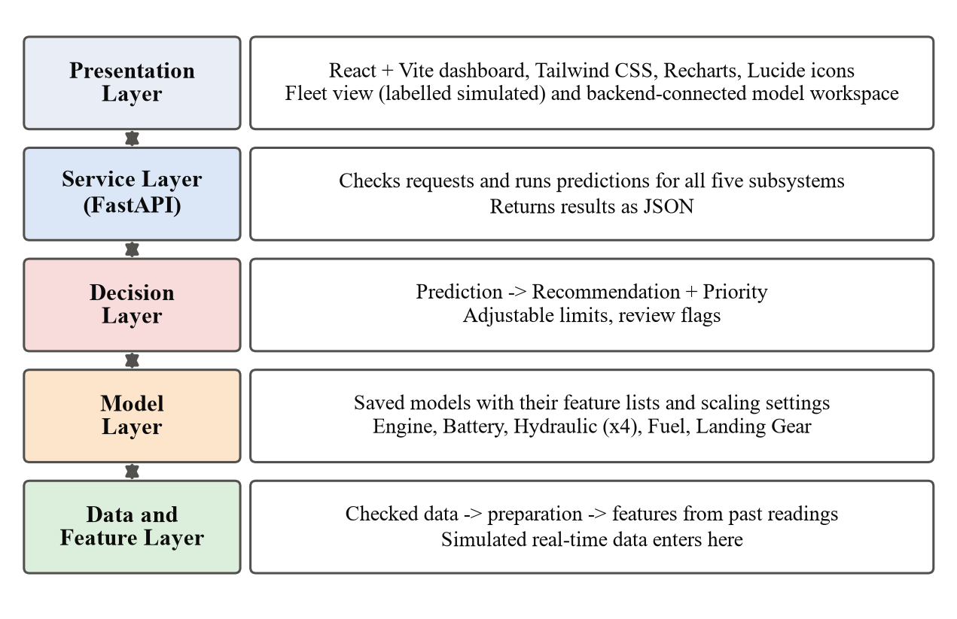
Figure 4.2: Layers of the software system
- Data and feature layer – loads the data, runs the checks and calculates the features. Simulated data also enters the system here.
- Model layer – holds the saved models: engine RUL, battery SOH and RUL, four hydraulic classifiers, fuel anomaly detection, and landing-gear fault and RUL.
- Decision layer – turns each prediction into a Maintenance Recommendation and a Maintenance Priority, and passes on any review flag.
- Service layer – the FastAPI backend, which receives requests and returns results.
- Presentation layer – the React dashboard that the user sees.

4.1.2 Backend Design
The backend is written in Python using FastAPI. It loads the saved models and provides a prediction route for each of the five subsystems, along with routes that return example inputs and the test results behind each model. For every request, the backend checks the input, calculates the features in the same way as during training, runs the model, applies the decision layer and returns the result in JSON format. The engine routes were built first and then used as the pattern for the other subsystems.
Each saved model is stored together with its list of input features and its scaling settings, so the backend always uses the same steps as during testing. The automated tests confirm that the saved models have not changed.

4.1.3 Frontend Design
The frontend is a React web application built with Vite, styled with Tailwind CSS, with charts drawn by Recharts and icons from Lucide React. It started as a prototype dashboard that showed a fleet of aircraft with random sensor values and also listed Avionics. During the project, three main changes were made:
- Avionics was removed, so the dashboard shows only the five implemented subsystems.
- Tailwind CSS was set up so that the dashboard displays as designed.
- The random values in the main prediction screen were replaced by real calls to the FastAPI backend, and every screen that still uses simulated values is clearly labelled as simulated.
The dashboard, named AeroPredict – Predictive Maintenance Console, has three views: AI Predictions, where results for all five subsystems come from the backend; Fleet, a fleet health overview; and Maintenance, a list of components needing attention. Each view states where its data comes from, and the fleet and maintenance views state that no live aircraft data is connected. For the engine, the dashboard shows a prototype RUL risk band with a note that it is a demonstration limit, not an approved maintenance limit.

4.1.4 How a User Works with the System
A typical session on the dashboard follows these steps:
- The user opens the dashboard in a web browser and selects the AI Predictions view.
- The user chooses a subsystem, for example Engine or Hydraulic.
- The user loads an example input provided by the backend.
- The dashboard sends the input to the FastAPI backend.
- The backend prepares the features, runs the model and applies the decision rules.
- The dashboard shows the prediction, the health state, the Maintenance Recommendation, the Maintenance Priority and any review flag.
- The Fleet and Maintenance views give an overview of many components, clearly labelled as research or simulated outputs.
Table 4.1 shows the information exchanged between the dashboard and the backend for one prediction.
Table 4.1: Information exchanged for one prediction
Item | Description
Sent by the dashboard | The subsystem and its sensor values or features (for example, an engine’s recent cycles)
Prediction | RUL in cycles or %, SOH in %, a condition class, or a normal/abnormal flag
Health state | A short description of the condition, based on the prediction
Maintenance Recommendation | Monitor, Inspect, Schedule Maintenance or Immediate Maintenance
Maintenance Priority | Low, Medium, High or Critical
Review flag | Shown when the input is unusual or the model is not confident

4.1.5 Key Design Decisions
Table 4.2: Key design decisions and the reasons for them
Decision | Reason
Different model for each subsystem | The datasets support different kinds of predictions
Separate decision layer | Predictions and decisions can be checked and changed independently
Only two decision outputs | Recommendation and Priority are supported by the available data; cost and downtime were not
Features from past readings only | The same calculation must work on streaming data
Review flag for unsure predictions | Uncertain results should not be shown as facts
Avionics excluded | No public dataset of avionics component health was found
Simulated data clearly labelled | The system must not suggest it receives live aircraft data

4.2 Process Flow

4.2.1 Training Flow
Figure 4.3 shows how each model was produced. The raw dataset is checked and recorded, labels are created, features are calculated, several models are compared using the subsystem’s testing method, the best model is tested on held-out data, and the final model is saved. All settings learned from data come from the training part only.
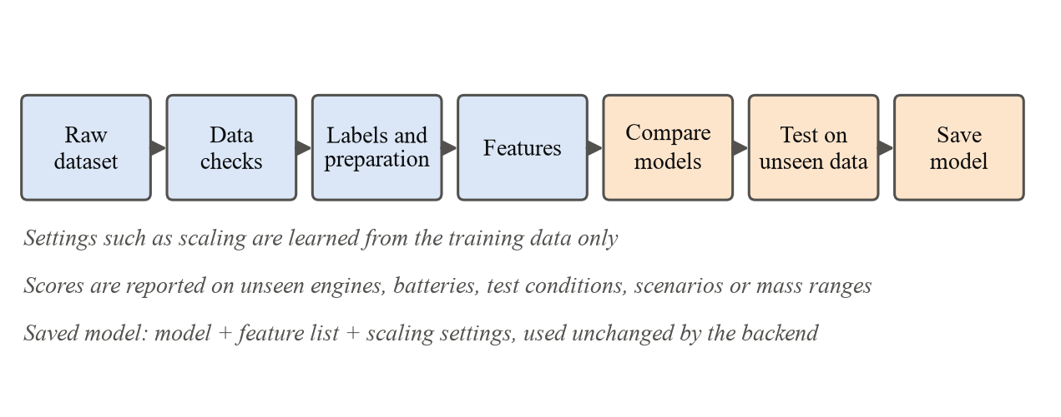
Figure 4.3: Model training flow

4.2.2 Prediction Flow
Figure 4.4 shows what happens when the dashboard or the data simulator sends sensor values. The backend checks the input, calculates features exactly as in training, runs the model and applies the decision layer. The response contains the prediction, the health state, the Maintenance Recommendation, the Maintenance Priority and any review flag. Inputs outside the training range, or predictions with low confidence, are flagged for review.
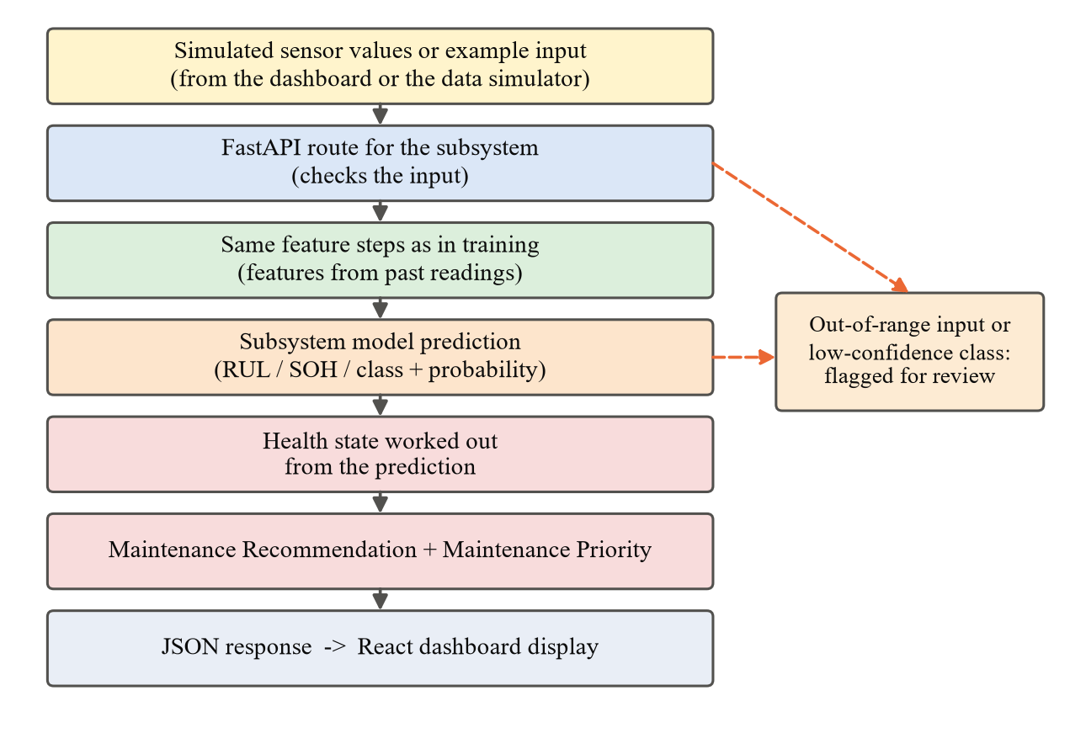
Figure 4.4: Prediction flow from sensor input to dashboard

4.2.3 Simulated Real-Time Data
“Real-time” in the project title means simulated real-time data. A simulator sends or replays sensor values for each subsystem at a chosen rate, so that the whole pipeline can be demonstrated from start to finish and different wear scenarios can be replayed. The simulated values are based on the same public datasets used for training. The system does not receive data from a real aircraft, and the speed of the system under continuous data has not yet been measured.

4.3 Key Components/Modules
Table 4.3 summarises the five subsystem modules.
Table 4.3: Summary of the subsystem modules
Module | Input | Model | Output
Engine | Engine cycle history | Random Forest | RUL in cycles (up to 125)
Electrical / Battery | About 21 discharge features | Linear Regression; Random Forest | SOH (%); RUL in cycles
Hydraulic | Per-cycle sensor statistics | Logistic Regression, Extra Trees, Random Forest | Four condition classes, with review flags
Fuel | 32 rolling features | Extra Trees | Normal or abnormal (screening only)
Landing Gear | Per-landing values | Random Forest (two models) | Fault type (0–3); RUL (%)

4.3.1 Engine RUL Module
The engine module receives an engine’s cycle history, removes unused sensors, scales the values, calculates rolling features and predicts the RUL in cycles with a Random Forest. The prediction is shown as a risk band on the dashboard. The module also accepts engine data in the original C-MAPSS column format. Because late predictions near failure are the most dangerous errors, a study was made on an earlier version of the model to shift low predictions slightly earlier; its results are given in Chapter 5.

4.3.2 Electrical/Battery Module
The battery module reads the discharge records of a cell in time order, extracts about 21 features from each discharge curve, and predicts the SOH with Linear Regression and the remaining life with a Random Forest. The dashboard shows it under Electrical/Battery, while the report makes clear that the data comes from laboratory battery tests.

4.3.3 Hydraulic Condition Module
The hydraulic module has four separate classifiers, one for each component: Logistic Regression for the cooler and valve, Extra Trees for pump leakage and Random Forest for the accumulator. Each returns a class and its probability. For the valve and accumulator, the confidence check in Figure 4.5 is applied, and cycles that do not pass it are marked for review on the dashboard.
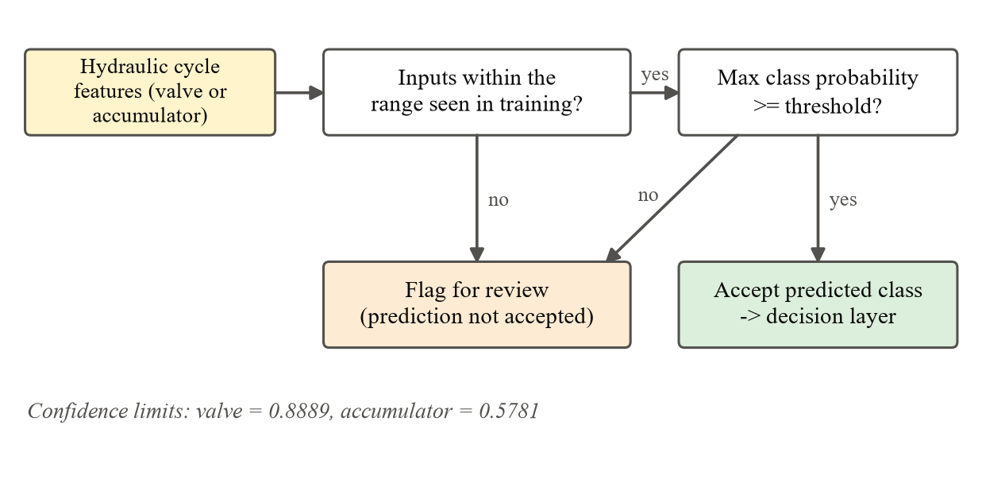
Figure 4.5: Confidence check for the hydraulic valve and accumulator

4.3.4 Fuel Anomaly Module
The fuel module calculates 32 rolling features from the 8 sensors and uses Extra Trees to label each moment as normal or abnormal. Because the training data contains only one normal scenario, the model raises many false alarms. Its output is therefore used only as a screening signal that suggests an inspection, not as proof of a fault, and the fuel route is not treated as production-ready.

4.3.5 Landing Gear Module
The landing-gear module uses two Random Forest models: one predicts the fault type (normal, gas leak, worn seal or early structural damage) and the other predicts the remaining life as a percentage. It shows that the pipeline can take landing-gear data all the way to a maintenance decision. Its high scores reflect clean simulated data and do not prove performance on real landing gear.

4.3.6 Maintenance Decision Layer
The decision layer turns every subsystem output into two decisions. The Maintenance Recommendation is one of Monitor, Inspect, Schedule Maintenance or Immediate Maintenance, and the Maintenance Priority is one of Low, Medium, High or Critical. Table 4.4 shows the rules and Figure 4.6 shows them as a flowchart.
Table 4.4: Rules for the maintenance decisions
Health state | Recommendation | Priority
RUL above 50 cycles; SOH high; normal class | Monitor | Low
RUL 20 to 50 cycles; SOH reduced; mildly degraded class; fuel anomaly flag | Inspect | Medium
RUL 20 cycles or less; seriously degraded class | Schedule Maintenance | High
Most severe fault class; RUL near zero | Immediate Maintenance | Critical

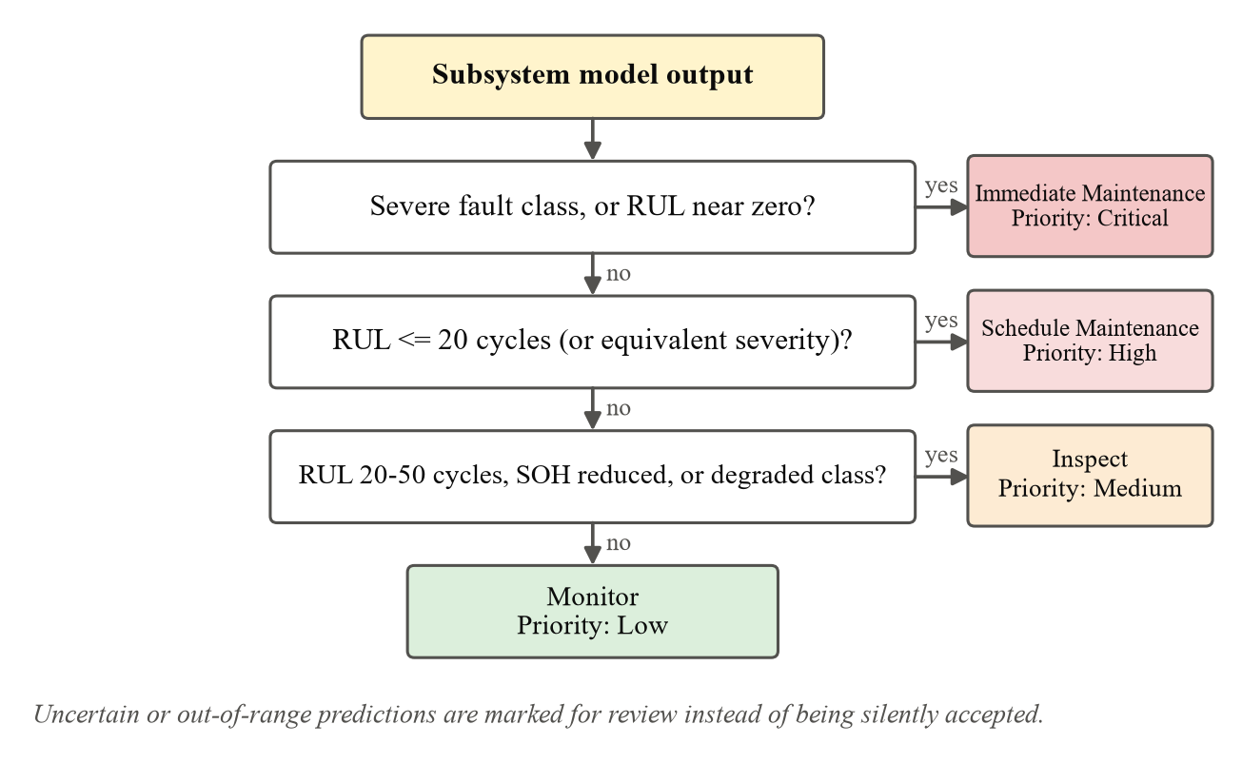
Figure 4.6: Decision rules shown as a flowchart
For classifiers, a normal class maps to Monitor and the most severe class to Immediate Maintenance, with other classes placed in between by severity. The limits are stored as settings that can be changed for a particular fleet. These are rule-based decisions, not decisions learned from maintenance records: no available dataset links sensor readings to the maintenance actually carried out, so the recommendations would need to be checked by maintenance experts before any real use.
Table 4.5 gives some worked examples of how the rules are applied.
Table 4.5: Examples of maintenance decisions
Model output | Recommendation | Priority
Engine RUL = 90 cycles | Monitor | Low
Engine RUL = 35 cycles | Inspect | Medium
Engine RUL = 15 cycles | Schedule Maintenance | High
Hydraulic valve = 100% (optimal switching) | Monitor | Low
Hydraulic valve = 73% (close to total failure) | Immediate Maintenance | Critical
Fuel readings flagged as abnormal | Inspect | Medium

4.3.7 Dashboard Module
In the AI Predictions view, the user selects a subsystem, loads an example input, sends it to the backend and sees the prediction with its health state, recommendation, priority and any review flag. Status is shown with both icons and text so that colour is not the only signal. Explanations of which sensors influenced a prediction, and trend charts over time, are planned for the future.

4.3.8 Testing the Integrated System
Besides testing each model, the complete system was checked. The automated test suite includes tests of the backend routes, so that each subsystem’s route is checked to return a valid result. The example inputs provided by the backend allow every subsystem to be tried from the dashboard, from input to recommendation and priority. The dashboard was also built successfully for production, which confirms that the frontend code compiles without errors.

4.4 Challenges and Solutions
Table 4.6 lists the main challenges faced during the project and how they were handled.
Table 4.6: Challenges and solutions
Challenge | Solution
Datasets of very different types | A separate model per subsystem inside one shared pipeline and decision layer
Risk of over-optimistic test results | Test groups kept completely separate from training groups
Some datasets were unsuitable or easy to misdescribe | Clear selection rules; unsuitable sources rejected; Avionics excluded
Engine model is often late near failure | Late predictions checked separately; a correction tested on an earlier model; safety note on the dashboard
Valve and accumulator were hard to classify | Confidence check; unsure cycles flagged for review
Only one normal fuel scenario | Fuel output used only for screening; more normal data identified as the main need
Landing-gear dataset version unclear | Recorded as an open issue; data always described as synthetic
A bad value in one fuel file caused two test failures | Raw data left unchanged and re-checked; preparation repeated with identical results
Prototype dashboard used random data and listed Avionics | Tailwind set up, Avionics removed, prediction screen connected to the backend

Several rounds of retraining were also tried for the weaker models. Some new versions scored better on the engine test set, but they were not adopted because they did not pass all of the project’s checks; the models reported in Chapter 5 are the ones currently used by the system.

CHAPTER 5: RESULT AND OBSERVATION
This chapter presents the results of the models used by the system. Each model was tested on data it had not seen during training, using the testing method of its subsystem (Table 3.9).

5.1 Data/Results/Screenshots
Table 5.1 gives the results of the number-prediction tasks, Table 5.2 the hydraulic results and Table 5.3 the landing-gear and fuel results. Figure 5.1 compares the classification accuracies.
Table 5.1: Results of the RUL and SOH prediction tasks
Task (unit) | Model | MAE | RMSE | R² | Tested on
Engine RUL (cycles) | Random Forest | 13.80 | 18.61 | 0.799 | 100 unseen test engines
Battery SOH (percentage points) | Linear Regression | 2.62 | 5.17 | 0.950 | Time-ordered data within each cell
Battery RUL (cycles) | Random Forest | 9.36 | 12.32 | 0.862 | Each battery unseen in training
Landing-gear RUL (percentage points) | Random Forest | 1.37 | 2.63 | 0.992 | Unseen aircraft-mass ranges

Table 5.2: Hydraulic condition classification results
Target | Model | Accuracy, all cycles (%) | Accuracy, accepted (%)
Cooler condition | Logistic Regression | 96.10 | –
Valve condition | Logistic Regression | 83.99 | 91.86
Internal pump leakage | Extra Trees | 95.50 | –
Hydraulic accumulator | Random Forest | 88.82 | 92.33

“All cycles” covers all 2,205 cycles. “Accepted” covers only the predictions that passed the confidence check; the remaining cycles are flagged for review.
Table 5.3: Landing-gear fault and fuel anomaly results
Task | Model | Result
Landing-gear fault type (four classes) | Random Forest | Accuracy 95.07%; balanced accuracy 95.36%; macro F1 0.950
Fuel anomaly (normal or abnormal) | Extra Trees | Detection rate 93.13%; false-alarm rate 71.35%; balanced accuracy 60.89%

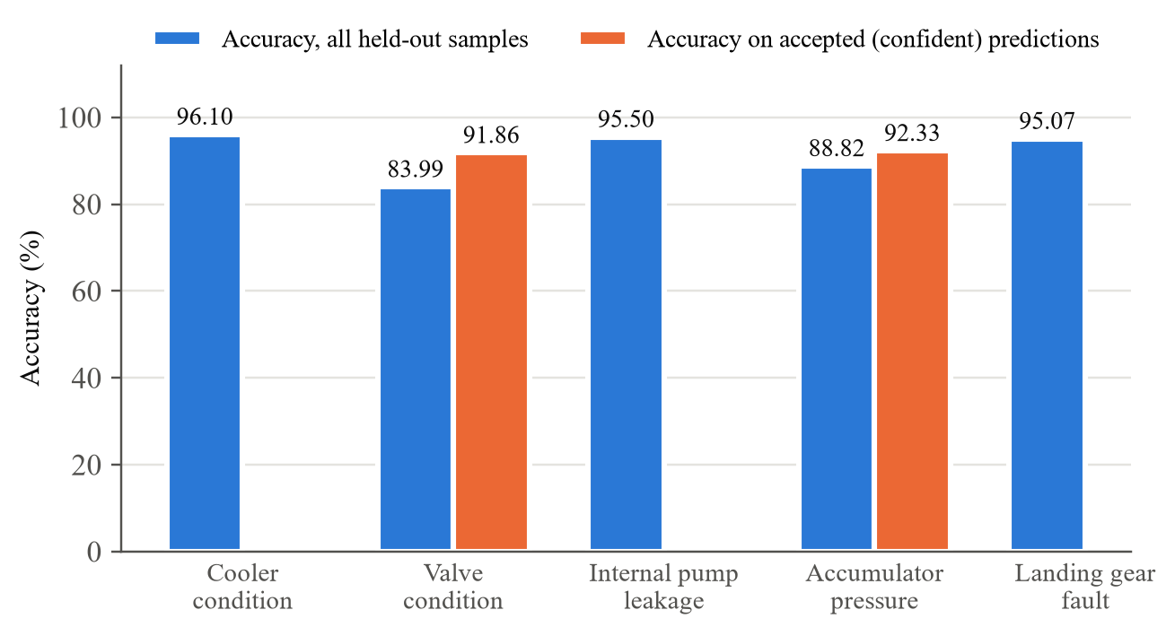
Figure 5.1: Accuracy of the hydraulic and landing-gear classifiers
For engines close to failure, the final engine model gives a late prediction (more life than is really left) in 72.42% of cases. On an earlier version of the model, a small correction that lowers the predictions near failure reduced this from about 72% to 35.3% (Figure 5.2). This correction has not yet been applied to the final model.
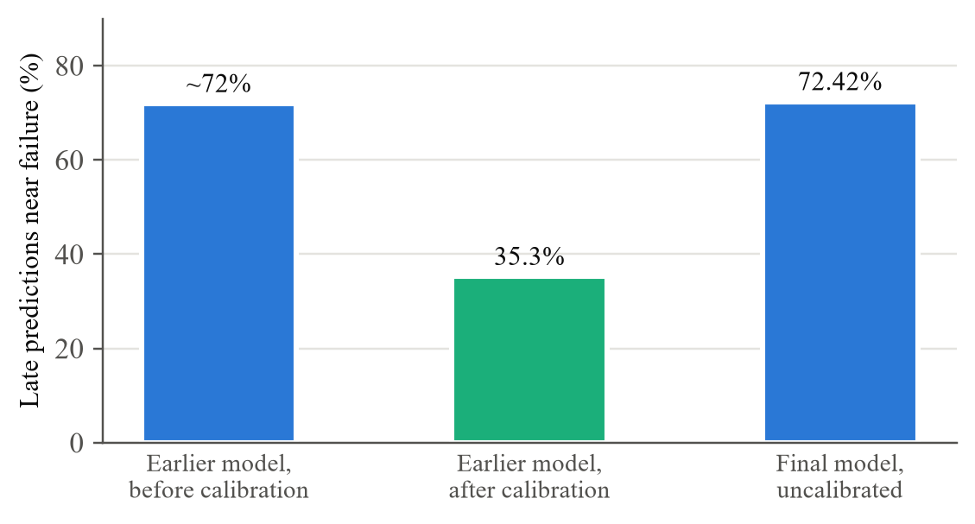
Figure 5.2: Share of late engine predictions near failure
Figure 5.3 to Figure 5.5 show the running system.
[ PASTE SCREENSHOT HERE ]
AeroPredict – AI Predictions screen: engine RUL prediction with risk band and safety note
Figure 5.3: AI Predictions screen showing an engine RUL prediction
[ PASTE SCREENSHOT HERE ]
Prediction with health state, Maintenance Recommendation, Maintenance Priority and review flag
Figure 5.4: Maintenance Recommendation and Priority for a prediction
[ PASTE SCREENSHOT HERE ]
FastAPI documentation page listing the five subsystem prediction routes
Figure 5.5: FastAPI backend documentation page

5.2 Interpretation of Results
Engine. The engine model is off by about 14 cycles on average (MAE 13.80) on 100 engines it never saw, and it explains about 80% of the variation in remaining life (R² 0.799; this is not an accuracy figure). RMSE is higher than MAE, which means most engines are predicted closely but a few have larger errors. This is expected because a healthy engine’s sensors change very little, so early predictions are harder. The high share of late predictions near failure is the main safety concern; the earlier correction study shows it can be reduced, at the cost of some predictions being slightly early.
Battery. Battery health is usually predicted within about 3 percentage points (MAE 2.62, R² 0.950). RMSE is about twice the MAE, showing a few larger errors—most likely when a battery’s capacity briefly recovers after a rest, which the model reads as an improvement. Because SOH was tested within the same cells, it does not by itself show performance on a brand-new cell. The battery RUL model was tested on batteries it never saw and is off by about 9 cycles on average.
Hydraulic. The cooler and pump leakage are easy to recognise because they clearly affect the temperature, flow and pressure readings. The valve and accumulator are harder because their effect on the sensors is smaller and depends on whether the rig had settled. The confidence check raises accuracy on accepted predictions to above 91%, but this number should always be read together with how many cycles were flagged for review.
Landing gear. Accuracy (95.07%) and balanced accuracy (95.36%) are almost equal, so all four fault types are recognised about equally well. These are the best results in the project because the simulated data is clean and consistent. They show that the pipeline works on landing-gear data, not that the same accuracy would be achieved on a real aircraft.
Fuel. The fuel model catches 93.13% of abnormal rows but also wrongly flags 71.35% of normal rows, so its balanced accuracy (60.89%) is only a little above chance (50%). It is therefore useful only as an early warning that suggests an inspection. The main reason is that the dataset has only one normal scenario, so the model has seen very little normal behaviour.
Overall. The simplest model worked best for three tasks (battery SOH, cooler and valve), which also makes these results easy to explain. Performance varies a lot between datasets—very high on simulated landing-gear data and weak on fuel. The results show that one common pipeline and decision layer can be applied to five very different subsystems; they do not show that combining them improves accuracy.

5.3 Comparison with Existing Solutions/Approaches
A direct number comparison is possible mainly for the engine, because many studies use the same FD001 test set (Table 5.4). The comparison is approximate, as studies use slightly different RUL caps and preparation steps.
Table 5.4: Engine RUL compared with published models on FD001
Study | Model | RMSE (cycles) | RUL cap
Babu, Zhao and Li (2016) [4] | Deep CNN | 18.45 | About 130
Zheng et al. (2017) [48] | LSTM network | 16.14 | 130
This project | Random Forest | 18.61 | 125

The project’s Random Forest is close to the published CNN and a little behind the LSTM, which agrees with the finding that well-prepared tree models remain competitive [2]. For the hydraulic rig, the valve and accumulator being the hardest targets also agrees with earlier work [1]. Table 5.5 compares the overall approach with typical existing studies.
Table 5.5: Comparison with typical existing approaches
Aspect | Typical existing studies | This project
Subsystems | Usually one, mostly the engine | Five subsystems in one system
Prediction types | Usually one | RUL, SOH, condition classes and anomaly detection
Testing | Random splits sometimes used | Always tested on unseen units
Decision output | Usually stops at prediction | Recommendation and Priority (rule-based)
Software | Mostly offline experiments | Backend and dashboard with simulated data
Algorithms and data | New models on public data | Standard models on public data; no new algorithm

5.4 Limitations and Constraints
- No real airline data. All datasets are simulated, laboratory, test-rig or synthetic; no live aircraft data or maintenance records were used.
- Dataset issues. The battery data comes from laboratory tests; the landing-gear data is synthetic and its exact version is unconfirmed; the fuel data has only one normal scenario.
- Avionics excluded. No public dataset on avionics component health was found.
- Simulated real-time only. The speed of the system under continuous data has not yet been measured.
- Rule-based decisions. The recommendations and priorities have not been checked against real maintenance actions or expert judgement.
- Engine safety. The final engine model is late for 72.42% of engines near failure; the correction was tested only on an earlier version.
- Unfinished features. Explanations for each prediction and trend charts are not yet on the dashboard, and some views still use labelled simulated values.

CHAPTER 6: CONCLUDING REMARKS AND SCOPE FOR THE FUTURE WORK
This project set out to take aircraft predictive maintenance beyond the engine, where most published work is focused. A common pipeline for data checking, preparation and feature engineering was built; five public datasets were passed through it; the best model for each subsystem was chosen by testing on unseen data; and every prediction was turned into a Maintenance Recommendation and a Maintenance Priority, served by a FastAPI backend and shown on a React dashboard using simulated data.
The engine model predicted remaining life with an average error of 13.80 cycles on 100 unseen engines. Battery health was predicted within 2.62 percentage points on average, and battery remaining life within 9.36 cycles on unseen batteries. The hydraulic classifiers reached accuracies between 83.99% and 96.10%, the landing-gear model reached 95.07% accuracy on synthetic data, and the fuel model detected 93.13% of abnormal rows but with many false alarms. Overall, the results show that one pipeline can be applied to five very different subsystems, although performance depends strongly on the quality of each dataset.

6.1 Achievements
- Built a predictive-maintenance system covering five aircraft subsystems: engine, electrical/battery, hydraulic, fuel and landing gear.
- Selected suitable public datasets, described each one honestly, and rejected unsuitable sources, including the avionics data.
- Trained and tested models for all five subsystems, always on data the models had not seen.
- Added safety-focused checks: late-prediction analysis for the engine and a confidence check that flags unsure hydraulic predictions.
- Created a decision layer that gives a Maintenance Recommendation and a Maintenance Priority for every prediction.
- Built a working FastAPI backend and React dashboard, with simulated data clearly labelled.
- Verified the software with 232 automated tests that pass in a fresh setup.

6.2 Future Scope
- Apply the late-prediction correction to the final engine model and report its effect.
- Compare each model with simpler baseline models, and show the difference between random and grouped testing.
- Measure the speed of the system (response time and messages per second) under continuous simulated data.
- Review the decision rules with maintenance experts and, if records become available, compare them with real maintenance actions.
- Show on the dashboard which sensor readings influenced each prediction, and add trend charts.
- Obtain more normal fuel-system data and confirm the landing-gear dataset version.
- Test the models on real aircraft-representative data before any practical use.
- Add avionics if a public dataset on avionics component health becomes available.
In conclusion, the project shows that a single, carefully tested pipeline can handle five very different aircraft subsystem datasets and turn their predictions into clear maintenance decisions. The design allows real fleet data to be added in future, provided the models are retrained and tested again on that data.

REFERENCES
References are listed in alphabetical order of the last name of the first author, as required by the report guidelines, and are cited in the text by their number in this list.
[1] A. Alenany, A. M. Helmi, and B. M. Nasef, “Comprehensive analysis for sensor-based hydraulic system condition monitoring,” International Journal of Advanced Computer Science and Applications, vol. 12, no. 6, pp. 133–140, 2021, doi: 10.14569/IJACSA.2021.0120615.
[2] Y. Alomari, M. Andó, and M. L. Baptista, “Advancing aircraft engine RUL predictions: An interpretable integrated approach of feature engineering and aggregated feature importance,” Scientific Reports, vol. 13, art. 13466, 2023, doi: 10.1038/s41598-023-40315-1.
[3] K. Aslansefat, Y. Gheraibia, S. Kabir, I. Sorokos, and Y. Papadopoulos, “Aircraft fuel distribution system,” IEEE DataPort, 2020, doi: 10.21227/c0kw-c455; also distributed via Kaggle, 2021. [Online]. Available: https://www.kaggle.com/datasets/kooaslansefat/aircraft-fuel-distribution-system
[4] G. S. Babu, P. Zhao, and X.-L. Li, “Deep convolutional neural network based regression approach for estimation of remaining useful life,” in Database Systems for Advanced Applications (DASFAA 2016), Lecture Notes in Computer Science, vol. 9642. Cham, Switzerland: Springer, 2016, pp. 214–228, doi: 10.1007/978-3-319-32025-0_14.
[5] C. Bergmeir and J. M. Benítez, “On the use of cross-validation for time series predictor evaluation,” Information Sciences, vol. 191, pp. 192–213, 2012, doi: 10.1016/j.ins.2011.12.028.
[6] O. Bougacha, C. Varnier, and N. Zerhouni, “Review of post-prognostics decision-making in prognostics and health management,” International Journal of Prognostics and Health Management, vol. 11, no. 2, 2020, doi: 10.36001/ijphm.2020.v11i2.2928.
[7] L. Breiman, “Random forests,” Machine Learning, vol. 45, no. 1, pp. 5–32, 2001, doi: 10.1023/A:1010933404324.
[8] J. Chen, Q. Xu, Y. Guo, and R. Chen, “Aircraft landing gear retraction/extension system fault diagnosis with 1-D dilated convolutional neural network,” Sensors, vol. 22, no. 4, art. 1367, 2022, doi: 10.3390/s22041367.
[9] M. Esperon-Miguez, P. John, and I. K. Jennions, “A review of integrated vehicle health management tools for legacy platforms: Challenges and opportunities,” Progress in Aerospace Sciences, vol. 56, pp. 19–34, 2013, doi: 10.1016/j.paerosci.2012.04.003.
[10] O. Fink, Q. Wang, M. Svensén, P. Dersin, W.-J. Lee, and M. Ducoffe, “Potential, challenges and future directions for deep learning in prognostics and health management applications,” Engineering Applications of Artificial Intelligence, vol. 92, art. 103678, 2020, doi: 10.1016/j.engappai.2020.103678.
[11] M. Gerdes, D. Scholz, and D. Galar, “Effects of condition-based maintenance on costs caused by unscheduled maintenance of aircraft,” Journal of Quality in Maintenance Engineering, vol. 22, no. 4, pp. 394–417, 2016, doi: 10.1108/JQME-12-2015-0062.
[12] P. Geurts, D. Ernst, and L. Wehenkel, “Extremely randomized trees,” Machine Learning, vol. 63, no. 1, pp. 3–42, 2006, doi: 10.1007/s10994-006-6226-1.
[13] Y. Gheraibia, S. Kabir, K. Aslansefat, I. Sorokos, and Y. Papadopoulos, “Safety+AI: A novel approach to update safety models using artificial intelligence,” IEEE Access, vol. 7, pp. 135855–135869, 2019, doi: 10.1109/ACCESS.2019.2941566.
[14] K. Goebel, G. Gorospe, C. Kulkarni, J. Schumann, C. C. Quach, and E. Hogge, “Health monitoring and prognostics for more electric aircrafts,” NASA Technical Reports Server, Doc. ID 20180007743, 2018. [Online]. Available: https://ntrs.nasa.gov/citations/20180007743
[15] F. O. Heimes, “Recurrent neural networks for remaining useful life estimation,” in Proc. Int. Conf. Prognostics and Health Management (PHM), Denver, CO, USA, 2008, pp. 1–6, doi: 10.1109/PHM.2008.4711422.
[16] N. Helwig, E. Pignanelli, and A. Schütze, “Condition monitoring of a complex hydraulic system using multivariate statistics,” in Proc. IEEE Int. Instrumentation and Measurement Technology Conf. (I2MTC), Pisa, Italy, 2015, pp. 210–215, doi: 10.1109/I2MTC.2015.7151267.
[17] N. Helwig, E. Pignanelli, and A. Schütze, “Condition monitoring of hydraulic systems,” UCI Machine Learning Repository, dataset 447, 2015, doi: 10.24432/C5CW21. [Online]. Available: https://archive.ics.uci.edu/dataset/447/condition+monitoring+of+hydraulic+systems
[18] A. K. S. Jardine, D. Lin, and D. Banjevic, “A review on machinery diagnostics and prognostics implementing condition-based maintenance,” Mechanical Systems and Signal Processing, vol. 20, no. 7, pp. 1483–1510, 2006, doi: 10.1016/j.ymssp.2005.09.012.
[19] S. Kaufman, S. Rosset, C. Perlich, and O. Stitelman, “Leakage in data mining: Formulation, detection, and avoidance,” ACM Transactions on Knowledge Discovery from Data, vol. 6, no. 4, art. 15, 2012, doi: 10.1145/2382577.2382579.
[20] K. Khan, M. Sohaib, A. Rashid, S. Ali, H. Akbar, A. Basit, and T. Ahmad, “Recent trends and challenges in predictive maintenance of aircraft’s engine and hydraulic system,” Journal of the Brazilian Society of Mechanical Sciences and Engineering, vol. 43, art. 403, 2021, doi: 10.1007/s40430-021-03121-2.
[21] D. Kim and T.-Y. Heo, “Anomaly detection with feature extraction based on machine learning using hydraulic system IoT sensor data,” Sensors, vol. 22, no. 7, art. 2479, 2022, doi: 10.3390/s22072479.
[22] C. König and A. M. Helmi, “Sensitivity analysis of sensors in a hydraulic condition monitoring system using CNN models,” Sensors, vol. 20, no. 11, art. 3307, 2020, doi: 10.3390/s20113307.
[23] C. S. Kulkarni, I. Roychoudhury, and J. Schumann, “On-board battery monitoring and prognostics for electric-propulsion aircraft,” in Proc. AIAA/IEEE Electric Aircraft Technologies Symposium (EATS), Cincinnati, OH, USA, 2018, doi: 10.2514/6.2018-5034.
[24] J. Lee, M. Mitici, H. A. P. Blom, P. Bieber, and F. Freeman, “Analyzing emerging challenges for data-driven predictive aircraft maintenance using agent-based modeling and hazard identification,” Aerospace, vol. 10, no. 2, art. 186, 2023, doi: 10.3390/aerospace10020186.
[25] Y. Lei, N. Li, L. Guo, N. Li, T. Yan, and J. Lin, “Machinery health prognostics: A systematic review from data acquisition to RUL prediction,” Mechanical Systems and Signal Processing, vol. 104, pp. 799–834, 2018, doi: 10.1016/j.ymssp.2017.11.016.
[26] X. Li, C. Yuan, X. Li, and Z. Wang, “State of health estimation for Li-ion battery using incremental capacity analysis and Gaussian process regression,” Energy, vol. 190, art. 116467, 2020, doi: 10.1016/j.energy.2019.116467.
[27] C. Li, W. Chen, and W. Qin, “A deep learning on-board health monitoring method for landing gear shock-absorbing systems,” Sensors, vol. 25, no. 9, art. 2767, 2025, doi: 10.3390/s25092767.
[28] B. Matthews, “Curated 4 class anomaly detection data set,” Sample Flight Data project, NASA DASHlink, NASA Ames Research Center, updated Dec. 2022. [Online]. Available: https://c3.ndc.nasa.gov/dashlink/resources/1018
[29] L. Mbagaya, K. Reddy, and A. Botes, “Machine learning techniques for battery state of health prediction: A comparative review,” World Electric Vehicle Journal, vol. 16, no. 11, art. 594, 2025, doi: 10.3390/wevj16110594.
[30] N. M. Mohamud, S. M. Ayob, S. M. Saimon, A. M. Nahhas, Z. A. Arfeen, M. I. Masud, and M. Aman, “Lithium-ion battery state of health prediction using a hybrid BiLSTM-random forest framework,” Batteries, vol. 12, no. 6, art. 210, 2026, doi: 10.3390/batteries12060210.
[31] F. Pedregosa et al., “Scikit-learn: Machine learning in Python,” Journal of Machine Learning Research, vol. 12, pp. 2825–2830, 2011.
[32] L. Pinello, O. Hassan, M. Giglio, and C. Sbarufatti, “Preliminary nose landing gear digital twin for damage detection,” Aerospace, vol. 11, no. 3, art. 222, 2024, doi: 10.3390/aerospace11030222.
[33] L. Ren, L. Zhao, S. Hong, S. Zhao, H. Wang, and L. Zhang, “Remaining useful life prediction for lithium-ion battery: A deep learning approach,” IEEE Access, vol. 6, pp. 50587–50598, 2018, doi: 10.1109/ACCESS.2018.2858856.
[34] B. Saha and K. Goebel, “Battery data set,” NASA Prognostics Data Repository, NASA Ames Research Center, Moffett Field, CA, USA, 2007. [Online]. Available: https://www.nasa.gov/intelligent-systems-division/discovery-and-systems-health/pcoe/pcoe-data-set-repository/
[35] B. Saha, K. Goebel, S. Poll, and J. Christophersen, “Prognostics methods for battery health monitoring using a Bayesian framework,” IEEE Transactions on Instrumentation and Measurement, vol. 58, no. 2, pp. 291–296, 2009, doi: 10.1109/TIM.2008.2005965.
[36] M. B. Sani, “Aircraft landing gear digital twin dataset: PdM/SHM,” Kaggle, 2026. [Online]. Available: https://www.kaggle.com/datasets/mohammedbellosani/aircraft-landing-gear-digital-twin-datasetpdmshm
[37] M. B. Sani and O. Uhiah, “Physics-informed digital twin for predictive maintenance of aircraft landing gear systems,” SSRN preprint, 2026. [Online]. Available: https://papers.ssrn.com/sol3/papers.cfm?abstract_id=6080365
[38] A. Saxena and K. Goebel, “Turbofan engine degradation simulation data set,” NASA Prognostics Data Repository, NASA Ames Research Center, Moffett Field, CA, USA, 2008. [Online]. Available: https://www.nasa.gov/intelligent-systems-division/discovery-and-systems-health/pcoe/pcoe-data-set-repository/
[39] A. Saxena, K. Goebel, D. Simon, and N. Eklund, “Damage propagation modeling for aircraft engine run-to-failure simulation,” in Proc. Int. Conf. Prognostics and Health Management (PHM), Denver, CO, USA, 2008, pp. 1–9, doi: 10.1109/PHM.2008.4711414.
[40] A. Saxena, J. Celaya, B. Saha, S. Saha, and K. Goebel, “Metrics for offline evaluation of prognostic performance,” International Journal of Prognostics and Health Management, vol. 1, no. 1, 2010, doi: 10.36001/ijphm.2010.v1i1.1336.
[41] M. J. Scott, W. J. C. Verhagen, M. T. Bieber, and P. Marzocca, “A systematic literature review of predictive maintenance for defence fixed-wing aircraft sustainment and operations,” Sensors, vol. 22, no. 18, art. 7070, 2022, doi: 10.3390/s22187070.
[42] M. M. R. Shamim, M. Nuruzzaman, Z. Ferdus, M. R. Ahmed, A. N. Anward, M. Tooneer, J. U. Khan, and K. Hossen, “Leakage-robust evaluation and data-scale sensitivity of attention-enhanced multi-task learning for joint fault diagnosis and remaining useful life estimation,” arXiv preprint arXiv:2607.16493, 2026.
[43] K. Shen and D. Zhao, “Fault diagnosis for aircraft hydraulic systems via one-dimensional multichannel convolution neural network,” Actuators, vol. 11, no. 7, art. 182, 2022, doi: 10.3390/act11070182.
[44] Z. Skaf, H. Abdulmouti, S. Alblooshi, A. Alkaabi, and R. Almarzooqi, “Fault detection for aircraft fuel system with machine learning techniques,” in Proc. Advances in Science and Engineering Technology Int. Conf. (ASET), Dubai, UAE, 2023, doi: 10.1109/ASET56582.2023.10180668.
[45] M. Sokolova and G. Lapalme, “A systematic analysis of performance measures for classification tasks,” Information Processing and Management, vol. 45, no. 4, pp. 427–437, 2009, doi: 10.1016/j.ipm.2009.03.002.
[46] I. Stanton, K. Munir, A. Ikram, and M. El-Bakry, “Predictive maintenance analytics and implementation for aircraft: Challenges and opportunities,” Systems Engineering, vol. 26, no. 2, pp. 216–237, 2023, doi: 10.1002/sys.21651.
[47] D. Swain, M. Kumar, A. Nour, K. Patel, A. Bhatt, B. Acharya, and A. Bostani, “Remaining useful life predictor for EV batteries using machine learning,” IEEE Access, vol. 12, pp. 134418–134426, 2024, doi: 10.1109/ACCESS.2024.3461802.
[48] S. Zheng, K. Ristovski, A. Farahat, and C. Gupta, “Long short-term memory network for remaining useful life estimation,” in Proc. IEEE Int. Conf. Prognostics and Health Management (ICPHM), Dallas, TX, USA, 2017, pp. 88–95, doi: 10.1109/ICPHM.2017.7998311.

