Ssm集成
- File -new Project ->maven
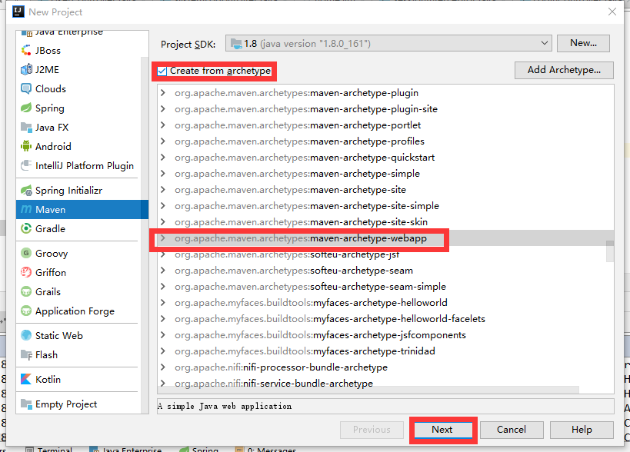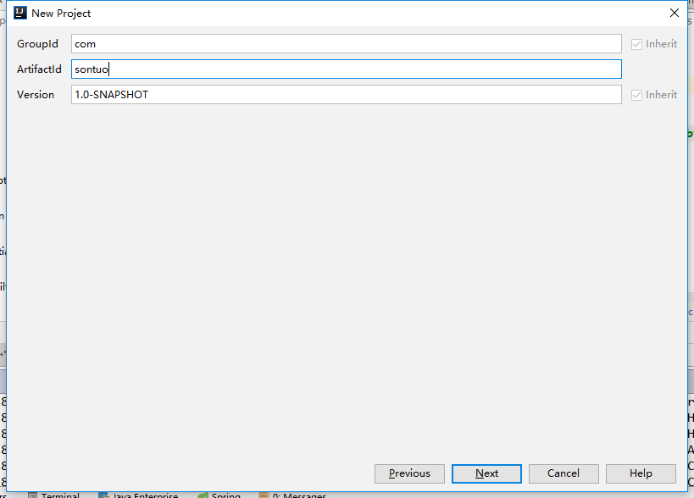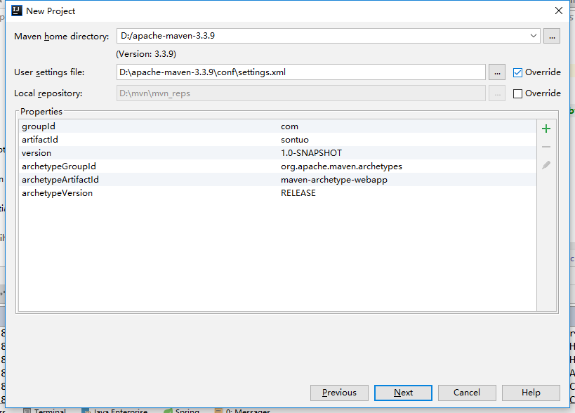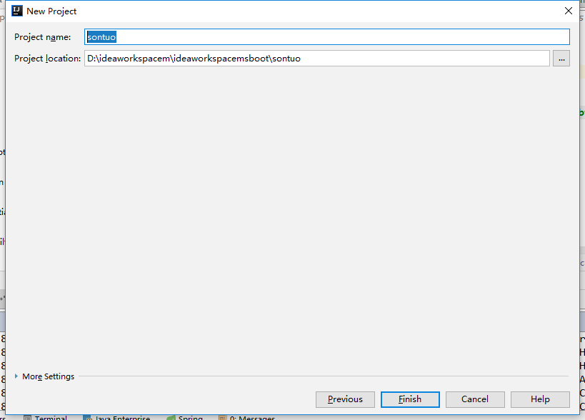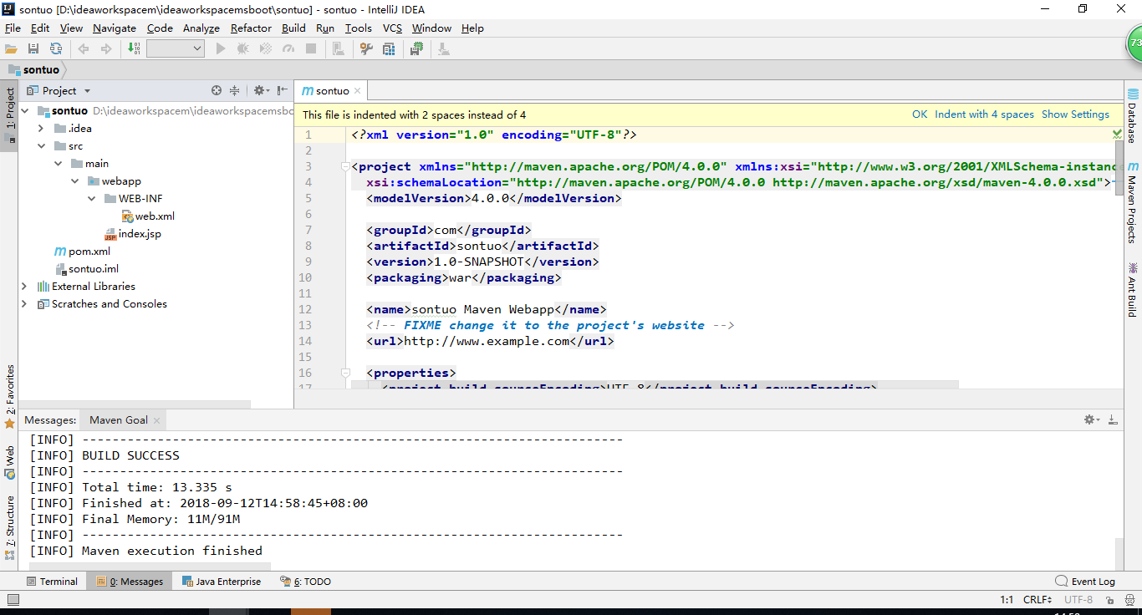
至此项目创建完毕
- 完善
File -> Project Structure 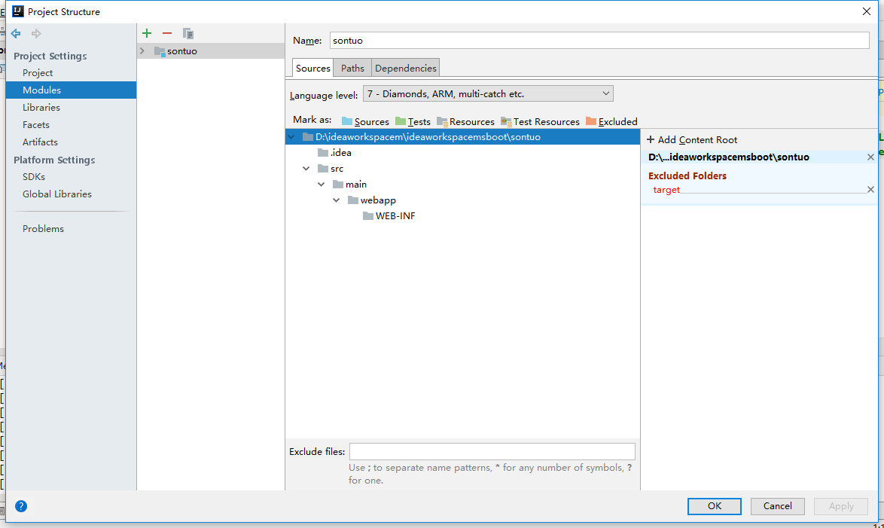
Main 下new folder java 选为Sources new folder resources 选为 Resources
Test 自己加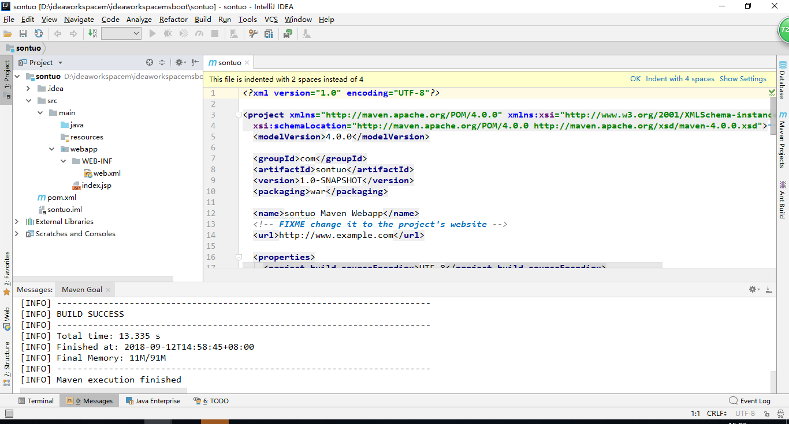
- Pom.xml中加入依赖
<?xml version="1.0" encoding="UTF-8"?>
<project xmlns="http://maven.apache.org/POM/4.0.0" xmlns:xsi="http://www.w3.org/2001/XMLSchema-instance"
xsi:schemaLocation="http://maven.apache.org/POM/4.0.0 http://maven.apache.org/xsd/maven-4.0.0.xsd">
<modelVersion>4.0.0</modelVersion>
<groupId>com</groupId>
<artifactId>giant</artifactId>
<version>1.0-SNAPSHOT</version>
<packaging>war</packaging>
<name>giant Maven Webapp</name>
<!-- FIXME change it to the project's website -->
<url>http://www.example.com</url>
<properties>
<project.build.sourceEncoding>UTF-8</project.build.sourceEncoding>
<maven.compiler.source>1.7</maven.compiler.source>
<maven.compiler.target>1.7</maven.compiler.target>
<spring.version>4.1.4.RELEASE</spring.version>
<mybatis.version>3.3.0</mybatis.version>
<slf4j.version>1.7.7</slf4j.version>
<log4j.version>1.2.17</log4j.version>
<quartz.version>2.2.2</quartz.version>
<activiti.version>5.15.1</activiti.version>
</properties>
<dependencies>
<dependency>
<groupId>org.springframework</groupId>
<artifactId>spring-core</artifactId>
<version>${spring.version}</version>
</dependency>
<dependency>
<groupId>org.springframework</groupId>
<artifactId>spring-context</artifactId>
<version>${spring.version}</version>
</dependency>
<!-- 添加spring-tx包 -->
<dependency>
<groupId>org.springframework</groupId>
<artifactId>spring-tx</artifactId>
<version>${spring.version}</version>
</dependency>
<!-- 添加spring-jdbc包 -->
<dependency>
<groupId>org.springframework</groupId>
<artifactId>spring-jdbc</artifactId>
<version>${spring.version}</version>
</dependency>
<!-- 为了方便进行单元测试，添加spring-test包 -->
<dependency>
<groupId>org.springframework</groupId>
<artifactId>spring-test</artifactId>
<version>${spring.version}</version>
</dependency>
<!--添加spring-web包 -->
<dependency>
<groupId>org.springframework</groupId>
<artifactId>spring-web</artifactId>
<version>${spring.version}</version>
</dependency>
<dependency>
<groupId>org.springframework</groupId>
<artifactId>spring-webmvc</artifactId>
<version>${spring.version}</version>
</dependency>
<dependency>
<groupId>org.springframework</groupId>
<artifactId>spring-aop</artifactId>
<version>${spring.version}</version>
</dependency>
<dependency>
<groupId>org.springframework</groupId>
<artifactId>spring-context-support</artifactId>
<version>${spring.version}</version>
</dependency>
<!--添加aspectjweaver包 -->
<dependency>
<groupId>org.aspectj</groupId>
<artifactId>aspectjweaver</artifactId>
<version>1.8.5</version>
</dependency>
<!-- 添加mybatis的核心包 -->
<dependency>
<groupId>org.mybatis</groupId>
<artifactId>mybatis</artifactId>
<version>${mybatis.version}</version>
</dependency>
<!-- 添加mybatis与Spring整合的核心包 -->
<dependency>
<groupId>org.mybatis</groupId>
<artifactId>mybatis-spring</artifactId>
<version>1.2.2</version>
</dependency>
<!-- 添加servlet3.0核心包 -->
<dependency>
<groupId>javax.servlet</groupId>
<artifactId>javax.servlet-api</artifactId>
<version>3.0.1</version>
</dependency>
<dependency>
<groupId>javax.servlet.jsp</groupId>
<artifactId>javax.servlet.jsp-api</artifactId>
<version>2.3.2-b01</version>
</dependency>
<!-- jstl -->
<dependency>
<groupId>javax.servlet</groupId>
<artifactId>jstl</artifactId>
<version>1.2</version>
</dependency>
<!-- 添加mysql驱动包 -->
<dependency>
<groupId>mysql</groupId>
<artifactId>mysql-connector-java</artifactId>
<version>5.1.34</version>
</dependency>
<!-- 添加druid连接池包 -->
<dependency>
<groupId>com.alibaba</groupId>
<artifactId>druid</artifactId>
<version>1.0.12</version>
</dependency>
<!-- 日志文件管理包 -->
<!-- log start -->
<dependency>
<groupId>log4j</groupId>
<artifactId>log4j</artifactId>
<version>${log4j.version}</version>
</dependency>
<!-- 格式化对象，方便输出日志 -->
<dependency>
<groupId>com.alibaba</groupId>
<artifactId>fastjson</artifactId>
<version>1.1.41</version>
</dependency>
<dependency>
<groupId>org.slf4j</groupId>
<artifactId>slf4j-api</artifactId>
<version>${slf4j.version}</version>
</dependency>
<dependency>
<groupId>org.slf4j</groupId>
<artifactId>slf4j-log4j12</artifactId>
<version>${slf4j.version}</version>
</dependency>
<!-- log end -->
<!-- 映入JSON -->
<dependency>
<groupId>org.codehaus.jackson</groupId>
<artifactId>jackson-mapper-asl</artifactId>
<version>1.9.13</version>
</dependency>
<!-- 上传组件包 -->
<dependency>
<groupId>commons-fileupload</groupId>
<artifactId>commons-fileupload</artifactId>
<version>1.3.1</version>
</dependency>
<dependency>
<groupId>commons-io</groupId>
<artifactId>commons-io</artifactId>
<version>2.4</version>
</dependency>
<dependency>
<groupId>commons-codec</groupId>
<artifactId>commons-codec</artifactId>
<version>1.9</version>
</dependency>
<dependency>
<groupId>org.apache.velocity</groupId>
<artifactId>velocity</artifactId>
<version>1.7</version>
</dependency>
<dependency>
<groupId>org.apache.velocity</groupId>
<artifactId>velocity-tools</artifactId>
<version>2.0</version>
</dependency>
<!--apache shiro -->
<dependency>
<groupId>org.apache.shiro</groupId>
<artifactId>shiro-core</artifactId>
<version>1.2.2</version>
</dependency>
<dependency>
<groupId>org.apache.shiro</groupId>
<artifactId>shiro-web</artifactId>
<version>1.2.2</version>
</dependency>
<dependency>
<groupId>org.apache.shiro</groupId>
<artifactId>shiro-ehcache</artifactId>
<version>1.2.2</version>
</dependency>
<dependency>
<groupId>org.apache.shiro</groupId>
<artifactId>shiro-spring</artifactId>
<version>1.2.2</version>
</dependency>
<dependency>
<groupId>org.apache.shiro</groupId>
<artifactId>shiro-quartz</artifactId>
<version>1.2.2</version>
</dependency>
<!--apache shiro end-->
</dependencies>
<build>
<finalName>ssm-shiro</finalName>
<resources>
<resource>
<directory>src/main/java</directory>
<includes>
<include>**/*.xml</include>
</includes>
</resource>
</resources>
<pluginManagement><!-- lock down plugins versions to avoid using Maven defaults (may be moved to parent pom) -->
<plugins>
<plugin>
<artifactId>maven-clean-plugin</artifactId>
<version>3.0.0</version>
</plugin>
<!-- see http://maven.apache.org/ref/current/maven-core/default-bindings.html#Plugin_bindings_for_war_packaging -->
<plugin>
<artifactId>maven-resources-plugin</artifactId>
<version>3.0.2</version>
</plugin>
<plugin>
<artifactId>maven-compiler-plugin</artifactId>
<version>3.7.0</version>
</plugin>
<plugin>
<artifactId>maven-surefire-plugin</artifactId>
<version>2.20.1</version>
</plugin>
<plugin>
<artifactId>maven-war-plugin</artifactId>
<version>3.2.0</version>
</plugin>
<plugin>
<artifactId>maven-install-plugin</artifactId>
<version>2.5.2</version>
</plugin>
<plugin>
<artifactId>maven-deploy-plugin</artifactId>
<version>2.8.2</version>
</plugin>
</plugins>
</pluginManagement>
</build>
</project>

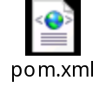

- Resources 中spring配置文件

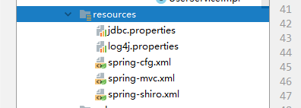

- Java中编写Java代码
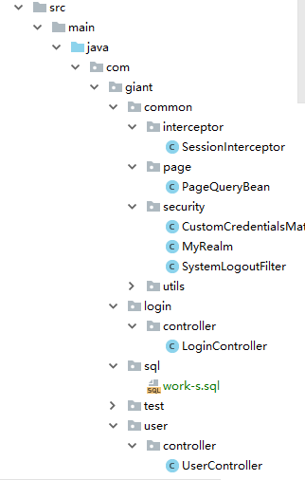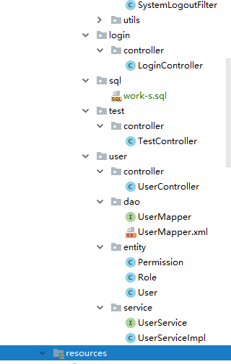
- Web.xml 文件中配置
<?xml version="1.0" encoding="UTF-8"?>
<web-app xmlns:xsi="http://www.w3.org/2001/XMLSchema-instance"
xmlns="http://java.sun.com/xml/ns/javaee"
xsi:schemaLocation="http://java.sun.com/xml/ns/javaee http://java.sun.com/xml/ns/javaee/web-app_3_0.xsd"
version="3.0">
<display-name>ssm-shiro</display-name>
<context-param>
<param-name>contextConfigLocation</param-name>
<param-value>classpath:spring-cfg.xml</param-value>
</context-param>
<!-- 编码过滤器 -->
<filter>
<filter-name>encodingFilter</filter-name>
<filter-class>org.springframework.web.filter.CharacterEncodingFilter</filter-class>
<async-supported>true</async-supported>
<init-param>
<param-name>encoding</param-name>
<param-value>UTF-8</param-value>
</init-param>
</filter>
<filter-mapping>
<filter-name>encodingFilter</filter-name>
<url-pattern>/</url-pattern>
</filter-mapping>
<!-- Spring监听器 -->
<listener>
<listener-class>org.springframework.web.context.ContextLoaderListener</listener-class>
</listener>
<!--shiro权限过滤器-->
<filter>
<filter-name>shiroFilter</filter-name>
<filter-class>org.springframework.web.filter.DelegatingFilterProxy</filter-class>
<async-supported>true</async-supported>
<init-param>
<!-- 该值缺省为false,表示生命周期由SpringApplicationContext管理,设置为true则表示由ServletContainer管理 -->
<param-name>targetFilterLifecycle</param-name>
<param-value>true</param-value>
</init-param>
</filter>
<filter-mapping>
<filter-name>shiroFilter</filter-name>
<url-pattern>/*</url-pattern>
</filter-mapping>
<!--Spring MVC servlet -->
<servlet>
<servlet-name>SpringMVC</servlet-name>
<servlet-class>org.springframework.web.servlet.DispatcherServlet</servlet-class>
<init-param>
<param-name>contextConfigLocation</param-name>
<param-value>classpath:spring-mvc.xml</param-value>
</init-param>
<load-on-startup>1</load-on-startup>
<async-supported>true</async-supported>
</servlet>
<servlet-mapping>
<servlet-name>SpringMVC</servlet-name>
<url-pattern>/</url-pattern>
</servlet-mapping>
<!--static下的所有资源都不拦截 针对spring-mvc里的拦截器的拦截所有资源-->
<servlet-mapping>
<servlet-name>default</servlet-name>
<url-pattern>/static/*</url-pattern>
</servlet-mapping>
<context-param>
<param-name>log4jConfigLocation</param-name>
<param-value>classpath:log4j.properties</param-value>
</context-param>
<error-page>
<error-code>404</error-code>
<location>/error/404.html</location>
</error-page>
<error-page>
<error-code>500</error-code>
<location>/error/500.html</location>
</error-page>
<welcome-file-list>
<welcome-file>/index.html</welcome-file>
</welcome-file-list>
</web-app>

- Webapp 下的静态资源
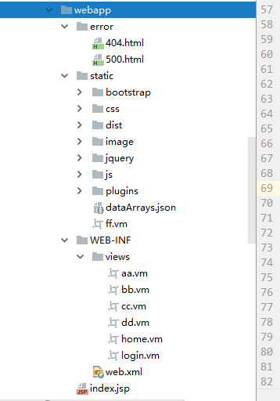
- 配置tomcat
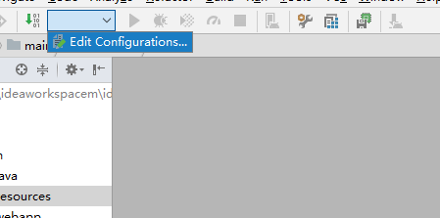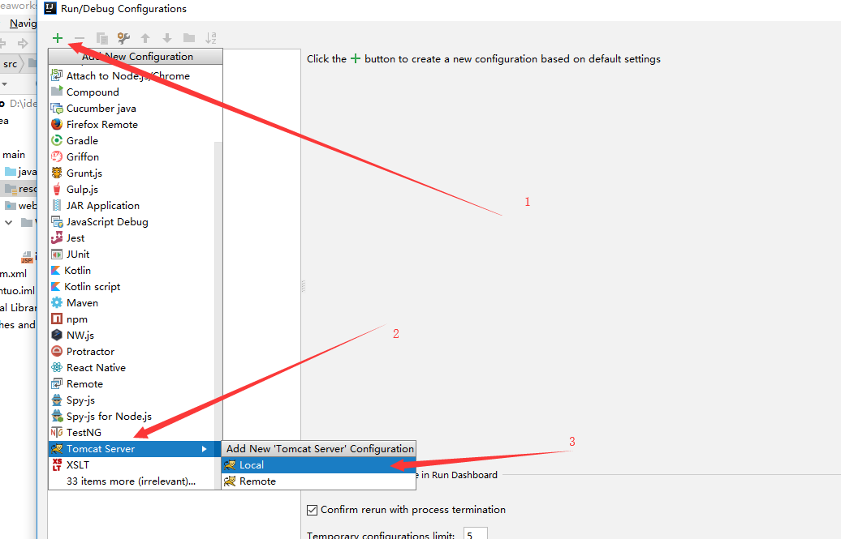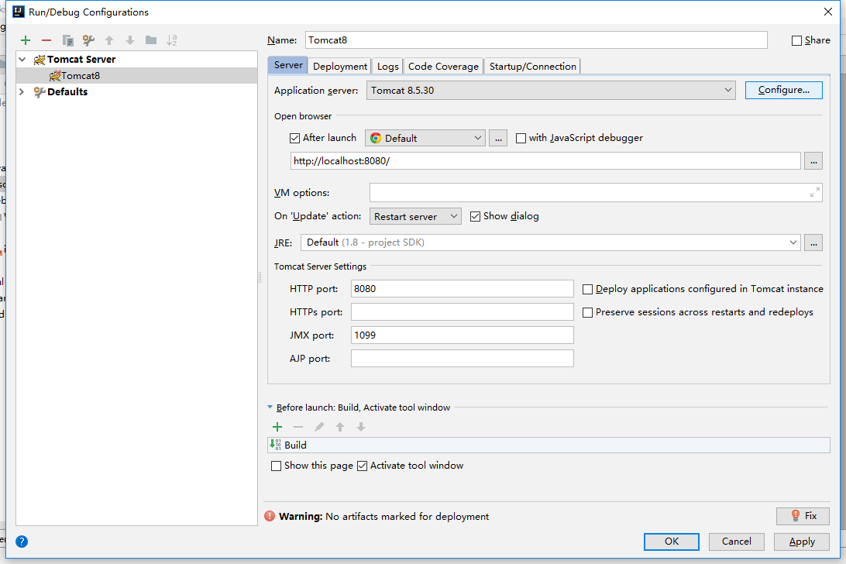
选择本地tomcat
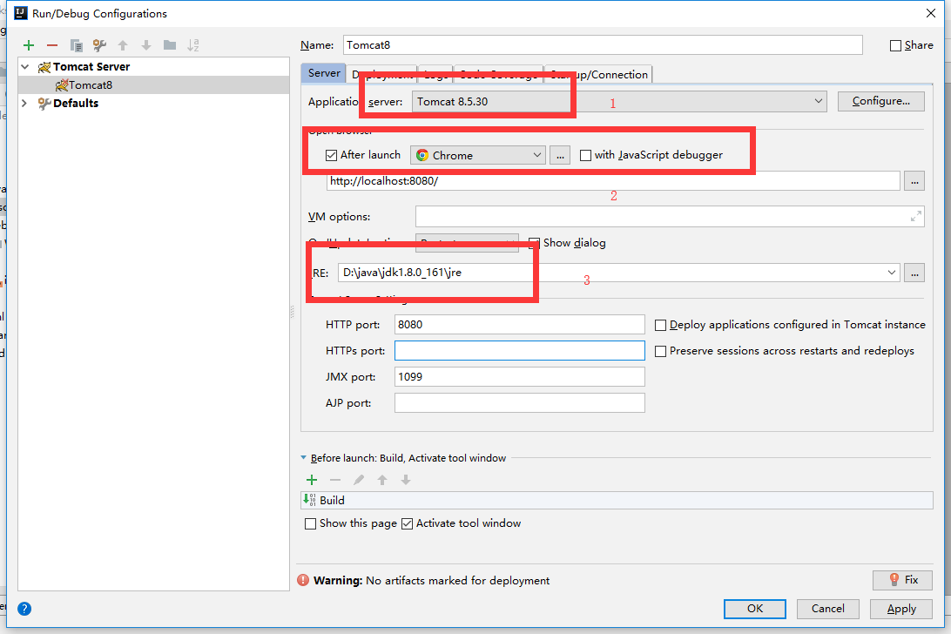
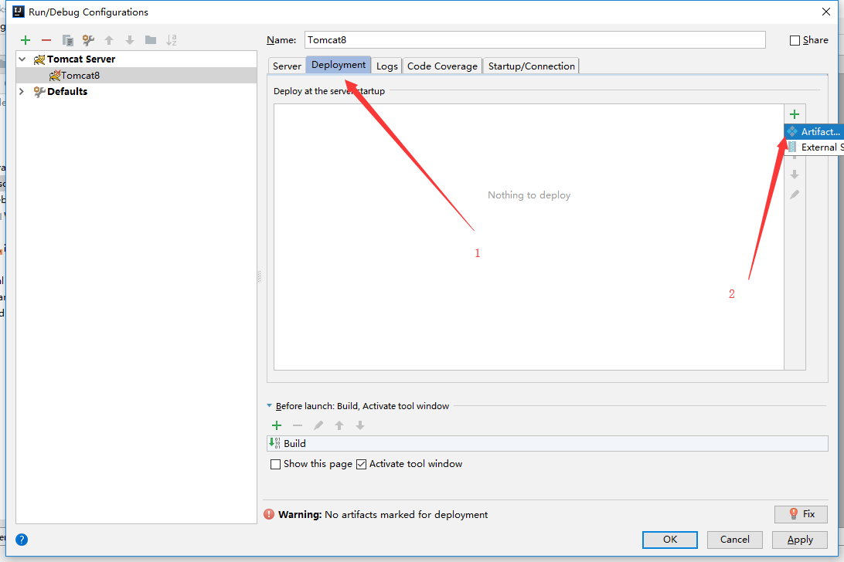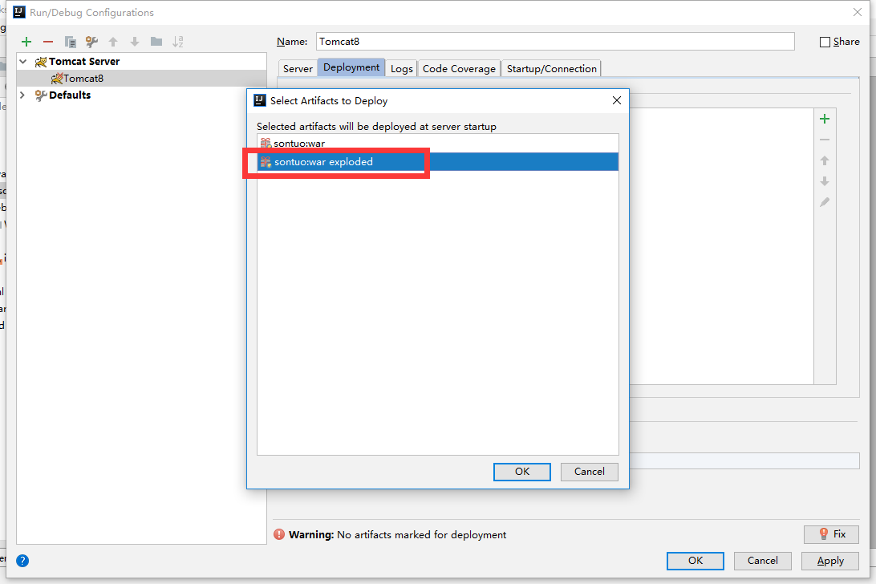
Apply -> ok 完成tomcat配置
- Maven 构建 注意输入 mvn install
- 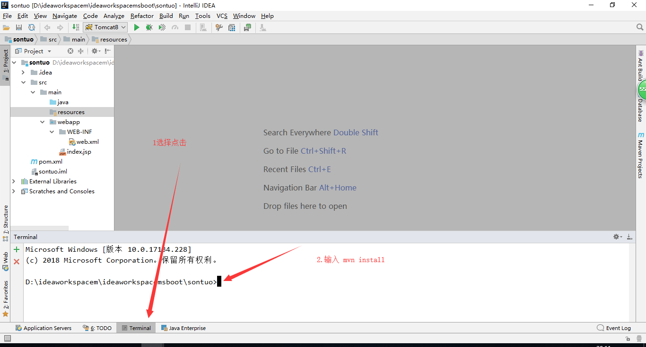
11.启动项目 输入登陆信息 laowang 123 和 laowang666 123

