Expanding the Palette: Audio Information Retrieval for

Intelligent Sound Design

Ananya Misra Matt Hoffman Perry R. Cook† Ge Wang
Department of Computer Science (†also Music)
Princeton University
{amisra, mdhoffma, prc, gewang }@cs.princeton.edu

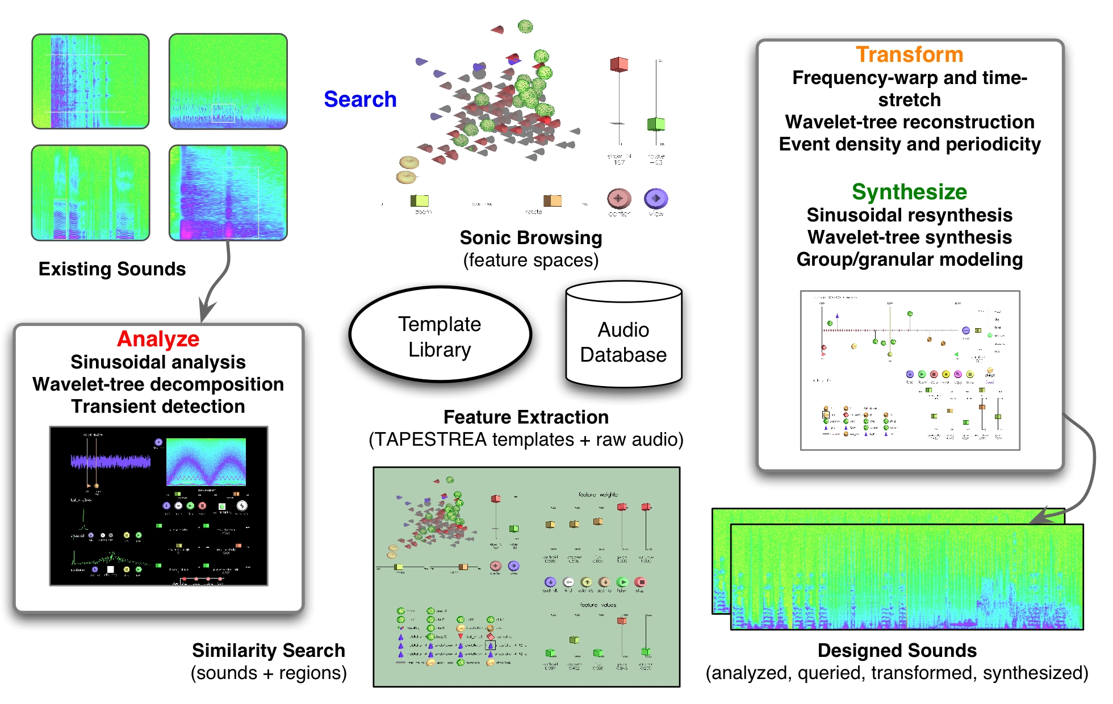
Figure 1. The TAPESTREA sound design workbench—augmented with Audio Information Retrieval.

Abstract
TAPESTREA is a unified sound design framework for selectively extracting sound components from existing recordings and flexibly transforming and resynthesizing them to create new sound scenes or recompositions. While the existing techniques and paradigms enable the production of a wide range of recompositions, so far it has been left to the user to navigate the space of available sounds at each stage. We now expand the TAPESTREA palette by incorporating a query-based framework to assist the user in locating sound components during analysis and synthesis. We integrate music information retrieval technologies with TAPESTREA techniques to facilitate and enhance sound design, providing a new "intelligent" sound design workbench.
Permission to make digital or hard copies of all or part of this work for personal or classroom use is granted without fee provided that copies are not made or distributed for profit or commercial advantage and that copies bear this notice and the full citation on the first page.
© 2006 University of Victoria
Keywords: sound design by example, audio information retrieval, interfaces, visualization, navigation, composition.

Introduction
Sound designers who work with environmental or natural sounds are faced with a large selection of existing audio samples, including sound effects, field recordings, and soundtracks from movies and television. The TAPESTREA system [1,2] facilitates the reuse of existing recordings by offering a new framework for interactively extracting desired components of sounds, transforming these individually, and flexibly resynthesizing them to create new sounds. However, the corpus of existing audio remains unstructured and largely unlabeled, making it difficult to locate desired sounds without minute knowledge of the available database. This paper explores ways to leverage audio analysis at multiple levels in interactive sound design, via TAPESTREA. It also considers methods for TAPESTREA in turn to aid audio analysis.
The main goals of this work include: (1) aiding sound designers in creating varied and interesting sound scenes by combining elements of existing sounds, and (2) enabling a human operator to quickly identify similar sounds in a large collection or database. Combined with TAPESTREA’s analysis + transformation + synthesis framework, this presents an extended "query by example" system, where feature-based querying can enhance both the analysis and synthesis aspects of interactive sound recomposition.
The rest of this paper is organized as follows. Section 2 addresses related work, and also provides an overview of the TAPESTREA system. Section 3 discusses the integration of the audio information retrieval with the analysis + transformation + synthesis framework of TAPESTREA. Section 4 delineates some applications. We conclude and discuss future work in Section 5.

Previous Work

Related Work
We build on previous research in sinusoidal modeling [3], wavelet-tree decomposition [4], feature-based audio information retrieval [5], user interface design for audio/multimedia browsing [6,7,8], and, more recently, feature-based synthesis [9].
Additional related work includes “intelligent” audio editors and sonic browsers [10,11]. In contrast, TAPESTREA is intended to provide a truly data-driven, “by-example” approach to sound design.

TAPESTREA
TAPESTREA, Techniques And Paradigms for Expressive Synthesis, Transformation and Rendering of Environmental Audio, facilitates the creation of new sound scenes and recompositions from existing sounds. It builds on the notion that most natural or environmental sounds consist of foreground and background components, and these are best modeled separately. It therefore enables the extraction of the following types of components or templates from an existing sound: (1) Deterministic events: highly sinusoidal foreground events, often perceived as pitchy, such as bird chirps or voices. (2) Transient events: brief, noisy foreground events with high stochastic energy, such as a door slamming. (3) Stochastic background: The background noise or "din" that is heard beneath the foreground events, such as ocean waves or street noise.
Each type of template is detected, extracted and resynthesized using techniques suited to its particular characteristics. Deterministic events are found and extracted by sinusoidal modeling based on the spectral modeling synthesis framework [3]. They are then synthesized via sinusoidal resynthesis, enabling massive real-time frequency and time transformations. Transient events are located by examining energy changes in the time-domain envelope of the sound, and are resynthesized with desired transformations through a phase vocoder. The stochastic background is obtained by (a) removing deterministic events during spectral modeling, and (b) removing transient events in the time domain and filling in the "holes" via wavelet tree learning [4] of nearby transient-free segments. A modified wavelet tree learning algorithm is then used to continuously resynthesize more background texture, controllably similar to the extracted background template.
In addition to this basic template set, TAPESTREA also provides additional templates to facilitate sound analysis and synthesis. These include: (1) "Raw" template: A selected segment in time extracted from a recording, bandpass filtered between specified frequency bounds, thus capturing both foreground and background components of the selected time-frequency region. It can be resynthesized with time and frequency transformations. (2) Loop: A structure for synthesizing repeating events, varying parameters such as periodicity, density, and range of random transformations. (3) Timeline: A structure for synthesizing a collection of templates explicitly placed in time relative to each other. (4) Mixed Bag: A structure for synthesizing multiple events repeating at different likelihoods. (5) Scripts: strongly-timed programs (ChucK) for finer control over the synthesis parameters.
TAPESTREA presents interfaces for interactive, parametric control over all aspects of the analysis, transformation and resynthesis, and can be used to create a wide range of sounds from a given set of recordings. Since templates can be saved to file and reloaded at a later sitting, it also paves the way for building a reusable database of extracted templates and raw sound effects, to be loaded in and used at any time. As this database grows, it becomes worthwhile to include audio information retrieval techniques for searching through it, visualizing it, and using it to its full potential. Information retrieval can also be beneficial in finding specific segments of a recording during the analysis phase. The new feature-enabled TAPESTREA addresses some of these topics.

Feature-based Sound Design
We augment TAPESTREA with audio information retrieval capabilities in two main areas. First, we integrate a feature-based similarity query engine into the TAPESTREA system, and interface it with the analysis, synthesis, and template library components. Second, we provide a new user interface devoted to and specialized for similarity-based search and retrieval of TAPESTREA templates and raw audio files. This interface also permits

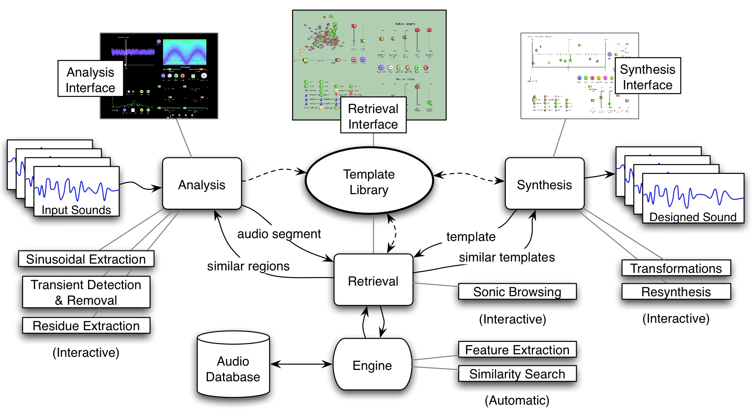
Figure 2. System architecture.

Interactive visualization and browsing of the feature-space in regions of interest. These additions allow the user to begin with a TAPESTREA template, transform it, and query for similar sounds (Section 3.2). Additionally, several retrieval-aware hooks were embedded into the existing user interfaces to allow the query and marking of sound events during analysis (Section 3.3).

System Architecture
The TAPESTREA system architecture (Figure 2) has been augmented with a Retrieval Engine and an Audio Database containing TAPESTREA templates, raw audio files, and their associated feature values and other meta-data. As sound files are analyzed, the resulting templates are stored in the TAPESTREA working library, and optionally assimilated into the Audio Database. The latter is performed by the Retrieval Engine, which extracts features from each template, and stores a copy of the template and its features into the persistent storage and index of the database.
A query can be made at any time against the Retrieval Engine, either through the Search user interface, or from embedded features in the Analysis user interface. A retrieval query involves specifying weights on the available and desired features, and a set of target values for all non-zero-weight features. The target feature values can be provided in two ways. The feature values can be extracted from an existing template or a raw sound file. Also, it is possible to manually select and/or modify some or all of the feature values. The query is then presented to the Retrieval Engine, which finds the N sounds in the database whose feature values (as optionally weighted by the user) most closely match those in the query, i.e. those with the smallest Euclidean distance to the query point.

Interactive Template-based Similarity Search
The template-based similarity search allows a user to select a template in the Template Library and find similar templates and raw sound files from the Audio Database. Figure 3 displays the interface for doing so.

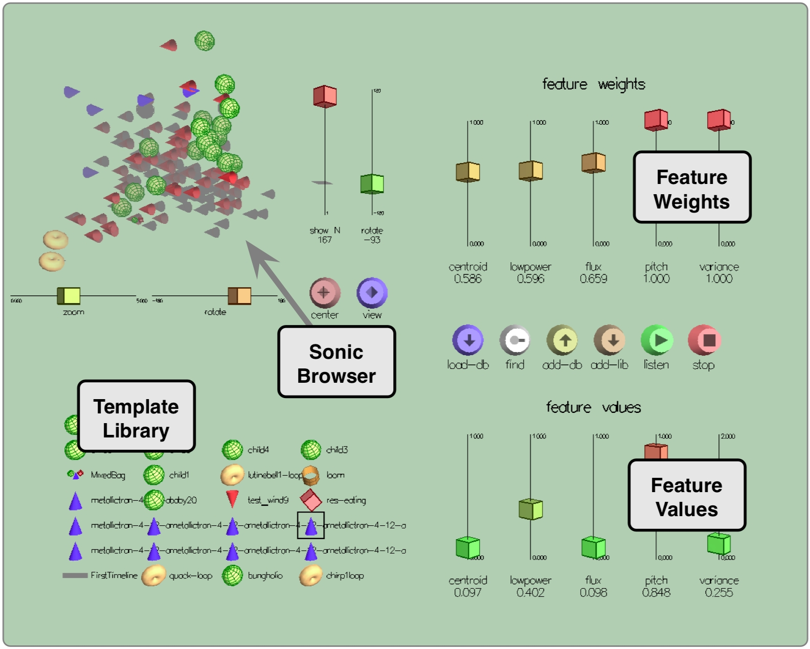
Figure 3. Retrieval user interface.
Selecting a sound displays its associated feature values on the sliders at the bottom right. Corresponding sliders at the top right determine the weight of each feature for the similarity search. Search results are displayed either in the form of a list, or as a 3D visualization. In the list view, the closest matches are displayed, sorted by distance from the query. The 3D visualization displays a specified number of matches, with the feature vector of each match mapped to 3D space either through principal component analysis [12] or by visualizing three specifically selected features. Any of the matches found can be played, loaded to the Template Library for transformation and synthesis, or used as a query for the next search. By browsing through the matches with these views, the user can find templates similar to the query, which can be used to create a richer and more varied sound scene.
The feature extraction is performed on audio clips synthesized from the template, in a type-sensitive manner, and taking existing transformations into account. For example, a deterministic template with 0.5x frequency-warping and 15x time-stretching is synthesized as such and in its entirety, whereas potentially longer templates such as loops, background, and timelines may only provide portions, as directed by the user. The spectral centroids, root mean square (RMS) powers, spectral fluxes, and autocorrelation strengths are computed for the 512-sample frames of audio beginning at every 256th sample in the sound. The mean centroid, fraction of windows with RMS-power less than the average (a.k.a. low power), mean flux, and mean autocorrelation strength are calculated from these window-level features. Finally, the variances of the centroid, power, flux, and autocorrelation strength are calculated, normalized, and summed to produce a fifth feature, completing our descriptor. This data is then associated with the template and added to the Audio Database, making it available to future queries.

Querying and Marking Recorded Sounds
During the analysis phase, audio information retrieval can also aid the discovery of desired templates in a given recording. This feature enables the user to find useful audio in files that may be too long to conveniently search by hand. A user can select an interesting time and frequency region in the recording, and send this to the retrieval engine as a query for a similarity search (Figure 4). The recording is broken into a series of overlapping regions (with a hop size of 256 samples) of the same length as the query region. The window-level features are only calculated once, and most of the region-level features described above can be derived from their values in the previous overlapping region using a finite number of operations, making search efficient despite the large number of overlapping regions.
Once feature values have been extracted for each region in the recording, the Euclidean distance of each region's feature vector to the feature vector describing the query region is calculated. All of the regions characterized by distances below a user-specified threshold parameter are deemed similar to the query region, but since there is substantial redundancy between overlapping regions, we return only the regions whose distances are local minima. In essence, the system locates potential templates that are similar to the user's selection and may thus be interesting to the user. The query need not be restricted to a raw time-frequency region, but can also be extended to include extracted deterministic and transient event templates.

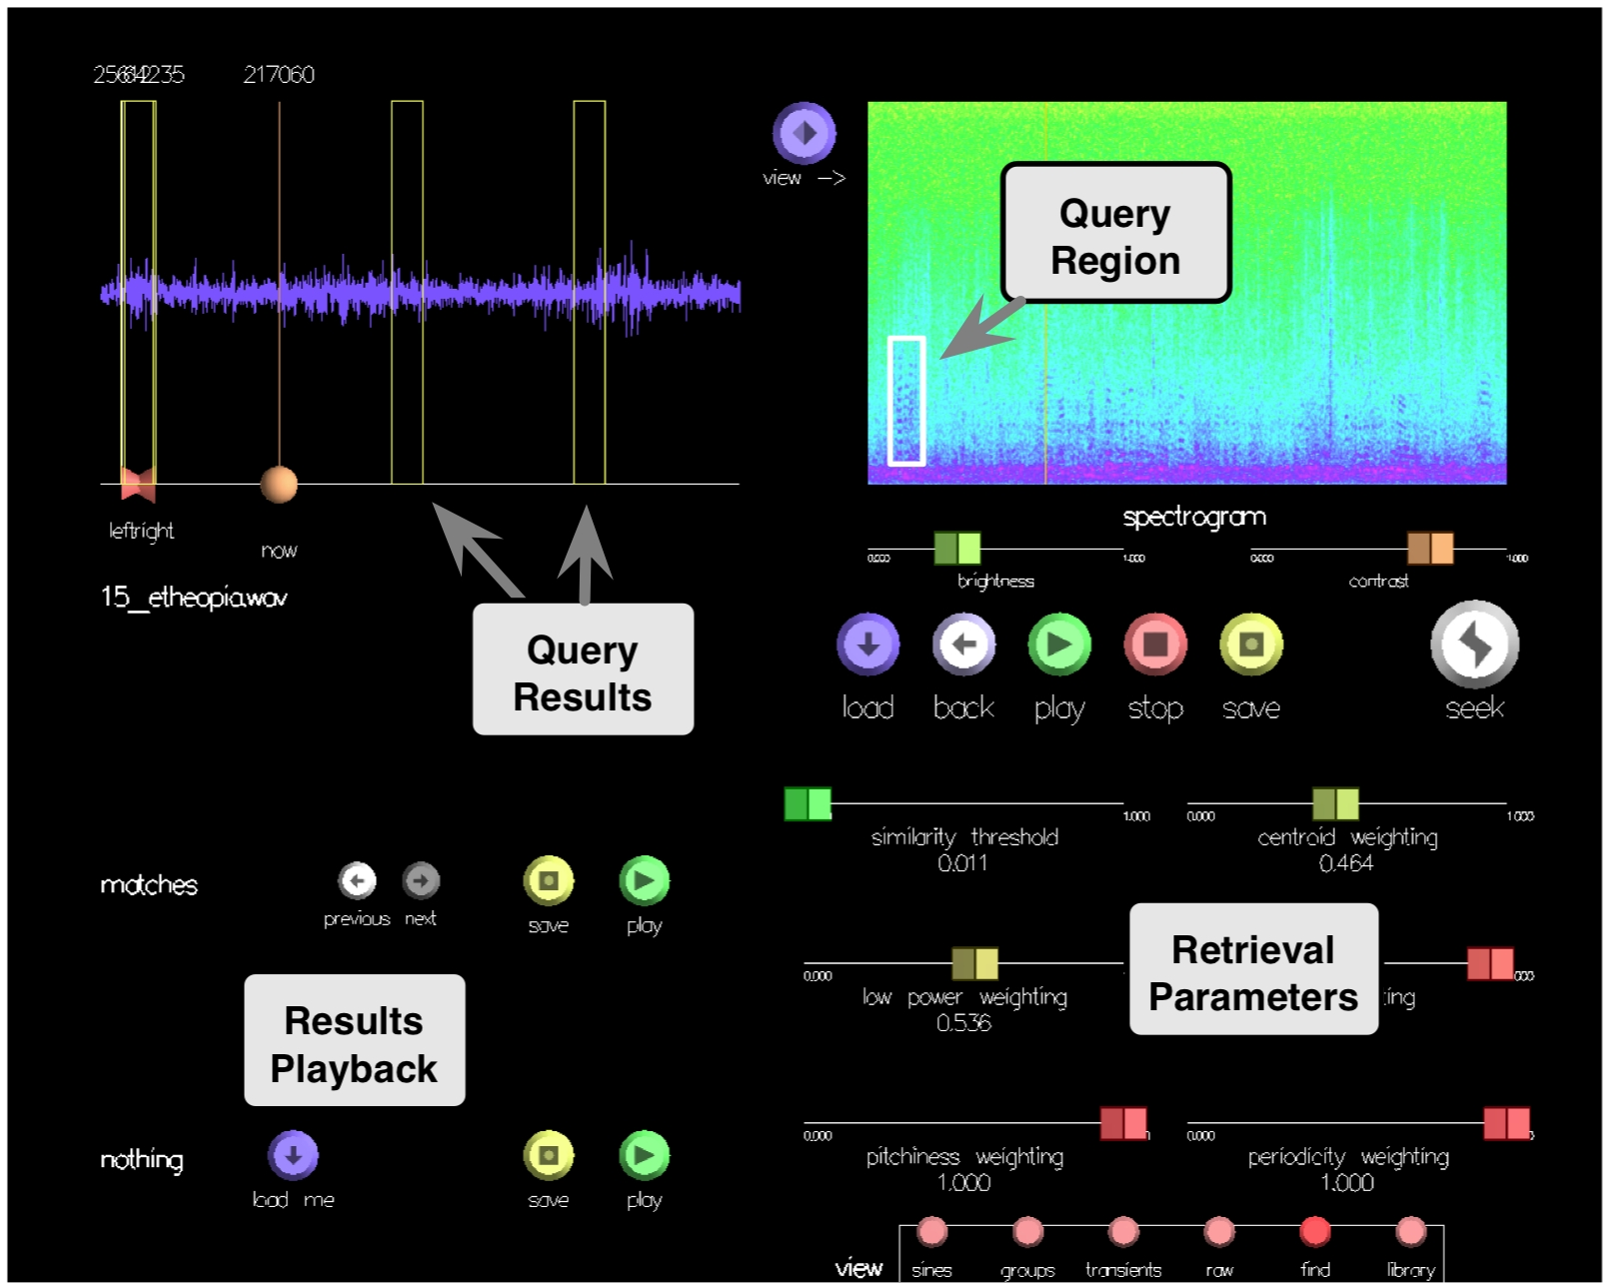
Figure 4. Analysis + retrieval user interface.

Applications and Examples
Figure 5 shows the results of a query on the database. The template child2 was chosen as the query, and is returned as the sound most similar to itself. The next five query results are also similar-sounding templates of children's voices, followed by several strongly pitched ringing sounds. The distances in feature space are presented to the right of the results.

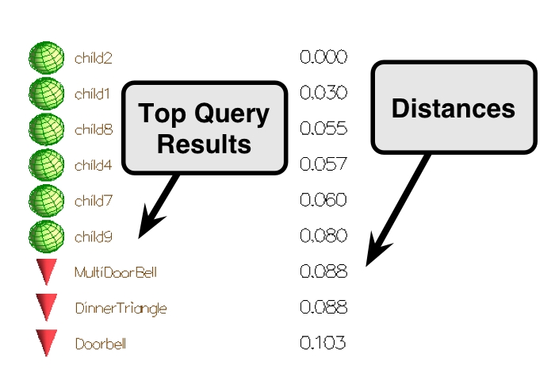
Figure 5. List of results, sorted by distance from target. The green spheres represents deterministic templates and the red cones represent raw sound files.

In figure 6, the sonic browser is shown after resetting the weights of the flux and centroid features. In the first pane, the Audio Database is visualized in the three feature dimensions of spectral centroid, low power, and flux. In the second pane, the weight of flux has been reduced to zero, effectively flattening the space to two dimensions. In the final pane, the centroid dimension's weight has also been reduced to zero, further compressing the space into a single dimension (low power). By querying on only one or two features at a time, the user can get more focused results, while using more features allows for broader definitions of similarity.

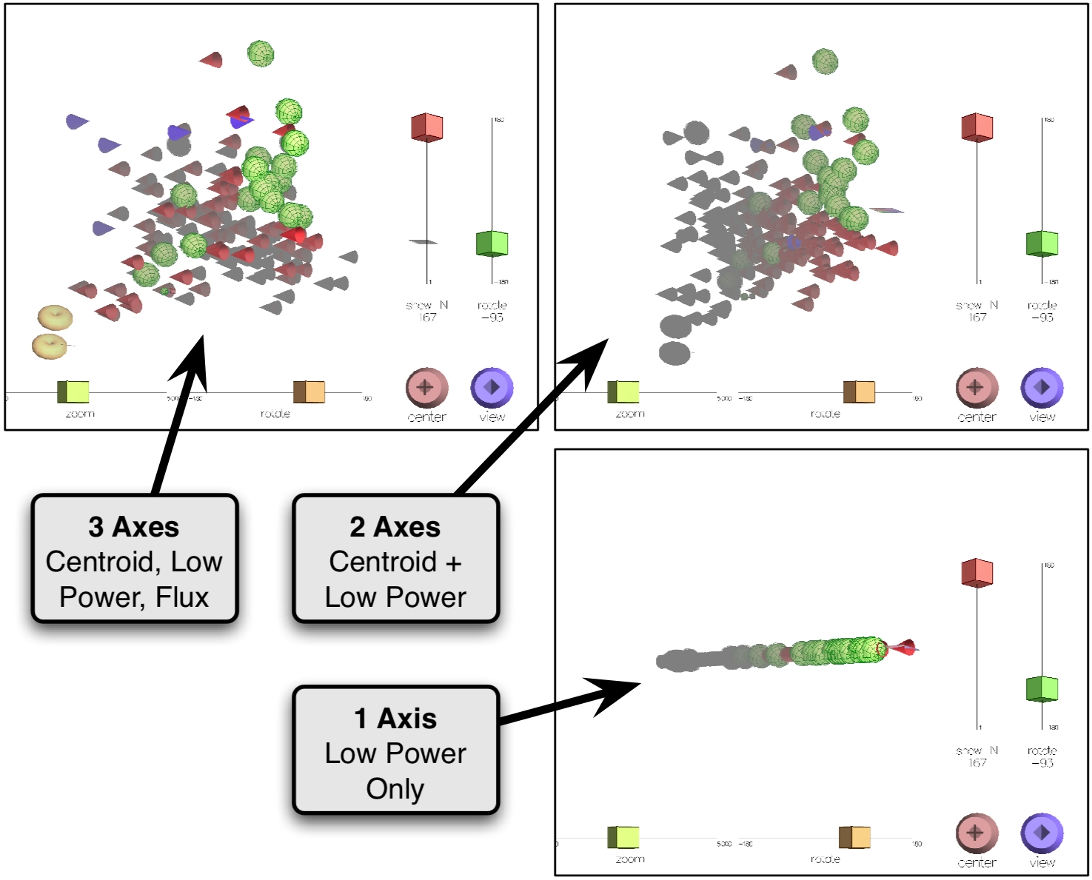
Figure 6. Browsing a region in feature space. In this example, 3D axes are mapped to individual features, whose weights can be interactively controlled.

Conclusions and Future Work
We have presented a system that integrates the analyze-transform-synthesize paradigm of TAPESTREA with audio information retrieval techniques. The newly integrated feature-based similarity query functionality enables users to access a broader range of sounds for use in sound design, expanding their palette of sonic possibilities. Conversely, users have the option of applying template-sensitive transformations to the sounds they use as queries, thereby gaining a new dimension of fine-tuned control over their search results.
The most obvious next step toward improving the relevance of our query results is the incorporation of more features, particularly features capturing information about the time domain dynamics of our sounds. At the moment our only two primarily time-domain-oriented features (low power and feature variance) do not consider any potential long-scale periodicity or order-dependent qualities present in sounds, which could be potentially quite relevant. A finer-grained set of spectral features might also provide better results.
One advantage to using a relatively small number of features, however, is that it remains practical for a user to manually set the weights to give each feature when ranking similarity. When using large numbers of features, many of which may be strongly correlated with each other, choosing the relative importance of each feature becomes both increasingly important (lest one set of features dominate the distance calculation) and increasingly difficult and time-consuming. An approach to dealing with this problem is to use machine learning algorithms such as [13] to try to infer how a user would rank the similarity of a set of sounds to one another from feature data. However, such an approach requires a substantial amount of human-labeled data, and presupposes that a general mapping is possible.
A disadvantage to query-by-example systems is that, by definition, they require the user to have an example on hand of the sort of sound they wish to find. It may be possible to circumvent this problem using the feature-based synthesis techniques we are currently developing, as described in [9]. Using feature-based synthesis, we can synthesize audio matching arbitrary feature values specified by the user in real time. Once the sound generated in this way begins to resemble what the user is looking for, the features used to specify that sound can be passed as a query to the database, which should return a sound resembling what the user had in mind.
Finally, we hope to use machine learning techniques to better predict appropriate source separation parameters for TAPESTREA based on the feature values we extract for each sound. Since we have and continue to build a large library of extracted template files recording good separation parameters for a wide variety of sounds, it may be possible to leverage the features we extract and classify sounds into broad categories for which certain separation parameters are most appropriate. This in turn would allow us to do sinusoidal analyses of batches of sound files, and extract new features based on statistics about the deterministic, transient, and stochastic background components of those sounds as automatically separated. Thus, in the long-term, TAPESTREA template separation can itself enhance audio information retrieval.

References
- A. Misra, P. Cook, and G. Wang. (2006). "Musical Tapestry: Re-composing Natural Sounds," Submitted to International Computer Music Conference 2006.
- A. Misra, P. Cook, and G. Wang. (2006). "TAPESTREA: Sound Scene Modeling By Example," Submitted to International Conference on Digital Audio Effects 2006.
- X. Serra. (1989). "A System for Sound Analysis Transformation Synthesis based on a Deterministic plus Stochastic Decomposition," PhD thesis, Stanford University.
- Dubnov, S., Z. Bar-Joseph, R. El-Yaniv, D. Lischinski, and M. Werman (2002). "Synthesizing sound textures through wavelet tree learning," IEEE Computer Graphics and Applications 22(4).
- G. Tzanetakis and P. Cook. (2000). "MARSYAS: A Framework for Audio Analysis" Organized Sound, Cambridge University Press 4(3).
- G. Tzanetakis and P. Cook. (2001). "MARSYAS3D: A prototype audio browser-editor using a large-scale immersive visual and audio display," In Proceedings of the International Conference on Auditory Display.
- B. Shneiderman. (1998). Designing the User Interface: Strategies for Effective Human- Computer Interaction. Addison-Wesley, 3rd edition.
- H. Kang and B. Shneiderman. (2000). "Visualization Methods for Personal Photo Collections: Browsing and Searching in the PhotoFinder," In Proceedings of the International Conference on Multimedia and Expo, New York, IEEE.
- M. Hoffman and P. Cook. (2006). “Feature-based Synthesis: A Tool for Evaluating, Designing, and interacting with Music IR Systems,” Submitted to ISMIR 2006.
- C. Chafe, B. Mont-Reynaud, and L. Rush. (1982). "Towards an intelligent editor of digital audio: Recognition of musical constructs," Computer Music Journal 6(1).
- M. Fernstrom and E. Brazil. (2001). "Sonic Browsing: an auditory tool for multimedia asset management," In Proceedings of the International Conference on Auditory Display.
- L. Jolliffe. (1986). Principal Component Analysis. Springer-Verlag, New York.
- Y. Freund, R. Iyer, R. E. Schapire, and Y. Singer. (2003). “An efficient boosting algorithm for combining preferences.” Journal of Machine Learning Research, 4.

