Privacy-Preserving Evidence Sharing for Cross-Bank Anti-Money Laundering: A Pre-Registered Evaluation
Allaudin Ansari  UG Student  SRM Institute of Science and Technology  Kattankulathur, Chennai 603203,  Tamil Nadu, India  allu456654ansari@gmail.com | Ravi Sah  UG Student  SRM Institute of Science and Technology  Kattankulathur, Chennai 603203,  Tamil Nadu, India  rsahravi57@gmail.com | M. Jagadeesh  Assistant Professor  Department of Computing Technologies  SRM Institute of Science and Technology  Kattankulathur, Chennai 603203,  Tamil Nadu, India  jagadeeshdevika@gmail.com

Abstract—A laundering scheme usually touches several banks, and each bank’s monitoring sees only its own part of it. We design and evaluate a privacy-preserving protocol in which banks answer each other’s queries with minimised evidence about counterparty accounts (an alert flag, a probability bucket and bucketed behaviour counters), addressed by tokens from an oblivious pseudorandom function. All hypotheses were pre-registered and decided once on sealed test data from the synthetic AMLworld benchmark; improvements made afterwards were confirmed on two further test windows that had never been opened. On the unopened high-illicit window, sharing raised the share of laundering schemes linked into one case from 0.063 to 0.534 (gain 0.47, 95% CI [0.43, 0.51]), recovering 0.92 of the gain of a pooled relational model. The gain was significant on all four sealed tests, persisted without the suspected simulator artefacts, and persisted with a per-bank version of a transaction-level detector that outperforms published gradient-boosting results on AMLworld. On the replication windows, analysts reviewed 6.8 to 8.5 times fewer alerts per linked scheme. An attack-based leakage audit found that the plain alert flag reveals high fan-in in the low-illicit data; a gated flag selected on validation removed this leakage on the replication windows while keeping 93–100% of the flag’s detection gain. Typology attribution did not replicate, and the oblivious tokens reduced re-identification 8 to 9 times relative to hashing, short of the pre-registered tenfold target.
Index Terms— anti-money laundering, inter-bank information sharing, leakage audit, oblivious pseudorandom functions, pre-registration, privacy-enhancing technologies

I. Introduction
Money laundering commonly moves funds through accounts held at different institutions. Funds may be collected at one bank, passed through accounts at others and withdrawn elsewhere, so the transaction monitoring of any single bank observes only some of the legs. Alerts therefore tend to be investigated in isolation, and few cases capture a scheme as a whole. Sharing information between banks can connect these fragments, and the Financial Action Task Force encourages such sharing within data-protection rules [1], [2]; but sharing also discloses information about customers who may be innocent. Two questions therefore arise together: how much detection improves with sharing, and how much a receiving bank can infer from what it is sent.
Existing work on collaborative detection relies mainly on federated learning, secure computation or supervisory analytics (Section II). These studies are typically evaluated on a single data split, and their privacy is argued from the properties of the mechanism used. In the design studied here, banks do not exchange model parameters; when an account is suspicious, its bank asks the banks holding its counterparties for a small, bucketed evidence record about those counterparties. A ladder of sharing levels, from no sharing (S0) to records with learned embeddings (S4), lets us measure what each additional field contributes to detection and what it discloses. Disclosure is measured directly, by attacks run by a curious peer bank against everything it receives.
The evaluation follows a pre-registered protocol [3]. Hypotheses, metrics, operating points and model settings were registered at the outset; provisional thresholds were fixed once, from validation data, at a planned gate; and each frozen configuration was then evaluated once on sealed test data, with every opening of the test labels logged. Later improvements were developed on validation data only, selected by rules written before the candidates were run, and confirmed on two 16-day windows of AMLworld [4] that had never been used. We call the first round the primary tests and the second the replication tests.
The contributions are as follows.
- A protocol for cross-bank detection based on minimised evidence records, OPRF tokens [5], a per-bank fusion stacker and a cross-bank linking rule, organised as a ladder of sharing levels. The implementation, pre-registration, amendments and sealed-test access log are public.
- A pre-registered evaluation on four sealed tests: two primary and two replication tests. Sharing increased linked scheme detection by 0.38 to 0.57 over local monitoring and recovered 0.64 to 0.98 of the gain of a pooled relational model. The gain persisted without the suspected artefact features and with a stronger local detector.
- An attack-based leakage audit that identified attribute leakage through alert flags, and a gated flag, selected by a pre-registered rule, that removed it on the replication tests.
- Case-quality measures relevant to investigators: on the replication tests, more complete cases and 6.8 to 8.5 times fewer alerts per linked scheme.
- Evidence that small local language models do not produce reliably grounded case narratives, and a select-then-template design that does.

II. Related Work
Federated learning allows banks to train a shared model without exchanging data. Suzumura et al. [6] proposed federated graph learning across banks, and Zheng et al. [7] trained a federated graph network on country-level subgraphs of AMLworld. Several entries to the financial-crime track of the US/UK PETs Prize combined a payment hub’s transaction data with account flags held privately by banks, using multi-party computation with federated learning [8], private set intersection with secure federated learning [9], or differential privacy with secure summation [10]. Secure computation has also been used to propagate risk scores across banks [11] and to trace money flows at national scale under homomorphic encryption [12]. Project Aurora [13] compared siloed, national and cross-border collaborative analysis on synthetic payments.
Table I summarises these works. Our approach differs in three respects. Banks exchange evidence about counterparty accounts rather than model updates. Leakage is estimated empirically with attacks, in addition to the guarantees of the mechanisms. None of the studies in the table reports results on a pre-registered sealed test or replicates them on data withheld throughout development, and at least one reports peak test performance without a separate validation split [10].
For the data and the detector we build on AMLworld [4], a synthetic transaction set with laundering labels and typologies. Directed multigraph GNNs [14] and subgraph features combined with gradient boosting [15] report strong transaction-level results on it, and we compare our detector with those published numbers (Table IV).
Three building blocks come from other literatures. Our tokens follow the use of oblivious pseudorandom functions for private matching and keyword search [16], in the form standardised by RFC 9497 [5]. Our audit takes the attack-based view of privacy risk, in which an adversary infers membership or attributes from what is released [17]. Our sealed test answers evidence that leakage between development and test data inflates results in machine-learning-based science [18]; pre-registration [3] is one remedy.

III. System
Fig. 1 shows the protocol for one query between two banks. Every bank plays both roles.
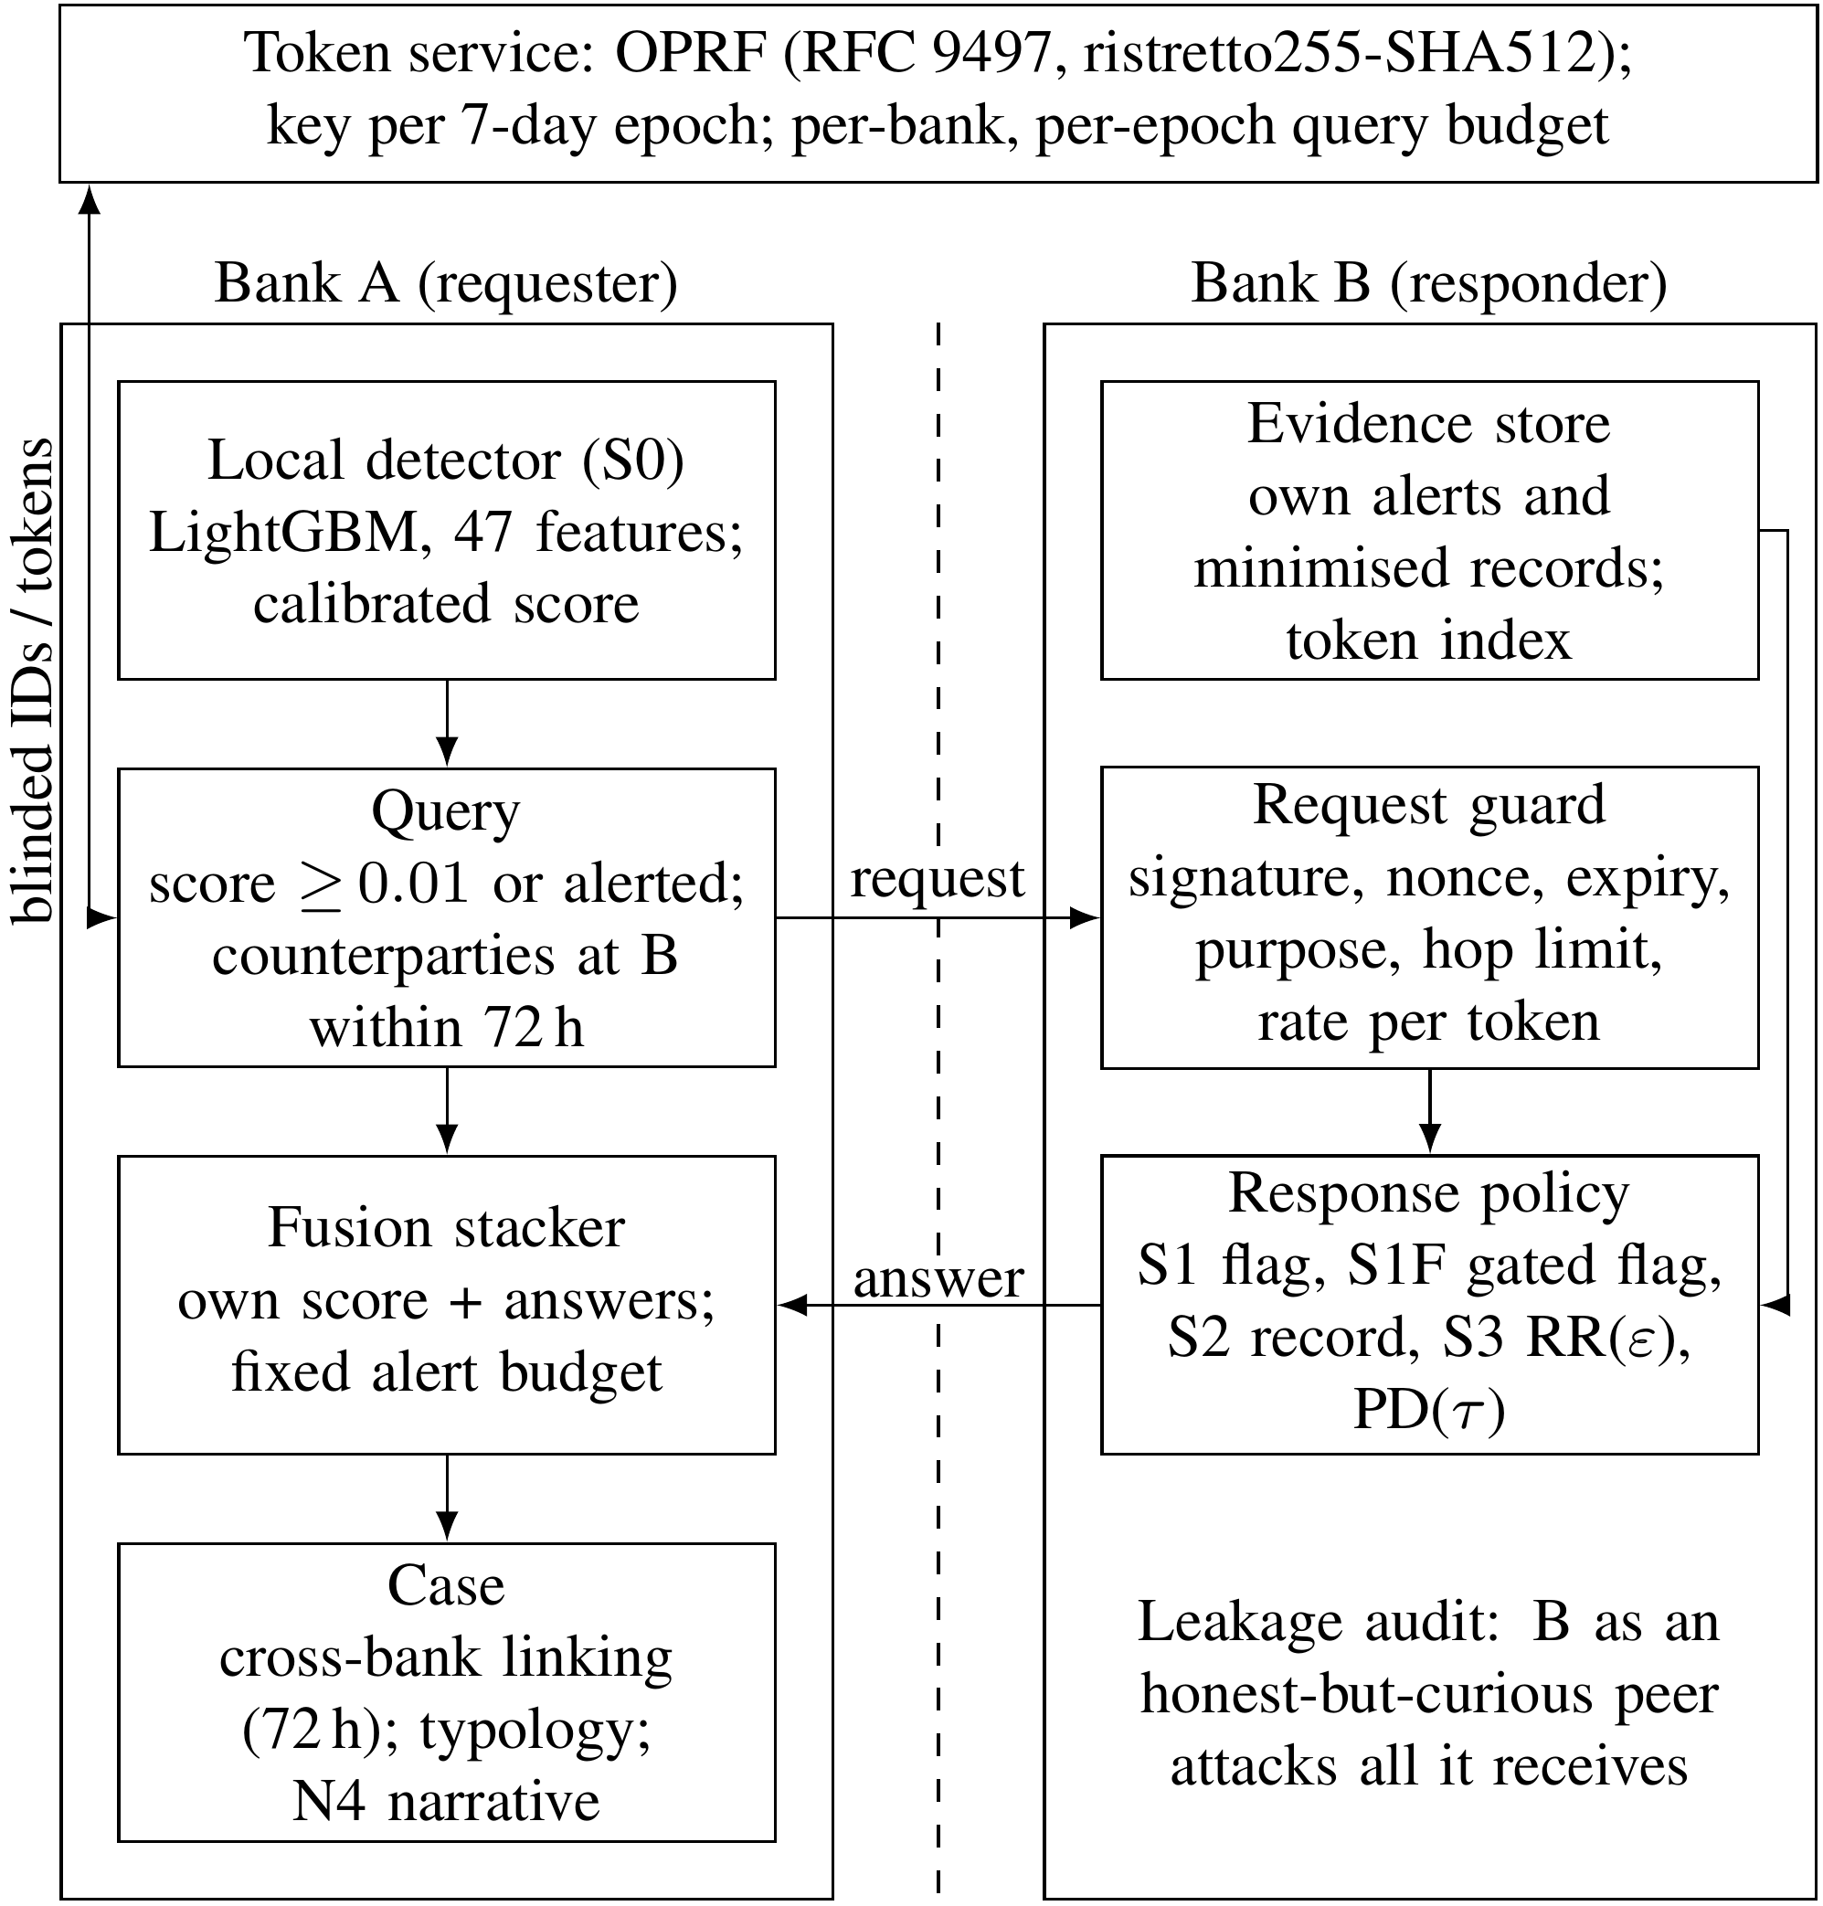
Fig. 1. Protocol for one query. Bank A tokenises the counterparties of a suspicious account through the token service and sends a signed request to the bank that holds them; Bank B’s guard checks the request and its policy answers at the configured sharing level. Only the request and the answer cross the boundary between banks (dashed line). S4 (S2 with an embedding) is a leakage reference and is not shown.

A. Setting and threat model
Each bank in the federation observes the transactions that have one end at one of its own accounts, including the counterparty’s account and bank. The adversaries are honest-but-curious. A peer bank follows the protocol but examines every token, request and response it receives, and knows the accounts it has itself paid or been paid by. The token service sees only blinded queries and does not collude with banks; it learns how many queries each bank makes, but not their content. Poisoning, collusion and compromised hosts are outside the scope, and we make no legal or regulatory claim.

B. Local detection (S0)
Every 6-hour window, each bank scores each of its accounts that was active in the window with a LightGBM model [19]. The 47 features fall into four families (behaviour, graph, history and neighbourhood) and are computed from the current window and the preceding 72 hours of the bank’s own view. Scores are calibrated per bank, and each bank raises a fixed number of alerts per window (Section IV). Sharing can therefore change which accounts are alerted but not how many. A bank merges its own alerts into incidents when the accounts transacted directly with each other within 72 hours.

C. Tokens
A bank must be able to recognise that the account a peer asks about is one of its own counterparties, without account numbers being exchanged and so that no bank holds a key with which it could tokenise identifiers offline. Tokens are therefore produced by an oblivious pseudorandom function in the mode-0 ristretto255-SHA512 suite of RFC 9497 [5]. A bank blinds an identifier, the token service evaluates it under the key of the current seven-day epoch, and the bank unblinds the result. Every evaluation is an online, logged query, and each bank has a per-epoch budget set to twice the largest legitimate use observed on validation. Each bank tokenises its own accounts in the same way, so that it can recognise the tokens it receives. Tokens derived from a key shared by all banks are used only as a control in the audit.

D. Evidence and sharing levels
An account-window whose calibrated probability is at least 0.01, or which has been alerted, queries the banks that hold its counterparties within the 72-hour lookback. A request carries the token, the time range, a declared purpose, a hop limit and the requester’s probability bucket, and is signed by a request issuer whose public key every bank holds. The responder’s guard refuses a request with an invalid signature, an expired or replayed request, one with an undeclared purpose or a spent hop limit, and any request for a token that has already received 20 answers in the epoch. The answer depends on the sharing level.
- S1: the alert flag for the counterparty and a time bucket.
- S2: an evidence record containing the probability bucket (five buckets, with edges at 0.01, 0.05, 0.2 and 0.5), the three features that deviate most from the bank’s local autoencoder reconstruction (each with a direction and a magnitude bucket), and bucketed counters for fan-in, fan-out, transaction counts and amounts in each direction, pass-through, cross-bank share, share of new counterparties and minimum delay. Raw values are never sent.
- S3: S2 with every field other than the time bucket and the flag released by k-ary randomised response [20], [21], at a total ε ∈ {0.5, 1, 2, 4, 8} per record, with at most ε = 8 spent per account and epoch.
- S4: S2 together with an 8-dimensional autoencoder embedding, included as an upper reference for leakage.
- PD (progressive disclosure): the S1 answer, with the S2 record added only when the requester’s own probability bucket is at least τ ∈ {2, 3, 4}.
- S1F (gated flag, introduced in Section IV-D): the S1 answer, given only when the requester’s probability bucket is at least 2 (calibrated probability at least 0.05).

E. Fusion and linking
Each bank re-scores its queried accounts with a logistic regression stacker. The inputs are the account’s own score, the numbers of requests sent, refused and answered with an alert, the requests the account itself received and, where records are shared, the number of records together with the highest and summed probability buckets and the largest deviation, fan-in, fan-out and pass-through buckets. The stacker is cross-fitted on the two halves of the validation period. Each bank then applies its own alert budget, and alerts from different banks are linked when their accounts transacted within 72 hours. Two pooled references are used. The oracle is a single LightGBM model trained on every bank’s data. The relational oracle adds a stacker over each account’s pooled score and the pooled scores of all its counterparties in the federation; it is the reference for every recovery ratio reported below.

F. Case narratives
A gradient-boosted attributor assigns a typology to each linked case from the fused evidence, or leaves the case unattributed when its confidence is below a threshold. A local language model then writes a short narrative in JSON. The schema requires the typology to match the attributed one and every cited field to exist in the evidence; a failed check leads to one retry and then to a fixed template. In the select-then-template variant (N4), the model only chooses up to four evidence fields, and every sentence is produced by fixed templates.

TABLE I
Collaborative anti-money-laundering and financial-crime detection: what is shared, how it is protected, and how it is evaluated
Work | Shared between institutions | Protection | Data | Evaluation | Privacy evidence
Suzumura et al. [6] | Model parameters (global graph features planned) | Federated learning; DP/MPC proposed, not evaluated | Simulated, six banks (FCA TechSprint) | One test split, prototype | None
Arora et al. [8] | Bank account flags, inside a payment hub's training | Federated learning + MPC (oblivious transfer, secret sharing), noise | PETs Prize synthetic payments | Challenge test environment | Design argument
Abadi et al. [9] | Identity alignment and model updates | Private set intersection + secure federated learning | Synthetic payments | Scalability and accuracy, prototype | Security proof
Khan et al. [10] | Embeddings and gradients | Differential privacy + secure summation | PETs Prize synthetic, AMLSim | One test split; best test epoch reported | Formal DP bound
van Egmond et al. [11] | Encrypted risk scores, propagated across banks | Secure multi-party computation | One bank's transactions | Precision at fixed recall | Design argument
Brand et al. [12] | Encrypted flow-tracing indicators | Homomorphic encryption | Nation-scale deployment | Run time only | Design argument
BIS Innovation Hub [13] | Collaborative analysis and learning | Privacy-enhancing technologies | Synthetic, national and cross-border | Scenario comparison | Not reported
Zheng et al. [7] | Model updates and aggregated node embeddings | Federated learning (no formal guarantee) | AMLworld HI-Small subset [4] | One split (5% train) | None
This work | Minimised evidence records keyed by OPRF tokens; alert flags, gated | Pseudonymous tokens (OPRF), data minimisation, flag gating; LDP and progressive disclosure as options | AMLworld HI/LI Medium and two never-opened Large windows [4] | Pre-registered sealed tests, replication on unopened windows, 95% CIs, Holm | Empirical attacks (4 targets) and token re-identification

IV. Evaluation Method

A. Data and federation
The experiments use the high-illicit (HI) and low-illicit (LI) variants of the IBM AMLworld synthetic data [4]. Table II lists the four sealed tests. A label-free rule selects the densely populated period of each file. For the Medium sets this period lasts 16 days; for the Large sets we took the last 16 days of it. Time is divided into 6-hour windows, of which 60%, 20% and 20% form the training, validation and test partitions, separated by a one-window gap. The banks are grouped into eight institutions of similar size (federation B8), so that every account is held by a member.
TABLE II
Test sets
Test set | Transactions | Laundering | Schemes | Cross-member
 | (millions) | rows |  | test schemes
HI-Medium | 31.9 | 31,146 | 2,756 | 480
LI-Medium | 31.3 | 15,270 | 456 | 91
HI-Large | 30.3 | 39,798 | 6,638 | 559
LI-Large | 29.7 | 18,037 | 896 | 78
Each set is a 16-day dense window of AMLworld, split by 6-h window 60/20/20 into train, validation and test with one-window gaps; eight institutions (federation B8) hold every account. Cross-member test schemes: laundering schemes in the test partition that touch two or more institutions. Medium: the primary tests; Large: the replication tests.

B. Unit, labels and metrics
The unit of scoring is the account-window, that is, an account held by a member during one window in which it made or received at least one transaction. An account-window is positive when it touches a laundering transaction that is not masked. Masking applies to legs of schemes assigned to a different partition and to busy accounts that a scheme crossed only once (at least 20 legs, fewer than 10% of them laundering). Each bank raises exactly one alert per 1,000 accounts per day. A scheme counts as detected when one of its account-windows is alerted within 72 hours of its first window, and as linked, the primary metric, when at least two of its accounts fall into the same incident within that period. Before any sharing level was implemented, a pre-registered gate required the oracle to exceed S0 in linked detection on validation by at least 0.05. On HI-Medium the difference was 0.508 [0.465, 0.550], and nearly all of it came from linking: any-alert detection was 0.864 for S0 and 0.886 for the oracle.

C. Pre-registration and sealed test
Hypotheses (Table III), operating points, model settings and statistical rules were registered at the outset. Thresholds marked as provisional could be revised once, using validation results, at a pre-planned gate (G1), after which the registration was frozen; the registered model settings were fixed in advance rather than tuned on validation data. Every later change was recorded as a dated amendment with its reason. All but one were made before the results they concerned existed; the exception corrected a report page after an opening without changing any score (Section VI). Test labels were kept sealed. Each configuration scored the test data without labels, and a SHA-256 digest of its scores was logged at the single opening allowed for each experiment, dataset and seed. A repeated opening was permitted only after a crash and was logged. The primary tests on HI-Medium and LI-Medium decided the pre-registered hypotheses.

D. Replication on unopened windows
Improvements made after the primary tests could not be evaluated on those tests without fitting to them. They were developed on Medium validation data and chosen by rules written before the candidates were run (amendment A25 in the public amendment log).
- Protected flag. Among randomised-response and gated versions of the S1 flag, the rule selected the candidate that stayed within the privacy margin on every attack target of both Medium sets and kept the largest share of the plain flag’s gain. The gated flag was selected, keeping 1.01 of that gain.
- Narrative. Among four local models of 3 to 8 billion parameters, the rule selected the one with the highest strict grounding, and N4 built on it if N4 was at least as grounded. N4 on qwen3:8b was selected.
- Benchmark adequacy. If our pooled detector scored more than 5 F1 points below the published LightGBM result on the validation split of the AMLworld benchmark, a stronger detector was to be added as an extra track. The gap on HI-Medium was 14.5 points, so a transaction-level detector (Section V-B) was added as the configurations S0+, S2+ and oracle+.
The first author then signed a frozen commit, and each experiment and seed was run once on the two Large windows, the replication tests: the main track, an artefact-free track and the stronger-detector track.

E. Statistics
Headline configurations were run with five seeds and the remaining ones with three; the seed controls model training and negative sampling. Per-scheme outcomes were averaged over seeds, and confidence intervals were obtained from a bootstrap over schemes with 1,000 replicates. Gains over S0 were paired by scheme, and their p-values were adjusted with the Holm procedure [22] across all sharing configurations compared with S0. All runs used a single laptop with 8 GB of memory.

F. Leakage audit
A curious peer bank attacks everything it receives in seed 0 of each main run. Attack A1 attempts to re-identify the tokens in other banks’ records from lists of the peer’s own counterparties, under shared-key hashing and under the OPRF budget. Attack A2 infers whether the queried account transacted with a third member. Attack A3 infers whether its outgoing amount or its fan-in is in the top decile and whether it passes funds through. The A2 and A3 attacker is a gradient-boosted classifier trained on the true attributes of half of the queried accounts, and it is compared with a classifier that uses only what the peer knew before asking. The pre-registered margin requires the upper 95% bound of the difference in true-positive rate at a 1% false-positive rate to be at most 0.05 on every target, for S1 and for S3 with ε ≤ 2.

V. Results

A. Detection
Fig. 2 and Table III summarise the sealed tests. Local monitoring linked between 0.063 and 0.136 of the schemes. With evidence records (S2), linked detection rose to 0.702 on HI-Medium and 0.657 on LI-Medium in the primary tests, and to 0.534 on HI-Large and 0.450 on LI-Large in the replication tests. All gains had 95% intervals above zero after Holm correction, and random alerts at the same budget linked no scheme. S2 recovered 0.98, 0.79, 0.92 and 0.64 of the relational oracle’s gain, which meets the pre-registered threshold of 0.60 on all four tests, although the interval for LI-Large extends down to 0.52. Much of the improvement is already obtained with alert flags alone (S1 reaches 0.516 on HI-Large), which agrees with the gate result: the difficulty lies in linking alerts across banks rather than in raising them. Pooling all data is not sufficient by itself. A single model trained on every bank’s data and linked by the same rule reached 0.434 on HI-Large, below S2.

TABLE III
Pre-registered claims on the sealed tests
Pre-registered claim | HI-Medium | LI-Medium | HI-Large | LI-Large
H1a: S2 − S0 linked detection | 0.57 [0.53, 0.61] ✓ | 0.55 [0.45, 0.63] ✓ | 0.47 [0.43, 0.51] ✓ | 0.38 [0.29, 0.48] ✓
H1b: share of oracle gain (≥0.60) | 0.98 [0.94, 1.03] ✓ | 0.79 [0.69, 0.88] ✓ | 0.92 [0.87, 0.97] ✓ | 0.64 [0.52, 0.77] ✓
H1c: plain flag, fan-in advantage | −0.002 [−0.008, 0.003] ✓ | 0.092 [0.079, 0.103] ✗ | 0.001 [−0.002, 0.003] ✓ | 0.043 [0.031, 0.059] ✗
gated flag (A25) | — | — | 0.001 [−0.001, 0.003] ✓ | 0.004 [0.000, 0.007] ✓
H1d: PD gain share, least disclosure | 0.98 at 0.07 ✓ | 0.99 at 0.01 ✓ | 0.95 at 0.03 ✓ | 0.81 at <0.01 ✓
H3a: attribution above baselines | ✓ | ✗ | ✗ | ✗
H3b: narrative grounding (≥0.95) | 0.86 [0.81, 0.90] ✗ | 0.92 [0.84, 0.96] ✗ | 1.00 [0.98, 1.00] ✓ | 0.95 [0.87, 0.98] ✓
PT2: hashing ÷ OPRF re-id. (≥10) | 19.9 ✓ | 8.7 ✗ | 8.1 ✗ | 9.3 ✗
Sealed tests; 95% intervals from a scheme bootstrap. H1c: upper 95% bound of (attack − prior) TPR at 1% FPR at most 0.05 on every attack target (A2, A3); the value shown is the binding target, A3 fan-in, and the mark is the verdict over all targets and, for the plain flag, the S3 levels with ε ≤ 2. H1d: PD configuration reaching ≥0.80 of S2's gain with the smallest share of S2's disclosed accounts. H3b on Medium: free-text narratives; on Large: select-then-template (N4). Medium columns: primary tests; Large: replication tests. H2 (a federated DP scorer, a supporting track) is reported in Section VI.

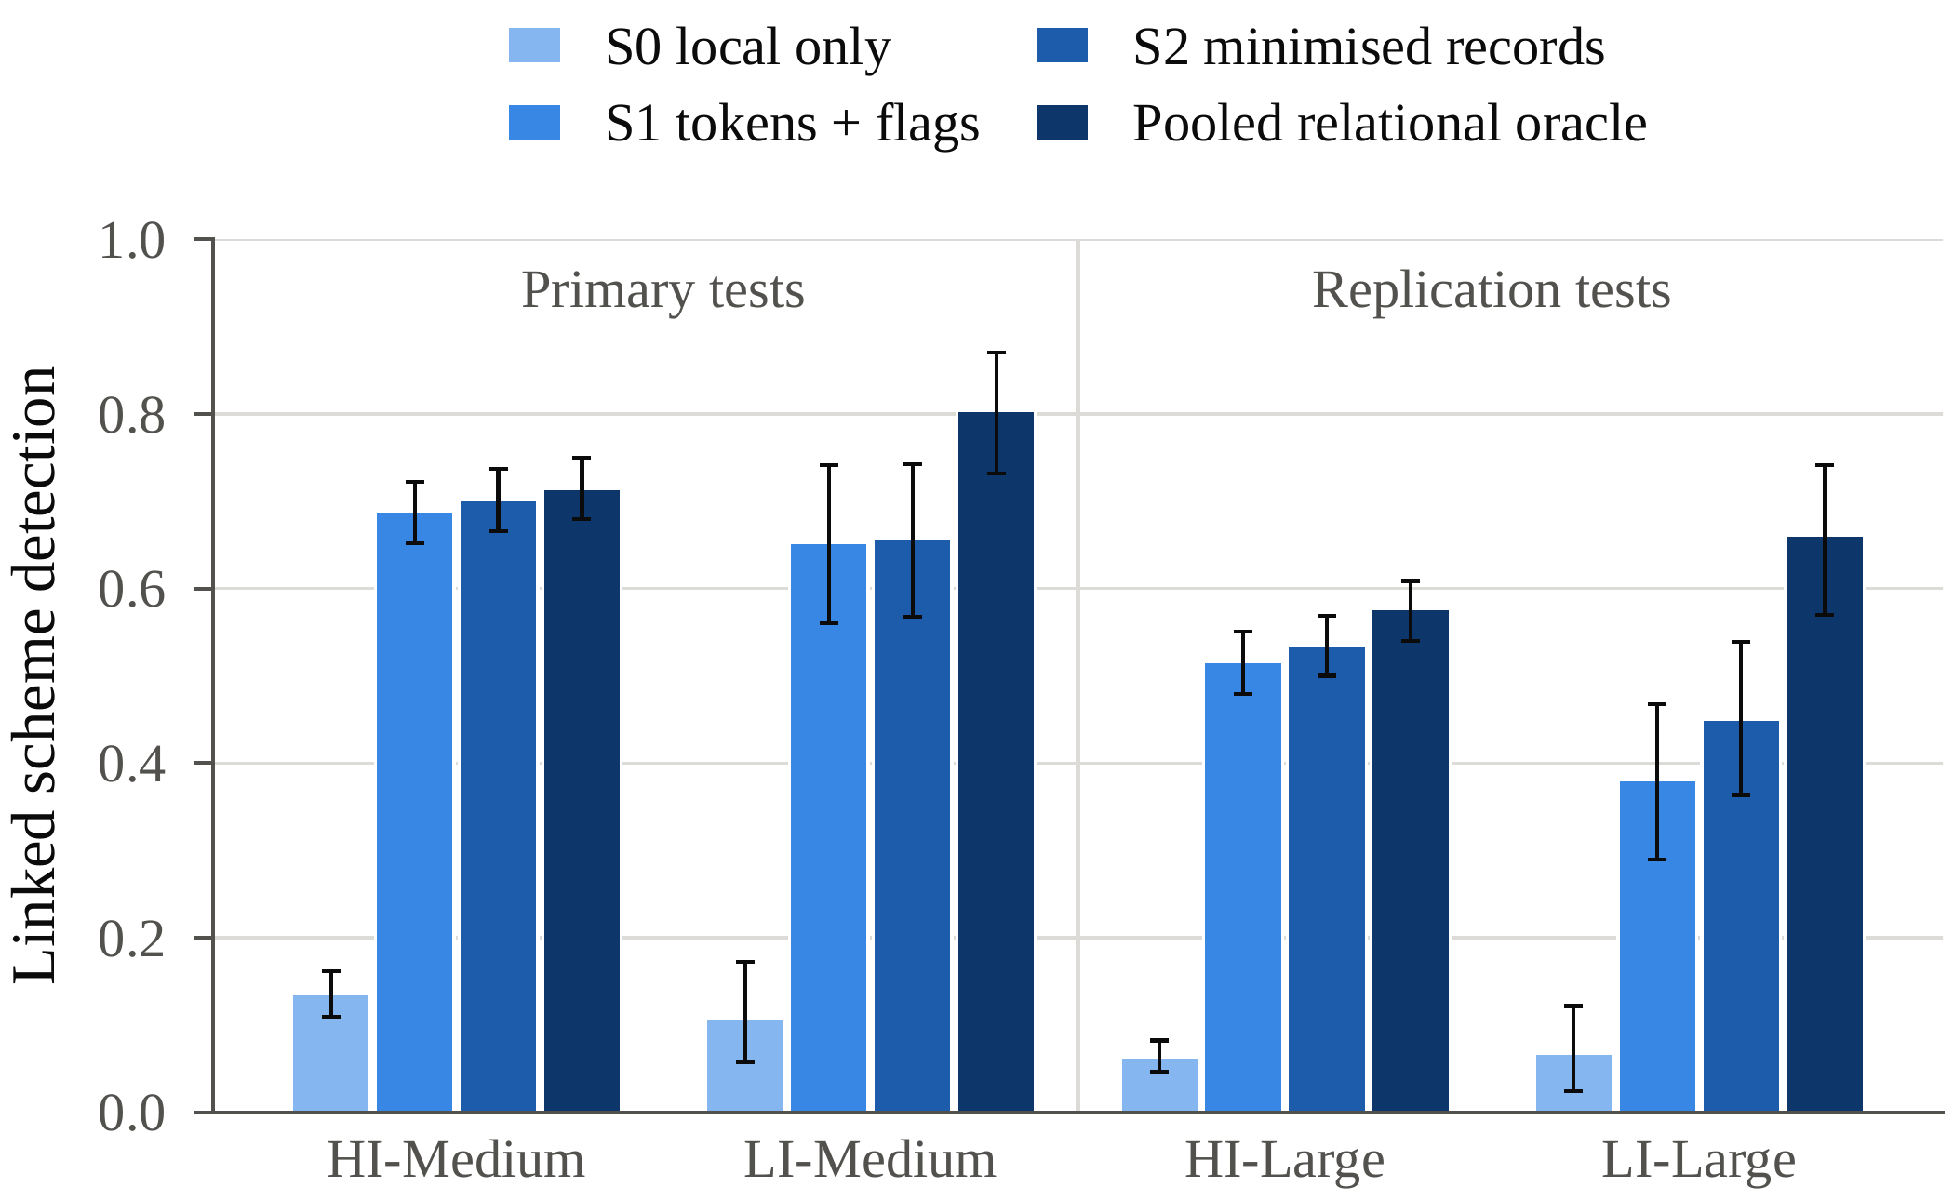
Fig. 2. Linked scheme detection on the four sealed tests by sharing level: local only (S0), tokens and alert flags (S1), minimised evidence records (S2), and the pooled relational oracle. Bars show the mean over seeds and whiskers the 95% bootstrap interval over schemes. HI- and LI-Medium are the primary tests; HI- and LI-Large are the replication tests, on windows that were not opened during development.

B. Robustness
Artefact features. At gate G1, the AMLworld payment-format shares and the self-transfer indicator were the strongest features of every baseline model; they may reflect properties of the simulator. With these features removed (Fig. 3), the gain was 0.438 on HI-Large and 0.210 on LI-Large, both with intervals above zero. On LI-Large the flags alone then contributed little (S1 reached 0.054), whereas the records still reached 0.217, so in this setting most of the information is carried by the records.
Stronger detector. On the published AMLworld split, a LightGBM model on the fields of each transaction and the features of both of its accounts (Table IV) outperformed both published gradient-boosting baselines on all four datasets and the best published GNN on two of them. A per-bank version of this model, used as the local detector (S0+), left the sharing gain largely unchanged: 0.433 on HI-Large and 0.355 on LI-Large. Its pooled version was much stronger on LI-Large (0.764), however, and S2+ recovered only 0.49 of the corresponding relational oracle’s gain there. This was the only robustness rule that was not met.

TABLE IV
Detector against published results
Model | HI-Small | LI-Small | HI-Medium | LI-Medium
Ours, account-window detector | 48.20 ± 0.69 | 23.21 ± 2.80 | 42.67 ± 2.76 | 24.08 ± 2.01
Ours, transaction model | 64.25 ± 1.24 | 34.99 ± 1.51 | 67.01 ± 2.27 | 34.34 ± 1.55
LightGBM + graph features [4], [14] | 62.86 | 20.83 | 59.48 | 20.85
XGBoost + graph features [4], [14] | 63.23 | 27.30 | 65.70 | 28.16
Multi-PNA + EU [14] | 68.16 | 33.07 | 66.48 | 36.07
Minority-class F1 (%) on AMLworld's published split (all transactions, by day 60/20/20), threshold chosen on validation; ours: mean ± s.d. over 5 seeds; best per column in bold. Pooled data in every row (the published models see all banks).

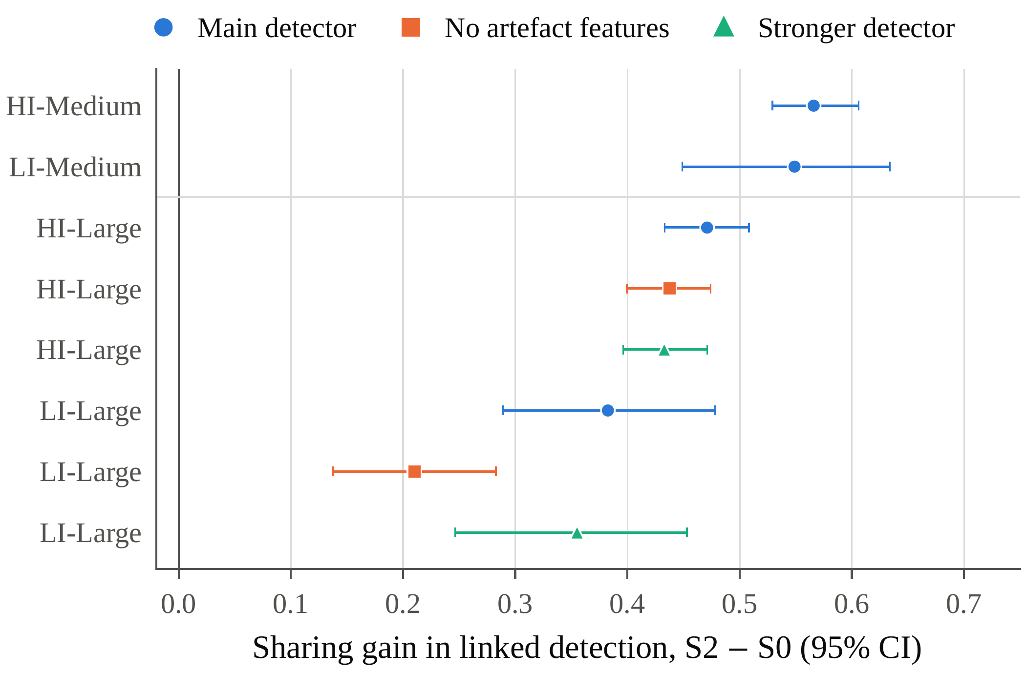
Fig. 3. Sharing gain (S2 − S0 in linked detection) with 95% intervals. The main detector is shown on all four tests; on the Large tests the gain is also shown without the suspected artefact features (payment-format shares and self-transfers) and with a per-bank version of the transaction-level detector of Table IV.

C. Privacy
Attribute inference. On the high-illicit tests, the alert flag and the randomised records stayed within the margin. On the low-illicit tests they did not (Fig. 4). A peer receiving flags inferred top-decile fan-in with an advantage of 0.092 on LI-Medium and 0.043 [0.031, 0.059] on LI-Large. A plausible reason is that in the low-illicit data an alert says more about an account’s number of payers. S3 did not reduce this leakage because it leaves the flag unperturbed. The gated flag reduced the advantage on LI-Large to 0.004 [0.000, 0.007] while keeping 1.00 (HI-Large) and 0.93 (LI-Large) of the plain flag’s detection gain. Evidence records (S2, S4) reveal such attributes by design; their fan-in advantage was 0.73 to 0.74.
Progressive disclosure. With τ = 4, PD kept 0.95 (HI-Large) and 0.81 (LI-Large) of the S2 gain while disclosing records for 3% and less than 1% as many accounts as S2. On the high-illicit data this comparison is not informative, because the flag alone already reaches 0.95 of the S2 gain.
Tokens. With shared-key hashing, a peer re-identified 0.39 of the record tokens of other banks on HI-Large; within the OPRF budget it re-identified 0.049. The resulting ratio of 8.1 (HI-Large), 9.3 (LI-Large), 8.7 (LI-Medium) and 19.9 (HI-Medium) is below the pre-registered value of 10 on three of the four tests. In the primary HI-Medium test, legitimate use exceeded the frozen budget in 2 of 16 bank-epochs (18.8% of token requests); for the replication tests the budget was therefore sized per window from validation traffic, and legitimate use stayed within it on both. We also replayed an adaptive budget, set to twice the previous epoch’s use, on the recorded traffic. It left refusals on busy days well above the 1% target and lowered the ratio to between 2.6 and 3.2 even under honest use, so it was not adopted.
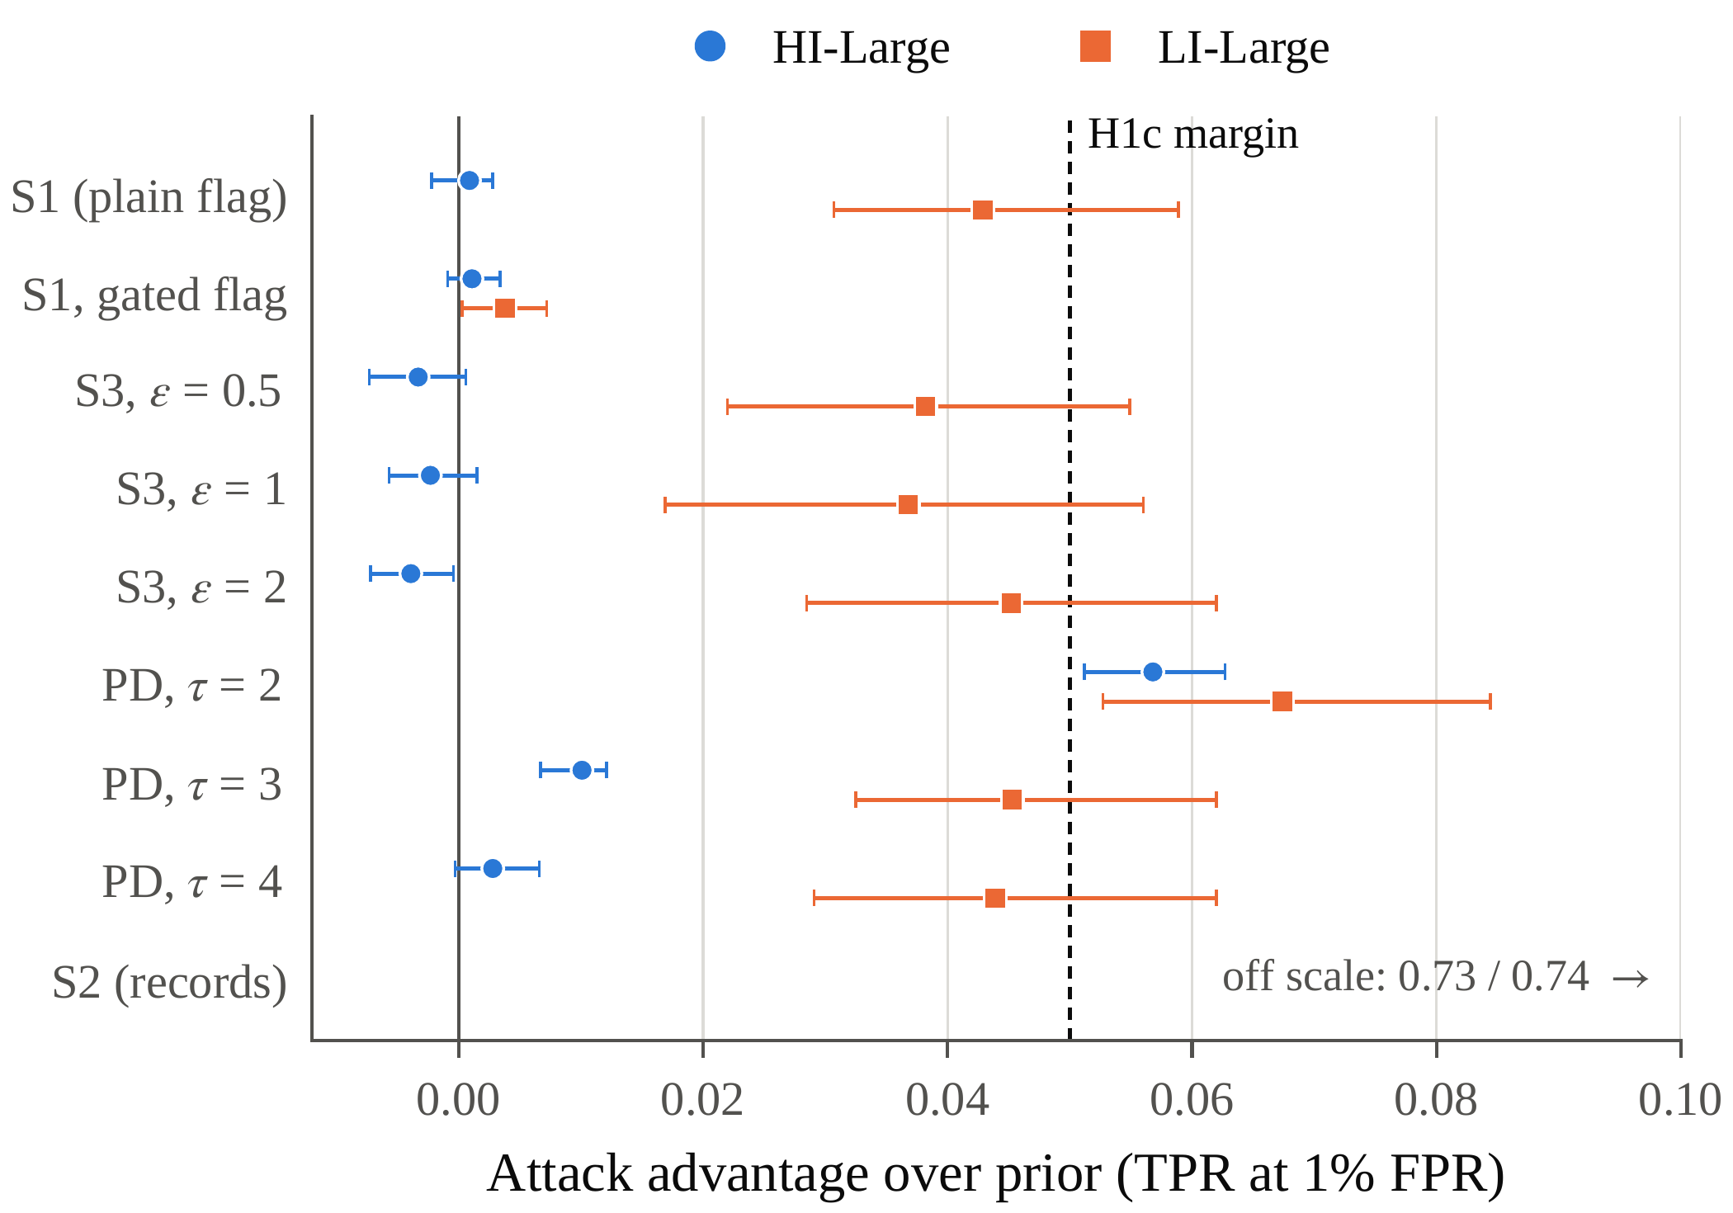
Fig. 4. Leakage audit on the Large tests. The horizontal axis is the advantage of the attacker over a prior-only classifier in inferring top-decile fan-in (the binding target), measured as the difference in true-positive rate at a 1% false-positive rate, with 95% intervals. The dashed line marks the pre-registered margin of 0.05 for the upper bound. On LI-Large the plain flag and every level that includes it exceed the margin; the gated flag selected on validation does not.

D. Case quality and analyst workload
For an investigator, a useful case contains as much of a scheme as possible. With sharing, the largest case for a detected scheme on HI-Large contained 0.77 of its accounts, compared with 0.47 without sharing, and a scheme was divided into 1.05 cases on average instead of 1.51 (Table V). Since every bank raises the same number of alerts at every sharing level, the number of alerts reviewed per linked scheme fell from 153 to 18 on HI-Large and from 944 to 140 on LI-Large (Fig. 5).
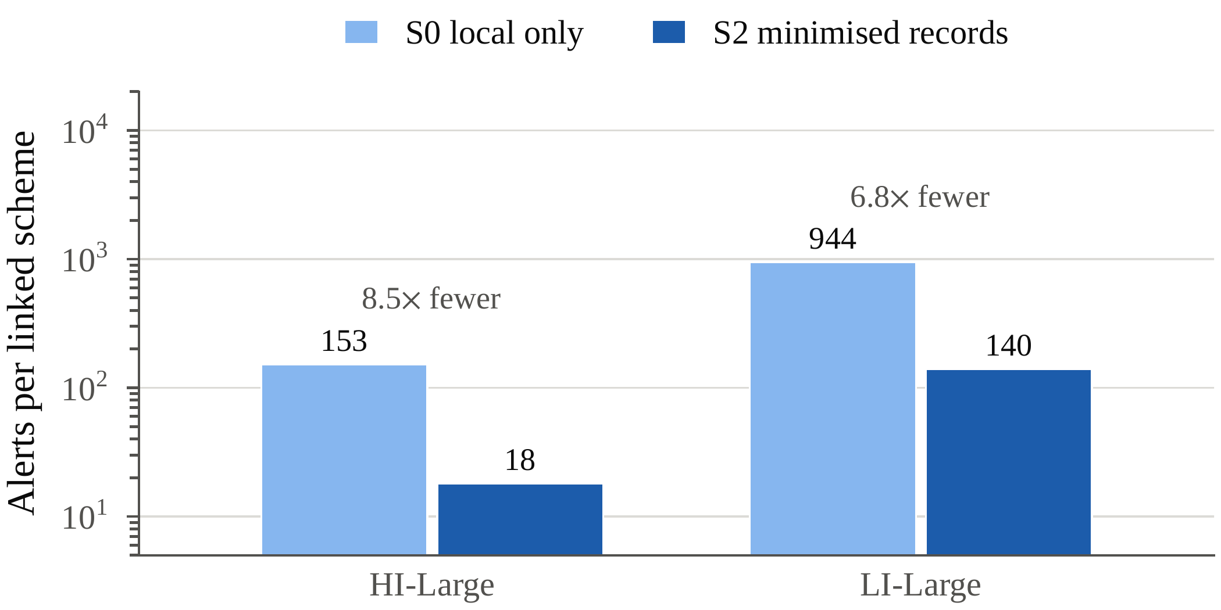
Fig. 5. Alerts reviewed per linked laundering scheme with local monitoring only (S0) and with minimised evidence sharing (S2) on the Large tests. The vertical axis is logarithmic.
TABLE V
Case quality and analyst workload
Measure | HI-Large |  | LI-Large
 | S0 | S2 | S0 | S2
Scheme accounts in the case | 0.47 | 0.77 | 0.48 | 0.73
Cases per linked scheme | 1.51 | 1.05 | 1.49 | 1.06
Alerts per linked scheme | 153 | 18 | 944 | 140
Per detected scheme, seed-averaged: share of the scheme's accounts in its largest case (completeness), number of cases it is split into (fragmentation), and alerts raised per scheme linked (analyst workload). Replication tests, seeds 0–4.

E. Attribution and narratives
Typology attribution with shared evidence outperformed local attribution and both baselines on HI-Medium, but not on LI-Medium or on either replication test, and we therefore regard it as exploratory. Free-text narratives from a small local model passed the structural checks (valid JSON, the attributed typology, existing fields) in 0.86 (HI-Medium) and 0.92 (LI-Medium) of first replies, below the target of 0.95. Larger models of 7 to 8 billion parameters did not resolve the problem: strict grounding, which also checks numbers, scope and claims, remained between 0.06 and 0.22 on validation for all four models (Table VI). N4 met the target on both replication tests (1.00 and 0.95), although its strict grounding was lower on LI-Large (0.56) than on HI-Large (0.82). An automated judge rated its validation narratives faithful in all 30 sampled cases, compared with 21 to 29 for the free-text models.
TABLE VI
Case narratives: local models and select-then-template
Design | Grounding | Strict | Faithful
HI-Medium validation, 200 cases (judge: 30)
N0: llama3.2:3b, free text | 0.96 | 0.13 | 21/30
N1: qwen2.5:7b, free text | 0.97 | 0.10 | 26/30
N2: llama3.1:8b, free text | 0.99 | 0.06 | 29/30
N3: qwen3:8b, free text | 0.98 | 0.22 | 23/30
N4: select-then-template (N3) | 0.99 | 0.83 | 30/30
N4 on the replication tests
HI-Large | 1.00 | 0.82 | —
LI-Large | 0.95 | 0.56 | —
Grounding (H3b): first reply is valid, keeps the attributed typology and cites only evidence fields. Strict: also 1–4 fields, every number from the evidence, claim consistency and scope. Faithful: automated judge (one rater, not blind) on the 30-case sheet; delivered text after retry and template fallback.

VI. Limitations
AMLworld is synthetic, so the results describe what minimised sharing achieves on the standard benchmark for this problem rather than on real bank data. The low-illicit windows contain few cross-member test schemes (78 and 91), which widens their intervals. The audit considers honest-but-curious peers and four inference targets; collusion, poisoning and side channels are not covered, and the S1, S2 and PD responses are minimised and audited but not differentially private. The oblivious tokens limit re-identification only as far as the per-epoch budget does: relative to hashing, re-identification fell 8- to 9-fold on three of the four tests, short of the tenfold target, and an adaptive budget made it worse. When the pooled model was strongest (the stronger detector on LI-Large), minimised sharing recovered less than half of its gain. All tests use one federation of eight members of similar size; larger or more unequal federations were not studied. The faithfulness of the narratives was judged by a single automated rater that was neither blind nor independent of the template design. A federated neural scorer with differential privacy, also pre-registered, met its target on LI-Medium but not on HI-Medium, where the local detector left little room for improvement. Finally, two amendments after the pre-registration changed how token requests are metered so that runs would not stop at a token cap (A24a and A25a), both before the tests they affected were opened, and one corrected a report page after an opening without altering any score (A24b).

VII. Conclusion
Sharing a small amount of evidence about counterparty accounts, namely an alert flag and a bucketed record addressed by metered tokens, allowed banks to link several times as many laundering schemes as local monitoring and to recover most of the gain of a pooled model, with far fewer alerts per linked scheme. These results held on four sealed tests, two of which were not opened during development, without the suspected artefact features and with a stronger local detector. Measuring leakage with attacks revealed that even the simplest disclosure, a bare alert flag, can leak an account attribute, and a gated flag removed this leakage on the replication tests. Typology attribution and the pre-registered limit on token re-identification were not achieved. Natural next steps are a pilot on real transaction data under a data-sharing agreement, larger federations of unequal banks, flags with formal privacy guarantees, and blind human review of the case narratives. We suggest that collaborative financial-crime detection adopt the same practice of pre-registration, sealed tests and replication on withheld data.

Acknowledgment
Parts of the software and a first draft of this manuscript were prepared with the assistance of an AI system (Claude, Anthropic). The authors designed the study, reviewed and revised all text and code, and take full responsibility for the content.

Data and Code Availability
The AMLworld datasets [4] are publicly available under the CDLA-Permissive-2.0 licence. The FinMesh implementation (MIT licence), the pre-registration and its amendments, the sealed-test access log and the outputs of all experiments are available at https://github.com/allu0786ansari/FinMesh. The repository provides step-by-step instructions to reproduce the experiments from the raw data and scripts that regenerate the result figures and tables of this paper.

References
[1] Financial Action Task Force, “Stocktake on data pooling, collaborative analytics and data protection,” FATF, Paris, France, Jul. 2021. Available: https://www.fatf-gafi.org/en/publications/Digitaltransformation/Data-pooling-collaborative-analytics-data-protection.html
[2] Financial Action Task Force, “Partnering in the fight against financial crime: Data protection, technology and private sector information sharing,” FATF, Paris, France, Jul. 2022. Available: https://www.fatf-gafi.org/en/publications/Digitaltransformation/Partnering-in-the-fight-against-financial-crime.html
[3] B. A. Nosek, C. R. Ebersole, A. C. DeHaven, and D. T. Mellor, “The preregistration revolution,” Proceedings of the National Academy of Sciences, vol. 115, no. 11, pp. 2600–2606, 2018.
[4] E. Altman, J. Blanuša, L. von Niederäusern, B. Egressy, A. Anghel, and K. Atasu, “Realistic synthetic financial transactions for anti-money laundering models,” in Advances in neural information processing systems 36 (NeurIPS 2023), datasets and benchmarks track, 2023.
[5] A. Davidson, A. Faz-Hernández, N. Sullivan, and C. A. Wood, “Oblivious pseudorandom functions (OPRFs) using prime-order groups.” RFC 9497, IETF, Dec. 2023.
[6] T. Suzumura et al., “Towards federated graph learning for collaborative financial crimes detection.” NeurIPS 2019 Workshop on Robust AI in Financial Services; arXiv:1909.12946, 2019.
[7] L. Zheng, J. Ni, C. Zobel, and J. R. Birge, “Networked markets, fragmented data: Adaptive graph learning for customer risk analytics and policy design.” arXiv:2512.24487, 2025.
[8] S. Arora et al., “Privacy-preserving financial anomaly detection via federated learning & multi-party computation.” arXiv:2310.04546, 2023.
[9] A. Abadi et al., “Starlit: Privacy-preserving federated learning to enhance financial fraud detection.” Cryptology ePrint Archive, Paper 2024/090, 2024.
[10] Md. S. I. Khan, A. Gupta, O. Seneviratne, and S. Patterson, “Fed-RD: Privacy-preserving federated learning for financial crime detection.” arXiv:2408.01609, 2024.
[11] M. B. van Egmond et al., “Privacy-preserving anti-money laundering using secure multi-party computation,” in Financial cryptography and data security (FC 2024), 2024.
[12] M. Brand, H. Ivey-Law, and T. Churchill, “FinTracer: A privacy-preserving mechanism for tracing electronic money.” Cryptology ePrint Archive, Paper 2023/649, 2023.
[13] BIS Innovation Hub, “Project Aurora: The power of data, technology and collaboration to combat money laundering across institutions and borders,” Bank for International Settlements, May 2023.
[14] B. Egressy, L. von Niederäusern, J. Blanuša, E. Altman, R. Wattenhofer, and K. Atasu, “Provably powerful graph neural networks for directed multigraphs,” in Proceedings of the AAAI conference on artificial intelligence, 2024, pp. 11838–11846. doi: 10.1609/aaai.v38i10.29069.
[15] J. Blanuša et al., “Graph feature preprocessor: Real-time subgraph-based feature extraction for financial crime detection,” in Proceedings of the 5th ACM international conference on AI in finance (ICAIF ’24), 2024. doi: 10.1145/3677052.3698674.
[16] M. J. Freedman, Y. Ishai, B. Pinkas, and O. Reingold, “Keyword search and oblivious pseudorandom functions,” in Theory of cryptography, second theory of cryptography conference (TCC 2005), in Lecture notes in computer science, vol. 3378. Springer, 2005, pp. 303–324.
[17] S. Yeom, I. Giacomelli, M. Fredrikson, and S. Jha, “Privacy risk in machine learning: Analyzing the connection to overfitting,” in IEEE computer security foundations symposium (CSF), 2018.
[18] S. Kapoor and A. Narayanan, “Leakage and the reproducibility crisis in machine-learning-based science,” Patterns, vol. 4, no. 9, p. 100804, 2023, doi: 10.1016/j.patter.2023.100804.
[19] G. Ke et al., “LightGBM: A highly efficient gradient boosting decision tree,” in Advances in neural information processing systems 30 (NeurIPS 2017), 2017.
[20] S. L. Warner, “Randomized response: A survey technique for eliminating evasive answer bias,” Journal of the American Statistical Association, vol. 60, no. 309, pp. 63–69, 1965.
[21] T. Wang, J. Blocki, N. Li, and S. Jha, “Locally differentially private protocols for frequency estimation,” in 26th USENIX security symposium (USENIX security 17), 2017, pp. 729–745.
[22] S. Holm, “A simple sequentially rejective multiple test procedure,” Scandinavian Journal of Statistics, vol. 6, no. 2, pp. 65–70, 1979.

