Feature ranking:
1. feature 6 (0.255917)
2. feature 5 (0.233227)
3. feature 7 (0.196250)
4. feature 4 (0.142613)
5. feature 0 (0.068914)
6. feature 3 (0.053490)
7. feature 2 (0.042740)
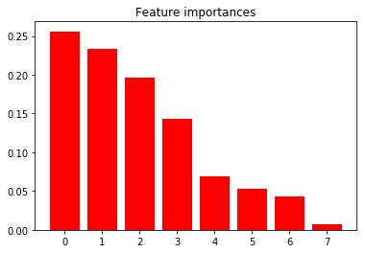
8. feature 1 (0.006849)

