

Aleksi Olkkonen
Drone flight controller

VAASAN AMMATTIKORKEAKOULU
Tietotekniikka
2018

TIIVISTELMÄ
Tekijä Aleksi Olkkonen
Opinnäytetyön nimi Drone flight controller
Vuosi 2018
Kieli Englanti
Sivumäärä x
Ohjaaja Jani Ahvonen

Opinnäytetyön tarkoituksena oli suunnitella, rakentaa ja ohjelmoida nelikopteri. Nelikopteri rakennettiin valmiista komponenteista ja mikrokontrollerille, antureille ja muille laitteille suunniteltiin ja rakennettiin piirilevy. Ohjain rakennettiin käyttäen potentiometrejä, mikrokonterolleria Työhön kuuluu ohjaimen ja nelikopterin välinen kommunikaatio, nelikopterin asennon laskeminen käyttäen kiihtyvyysanturia, gyroskooppia ja magnetometriä

Avainsanat Nelikopteri, sulautetut järjestelmät, säätötekniikka, LoRa

VAASAN AMMATTIKORKEAKOULU
UNIVERSITY OF APPLIED SCIENCES
Bachelor of engineering (IT)

ABSTRACT
Tekijä Aleksi Olkkonen
Opinnäytetyön nimi Drone flight controller
Year 2018
Language English
Pages x
Ohjaaja Jani Ahvonen

Scope of this thesis is to design, build and program a drone. Building a drone requires knowledge of drone's physical requirements and choosing compatible components such as battery, electronic speed controllers and motors. A circuit board is designed to connect microcontrollers, sensors and other devices together and provide supply voltage for them. A custom joystick is b

Flight controller is a program that reads user input and sensor measurements to calculate current orientation and target orientation.that uses sensor measurements to estimate drone's orientation and controls motor speed based on PID controller output. Joystick communicates to the drone using LoRa technology and part of the thesis is to find out if it is suitable technology for this use case.

Keywords Quadcopter, embedded systems, control theory, LoRa
Table of contents
Tiivistelmä
ABSTRACT
Table of contents
1Introduction 8
2Terms and abbrevations 9
3drone Physical properties 10
3.1Component list 10
3.1.1Motors 10
3.1.2Electric speed controllers 11
3.1.3Propellers 11
3.1.4Battery 11
3.1.5Microcontroller 11
3.1.6Gyroscope/Accelerometer 11
3.2Choosing proper components for a drone 11
3.3Mass / thrust ratio 11
3.4Usage temperature 11
3.5hyötysuhde 11
4Drone flying and Finnish law 13
5Flying the drone 14
5.1Flight modes 14
5.2Drone maneuvers 14
5.2.1Throttle 15
5.2.2Roll 15
5.2.3Pitch 15
5.2.4Yaw 15
6flight controller 16
6.1Flight controller Overview 16
6.2Flight controller wiring 17
6.3Software Architecture 18
6.3.1Flight controller 18
6.3.2LoRa joystick 18
6.3.3Communication 18
6.3.4Joystick 18
6.3.5IMU 18
6.3.6Motor controller 19
6.4Flight controller loop performance 19
6.5Interrupt services 19
6.6Calculating drone orientation 20
6.6.1Complementary filter 20
6.6.2PID-controller 20
6.6.3PID-controller tuning 21
6.6.4Motor RPM calculation 21
6.7Flight inactive 22
6.8Flight Safety 22
7Controlling devices with microcontroller 23
7.1Serial peripheral interface 23
7.2Pulse width modulation 23
8Joystick 24
8.1Component list 24
8.2joystick wiring 24
8.3Joystick functionality 24
8.4Joystick commands 25
9Communication 26
9.1Lora protocol 26
9.2Joystick and drone communication 26
9.3Packet validity and security 26
9.4Lora protocol in drone communication 26

LIITTEET

KUVIO- JA TAULUKKOLUETTELO

LIITELUETTELO
LIITE 1. Opinnäytetyöpassi
LIITE 2. Opinnäytetyön arviointikriteerit
LIITE 3. Liiteaineistot

Terms and abbrevations
BEC – Battery Elimination Circuit
ESC – Electronic Speed Controller
IMU – Inertial Measurement Unit
LoRa – Long Range wireless communication technology
PWM – Pulse Width Modulation
SPI - Serial Peripheral Interface
(C)CW – (Counter) Clock Wise
KV – rpm/V – roundes per minute per volt

Flying the drone

Flight modes

Drones usually support two flight modes: Acro and self-level mode. In this thesis only self-level mode is implemented, which is easier to fly, but harder to implement.

A drone can rotate on X, Y and Z axes. Rotation around X-axis is called pitch, rotation around Y-axis is called roll and rotation around Z-axis is called yaw.

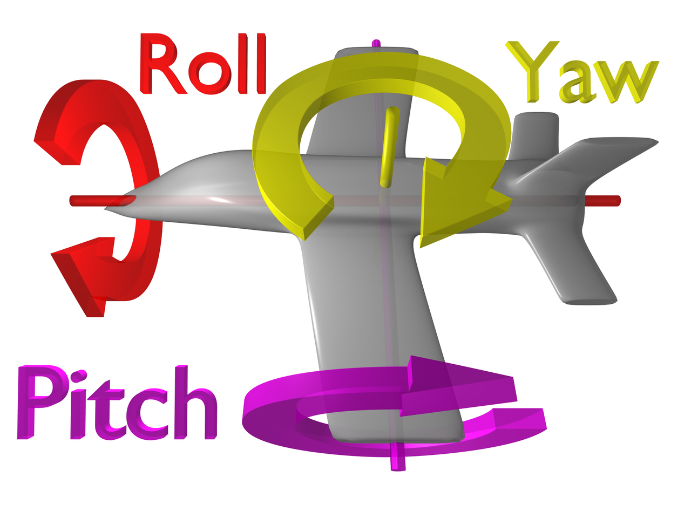
In acro mode pitch, roll and yaw control angular velocity of the drone. Angular velocity is measured with gyroscope in degrees per second on each axis. User input will increase or decrease drone's angular velocity and the person flying the drone needs to be quite good at controlling the drone, or it can come crashing down.

In self-level mode user input controls drone's orientation directly. If the joystick is in middle, the flight controller will attempt to bring drone into neutral orientation. Turning joystick to some direction will change drone's target orientation on that axis.

Drone maneuvers

A quadcopter has four different maneuvers that are achieved by spinning motors at different speeds.

Throttle
Throttle controls the altitude of the quadcopter by giving each motor equal amount of speed. This maneuver lifts the drone in the air. To increase and decrease throttle move the left joystick up and down.

Roll
Roll is rotation around Y-axis. Motors on left and right side are given different speed. User controls roll by moving right stick left and right.

Pitch
Pitch is rotation around X-axis. Motors in front and back are given different speed. User controls pitch by moving right stick up and down.

Yaw
Yaw is rotation around Z-axis. Counter clockwise and clockwise motors are given different speed. User controls yaw by moving left stick left and right.

drone's Physical properties

Component list

Below is a list of most important hardware components used in this project and their price. The total price of all components is 338,07 €. Most of the purchases were supported by VAMK, University of Applied Sciences.

Part | Description | Price (€)
Motors | 2x CCW and 2x CW EMAX MT2204 | 68
Electronic speed controllers | 4x Emax 20A ESC with BEC | 44
Propellers | 4x 6"4 propellers | 4,4
Battery | 2x Gens ace 2200 mAh 3 cell, 11.1v, 25C LiPo battery | 59,8
Charger | GT Power B3 2-3s LiPo charger | 14
Microcontroller | 2x Adafruit feather 32u4 RFM95 | 57,32
Sensors | PmodNAV 9-axis IMU | 27,13
Frame | Spedix S250Q | 26,13
Circuit board | Custom made circuit board for PmodNav, microcontroller and connections | 12,3
Power distribution board | 4 Axis Electric Connection Plate Quad Power Distribution Board | 5,7
PWM module | Adafruit 8-channel servo PWM module | 11,2
Joystick battery | ValueLine power bank 2200 mAh | 8,09
 |  | 338,07

Motors
A quadcopter needs two clockwise motors and two counter clockwise motors. Having motors that spin different directions and are positioned properly will eliminate torque in one direction which would cause the drone to yaw to opposite direction.

Brushed and brushless DC motors are two types of motors used in quadcopters. Brushless motors are more common nowadays because they are smaller, offer more power, higher efficieny and less mechanical wear. However they are more expensive and require an electronic speed controller.

Illustration 1: http://www.thinkrc.com/faq/brushless-motors.php
Electronic speed controller spins the motor by rapidly switching current input for each of the coils. This creates a rotating magnetic field around the coil and spins the magnet. Magnet is attached to the same shaft that a propeller is attached to and causes it to spin.

Motors with lower Kv rating produce higher torque and are able to spin a bigger propellers. Racing size drones use small propellers, motors with higher Kv rating and therefore they maneuver faster but can lift less mass. Kv is equivalent to rpm/V, that is rounds per minute per voltage when there is no load attached to the motor. The more input voltage motor is supplied the faster it spins. Emax MT2204 motors are used in this project. Their Kv rating is 2300. Drawing full voltage output from a 11.1 V battery results into 25 530 rpm with no load attached.

Electronic speed controllers
Electronic speed controllers control current flow from the battery to the motors. ESC employs a firmware that is responsible of translating PWM input signal into pulses of direct current for the three coils of a brushless motor. The coils create a rotating magnetic field that spins the rotor. Most ESC firmwares can be configured with parameters such as brake type, motor timing mode, motor control frequency and low voltage protection. These will affect flight properties of the drone.

ESC's maximum current rating must be equal or higher than maximum current draw for the motor. Emax BLHeli 20 A ESC has high enough current rating for Emax MT2204 motors that require 11.5 A at maximum thrust. It also has a built in battery elimination circuit that can be used to get a supply voltage for the microcontroller and other devices in the drone. Emax BLHeli ESC provides 5 V / 2 A supply voltage.

Battery
Emax MT2204 motor requires 11.5 A current at maximum thrust. Spinning all four motors at maximum thrust requires 46 A current output from the battery. Gens Ace 3S LiPo battery is used in this project. It has 3 cells, each 3.7 V, that results into total of 11.1 V. Its 2200 mAh capacity provides roughly 5-12 min flight time.

LiPo batteries are used because they have high discharge rate and relatively compact in size. Battery's discharge rate, C, describes how fast it can discharge and how much discharge current it can output. If battery's capacity is 2200 mAh and discharge rate is 1 C, the battery will deliver its capacity in 1 hour outputting 2,2 A. Therefore battery used in this project has discharge rate of 25, so it can output atleast 46 A required by the motors. 2200 mAh capacity with discharge rate of 25 can output 55 A and can discharge in 2,4 minutes. However most of the time the motors don't draw maximum current and estimated flight time is few minutes longer.

Propellers
MT2204 motor datasheet defines thre

that the full thrust for 6 inch, 4 pitch propellers is 440 g. Full thrust for all of the 4 motors is 1760 g. As a rule of thumb maximum weight of the quadcopter should be half of the lifting capacity, but lower weight can give better flight properties. The drone will respond to controls faster.

Propellers that have 2 wings provide better hyötysuhde than propellers that have 3 wings, but the 3 wing propellers provide quicker maneuvers. The drone in thesis uses 2 wing propellers.

Microcontroller
Feather...

Gyroscope/Accelerometer
PmodNav sensor 3-axis accelerometer and gyroscope, magnetometer, temperature meter and air pressure.

Choosing proper components for a drone
Mass / thrust ratio
How many battery cells the ESC and motor requires
how much total input current is for the motors
how much total output current the battery has
how much output current a single ESC has
propellers size accoring to the motors, frame size according to the propellers

Mass / thrust ratio
Each motor provides 440 g thrust, resulting into 1760 g total. A rule of thumb would be that the sum of the thrust of motors is at least twice as much as the mass of the drone. Meaning that the maximum mass of the drone is 880 g. Lower mass provides faster maneuvaribility and higher hyötysuhde and can be as low as 1/6 of the thrust. If the drone does not weight enough maneuvaribility decreases.

The drone in thesis weights around 650 g. It is well under the maximum, but does not provide the fastest maneuvaribility, but rather slow and smooth.

Usage temperature
List of the most critical components and their minimum usage temparature.

flight controller
- Libraries used
All libraries are open source and some of them have been modified to satisfy the needs of the drone.
- Arduino PID-controller
- RadioHead for LoRa communication
- Arduino basic libraries such as Servo library

Flight controller Overview
Flight controller is responsible for calculating current drone orientation using accelerometer, gyrometer and magnetometer, receive target orientation from the user and calculate control orientation using PID controller. Control orientation will be used to calculate speed for each motor. Flight controller can support different flight modes such as acro and self-level modes. Self-level mode is implented in the thesis. It is harder to implement, but easier to fly. Self-level mode allows multiple future improvements, such as using GPS signal to locate the drone and fly to a given location. It is also better option due to limitations of LoRa communication.

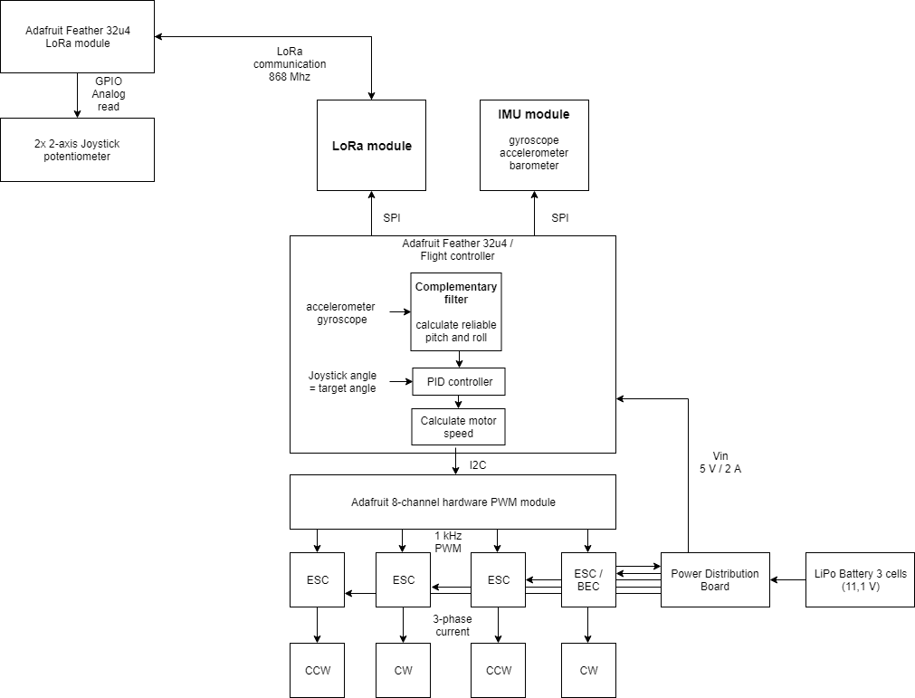

Flight controller wiring
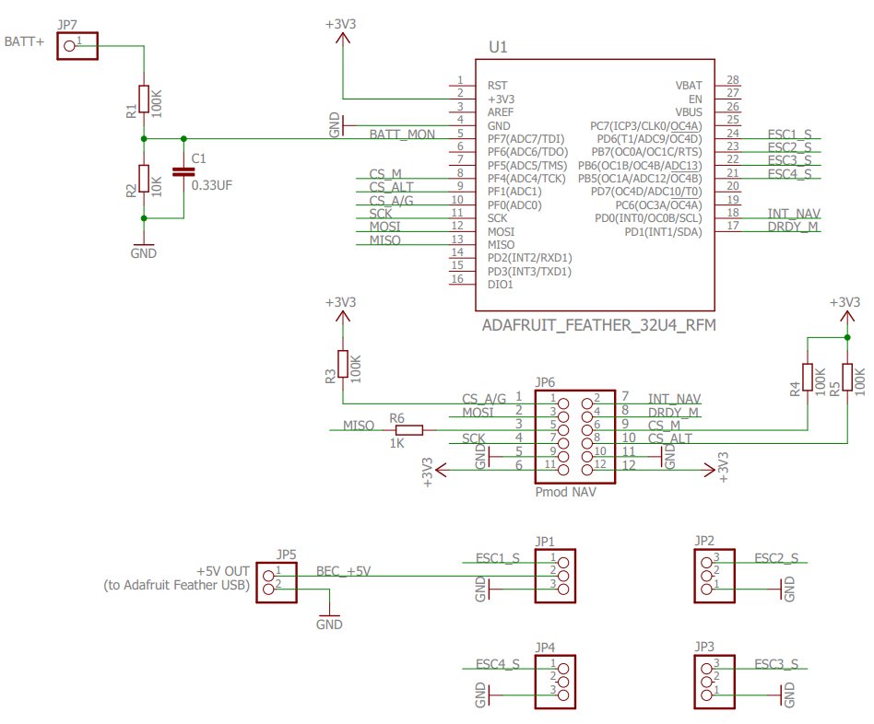
Microcontroller, sensors and hardware module are connected together with custom made circuit board. Supply voltage comes from electronic speed controller's battery elimination circuit to JP1. JP1-4 are connected to ESC's PWM signal inputs.

Microcontroller communicates with IMU using SPI. This requires wiring MOSI, MISO, SCK and chip select pins to microcontroller. PmodNav has 3 sensors: accelerometer, gyroscope and magnetometer and each of them needs a chip select signal. Other connected pins are for receiving interrupts that signal data ready events. Microcontroller and PmodNav are connected to same ground and supply voltage. There are resistors connected to signals coming from microcontroller to PmodNav, because its logic level is 3.3 V and for microcontroller it is 5 V.

JP7 can be used to read battery voltage level, but it is not in use because software has not been implented for this feature. It has voltage division to lower the incoming 11.1 V to match microcontroller's 5 v logic level.

Software Architecture

Flight controller and LoRa joystick are two separate projects that both use communication and joystick components. Flight controller also uses IMU and motor controller components to perform all the required tasks.

Flight controller
Flight controller is the main component for the drone implementation. It contains main function, so called flight controller loop, that will execute flight controller operations the whole run time. Each loop fresh sensor measurements are read, communication component is checked if there are any received packets and the packet is then parsed into joystick state. Joystick state and sensor readings are given to motor controller as input.

Flight controller loops needs to be as fast as possible to provide accurate approximations of the orientation, provide a steady PWM signal for the motors and read joystick input to provide a smooth and fast control of the drone.
ATMega32u4 has a 8 Mhz clock, configurable by fuses as 16 Mhz, by default uses clock divider 8 and runs on 1 Mhz system clock. This is quite low value, but for the time has provided control good enough. Clock divider can be changed to 1, resulting into 8 Mhz system clock which would allow 8 times faster performance for the flight controller. However this would require some study what libraries the change would affect. Arduino millis function values would be different, maybe Servo library that uses timers, etc...

LoRa joystick
LoRa joystick reads 3-axis potentiometer readings and uses joystick class to convert them into throttle, pitch, roll, yaw and press button commands 1 and 2. A LoRa packet is constructed from this data and it is sent using the communication component. Receiver will parse the payload into joystick state.

Communication
Flight controller and joystick use communication class to perform LoRa communication. Communication class handles receiving and sending packets as well as validating them.

Joystick
Joystick class represents joystick state and contains functions for

IMU
IMU class handles configuring sensors and reading sensor measurements from PmodNav using SPI (Serial Peripheral Interface).

Motor controller
Motor controller receives sensor readings and user commands as input. It uses complementary filter to calculate accurate estimation of drone's orientation. Complementary filter output and user input are passed to PID controller as current orientation and target orientation. PID controller calculates control orientation that is used to calculate speed for all four motors.

Motors are controlled with pulse width modulation (PWM), which is software generated using timer interrupt. ATMega32u4 provides hardware PWM, but it is not capable of generating signal waveform required by the electric speed controllers (ESC).

Flight controller loop performance

ATMega32u4 default system clock (DIV8 used) is 1 Mhz. DIV1 might need to be used to provide higher clock frequency.

Interrupt services

The drone has 2 interrupt services. One for receiving LoRa transmit/receive done and another for software PWM timer (more in PWM). IMU provides also different interrupts, but they are not used because flight controller loops runs a little slower than the sensor provides a new value, thus getting a fresh value on every read.
A specific interrupt order is important in the flight controller, because software PWM is used. On every timer tick motor PWM signal is updated and this needs to be consistent and fast to provide a proper signal so that motor rpm is smooth. This makes the timer highest priority and it needs to be able to interrupt lower priority interrupts, that is handling a received LoRa packet. LoRa packet handling is safe to interrupt. It is doing multiple SPI writes and reads and those are handled by hardware one byte at a time.
When sensor is being read via SPI, LoRa receive packet interrupt needs to be disabled, because both of them use SPI. Arduino beginTransaction function does not disable external interrupts, which LoRa receive is, and disabling the interrupt needs to be done by writing directly to processor's register EIMSK (External Interrupt Service Mask). When it was not disabled, the LoRa interrupt would start a new SPI transaction and the SPI hangs because sensor SPI communication was ongoing. SPI function will not return and only PWM timer interrupt is being handled providing the latest given PWM signal to the motors. At worst case this would be a high motor rpm and the drone would fly uncontrollably away.

Calculating drone orientation

Complementary filter
Calculating current orientation of the drone is important when implementing assisted flight mode. This is done by using accelerometer, gyroscope and magnetometer. Accelerometer measures linear acceleration on 3 axes. Gravity is is always visible on accelerometer. Using trigonometry on vectors results into orientation of the drone, but accelerometer is sensitive for noise. The system is under a lot of resonation by motors, wind, etc.
Gyroscope otherwise measures angular velocity on 3 axes, therefore drone must be in angular motion to produce values on gyroscope. Gravity will not be visible on gyroscope and noise won't be visible. However gyroscope value drifts. To get the current orientation of the drone is done by integrating angular velocity measured by the gyroscope. Due to inaccuracies such as floating point arithmetic, ODR of the sensor and speed of the flight controller loop will limit how often and accurately the value is read, as well as the inaccuracies of the gyroscope itself the value will start to drift. Meaning that when drone is rotated around and brought back to the exact same orientation as in the beginning, the gyroscope value will be offset a little bit. The longer the time, the greater the drift value. Accelerometer does not have this problem, but as said, it is vaikutuksenalainen for a noisy system.
To use good capabilities of the both sensors, complementary filter is used to combine those values to as accurate approximation of the orientation of the drone with a good performance. Complementary filter integrates gyroscope value and uses X amount of it's value, in the thesis 95%, and if the accelerometer reading is in a reasonable magnitude, we use that value in a trigonometric function to calculate orientation of the drone and use 5% of that value. This compensates gyroscope drift and accelerometer noisiness.

PID-controller
In addition to calculating orientation of the drone, it is required to control the speed of the motors according to calculated orientation and the target orientation given by user. These parameters are passed into a PID controller, where three configured terms are used to output a control orientation for the drone. These terms are porpotional (P), integral (I) and derivative (D).
Porpotional is the subtraction of current orientation and target orientation. This simply provides the error margin between those values. Using only this term would cause very oscillating system, where the drone would bounce around the target orientation never reaching it in a smooth manner.
Intergral term would slowly increase when the drone is not in its target orientation. This will fix the drone drifting away in a windy environment. It does not affect the drones orientation a lot unless it has been in a wrong angle for longer time.
Derivative term will dampen the aggressive corrections made by porpotional term. Without dampening, noise left by the complementary filter would affect porpotional term too much. Derivative term will bring too big corrections down.

PID-controller tuning
Tuning should be started with porpotional term. Initially set P value to 0 and increase until the drone can be controlled indoors, but the drone makes steady small oscillation natural to the P term. Then increase the I term until the oscillation gets smoother and the drone does not start to drift. Increase P term until the drift stops and start increasing I again until drift is minimal. Then D term until there is no drift. ????

Motor RPM calculation
PID controller outputs the control pitch, roll and yaw (maybe also throttle?) for the drone. This output will be used in an algorithm to calculate the actual PWM duty cycle for the ESCs.
The algorithm is roughly this for a X model drone:
Clock-wise front motor = targetThrottle - controlPitch - controlRoll - Yaw
Counter clock-wise front motor = targetThrottle - controlPitch + controlRoll + Yaw
Counter clock-wise back motor = targetThrottle + controlPitch + controlRoll + Yaw
Clock-wise back motor = targetThrottle + controlPitch - controlRoll – Yaw

This means that when the drone is maneuvered to fly forwards, the back motors will be given more throttle than the front motors. When maneuvering to left, right front and back motor will have higher RPM than the left motors. To yaw right, right top and left back motors are given more throttle.
Maximum value for motor speed is 255 (because joystick input is in range of 0...255). Giving only full throttle would result to 255 for each motor, considering that the PID controller does not need to stabilize the orientation of the drone. This is given as percentage multiplier to PWM signal (180 * motor speed %). The range provides enough accuracy: (-30...30 angle) -> 60 / 255 = 0,23 degree steps. And 255 steps for the throttle. This comes pretty close to the joystick accuracy also.
The motor control value can go over the limit of 255 when giving close to full throttle and tilting the drone or giving close to zero throttle and tilting the drone. Therefore the value needs to be clamped inside the range of 0...255. Highest over or under limit value is checked, and it is summed or subtracted from all of the motor values providing the same difference between motor duty cycles, but in the given range.
These motor values will be divided by 255, giving the value in percentages. The servo library duty cycle parameter will be multiplied by this (180 * (0...1)) to give proper PWM signal for the motors.

Also a + model drone can be implemented, where the drone will have one motor at front, one at back, and one at each side.
The X model copter has two front motors and two back motors. This is the most used model in commercial flight controllers, but they might have an option to change between these modes. What's the main difference between them??
What should the difference between motor RPMs be???

Flight inactive

Flight actives when throttle is 0. This provides a safe way to start the flight ensuring that throttle can be slowly increased. Flight is inactivated by pressing right joystick for 1 second (and letting throttle go from bottom to center). When flight is inactive drone's PID values can be configured with right joystick. Right press will cycle the term in order porpotional (P), integral (I), derivative (D). Up press will increase the term value by X and down press will decrease the term value by X. Holding joystick in left position for 1 second will set the terms to default values. Giving one of the commands will blink a red led on the drone once the right stick brought back to center position.

Flight Safety
Flight controller provides functionalities to safely start the flight from inactive state and land when the LoRa communication between the drone and joystick fails.
To start the flight user must slide throttle to zero so that the drone does not suddenly start flying when it is powered or has landed. If no LoRa packets have been received for 400 ms, the drone will stabilize itself and give low throttle for the motors. In this mode the drone will start slowly descending to ground. If communication restores, the user gains control of the drone again. After x seconds of no packets received the motors will be turned off and flight will be inactivated. If communication restores, user needs to slide the throttle to zero to activate the flight again.
If the drone code errors, no valid PWM signal will be generated for the ESC and motors will shutdown.
TODO: Every motor update a timestamp is updated and checked in an interrupt service. If the last update was executed over 400 ms ago, the flight will be inactivated and the motors shutdown. This prevents errors where some procedure, like SPI communication, hangs up but the actual code does not error. Without this interrupt service the PWM signal is still generated because timer interrupts are running and the drone will fly uncontrolled.

Controlling devices with microcontroller

Serial peripheral interface
Both peripheral devices, PmodNav sensor and sx1272 LoRa module, are communicated with SPI (Serial Peripheral Interface). Sensor has 3 chip select lines for accel/gyro, magnetometer and pressure. LoRa module requires 4th chip select line.
Device is active for SPI communication in when chip select is low. Only one device can be communicated at a time.

Pulse width modulation

Pulse Width Modulation (PWM) is a common way to control servo motors and ESCs. Quadcopter ESCs implement custom PWM firmware and there are different signals to command the ESC. BLHeli ESCs used in the thesis can be controlled with two types of PWM signal.

First is the usual servo motor PWM signal at 50...500 Hz frequency where period is 2...20 ms. Usually control signal would be from 1 to 2 ms, but in BLHeli ESC it is from 1.2 to 1.8 ms. For this reason frequency cannot be higher that 500 Hz, because then period would be shorter than 2 ms. When throttle is 0 %, signal is set high for 1.2 ms and for 100 % throttle signal is set to 1.8 ms. This provides safety in situations where signal would be erroneous due to problems in the program or hardware. A digital port in error state would not be able to generate this specific control signal, but rather being low or high all the time.

BLHeli can also be used with 1 kHz or higher frequency. In this case duty cycle directly represents motor speed. Control signal is set high from 0 to 100 % of the period. For example setting duty cycle to 25 % of the period, the motor speed would be 25 %. If the frequency is 1 kHz, it is possible to change motor speed every millisecond. That is 50 times faster than with 50 Hz signal. However this is prone to error states where digital port would be high all the time and command motor speed to 100 %. To eliminate this problem custom hardware needs to be implemented.

1 kHz PWM signal was chosen for the thesis because of speed and more importantly that hardware PWM modules used were not able to generate 50 Hz signal with 1 to 2 ms control signal as well. This would have been possible with software timer interrupts but it requires more performance from the microcontroller and more complex code to configure interrupt priority.

This needs to be done in software using timer interrupts. These are executed every x us, variating because... Handling these interrupts is the priority task of the flight controller, so that motors are provided with accurate PWM signal. During development there were other interrupts blocking the PWM timer interrupt and it resulted into erroneous signal, motors sometimes accelerating and deaccelerating in fast manner, making a whizzing sound and unsteady control.

Joystick

Component list
2x 3 axis joysticks from an old PS1 controller
Reikälevy and copper wires
Arduino Feather 32u4
Resistors
An old RC car controller case modified

joystick wiring
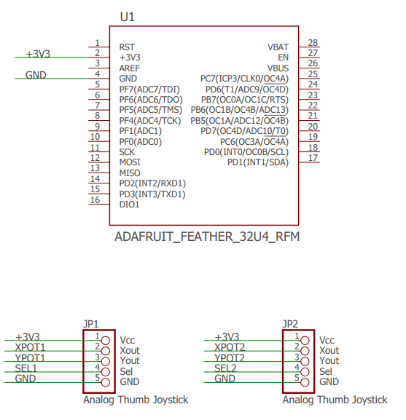

Joystick functionality
Each loop reads joystick values using ADC for X and Y axis of the both joysticks and digital comparison for Z axes. These values are converted from int16 to byte, because the range is enough, it uses less bytes in the payload. Center position integer values is 125, full throttle 255 and no throttle 0. This loop is lightweight and only the LoRa communication sets limit for the packet send ratio, which is roughly 10 (try this with packets per 10 s print, so that Serial does not slow down) packets per second.
These bytes are sent as payload to the drone using LoRa. The LoRa communication is explained in section ... and packet integrity and security in ...
Left joystick X axis represents yaw and Y axis throttle. Right joystick X axis represents roll and Y axis pitch. Explain the maneuvers here or on some other section.
Z axes are used for commands such as inactivate flight mode.

Joystick commands
Joystick provides several commands to set PID-controller values, user input dampening, setting the drone in flight and inactive mode, and resetting all the settings to default values. The drone indicates which command is selected and how it is changed by blinking Feather's default led.

Command | Function
Turn right joystick right | Rotate between P, I and D terms and user input dampening. Led blinks:  1: P  2. I  3: D  4: dampening
Turn right joystick up | Increase selected variable. Led blinks twice.
Turn right joystick down | Decrease selected variable. Led blinks once.
Hold right joystick left for 1 second | Reset all settings to default. Led blinks for 2 seconds.
Press right joystick and hold throttle (left joystick) down | Flight mode inactives
Hold left joystick down | Flight mode actives.

Communication

Lora protocol
LoRa is Long-Range Low Power radio communication protocol that is made mostly for industrial use for IoT (Internet of Things) implementations. It provides long range communication with low power (Semtech sx1272 around 120 mA during sending). It was chosen for this thesis, because we had a course at VAMK where we used LoRa and because it has simple libraries and payload to send all the required data to the drone, and if needed also from drone back to the joystick. For example sending battery state to the joystick. Also the Adafruit Feather devices have preinstalled LoRa module that is easy to configure for use.
It uses 868 Mhz which is allowed hobbyist frequency in Europe.

Joystick and drone communication
RadioHead library is used to communicate with the LoRa module. It handles initialization of the registers, switching between LoRa modes, receiving interrupts when a packet is received and parsing the LoRa packet and providing the payload.
Adafruit Feather 32u4 has interrupt pin 6 connected to the LoRa module interrupt service. It is used for transmit and receive done interrupts. Every flight controller loop a flag status is checked. When RadioHead has received and parsed a LoRa packet, it sets the flag to true and the payload can be accessed by using library function recv.
The payload will be copied to a buffer given as a parameter to the function. In this case, the payload buffer needs to be 7 bytes.

Packet validity and security
Since the drone might receive any LoRa packet, not only the ones sent from joystick, the packet needs to be validated to make sure that it comes from the joystick, contains proper data and is not corrupted during transmission. Packets are sent continuously as fast as possible, drone receiving at least 10 packets per second, and at the same time it is calculating its orientation, controlling PWM signal interrupts and other routines. For this reason only lightweight algorithms are used. Packet contains 6 bytes of joystick data (pitch, roll, yaw, throttle and 2 buttons) and the last byte is reserved for CRC (cross cyclic redundancy). CRC is calculated from the 6 data bytes.This gives some data integrity if the payload is corrupted (LoRa probably does this on its own??) and also makes identification that the packet is not any random packet sent by another LoRa device. These 7 bytes are XORed using a 3 byte XOR key to add some more data integrity and validation and making the intepretion of the packet slighty harder for receiver that it does not belong to.
LoRa packets are often encrypted with SHA256 or other strong encryption mechanisms, but to provide fast packet handling they are minimalistic in this project.

Lora protocol in drone communication
    - Slower than the usual communication method used in drones (explain what it is)
    - LoRa network can be used to control more self-sustaining drones that use GPS locations as control input. Command multiple drones etc.

50 hz -> eka 1/10 ohjaimesta toimii
500 Hz -> 1/2 ohjaimesta toimii
1000Hz -> koko tatti toimii

50hz 1-2ms signaali on 1/10 ohjaimesta jne.

eli ESC ottaa aina1-2ms signaalia vastaan, eli Hz saa olla niin korkea että jakso on yli 2ms
silloin myös resoluutio 1-2ms signaalin säädölle nousee
ESC säätää korkealla signaalilla moottoreita myös tarkemmin, tiheämmin eli moottorin rpm nousu ja laskuaika minimoituu
kun on/off vaihtelee tiheämmin, seuraa moottorin nopeus melko tarkasti asetettua nopeutta

joystick antaa 0.05 … 0.98
pyörii siis aina

1/1000 → 1 ms jakso, toimii silti?

The input signal to the BLHeli ESC can be a 0-100% PWM signal at a frequency of 1-8kHz. BLHeli reads this signalling because that is what is available when you connect the ESC to a brushed motor output (like on the mCPX).
Or it can be a 1-2ms pulse repeated at a rate from 50Hz to almost 500Hz. This is the "normal" signal from a receiver or flight controller, and it is somewhat incorrectly called PPM in the BLHeli documentation.
From the microcontroller to the ESC you can use whatever you prefer, 1,2,4,8kHz 0-100% pwm. Or 1-2ms pulses at a rate up to 500Hz. It does not really matter very much.

Kerro hardware pwm modulista

Drone flying and Finnish law
Drone is an unmanned flying vehicle that is meant for hobby or sport usage. Flying a drone does not have any age limit. It is against law to fly a drone in locations where it will disturb manned flying vehicles or otherwise cause any dangerous situation. A drone cannot be flied above a crowd. Flying a drone on your own property can still be dangerous for other people, it might disturb them or violate their privacy. In this case anyone can contanct Trafi to reclamate.
A drone can be flied indoors if the owner of the building accepts it.
A drone needs to evade all manned flying vehicles.
A drone does not need to be registered.
An autopilot can be used, if you can at any time take the control of the drone and evade people and other flying vehicles.
A drone can be flied in FPV (first person view) if there is another person that can observe the airspace and has constant line of sight to the drone. A drone cannot be flied without a constant line of sight to the drone, and using FPV equipments prevent that. A drone cannot be flied at over 150 meter altitude. Weather and lightness needs to be good enought to spot other flying vehicles and evade them with using bare eye contact, no equipment to help.
Lentäjän vastuu dronella: vastuu määräytyy vahingonkorvauslain (412/1974) perusteella.
Lakipykälä 864/2014,159 §
source:
https://www.trafi.fi/tietopalvelut/usein_kysyttya/ilmailu_-_miehittamattomat_ilma-alukset_ja_lennokit
https://www.finlex.fi/fi/laki/alkup/2014/20140864

