Introduction
....

1.1 Terms and abbrevations
BEC – Battery Elimination Circuit
ESC – Electronic Speed Controller
IMU – Inertial Measurement Unit
LoRa – Long Range wireless communication technology
PWM – Pulse Width Modulation
SPI - Serial Peripheral Interface
(C)CW – (Counter) Clock Wise
KV – rpm/V – roundes per minute per volt

2x CCW and 2x CW EMAX MT2204 motors are used in the copter. Their KV (rpm/V) value is 2300, using 11.1 V battery the rpm can be at maximum 25 000 rpm. Motors require 11.5 A each at max thrust (46 A total). 3 cell, 11.1 V, 2300 mAh LiPo battery is used. It has 20 C charge rate meaning it can output 46 A.

ESC's have a BEC which the Arduino will use as power source. BEC outputs 5 V and 2 A.

MT2204 motor datasheet defines that the full thrust for 6 inch, 4 pitch propellers is 440 g. Full thrust for all of the 4 motors is 1760 g. Quadcopter should weight 880 g at maximum, but lower weight gives better flight properties.

Drone physical properties
  - component list

Emax 20A ESC with BEC (battery elimination circuit) to provide 5 V / 2 A power supply for the Adafruit Feather 32u4. Using ATMega32u4 micro processor, 8 Mhz / 16 Mhz crystal, X program memory and Y RAM.
6"4 propellers being 6 inches long and 4 kallistuskulmaa, explain better...
Tipple LiON 2-3 cell 2300 mAh battery
Emax MT2204 cooling series 2300 kv motor
kv being rpm/voltage.
PmodNav sensor: 3 axis accelerometer and gyroscope, magnetometer, temperature meter and air pressure

  - mass / thrust ratio
Each motor provides 440 g thrust, resulting into 1760 g total. A rule of thumb would be that the sum of the thrust of motors is at least twice as much as the mass of the drone. Meaning that the maximum mass of the drone is 880 g. Lower mass provides faster maneuvaribility and higher hyötysuhde and can be as low as 1/6 of the thrust.
The drone in thesis weights around 650 g. It is well under the maximum, but does not provide the fastest maneuvaribility, but rather slow and smooth.

  - usage temperature
List of the most critical components and their minimum usage temparature, if this is sensible point at all. Probably resulting battery being worst?

  - things to know when choosing components (DIY lora arduino drone)
Mass / thrust ratio
How many battery cells the ESC and motor requires
how much total input current is for the motors
how much total output current the battery has
how much output current a single ESC has
propellers size accoring to the motors, frame size according to the propellers

  - battery properties
2200 mAh providing 8-15 min flight time, mass of 150 g, 20 C discharge rate (explain the C and requirements for all 4 motors), 11.1 V and 3 cells (requirement by motors), maximum output of 40 A.

  - hyötysuhde (propellit / moottorit / akku (cell lkm)
Propellers that have 2 wings provide better hyötysuhde than propellers that have 3 wings, but the 3 wing propellers provide quicker maneuvers. The drone in thesis uses 2 wing propellers.

  - Drone flying and Finnish law
Drone is an unmanned flying vehicle that is meant for hobby or sport usage. Flying a drone does not have any age limit. It is against law to fly a drone in locations where it will disturb manned flying vehicles or otherwise cause any dangerous situation. A drone cannot be flied above a crowd. Flying a drone on your own property can still be dangerous for other people, it might disturb them or violate their privacy. In this case anyone can contanct Trafi to reclamate.
A drone can be flied indoors if the owner of the building accepts it.
A drone needs to evade all manned flying vehicles.
A drone does not need to be registered.
An autopilot can be used, if you can at any time take the control of the drone and evade people and other flying vehicles.
A drone can be flied in FPV (first person view) if there is another person that can observe the airspace and has constant line of sight to the drone. A drone cannot be flied without a constant line of sight to the drone, and using FPV equipments prevent that. A drone cannot be flied at over 150 meter altitude. Weather and lightness needs to be good enought to spot other flying vehicles and evade them with using bare eye contact, no equipment to help.

Lentäjän vastuu dronella: vastuu määräytyy vahingonkorvauslain (412/1974) perusteella.

Lakipykälä 864/2014,159 §
source: https://www.trafi.fi/tietopalvelut/usein_kysyttya/ilmailu_-_miehittamattomat_ilma-alukset_ja_lennokit
https://www.finlex.fi/fi/laki/alkup/2014/20140864

Flight controller

- Libraries used
All libraries are open source and some of them have been modified to satisfy the needs of the drone.
- Arduino PID-controller
- RadioHead for LoRa communication
- Arduino basic libraries such as Servo library

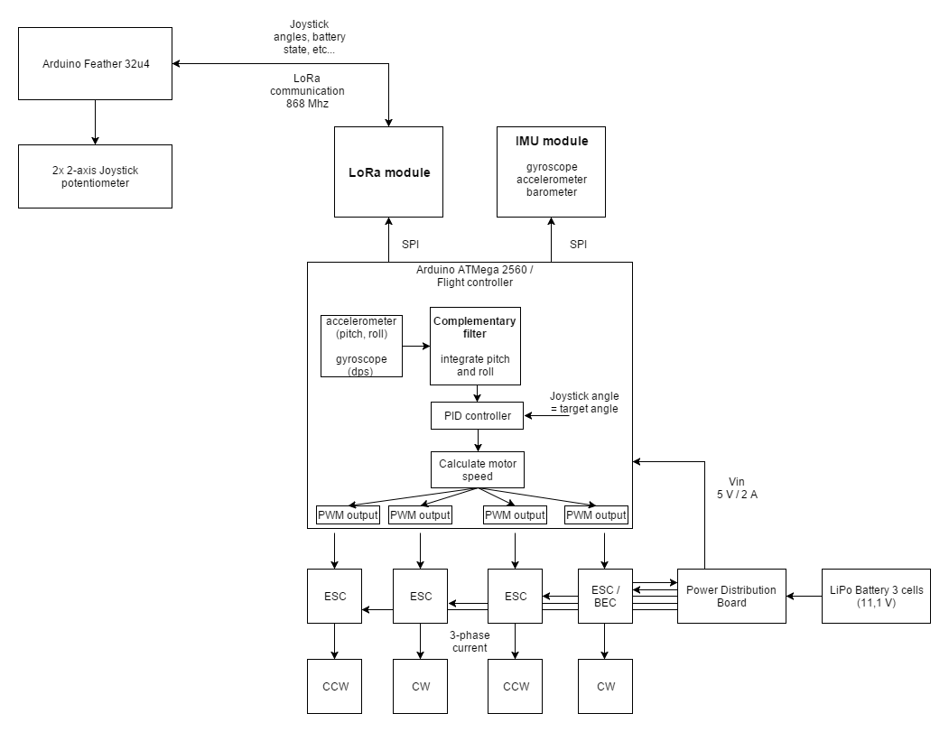
Picture: Add magnetometer for yaw calculation.

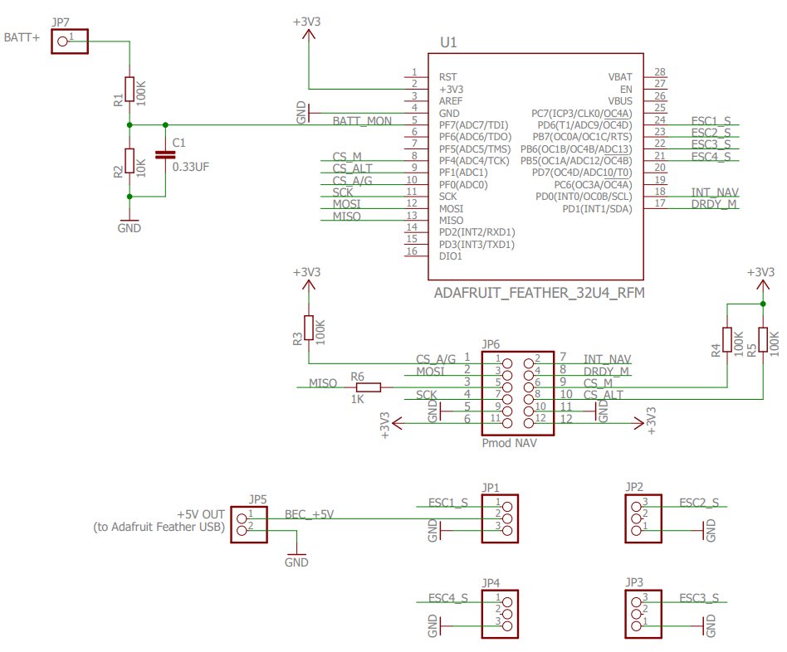

  - Flight controller functionality
Flight controller is responsible for calculating current drone orientation using accelerometer, gyrometer and magnetometer, receive target orientation from the user and calculate control orientation using PID controller and then using control orientation, a proper rpm for each motor is calculated. It also can support different fly modes such as aggro and assisted. Assisted mode is implemented in the thesis. It is harder to implement, but easier to fly. Assisted mode allows multiple future improvements, such as using GPS signal to locate the drone and fly to a given location.

  - Interrupt Services
The drone has 2 interrupt services. One for receiving LoRa transmit/receive done and another for software PWM timer (more in PWM). IMU provides also different interrupts, but they are not used because flight controller loops runs a little slower than the sensor provides a new value, thus getting a fresh value on every read.
A specific interrupt order is important in the flight controller, because software PWM is used. On every timer tick motor PWM signal is updated and this needs to be consistent and fast to provide a proper signal so that motor rpm is smooth. This makes the timer highest priority and it needs to be able to interrupt lower priority interrupts, that is handling a received LoRa packet. LoRa packet handling is safe to interrupt. It is doing multiple SPI writes and reads and those are handled by hardware one byte at a time.
When sensor is being read via SPI, LoRa receive packet interrupt needs to be disabled, because both of them use SPI. Arduino beginTransaction function does not disable external interrupts, which LoRa receive is, and disabling the interrupt needs to be done by writing directly to processor's register EIMSK (External Interrupt Service Mask). When it was not disabled, the LoRa interrupt would start a new SPI transaction and the SPI hangs because sensor SPI communication was ongoing. SPI function will not return and only PWM timer interrupt is being handled providing the latest given PWM signal to the motors. At worst case this would be a high motor rpm and the drone would fly uncontrollably away.

  - Calculating drone orientation, complementary filter
Calculating current orientation of the drone is important when implementing assisted flight mode. This is done by using accelerometer, gyroscope and magnetometer. Accelerometer measures linear acceleration on 3 axes. Gravity is is always visible on accelerometer. Using trigonometry on vectors results into orientation of the drone, but accelerometer is sensitive for noise. The system is under a lot of resonation by motors, wind, etc.
Gyroscope otherwise measures angular velocity on 3 axes, therefore drone must be in angular motion to produce values on gyroscope. Gravity will not be visible on gyroscope and noise won't be visible. However gyroscope value drifts. To get the current orientation of the drone is done by integrating angular velocity measured by the gyroscope. Due to inaccuracies such as floating point arithmetic, ODR of the sensor and speed of the flight controller loop will limit how often and accurately the value is read, as well as the inaccuracies of the gyroscope itself the value will start to drift. Meaning that when drone is rotated around and brought back to the exact same orientation as in the beginning, the gyroscope value will be offset a little bit. The longer the time, the greater the drift value. Accelerometer does not have this problem, but as said, it is vaikutuksenalainen for a noisy system.
To use good capabilities of the both sensors, complementary filter is used to combine those values to as accurate approximation of the orientation of the drone with a good performance. Complementary filter integrates gyroscope value and uses X amount of it's value, in the thesis 95%, and if the accelerometer reading is in a reasonable magnitude, we use that value in a trigonometric function to calculate orientation of the drone and use 5% of that value. This compensates gyroscope drift and accelerometer noisyness.

- Flight modes
Drones usually support two flight modes: Acro and self-level mode. In this thesis only self-level mode is implemented, which is easier to fly, but harder to implement.

Acro mode uses only gyroscope and it does not calculate the current orientation of the drone, but rather the angular velocity of the drone. Using right joystick to change pitch or roll will increase or decrease the drone's angular velocity and the person flying the drone needs to be quite good at controlling the drone, or it will come crashing down. In assisted mode the right joystick will give the target pitch and roll in degrees, limited to range of -30...30 degrees. When the right joystick is in center position, the roll and pitch will be both zero and the drone will be stabilized so that it will hover on the same position on X and Y axes, considering only throttle and yaw as input.

  - PID-controller & motor speed
In addition to calculating orientation of the drone, it is required to control the speed of the motors according to calculated orientation and the target orientation given by user. These parameters are passed into a PID controller, where three configured terms are used to output a control orientation for the drone. These terms are porpotional (P), integral (I) and derivative (D).
Porpotional is the subtraction of current orientation and target orientation. This simply provides the error margin between those values. Using only this term would cause very oscillating system, where the drone would bounce around the target orientation never reaching it in a smooth manner.
Intergral term would slowly increase when the drone is not in its target orientation. This will fix the drone drifting away in a windy environment. Does not affect the drones orientation a lot unless it has been in a wrong angle for longer time.
Derivative term will dampen the aggressive corrections made by porpotional term. Without dampening, noise left by the complementary filter would affect porpotional term too much. Derivative term will bring too big corrections down.

TUNING
Tuning should be started with porpotional term. Initially set P value to 0 and increase until the drone can be controlled indoors, but the drone makes steady small oscillation natural to the P term. Then increase the I term until the oscillation gets smoother and the drone does not start to drift. Increase P term until the drift stops and start increasing I again until drift is minimal. Then D term until there is no drift. ????

  - Flight controller loop
Flight controller loop calls all required drone operations the whole execution time. This is the main loop. Flight controller reads values from the sensors and provides them for the motor controller. Additionally it polls for LoRa packet flag and reads the target orientation from the joystick. Both of these inputs are provided to the motor controller, which uses complementary filter and PID controller to output a control orientation. From this orientation and joystick throttle input rpm for the motors is calculated. Motors are controlled with pulse width modulation (PWM), which is software generated using timer interrupt. ATMega32u4 provides hardware PWM, but it is not capable of generating signal waveform required by the electric speed controllers (ESC).
Flight controller loops needs to be as fast as possible to provide accurate approximations of the orientation, provide a steady PWM signal for the motors and read joystick input to provide a smooth and fast control of the drone.
ATMega32u4 has a 8 Mhz clock, configurable by fuses as 16 Mhz, by default uses clock divider 8 and runs on 1 Mhz system clock. This is quite low value, but for the time has provided control good enough. Clock divider can be changed to 1, resulting into 8 Mhz system clock which would allow 8 times faster performance for the flight controller. However this would require some study what libraries the change would affect. Arduino millis function values would be different, maybe Servo library that uses timers, etc...

  - Flight inactive
Flight actives when throttle is 0. This provides a safe way to start the flight ensuring that throttle can be slowly increased. Flight is inactivated by pressing right joystick for 1 second (and letting throttle go from bottom to center). When flight is inactive drone's PID values can be configured with right joystick. Right press will cycle the term in order porpotional (P), integral (I), derivative (D). Up press will increase the term value by X and down press will decrease the term value by X. Holding joystick in left position for 1 second will set the terms to default values. Giving one of the commands will blink a red led on the drone once the right stick brought back to center position.

  - Performance
ATMega32u4 default system clock (DIV8 used) is 1 Mhz. DIV1 might need to be used to provide higher clock frequency.

  - Safety
Flight controller provides functionalities to safely start the flight from inactive state and land when the LoRa communication between the drone and joystick fails.
To start the flight user must slide throttle to zero so that the drone does not suddenly start flying when it is powered or has landed. If no LoRa packets have been received for 400 ms, the drone will stabilize itself and give low throttle for the motors. In this mode the drone will start slowly descending to ground. If communication restores, the user gains control of the drone again. After x seconds of no packets received the motors will be turned off and flight will be inactivated. If communication restores, user needs to slide the throttle to zero to activate the flight again.
If the drone code errors, no valid PWM signal will be generated for the ESC and motors will shutdown.
TODO: Every motor update a timestamp is updated and checked in an interrupt service. If the last update was executed over 400 ms ago, the flight will be inactivated and the motors shutdown. This prevents errors where some procedure, like SPI communication, hangs up but the actual code does not error. Without this interrupt service the PWM signal is still generated because timer interrupts are running and the drone will fly uncontrolled.

  - SPI
Both peripheral devices, PmodNav sensor and sx1272 LoRa module, are communicated with SPI (Serial Peripheral Interface). Sensor has 3 chip select lines for accel/gyro, magnetometer and pressure. LoRa module requires 4th chip select line.
Device is active for SPI communication in when chip select is low. Only one device can be communicated at a time.

  - PWM
Pulse Width Modulation (PWM) is a common way to control servo motors and ESCs.
ESC uses usual servo PWM signal, that has 20 ms jakso (T), and 1.2 to 1.8 ms needs to be high. 1.2 ms represents 0% throttle and 1.8 ms represents 100 % throttle. Many servo controllers use 1ms to 2ms signal, but this smaller range is used often in drone ESCs. This needs to be done in software using timer interrupts. These are executed every x us, variating because... Handling these interrupts is the priority task of the flight controller, so that motors are provided with accurate PWM signal. During development there were other interrupts blocking the PWM timer interrupt and it resulted into erroneous signal, motors sometimes accelerating and deaccelerating in fast manner, making a whizzing sound and unsteady control.

  - motor use % calculation
PID controller outputs the control pitch, roll and yaw (maybe also throttle?) for the drone. This output will be used in an algorithm to calculate the actual PWM duty cycle for the ESCs.
The algorithm is roughly this for a X model drone:
Clock-wise front motor = targetThrottle - controlPitch - controlRoll - Yaw
Counter clock-wise front motor = targetThrottle - controlPitch + controlRoll + Yaw
Counter clock-wise back motor = targetThrottle + controlPitch + controlRoll + Yaw
Clock-wise back motor = targetThrottle + controlPitch - controlRoll – Yaw

This means that when the drone is maneuvered to fly forwards, the back motors will be given more throttle than the front motors. When maneuvering to left, right front and back motor will have higher RPM than the left motors. To yaw right, right top and left back motors are given more throttle.
Maximum value for motor speed is 255 (because joystick input is in range of 0...255). Giving only full throttle would result to 255 for each motor, considering that the PID controller does not need to stabilize the orientation of the drone. This is given as percentage multiplier to PWM signal (180 * motor speed %). The range provides enough accuracy: (-30...30 angle) -> 60 / 255 = 0,23 degree steps. And 255 steps for the throttle. This comes pretty close to the joystick accuracy also.
The motor control value can go over the limit of 255 when giving close to full throttle and tilting the drone or giving close to zero throttle and tilting the drone. Therefore the value needs to be clamped inside the range of 0...255. Highest over or under limit value is checked, and it is summed or subtracted from all of the motor values providing the same difference between motor duty cycles, but in the given range.
These motor values will be divided by 255, giving the value in percentages. The servo library duty cycle parameter will be multiplied by this (180 * (0...1)) to give proper PWM signal for the motors.

Also a + model drone can be implemented, where the drone will have one motor at front, one at back, and one at each side.
The X model copter has two front motors and two back motors. This is the most used model in commercial flight controllers, but they might have an option to change between these modes. What's the main difference between them??
What should the difference between motor RPMs be???

  - Drone maneuvers
Drone has 4 different control signals: throttle, yaw, pitch and roll.
Roll – Done by pushing the right stick to the left or right.
Literally rolls the quadcopter, which maneuvers the quadcopter left or right.
Pitch – Done by pushing the right stick forwards or backwards.
Tilts the quadcopter, which maneuvers the quadcopter forwards or backwards.
Yaw – Done by pushing the left stick to the left or to the right.
Rotates the quadcopter left or right. Points the front of the copter different directions and helps with changing directions while flying.
Throttle – To increase, push the left stick forwards. To decrease, pull the left stick backwards.
This adjusts the altitude of the quadcopter.

  - Handle joystick data
RadioHead library is used to communicate with the LoRa module. It handles initialization of the registers, switching between LoRa modes, receiving interrupts when a packet is received and parsing the LoRa packet and providing the payload.
Adafruit Feather 32u4 has interrupt pin 6 connected to the LoRa module interrupt service. It is used for transmit and receive done interrupts. Every flight controller loop a flag status is checked. When RadioHead has received and parsed a LoRa packet, it sets the flag to true and the payload can be accessed by using library function recv.
The payload will be copied to a buffer given as a parameter to the function. In this case, the payload buffer needs to be 7 bytes.

  - pictures

Joystick
  - components
2x 3 axis joysticks from an old PS1 controller
Reikälevy and copper wires
Arduino Feather 32u4
Resistors
An old RC car controller case modified

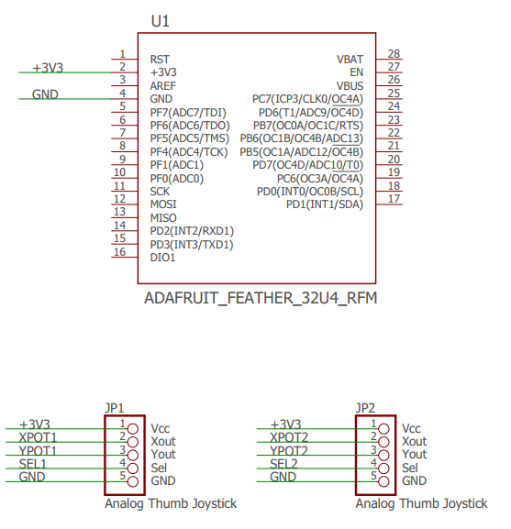

  - Joystick functionality
Each loop reads joystick values using ADC for X and Y axis of the both joysticks and digital comparison for Z axes. These values are converted from int16 to byte, because the range is enough, it uses less bytes in the payload. Center position integer values is 125, full throttle 255 and no throttle 0. This loop is lightweight and only the LoRa communication sets limit for the packet send ratio, which is roughly 10 (try this with packets per 10 s print, so that Serial does not slow down) packets per second.
These bytes are sent as payload to the drone using LoRa. The LoRa communication is explained in section ... and packet integrity and security in ...
Left joystick X axis represents yaw and Y axis throttle. Right joystick X axis represents roll and Y axis pitch. Explain the maneuvers here or on some other section.
Z axes are used for commands such as inactivate flight mode.

  - joystick commands like PID control configuration
The current hardware of the drone does not have any flash memory that can be used to save configurations on the fly and retrieved after the drone is powered up again. The optimal values will be defined in the source code and these can be configured if the drone behavior needs to be altered during the flight session, for example if the weather is more windy than usual.
This is explained more in section ..., should it be here or there?
  - pictures

Communication
  - LoRa
LoRa is Long-Range Low Power radio communication protocol that is made mostly for industrial use for IoT (Internet of Things) implementations. It provides long range communication with low power (Semtech sx1272 around 120 mA during sending). It was chosen for this thesis, because we had a course at VAMK where we used LoRa and because it has simple libraries and payload to send all the required data to the drone, and if needed also from drone back to the joystick. For example sending battery state to the joystick. Also the Adafruit Feather devices have preinstalled LoRa module that is easy to configure for use.
It uses 868 Mhz which is allowed hobbyist frequency in Finland (and most? European countries).

  - Packet validation and security
Since the drone might receive any LoRa packet, not only the ones sent from joystick, the packet needs to be validated to make sure that it comes from the joystick, contains proper data and is not corrupted during transmission. Packets are sent continuously as fast as possible, drone receiving at least 10 packets per second, and at the same time it is calculating its orientation, controlling PWM signal interrupts and other routines. For this reason only lightweight algorithms are used. Packet contains 6 bytes of joystick data (pitch, roll, yaw, throttle and 2 buttons) and the last byte is reserved for CRC (cross cyclic redundancy). CRC is calculated from the 6 data bytes.This gives some data integrity if the payload is corrupted (LoRa probably does this on its own??) and also makes identification that the packet is not any random packet sent by another LoRa device. These 7 bytes are XORed using a 3 byte XOR key to add some more data integrity and validation and making the intepretion of the packet slighty harder for receiver that it does not belong to.
LoRa packets are often encrypted with SHA256 or other strong encryption mechanisms, but to provide fast packet handling they are minimalistic in this project.

  - Performance in high speed requirements of quadcopter
  - Pros and cons
    - Slower than the usual communication method used in drones (explain what it is)
    - LoRa network can be used to control more self-sustaining drones that use GPS locations as control input. Command multiple drones etc.

