Maze Solver
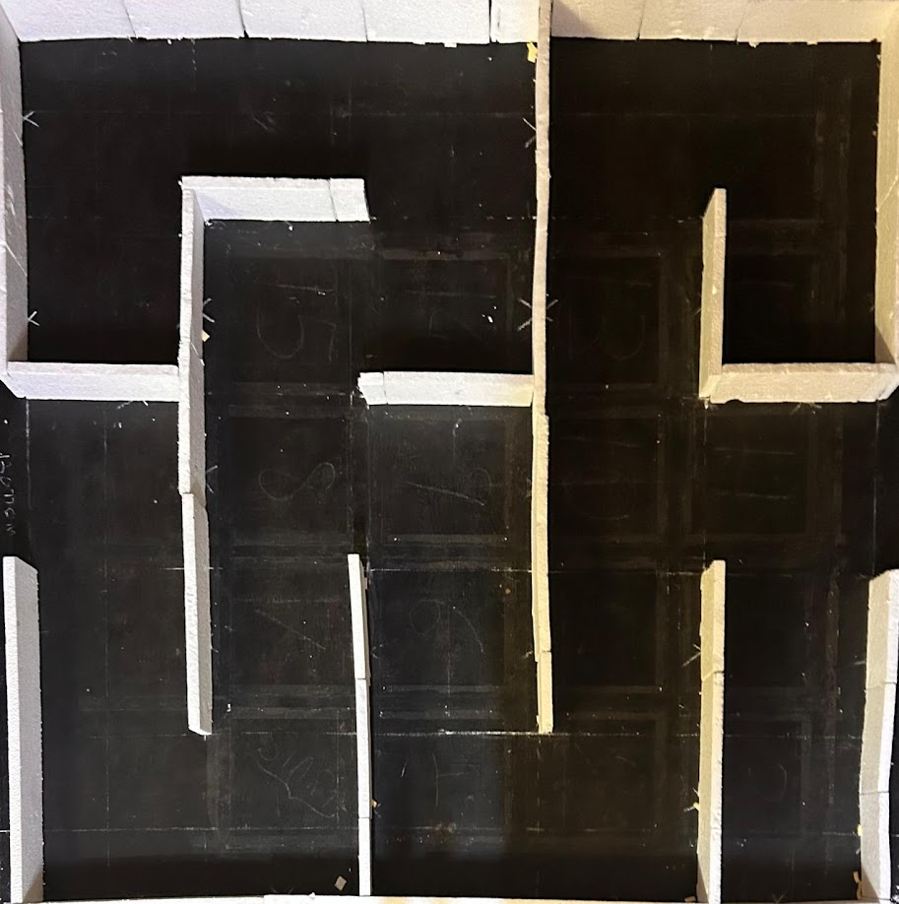
The maze can be simply expressed as a grid of squares, and thus the squares can be treated as points (in the middle of each square)
The first step was to find the adjacency matrix of the group of points in the centers of the grid squares. This is done in a similar way to Bresenham, but this is an easier version, since the only lines to be studied are either vertical or horizontal.
Two points were said to be neighbors, here, if there was no obstacle between them. After checking this condition, each of the node was added to the other’s neighbor list.
After this, is simple BFS, to find the shortest route. “bfs.py” in Day 5 is implemented to find the shortest path. The output route is then fed into the Arduino as a series of instructions (left, right, forward) according to the conditions.

