**Sales Data Analysis and Dashboard – Summary Report**

**1. Project Overview**

This project analyzes the company's historical sales data to identify key revenue drivers, seasonal trends, and actionable improvements. The insights are visualized through an interactive Power BI dashboard.

**2. Key Findings**

1. **Revenue Drivers**

* Top Products: Products such as Comics, Vacuum Cleaner, and Dresses generated the highest sales revenue.
* Top Categories: The Home & Kitchen and Books categories consistently outperformed others in total sales.

1. **Regional Performance**

* The South region led in total sales, followed closely by the West and East regions.
* All regions contributed significantly, but there is potential to boost sales in the North region.

**C. Seasonal Trends**

* Sales peaked in the months of June and July, indicating strong mid-year demand.
* A noticeable decline in sales was observed towards the end of the year (August and September).

**D. Profitability**

* The total profit for the analyzed period was 1.55M.
* The average unit price was 861.14K, indicating a focus on higher-value products.

**3. Recommendations**

* **Focus on High-Performing Products & Categories:** Increase marketing and inventory for top-selling products and categories to maximize revenue.
* **Boost Sales in Under performing Regions:** Investigate reasons for lower sales in the North region and implement targeted promotions.
* **Leverage Seasonal Trends:** Prepare for increased demand in June and July with special offers and stock planning also Launch end-of-year campaigns to counteract the typical sales decline.
* **Monitor Pricing Strategy:** Regularly review unit prices to ensure competitiveness while maintaining profitability.

**4. Dashboard Features**

* **Interactive Filters:** Users can filter data by region and custom date ranges.
* **Dynamic Visuals:** Includes bar charts, donut charts, line charts, and KPI cards for comprehensive analysis.
* **User-Friendly Layout:** Clear titles, color-coded visuals, and a modern design enhance readability.

1. **Attachments**

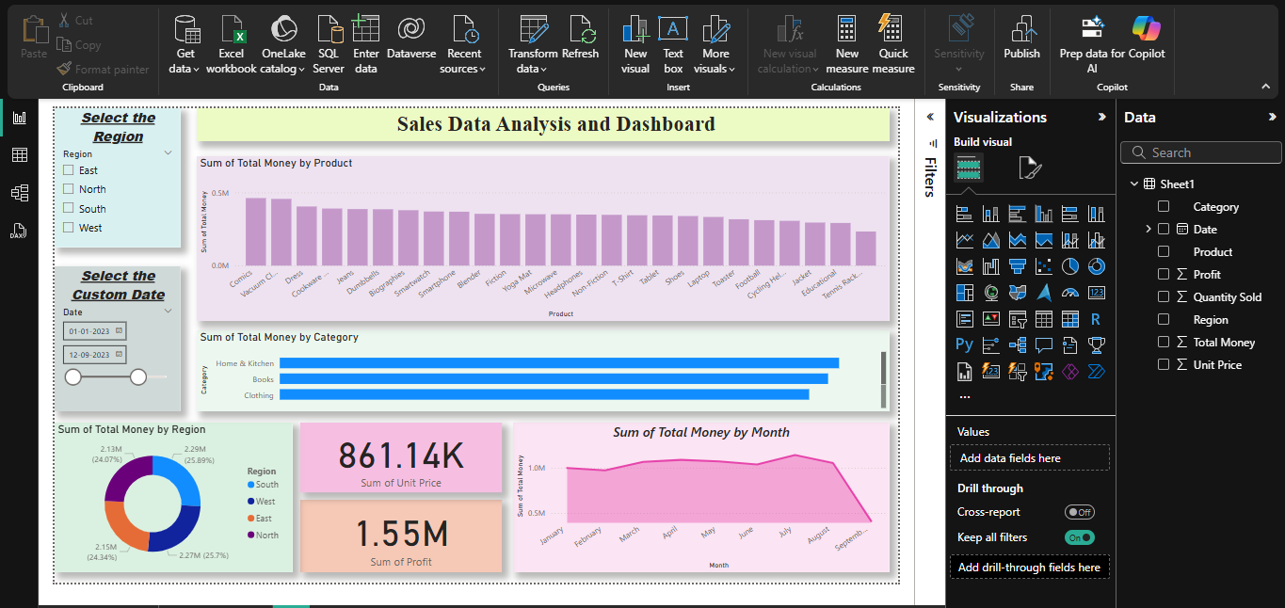

**Figure 1:**

Sales Data Analysis Overview Dashboard - This interactive Power BI Dashboard Provides a comprehensive overview of sales performance, including top products, Category-wise Sales, Regional Distribution, Key Performance Indicators and Monthly Sale Trends. Users can Filter the Data by Region and Custom Date Range for Deeper Insights.

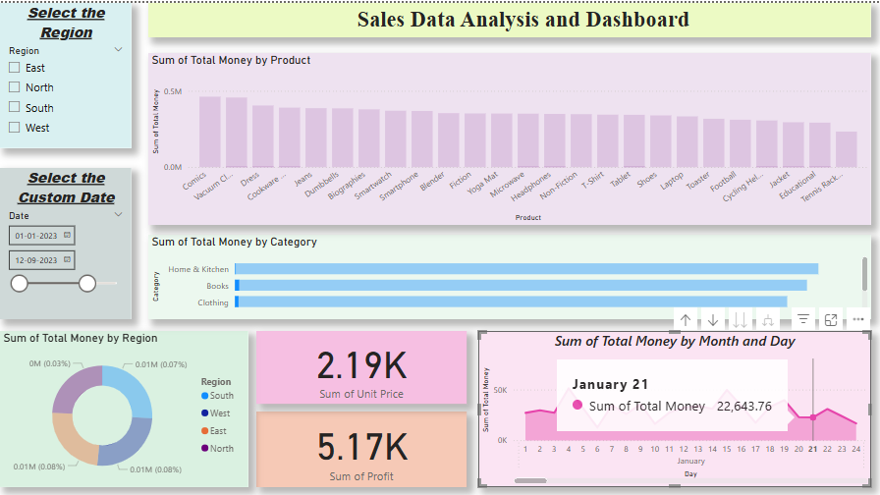

**Figure 2:**

Filtered Sales Dashboard with Daily Drill-Down This view demonstrates the dashboard’s interactive filtering and drill-down capabilities. Users can analyze sales by specific regions and custom date ranges, with detailed breakdowns by product, category, and daily sales trends. KPI cards highlight key metrics such as average unit price and total profit.

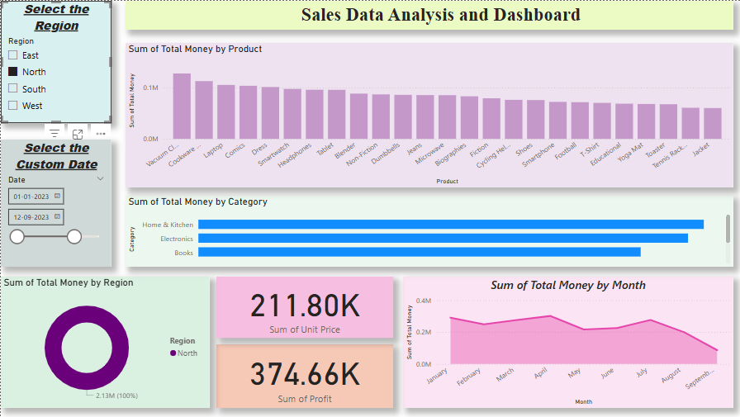

**Figure 3:**

Regional Sales Analysis – North Region Focus This dashboard view highlights sales performance exclusively for the North region. All visuals update dynamically to reflect product-wise, category-wise, and monthly sales, as well as key metrics and regional distribution, enabling targeted regional analysis.

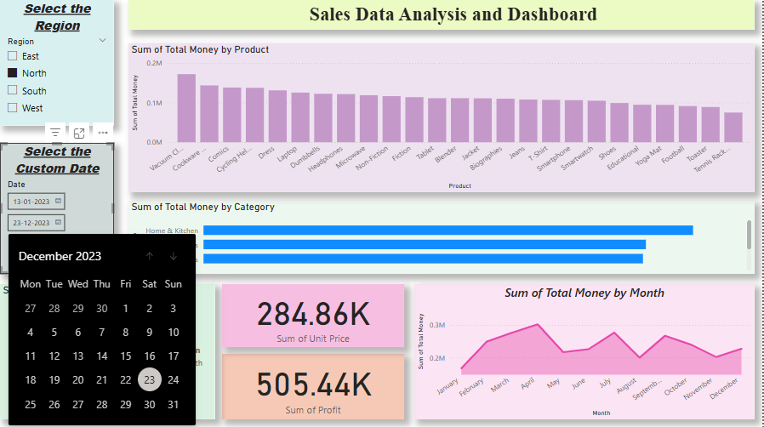

**Figure 4:**

Custom Date Range Selection in Sales Dashboard This screenshot illustrates the use of the custom date filter, allowing users to select specific time periods for analysis. All dashboard visuals—including product, category, and monthly sales, as well as key performance indicators—update instantly to reflect the selected date range.

Prepared by:

Allu Harini