# Social Media Sentiment Analysis Report

## Project Overview

### Objective:

To analyze customer sentiments from social media text using NLP techniques and determine public perception of the brand.

### Approach:

A data set of social media tweets was processed using Text-blob sentiment analysis to classify each tweet as Positive,Neutral, o r Negative.

## Data Summary

* **Total Tweets:** 27482
* **Columns Used:** text,sentiment,selected_text
* **Additional Features:** clean_text,predicted_sentiment

## 3. Preprocessing Steps

* Lowercasing all text
* Removing punctuation and special characters
* Tokenizing text into words
* Removing stopwords using NLTK
* Lemmatizing words to their root forms

## 4. Sentiment Classification

Tool Used: TextBlob (based on polarity score)

* Polarity > 0.1 → Positive
* Polarity < -0.1 → Negative
* Else → Neutral

**Sentiment Distribution:**

* Positive:10570
* Neutral:12250
* Negative:4662

## 5. Visualizations

**Word Clouds:**

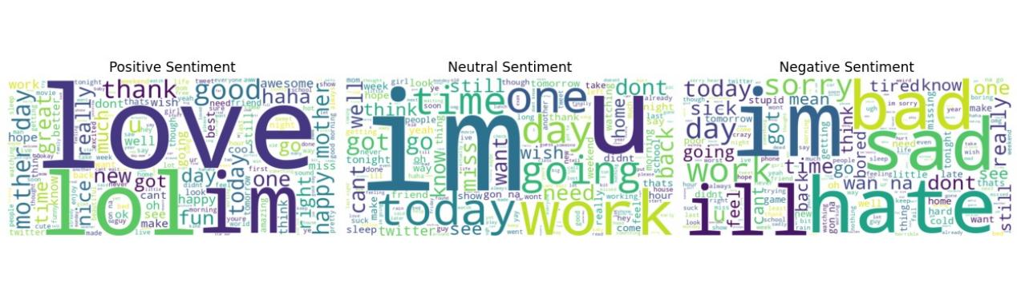

**Fig1:**

* **Positive:** Highlighted joyful and supportive terms.
* **Neutral:** General language without strong sentiment.
* **Negative:** Expressions of complaints, frustration.

**Bar Chart:**

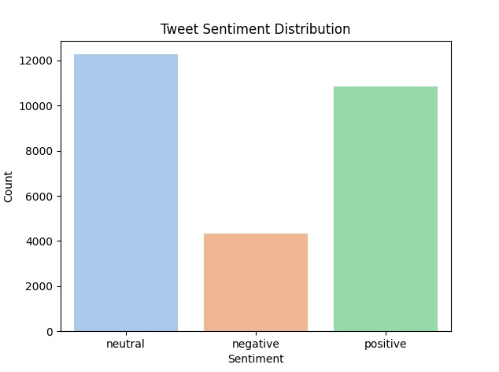

**Fig2:**

Shows frequency of each sentiment category.

## 6. Key Insights

* Majority of tweets were Neutral.
* Specific keywords in negative tweets hint at areas for improvement.
* Neutral content offers potential for sentiment shift through engagement.

## 7. Recommendations

* Address common complaints shown in negative sentiment word cloud.
* Engage neutral users with personalized messaging to turn them positive.
* Promote positive tweets to reinforce brand reputation.

## 8. Conclusion

This analysis provided a comprehensive view of customer sentiment using NLP. With actionable insights, the brand can focus on improving customer engagement and reputation management.

Prepared by

Allu Harini