**Exercise No** 8

::

**Information gathering using theHarvester**

Aim:

To demonstrate information gathering using theHarvester

Procedure:

STEP 1: Open Terminal in the kali linux

STEP 2: Run the following command

Command: theHarvester -d

arms.sse.saveetha.com

-

l 300 -b all

Step 4: run this command

“

theHarvester -d

arms.sse.saveetha.com

-l 300 -b all -f test

”

and hit enter to export the result as html file and xml file

Step 5: now close the terminal and navigate the home folder and search

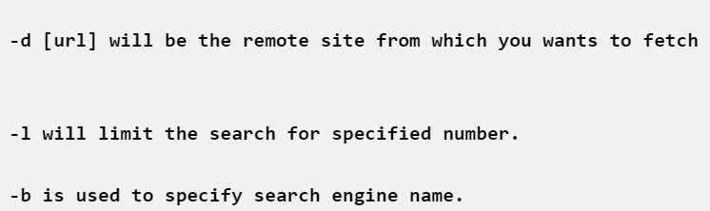

OUTPUT :

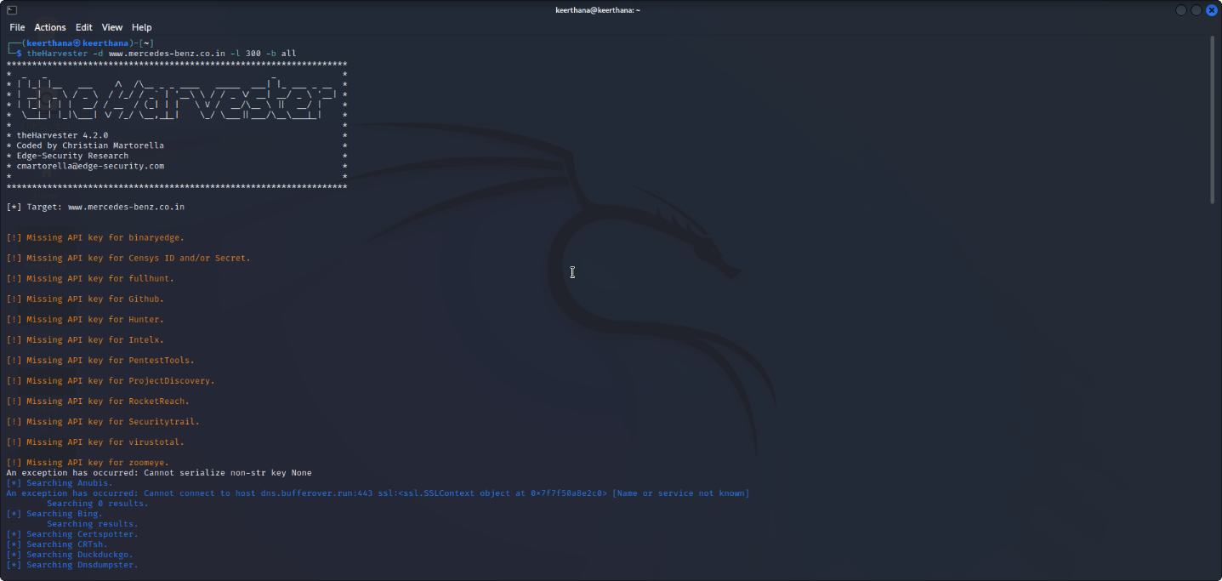

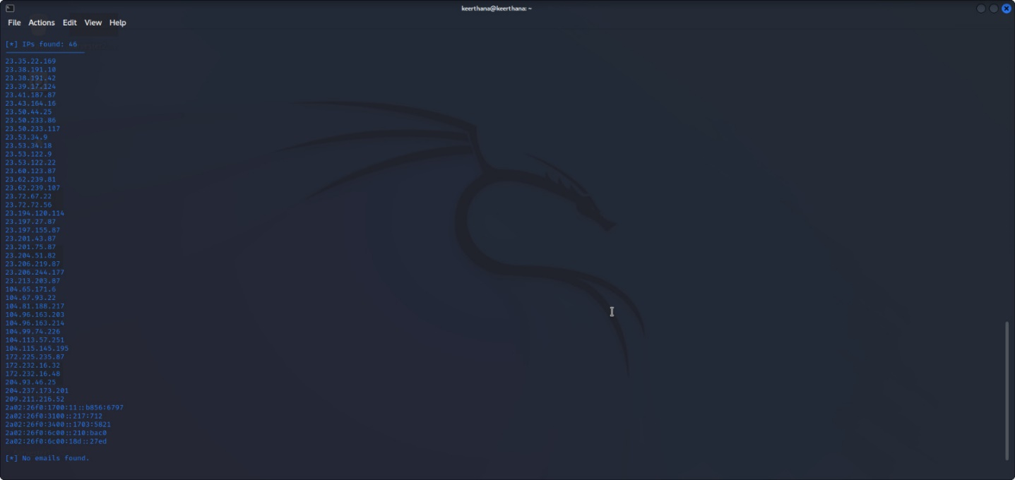

RESULT:

Hence we have performed information gathering using THE HARVESTER.

|  |
| --- |
|  |