**EXPERIMENT-1**

**Lab Book:**

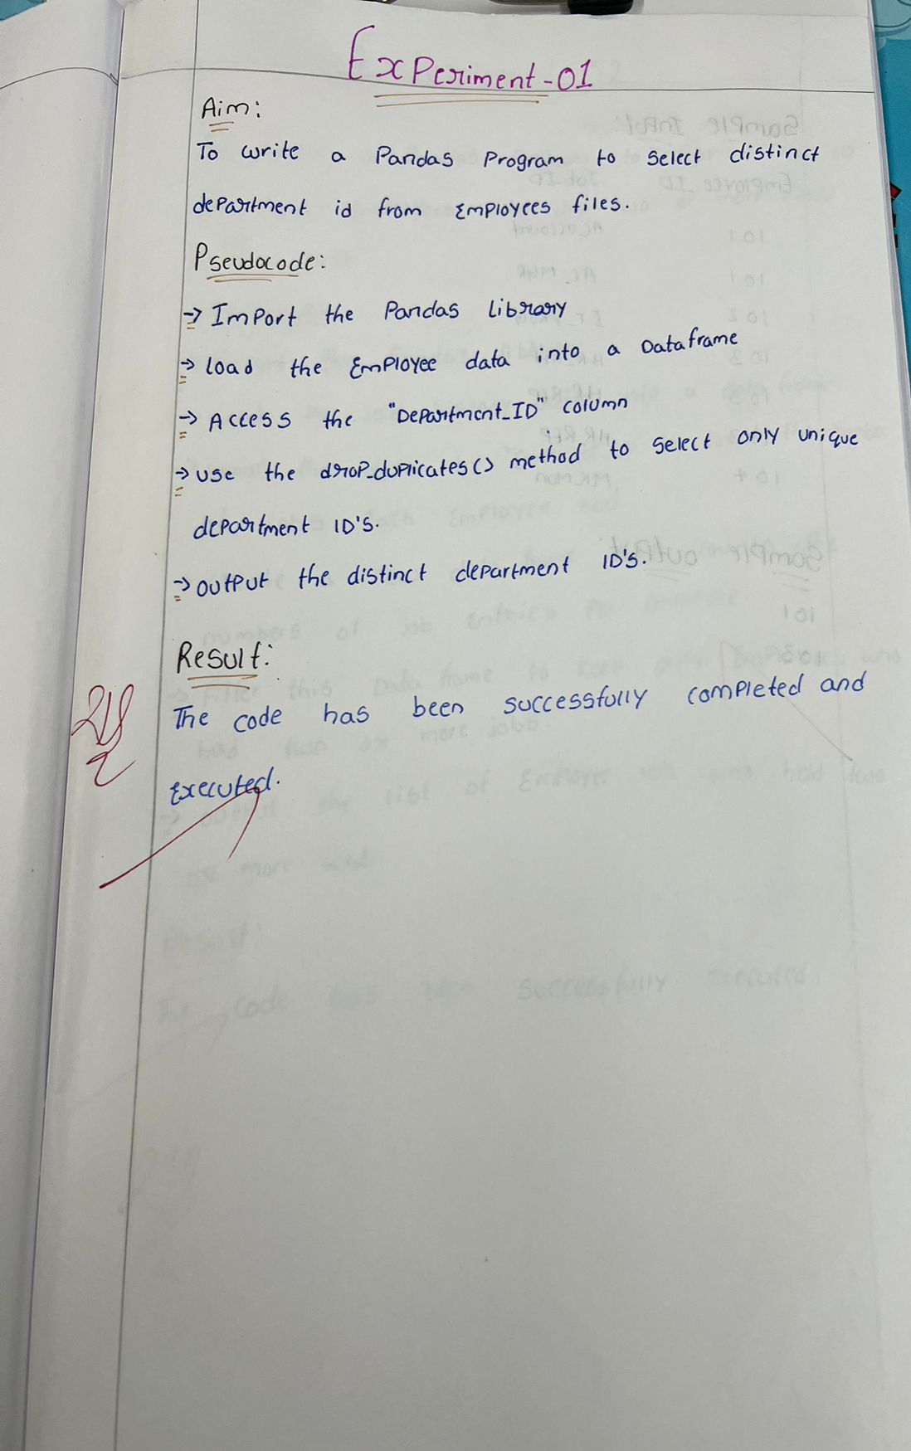

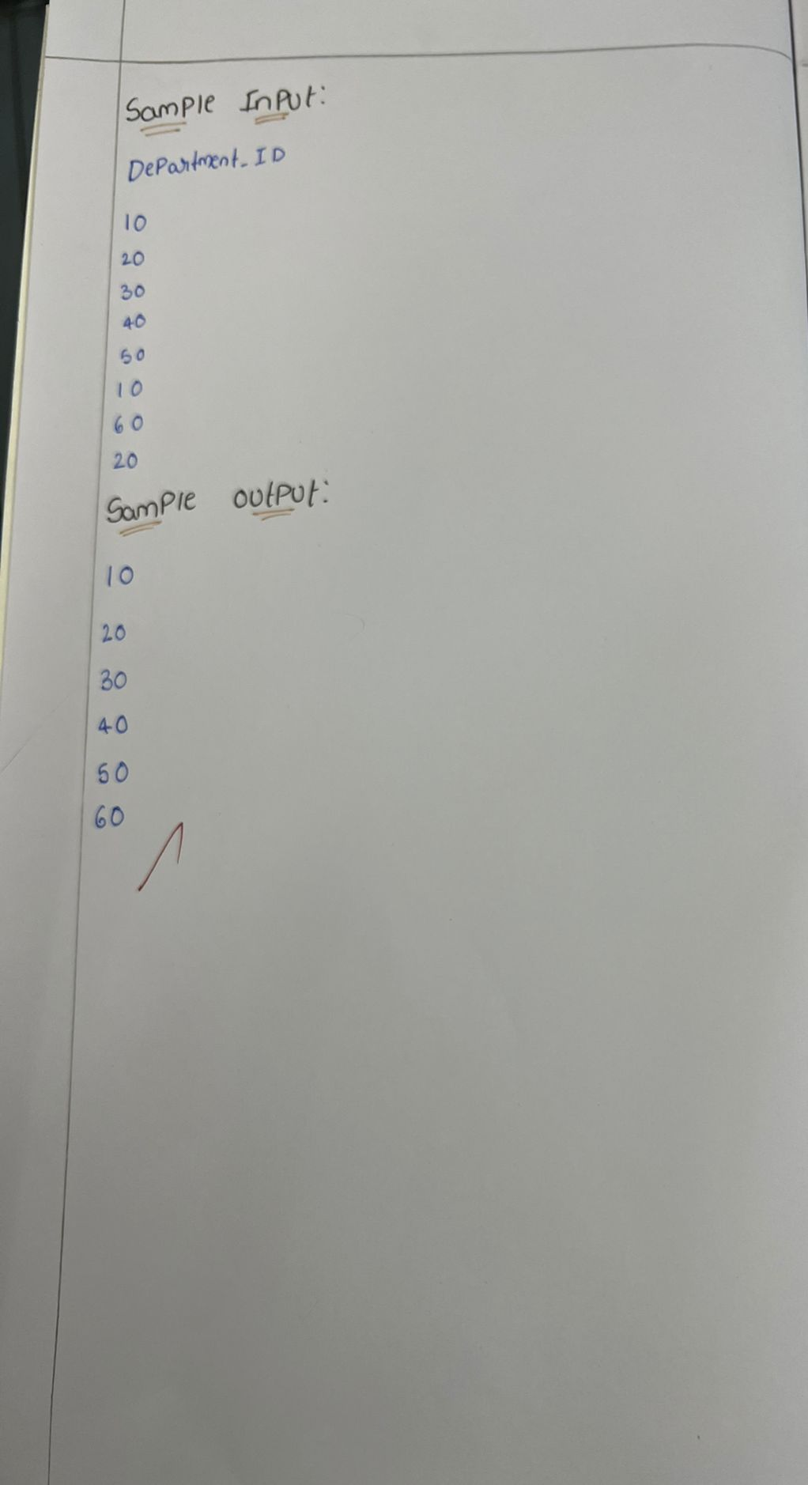  
**Sample code:**

import pandas as pd

data = {'DEPARTMENT_ID': [10, 20, 30, 40, 50, 60, 70, 80, 90, 100, 110, 120, 130, 140, 150, 160, 170, 180, 190, 200, 210, 220, 230, 240, 250, 260, 270]}

df = pd.DataFrame(data)

distinct_departments = df['DEPARTMENT_ID'].drop_duplicates()

print(distinct_departments)

**Sample output:**

