**EXPERIMENT-11  
LabBook:**



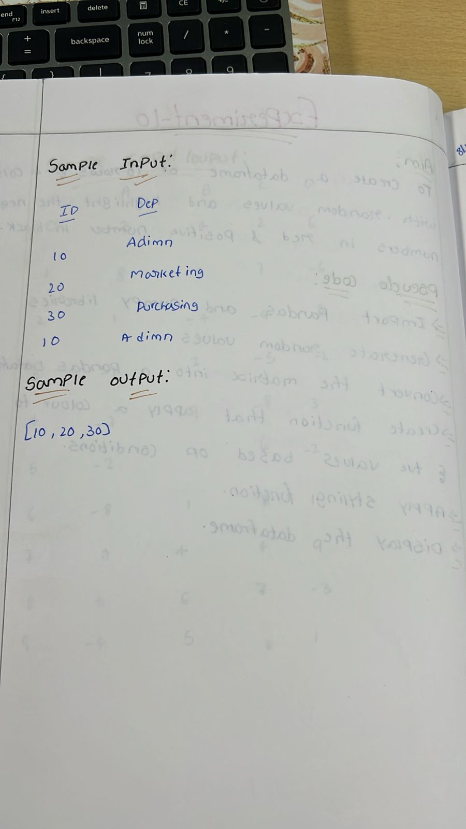

**Sample code:**

import numpy as np

import pandas as pd

np.random.seed(0)

df = pd.DataFrame(np.random.randn(10, 5), columns=list("ABCDE"))

nan_indices = [(0, 2), (4, 1), (4, 3), (6, 4), (9, 4)]

for row, col in nan_indices:

    df.iat[row, col] = np.nan

highlighted_df = df.copy()

highlighted_df = highlighted_df.fillna('NaN')

print(highlighted_df)

**Sample output:**

